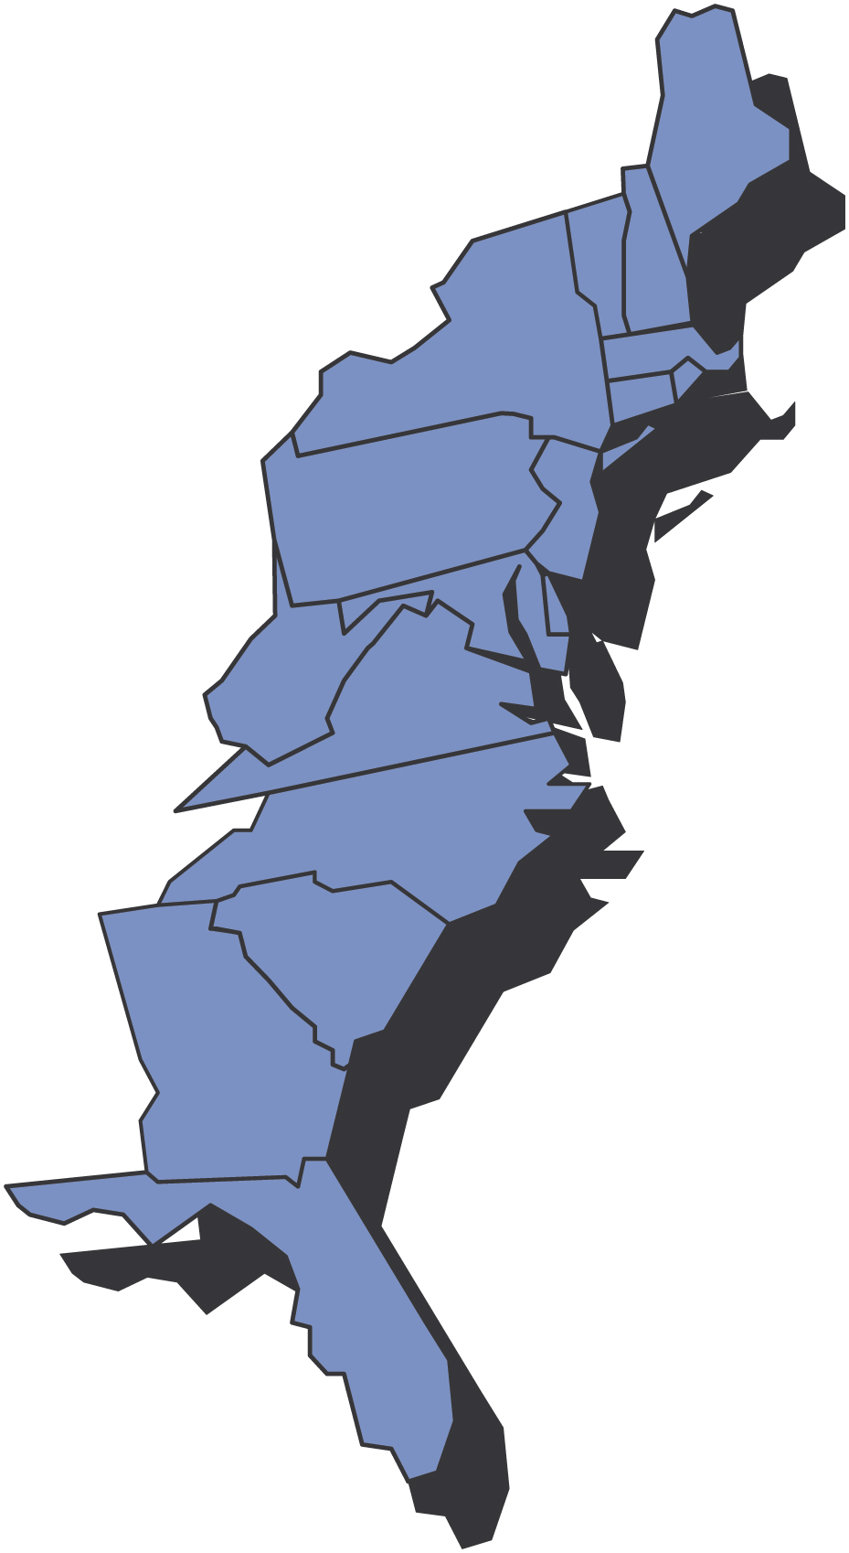

October, 2009

Third District Today

0BFra Presidenten Ralph Peterson

October 2009
Kjære Venner,
This is the first time in a long time that I have written a letter to SON members while I am in Norway. It is 6:30 AM and the sun is coming up. I am sitting in “min svigerinne søster kjøkken” looking at a cow pasture on my right. The sheep and cows will be showing up shortly and the center of Oslo is only 20 minutes away.
I just read the Hartford lodge newsletter and they included a copy of their bylaws in this edition. I think that publishing your bylaws on a set schedule is a great idea.
Many lodges are offering their members an online copy of their newsletter. It saves a lot of money and time. Not all members have access to the internet, but for many, it is a great option. I receive many of your newsletters and I am happy to receive your electronic editions.
I received several newsletters this week that contained information about upcoming bazaars. Please make sure your event is listed on the District Website www.sofn3D.org .
The results of the District bowling tournament are now posted on the web site (10 teams competed) as well as pictures from the Maine Nordmenn Hummer Fest. The lobsters were terrific.
This past month we tried to reach many of our members by email. At least 5-10% of the emails were undeliverable. If you didn’t get an email stating that the September D3 newsletter had been posted we probably didn’t have an email listing for you or it was listed incorrectly in the SON data base. If you were one of those people please go on line to www.sofn.com , update your information or call headquarters and have it done.
Many of our lodges are putting a slate of candidates together for a fall election. This is a most important process. Please say yes if you are asked to run for an office.
The number of Financial Benefit counselors in D3 continues to grow. My last count was 19 FBC’s assigned to the District with more coming. This is great news.
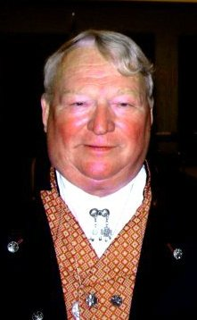
Our membership numbers so far this year are in step with the rest of the order, not good. But this is the time of the year when we add members. Let’s not only add members but take action to keep those that we have. In the September Viking, International President Rude points out some of the challenges we face and the opportunities we have as our lodges move forward. In my opinion, the opportunities are greater than the challenges. For those of you with internet access please check out the SON web site www.sonsofnorway.com/retention . The section contains a lot of good information that should be discussed and disseminated at your lodge and board meetings.
Our new lodge at New Bern is only 6 members away from the magic number of 40. Let’s see if we can’t help them along.
The winners of the Hurtigruten raffle are listed on the web site. We had winners from North Carolina and Maine. Congratulations and thanks to all of you who participated in this important fund raiser. Special thanks to Kris Rasmussen and Rolf Ekloff who worked so hard to make the raffle work. Look for more news about a District 3 July 2010 Hurtigruten trip.

Med Vennlig Hilsen
Ralph Peterson
President District 3
Sons of Norway

*****************************


Don’t forget to:

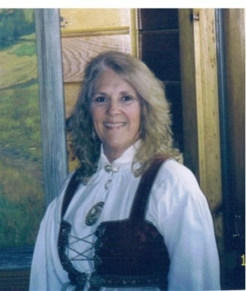
Fra Vise Presidenten Gail Ekloff

October Newsletter

October Letter
Leif Erikson: Does your lodge celebrate this historical Norwegian day?
Leif Erikson Day was designated by Act of Congress in a joint resolution approved on September 2, 1964. (Public Law 88-566). This resolution established October 9th each year as "Leif Erikson Day". October 9th was selected because in 1825 it was the arrival date of the first Norwegian immigrant ship, the Restauration, which landed in New York from Norway. It was thought to be the start of Norwegian immigration to America. In fact, a lodge in our District chose its name from it ― Restauration #555 in Wallingford PA.!!!!!
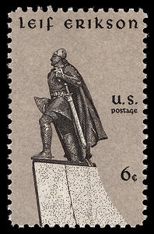
In 1968 the United States Post Office issued a commemorative stamp. → I was unaware of the stamp so I had to share it with you. What else can we learn about Leif Erikson? Has your Cultural Director researched the event and prepared a short report to share with your members; or are you more creative and plan to put on a skit about Leif’s travels to Vinland? Do you wear your T-shirt that states “Leif was here first”?
Let’s hear from all the lodges and see pictures of how creatively your lodge celebrated LEIF ERIKSON. And, let’s see who gets them on the website first!
Alt for denne gangen,
Gail
Medlemskap scorer bord*
LODGE | 1 | 2 | 3 | 4 | 5 | 6 | 7 | 8 | 9 | tOTAL
Nansen # 410 | 1
Washington # 428 | 1
Oslo #438 |  | 1
Hampton Rd. #522 |  | 1
*number 0f 999 members that transfer to a lodge- source activity report /Minneapolis
REMEMBER THE 2 A’S TO GET NEW MEMBERS--- ASK AND ADVERTISE
AND, TO KEEP MEMBERS, THE 2 M’S -----------------MENTOR AND MINGLE

The Hurtigruten Raffle

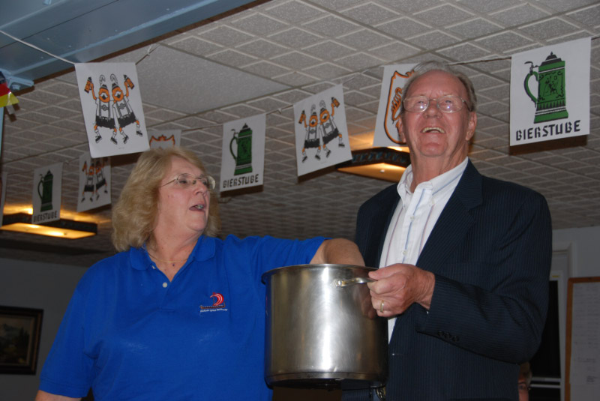
D3 Vice President Gail Eklof draws the raffle winners from LOV Chairman Rolf Ekloff at Oktoberfest weekend at LOV

And the winners are:
Diane Eiker from Maine Nordsmenn and
Erik Wiik friend of North Carolina Vikings

Congratulations Diane and Erik!!!
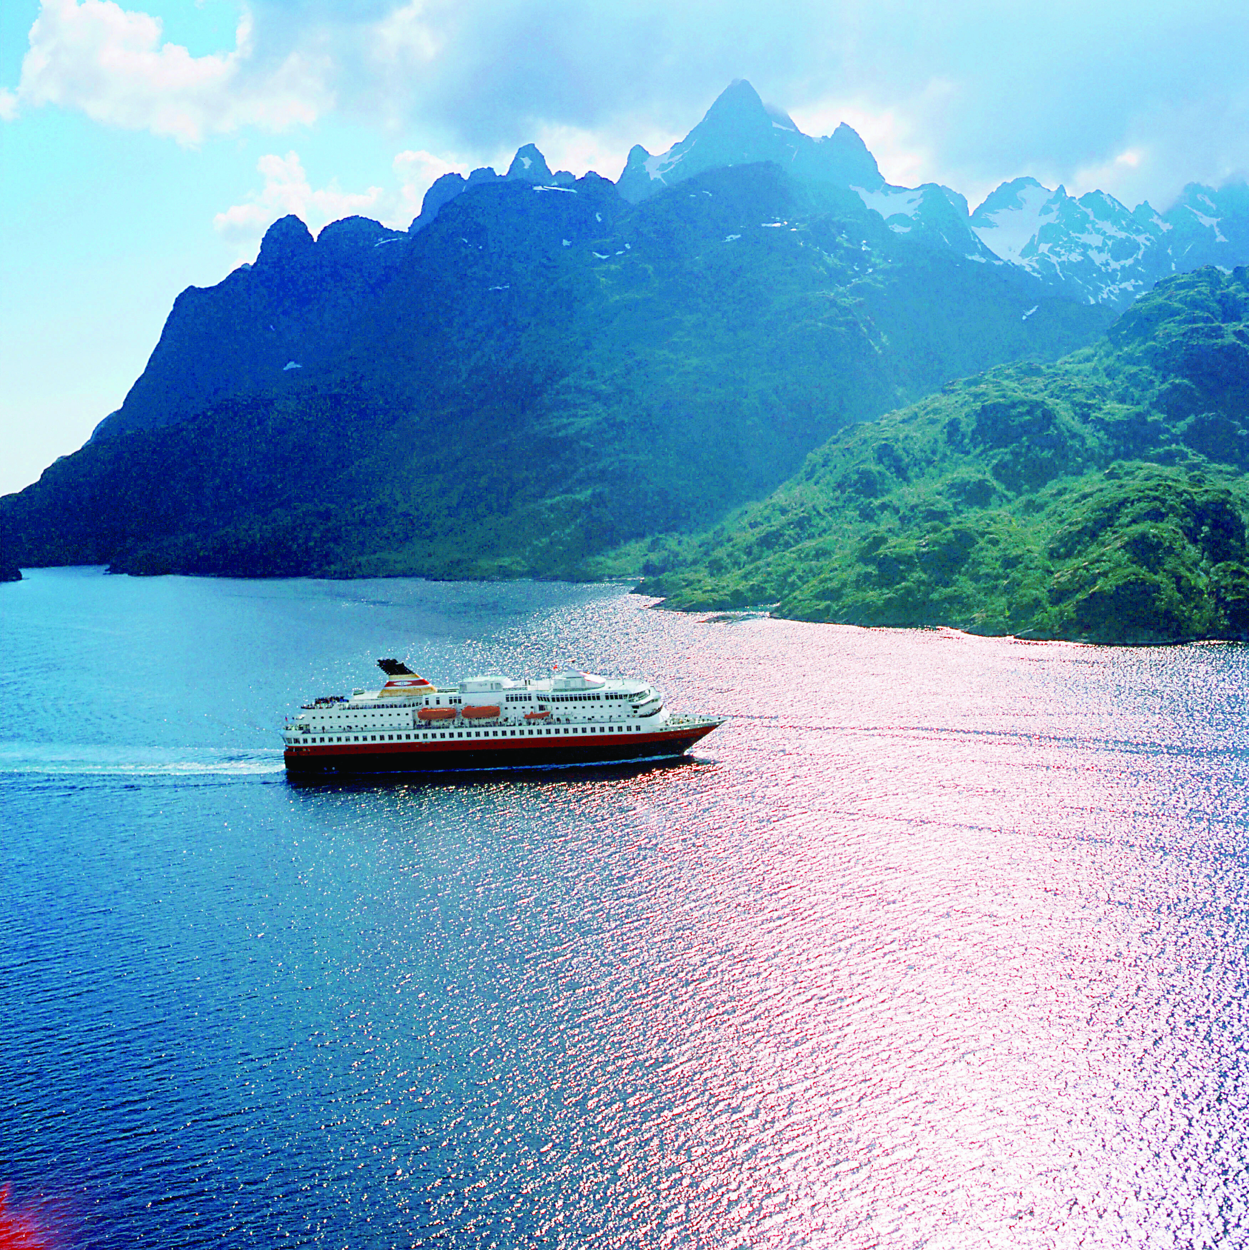

Make sure you send in some pictures for the TDT!!!

Adopt A School
By Gene & Nalda Olson, Adopt A School Coordinators

“SCHOOL DAYS, SCHOOL DAYS
GOOD OLD GOLEN RULE DAYS”

Sound familiar? I watched the kids board the school bus this morning such energy and enthusiasm! - at least for some. There were several mothers wiping away tears - from their eyes! By the time you read this, school will be in full swing. NOW is the time for you to swing into action with the ADOPT A SCHOOL PROGRAM.

The cover on the September issue of the Viking magazine is frightening. Bright red with bold letters, “IS OUR FUTURE IN JEOPARDY”? The future of Sons of Norway is in the hands of our young people. The ADOPT A SCHOOL PROGRAM is one way to reach out into our schools and communities with Norwegian cultural programs and events as well as individual volunteers. The rewards are three fold: the school children and teachers learn about Norway, the community gains knowledge of Norwegian culture and food, and the participating lodges benefit from positive public relations. The results? - hopefully an increase in membership. The ADOPT A SCHOOL PROGRAM is a treasure/tool box just waiting to be opened.

Many lodges are already involved in the ADOPT A SCHOOL PROGRAM, however, many are not! Interested? You can send for an ADOPT A SCHOOL PROGRAM kit from Sons of Norway International or contact your 3rd District ADOPT A SCHOOL PROGRAM coordinator for information and advice.

In the meantime, for those lodges that do have an ADOPT A SCHOOL PROGRAM, post our success stories on the 3DT ADOPT A SCHOOL PROGRAM soon to be available blog! What better encouragement then a firsthand experience?

NOW HOP ON THAT SCHOOL BUS AND GET GOING!

Gene and Nalda Olson Bondelandet Lodge 3-612
adoptaschool@d3sofn.org

Publicity
by Mary Andersen

An Important Reminder Regarding Privacy
1. Honor a request to keep information private. If a member indicates that they do not want their contact information published, the request must be honored. Further, a communication strategy must be developed to ensure that the entire organization is honoring the request. Thus, if a local lodge officer receives such a request, it must be communicated to headquarters and the district.
2. Use contact information for official purposes only; published member information is for Sons of Norway purposes only. Warning language accompanying the publications (website, yearbooks, directories, etc.) will serve as an additional reminder.
3. Privacy warning language. When we publish information, there is a chance those outside the organization may view it. If so, they must be reminded that the information is published for Sons of Norway purposes only and not available for other use, such as commercial use. Likewise, our general membership should be reminded of the same. There is no magic to the terminology. You are free to draft whatever conveys the message. Language we have used is as follows:
"The following contact information is published for Sons of Norway purposes only. Use for any other purpose is strictly prohibited."
"This information is for official Sons of Norway business use only. Use of this information for solicitation or commercial purposes is a violation of the Sons of Norway privacy policy and is strictly prohibited."
4. Added privacy concerns for minors. With respect to minors, federal laws apply to the online publication of ANY contact information (picture, address, email, and phone) of a minor under age 13. In essence, the law requires parental consent prior to such a publication. While the law only applies to online publication, lodges should always be careful in publishing minor information without knowledge and consent of a parent.
In sum, there is no need to suggest that contact information not be published unless there is a specific request or lack of parental consent. The primary objective is to create a general awareness within the organization that the information published is for membership purposes only. Further, this awareness is of particular importance to those responsible for web sites. Special care must be given before scanning newsletters or directories and posting them on the web.
Sports
3rd District 2009 Bowling results

Category | First Place | Second Place
Mixed | Suncoast, Florida | Gateway to Florida
Men’s | Nor-bu Team #1 | Nor-bu Team #2
Women’s | Gulfstream, Florida
Men’s High game scratch | B. Karpek 248 Nor-bu
Men’s High series handicap | J. Jenkins 676 Nor-bu
Women’s High game scratch | Lillian Anderson 201, Sun Viking
Women’s High Series handicap | Gladys Balzarano 642 Sun Viking

Congratulations to the winners! Next year, we will get a much earlier start and have all results by April 30. This means that plans should be made early in the year ……and remember one of the tournaments is to get people together and other lodges together to enjoy the friendly competition.

Many thanks to those who helped in getting the groups together and hopefully you will help again next year and spread the word for more participation. Thanks again!

The prizes awarded were on a budget and based and based on the number of bowlers and/or teams, so let’s get more people for more prizes and/or trophies. Thanks again for your participation. Phil Nelsen, 3D Sports & Rec Director.

Celebrate Culture
This article is an excerpt from Wikipedia http://en.wikipedia.org/wiki/Leif_Ericson and http://en.wikipedia.org/wiki/Leif_Erikson_Day (Notice the difference in spelling!)
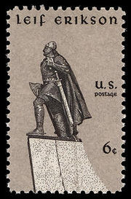
1968 U.S. postage stamp honoring Leif Erikson
- Presidential Proclamation of Leif Erikson Day, 2008
Leif Eriksson (Old Norse: Leifr Eiríksson)^{[1]} (c. 970 – c. 1020) was a Norse^{[2]} explorer who was probably the first European to land in North America (excluding Greenland) around 500 years before Christopher Columbus.^{[3]} According to the Sagas of Icelanders, he established a Norse settlement at Vinland, which has been tentatively identified with the L'Anse aux Meadows Norse site on the northern tip of the island of Newfoundland in Newfoundland and Labrador, Canada.

Leif Erikson Day is an American observance occurring on October 9. It honors Leif Ericson (Leifr Eiríksson), who brought the first Europeans known to have set foot on North American soil. In 1964, Congress authorized and requested the President to create the observance through an annual proclamation. Lyndon B. Johnson and each President since have done so. Presidents have used the proclamation to praise the contributions of Americans of Nordic descent generally and the spirit of discovery.
In addition to the federal observance, some states officially commemorate Leif Erikson Day, particularly in the Upper Midwest, where large numbers of people from the Nordic countries settled. In 1930, Wisconsin became the first state to officially adopt this holiday, thanks to efforts by the Norwegian-American initiator, Rasmus B. Anderson. A year later Minnesota followed suit. In 1963, the U.S. Representative from Duluth, John Blatnik, introduced a bill to observe it nationwide. The following year Congress adopted this unanimously.
October 9 is not associated with any particular event in Leif Erikson's life. The date was chosen because the ship Restauration coming from Stavanger, Norway, arrived in New York Harbor on October 9, 1825 at the start of the first organized immigration from Norway to the United States.

Learn more about Leif at http://www.mnc.net/norway/ericson.htm

Repeated from November 2008 TDT
CONTROVERSIAL SPELLING OF LEIF ERIKSON
The “correct” spelling of “Leif Erikson” has been a debated issue for many years. As a result, some have suggested that any spelling is acceptable so long as Leif gets his rightfully due publicity. To set the records straight however, and to suggest that a standard spelling be used, it would be good to examine the reasons for the “LEIF ERIKSON” spelling.
- The letter “C” is seldom if ever used in the Old Norse language. Even today, newspapers of Iceland, where they still use a modern version Norse, usually only use the letter “C” when it is included in foreign words.
- Since the letter “C” was seldom, if ever, used in the Norse Sagas, Leif’s fathers name was spelled, ERIK THE RED. Since Leif (born in Iceland) was the son of Erik (born in Norway), Leif’s last name became ERIKS’SON, or Erikson.
- In books, and in newspapers in Norway, the spelling most commonly used, is ERIKSON.
- The spelling usually used in Iceland is, Leifur Eiriksson. Since this spelling would be cumbersome and difficult to use in America, the traditional spelling of, LEIF ERIKSON was used in all U.S. Congressional records and hearings, and is used in the annual Presidential Leif Erikson Day Proclamations.



“In the Zone”
Did you know you can find out what is going on in other lodges by clicking on About Us and then lodges on the 3D website. This will take you to the Sons of Norway page which contains all of our lodges. Lodge names highlighted in blue means they have their own website; check out what they are doing and if you are travelling in the area, drop in and say hello!!

SON Summer Fun
Bernt Balchen July 4th parade
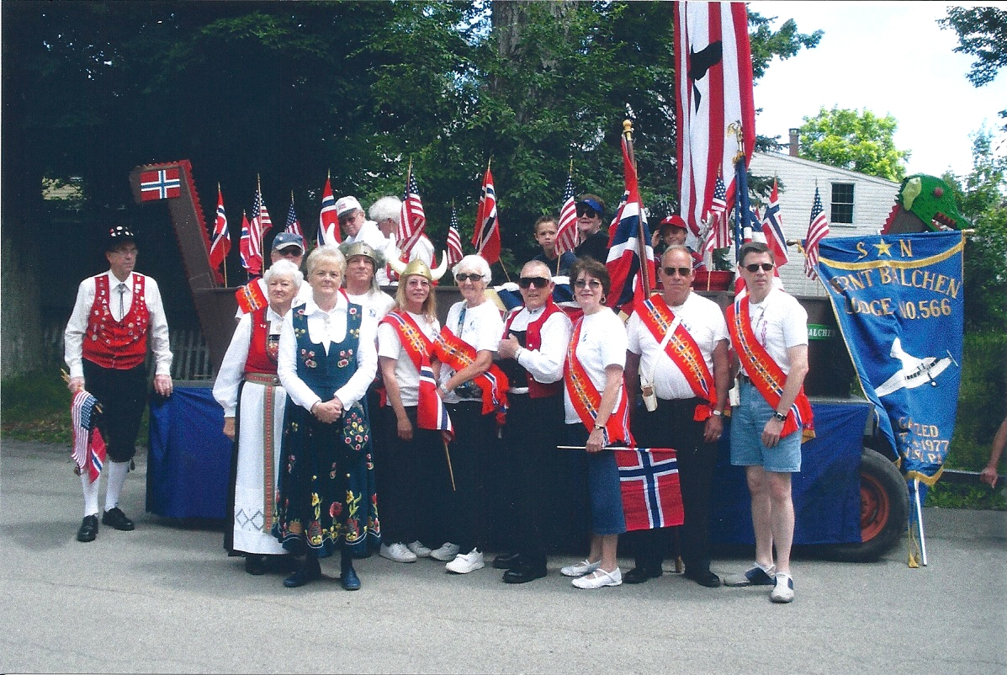

Bernt Balchen’s Scandinavian Fest September 12th

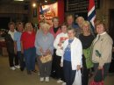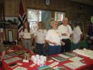
In the first picture, Norrona, Garbog and Bondelandet members stop by to say hello and enjoy the good food and items for sale.

Gateway to Florida Scan Fest
By Marci Larson – Gateway to Florida, President and Third District Secretary
When the Gateway to Florida Lodge in Jacksonville held its ScanFest Sept. 11, the evening had a special twist. The main course, appetizers and desserts were made by nine women who are working on cultural medals. Some of these members had very limited or no experience in preparing Norwegian/Nordic dishes. The women worked for two days preparing a wide range of Norwegian and Nordic specialties that included salmon prepared two ways, pork tenderloin, mashed and boiled potatoes, rutabaga, roelkel, braised carrots, kogt torsk salat (cod salad), frukt suppe (fruit soup), fiskeboller, rømmegrøt, six or seven platters of various open-faced sandwiches with herring, shrimp, anchovies, eggs, cheeses and meats, plenty of lefse and rolls, krumkake made on the spot, kransekake, sunbakkels and ablekage. Norwegian wines capped the feast for hungry Vikings. Nearly 75 members and guests attended who want an encore of the same dinner next year. The featured program was about rosemaling: what it is, how you do it and attendees could shop. Nearly 75 attendees and we had seven new members!!

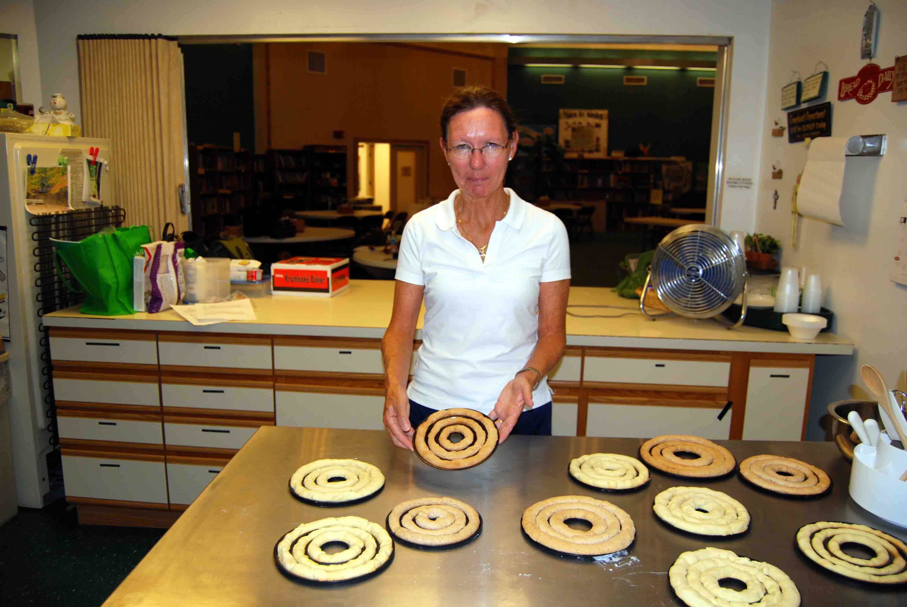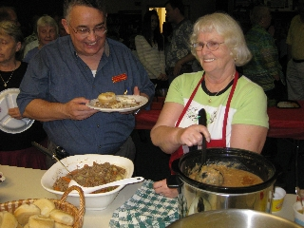

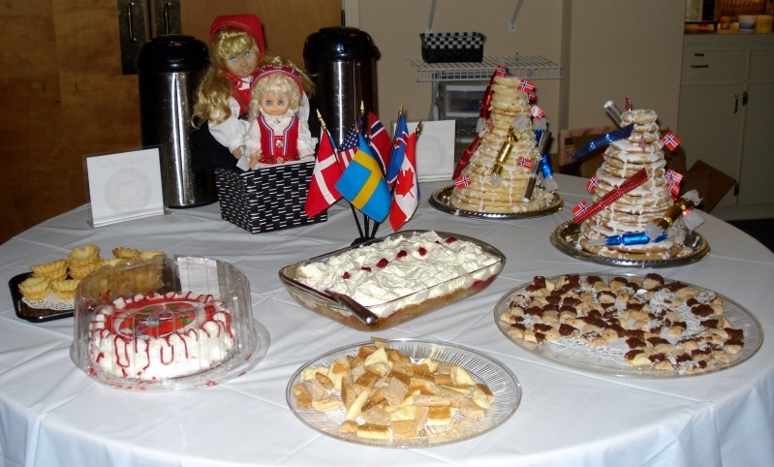


Hilsen from Sons of Norway,
We hope you’re refreshed from the summer festivities and breaks and ready to gear up to recruit new members with your lodge. And recruiting for your lodge this fall can mean winning big – a $500 prize!
Dues-paying new members* recruited between September 15th and December 15th qualify for this contest. Lodges will be divided into two categories based on size. The two lodges—one from the small and one from the large categories —that see the largest percentage growth will each win $500 and be featured in a spring 2010 Member Matters section.
This is a team effort, so call your lodge vice president to see what you can do to help plan a member recruitment event. You can also find ideas in the members section of www.sonsofnorway.com, including the contact information for your Financial Benefits Counselor, who can help with throwing an event.
If you have other questions or want help brainstorming, contact the Membership Coordinator at nneuman@sofn.com or (800) 945-8851 x697.
*Applications must be from new dues-paying members and must be received at Sons of Norway Headquarters by December 15th. For complete details, please visit www.sonsofnorway.com and click on Fall Blitz in the Highlights section.

Membership
By Mary Andersen, 3D Publicity Director

Ok, we probably all saw it; you know what I am referring to, the latest issue of the Viking regarding membership. What can we do about? The Sons of Norway established a bulletin board for members to express their thoughts; the following is an excerpt from a post:

To be perfectly honest; the results of your survey were not a surprise to me. I joined my lodge in my 30’s and at the time there were no programs of interest to me, but worse, the meetings were near torture, fraught with infighting and it seemed that several of the members who were the most active and were also the decision makers, i.e. Board Members in the Lodge, were entrenched in self-serving “cliques”, unwelcoming and unwilling to consider new ideas that might engage a younger membership base that would ultimately enrich the entire culture of the Lodge.
So you may ask, why on earth did you stay? The short answer is that I was fortunate to quickly connect with many members who were truly wonderful and the situation presented a unique challenge. I could imagine the potential of what this community could become; a home where all generations could gather and learn from each other, enjoy programming that would appeal to all age-groups as well as more age specific events and where every member was valued. I decided I’d make a go of it.
The simple truth is that anytime you have a group of people together there will be disagreements on how to operate, set priorities and gain consensus. Though your suggestions on building programming aimed at a younger membership are good ones and recruit, recruit, recruit all the new members you can is fine but you’ll never keep them as long the base problem is not addressed and solved. If 52% of those polled sited the same issues that I had walked into, the Lodges have a much larger and more difficult problem on their hands, a culture that doesn’t want to change. Bottom line; if a Lodge is dealing with a closed and unwelcoming mindset the membership must change to build a community of inclusiveness, transparency and open-mindedness and this is not an easy task.
From the onset it was clear that we needed to work on the one thing that was most important and that was our membership. Over time the mantra “What is good for the Lodge?” evolved. This simple question is asked after nearly every suggestion or idea and it helps to keep the best interest of our membership in the forefront of every equation which is paramount for retention and recruitment.
We have seen an amazing turnaround. We hear comments such as “I felt so welcomed” and “Everyone seems to be having so much fun”. We’ll we are. There have been some very difficult times over the past few years but we have come out on the other side a stronger organization and a more committed membership, a family. We still have a lot of work to do but our foundation is laid and we are well on our way creating engaging cultural programming for all ages and doing what SONs members do best, giving back to our community. I am very proud to be a member of Grieg Lodge.
A few things that would have helped us in the process:
A little help; if other Lodges are experiencing these difficulties as it clearly sounds like they are. Please give our Lodges the tools and support they need in order to be successful. Perhaps there could be a fund available to assist in mediation and conflict resolution. Also, it would be helpful if SON made it a priority to invest in professional leadership building and facilitation seminars for Board Members. As long as a Lodge is dealing with internal dysfunction there will be no capacity, time or point in recruiting new members. There are several nonprofits that specialize in low cost consultation services.
A look inside; though the Viking Magazine has certainly done a better job over the past two years with some articles targeted at a younger audience and I understand that the majority of your readership is typically 60+ but more articles would be worthwhile and in the “District Happenings” photo section, I rarely see any photos of 20-40 year olds.
Not the usual suspects; we are always on the lookout for interesting new groups from Norway to showcase at our Lodge. We have had several great successes on our own but it would be very helpful if SON would assist in communications with intercultural exchange.
A couple of other suggestions for Lodges that weren’t mentioned in your article:
Just not that into them; some younger members are not going to attend the monthly business meetings no matter how you dress them up. Until a young member is more engaged either by serving on a committee and/or eventually holding a Board seat, the business meetings may not appeal to them. Try to create other opportunities to socialize, maybe a regular after work happy hour or organize a picnic or go to a baseball game with the kids.
Something missing; The adopt a school program is great but other community benefit opportunities such as group volunteering can also provide an additional platform for team building not to mention good local PR. Most cities have a “Hands On” Network to help you put together group opportunities or check out idealist.org and volunteermatch.org
Three truths;
1) If you have lodge members that are unwelcoming and refuse new ideas they are not leaders and should not hold positions of influence until they turn the corner.
2) Be kind to each other, recognize one another’s strengths and keep an open mind.
3) Before you act always ask this question first, “Is it good for the Lodge?”
Check out the Son of Norway website for more posts and contribute some of your own; we are all in this together, no matter what part of the District or the country we are from.

It’s the little things
Our President emails an announcement to the 999 members each month after the TDT is posted. Here is one of the responses he received:

Hello,
This is the first time I have heard from anyone from "my district." Just to let you know...my dues are paid. I was considering letting my membership lapse because I have been a member for at least five years and it has served no purpose. Long ago I emailed my district and never got a reply. I thought that I'd eventually get a welcome or an invitation to a meeting, but I've never heard from anyone except for when my dues are due.
Then I received a few emails from you...perhaps things are changing and I will have a chance to really be a member of my district.
Thank you for the emails!

The moral of the story is, take the time to reach out and contact new members, old members you haven’t seen for awhile and prospective members; membership is the lifeblood of any organization.

Upcoming Events

September
18th Bondelandet – Leadership program
18th Noreg – Social, Sisters Night
18th Suncoast – Norwegian Craft Fair
19th Nor-Bu – Anniversary Month (67th)
19th Loyal – Lodge Garage Sale
17th Bernt Balchen – Financial planning
17th Sun Viking – Cultural Craft Fair
20th Noreg – Music Sunday
24th Loyal – Ladies Auxiliary
24th Hampton Roads – Potluck dinner
25th Loyal – Little Vikings
26th Blåfjell –Viking of the Valley
26th Blåfjell – Viking Auction at 3pm
26th Hampton Roads – Neptune Festival Parade
27th Loyal – booth at St. James Fair
27th Noreg – Cultural Sunday

October
2nd Roald – Viking Auction
2nd Nansen – Game night
2nd Norumbega – Cultural meeting
4th Loyal – St. James Day Fair
6th Sun Viking – Leif Erikson dinner
9th Loyal – Oktoberfest Dinner
9th Fredriksten – Leif Erikson Day
9th Norge – Brother’s night
9th Sun Viking – Lapskaus Dinner
9th Blåfjell – Local Colors - Iceland
9th-10th – Gulfstream Lodge –Leif Erikson weekend
10th Hudson Valley – Leif Ericsson Dinner
10th Nansen – Octoberfest
11th Færder – Leif Erikson Party
11th Lauderdale – Jensen Beach Viking Ship Regatta
15th Bernt Balchen – Leif Erikson celebration
16th Bondelandet – Hardanger fiddle
16th Nansen – Cultural Night
16th Noreg – Brothers Night
16th Suncoast – Viking Feast
17th Lauderdale – Halloween Party
17th Nor-Bu – mini walk a thon and dinner
17th Henrik Ibsen – yard sale
18th Loyal – 85th Anniversary Dinner
18th Noreg –Music Sunday
22nd Loyal - Ladies Auxiliary
23rd Loyal – Little Vikings
24th Blåfjell – 13th Anniversary Dinner
24th Henrik Ibsen Oktoberfest
24th Lauderdale – Halloween Party
24th Nansen – Scandinavian Heritage Fair
25th Norden On the Town
25th Noreg – Cultural Sunday

November
1st Norumbega – Cultural meeting
6th Loyal – Thanksgiving dinner
7th Morgensolen – Scandinavian Fair
8th Færder – Annual meeting
9th Hartford – Scandinavian Heritage Day
13th Sun Viking – Soup Dinner
14th Fredriksten – Flea market
14th Loyal - Bazaar
14th Bernt Balchen – membership drive luncheon
14th Hampton Roads – Norwegian Christmas Bazaar
14th Hudson Valley – Men’s night at Maennerchor
15th Nor-bu – Tricky tray
19th Bernt Balchen – Ellis Island presentation
20th Loyal – Little Vikings
20th Henrik Ibsen – Sisters night
20th Nansen – Brother’s Night
21st Noreg – Bazaar in Old Bridge, NJ
21st Norumbega – Scandinavian Fair
21st Nor-Bu – Fall Dance
21st Blåfjell – Grandin Holiday Parade (10 am)
21st Blåfjell – Traditional Seven Cookies exchange (3pm)

December
4th Loyal – Initiation
4th Nansen – First Christmas Party
4th Norumbega - Juletrefest
5th Bernt Balchen – Annual Christmas Party
5th Loyal – Deck the Halls Glogg Party
5th Lauderdale – Christmas Party
6th Færder – Children’s Christmas Party
6th Loyal – Children’s Christmas Party
11th Sun Viking – Juletrefest
12th Hampton Roads – Norwegian Christmas Dinner
12th Hudson Valley – Christmas Dinner
12th Lauderdale – Winterfest Boat Parade
12th Loyal – Adult Christmas Party
12th Henrik Ibsen – Children’s Christmas Party at 1
12th Henrik Ibsen – Adult’s Christmas Party at 7:30
13th Hudson Valley – Children’s Christmas Party
13th Nansen – Children’s Christmas Party
13th Norden – Christmas Party
13th Restauration – Christmas/JulFest
18th Nansen-Jultrefest – St. Lucia
19th Blåfjell – Julefest
19th Færder – Christmas Party
19th Norumbega – Juletrefest for children
19th Nor-Bu - Julefest

January 2010
10th Færder – Installation of Officers

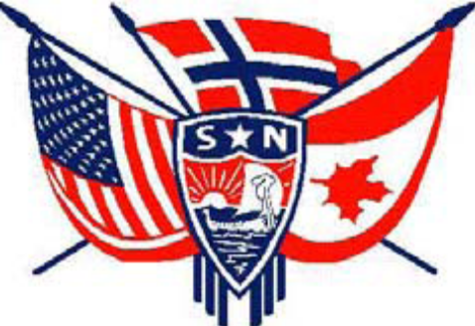

3D Officers

President, Ralph Peterson President@sofn3d.org
Vice President, Gail Ekloff VicePresident@sofn3d.org
Secretary, Marci Larson Secretary@sofn3d.org
Treasurer, John Gregg Treasurer@sofn3d.org
Counselor, Louis Olsen Counselor@sofn3d.org
Youth Director, Evelyn Karpack Youth@sofn3d.org
Sports/Recreation Director – Phil Nelsen Sports@sofn3d.org
Publicity Director, Mary Andersen Publicity@sofn3d.org
Cultural Director, Karen Doty Cultural@sofn3d.org
Adopt A School Coordinators, The Olson’s adoptaschool@d3sofn.org

Zone 1 Director, Kris Rasmussen Zone1@sofn3d.org
Zone 2 Director, Judith Mack Zone2@sofn3d.org
Zone 3 Director, Joan McKillop Zone3@sofn3d.org
Zone 4 Director, Arnold Johnsen Zone4@sofn3d.org
Zone 5 Director, Carol Anderson Zone5@sofn3d.org
Zone 6 Director, Kathy Dollymore Zone6@sofn3d.org

PRIVACY NOTICE: This information is for official Sons of Norway business use only. Use of this information for solicitation or commercial purposes is a violation of the Sons of Norway privacy policy and is strictly prohibited.

