March, 2009

Third District Today

0BFra Presidenten Ralph Peterson

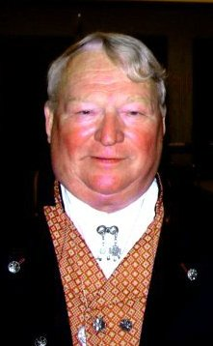
Hei Alle Sammen,
Norsk Carolina 3-679 is now officially District Three’s 53rd lodge. The Institution took place 24 January with members from a dozen lodges in attendance. The lodge now has almost 60 members as they continue to grow. Congratulations to President King and all those who worked so hard to make the Institution possible. If they continue to be as busy as they were before they officially became a lodge they will continue to be involved in a lot of activities.

There is more new lodge action occurring in the Mid Atlantic region. Our Vice President recently met with a group in New Bern NC who are interested in starting a lodge there. We have filed the necessary papers to start that lodge but we need another dozen members. We are also investigating Charleston SC and Hilton Head SC as possible lodge locations. If you know of any potential members in those areas please send the contact information to VP Gail Ekloff.

March is my month to play the snow bird role. I am looking forward to motoring the RV to Florida for a few weeks. I am not looking forward to the gas bills going and coming but the RV stays put once we arrive. I hope to see several of you while we are there.
I know that Hampton Roads has earned several Sports Medals in recent months and I hope your lodge has been doing the same. Hampton Roads just received paper work from one of our members who lives in London and just completed the requirements for his 4th enamel gangmerke award. I am sure there are many others in the District who have earned multiple awards as well and let’s include you on that list this year.

I am looking forward to see how many Cultural medals D3 earns this year. I would like to be able to brag heavily about our program when I get to Minneapolis. Remember, our heritage members can earn these medals as well as the adult members. There are five Cultural skills programs designed for our young members but they can work on any of the programs. I saw some of the Rosemaling the campers did at last year’s youth camp and I can assure you that those young campers had some real talent.

If you haven’t visited the member section of the SON web site you may not be aware of all the member benefits available to you. Discounts are available from Borton Travel agency, Icelandic Air, Best Western and Avis. There are other types of benefits available as well and more are coming.

In the travel world we have our own news. The Hurtigruten Company has donated two trips to the District which we will raffle off. Each trip will be a cabin for two leaving from Bergen Norway and completing the voyage in Kirkenes 7 days later. Someone is going to get a trip of a lifetime for a few dollars. The winners will be able to travel anytime during the period October 1, 2009 -March 31, 2010. More information will be available after the spring Board Meeting. You can check out the full details of the trip at their web site HUwww.hurtigruten.usUH. You will find a link to the site on our web site. We will also have more material about the trip in our newsletter during the next few months.

Don’t leave home without a SON membership application in your pocket and try to get it filled out before you come home.

Med Vennlig Hilsen

Ralph Peterson
*********************
Our President has arranged special trip for us!
One of us could be on this HUshipUH!!!!
More details in next month’s TDT!
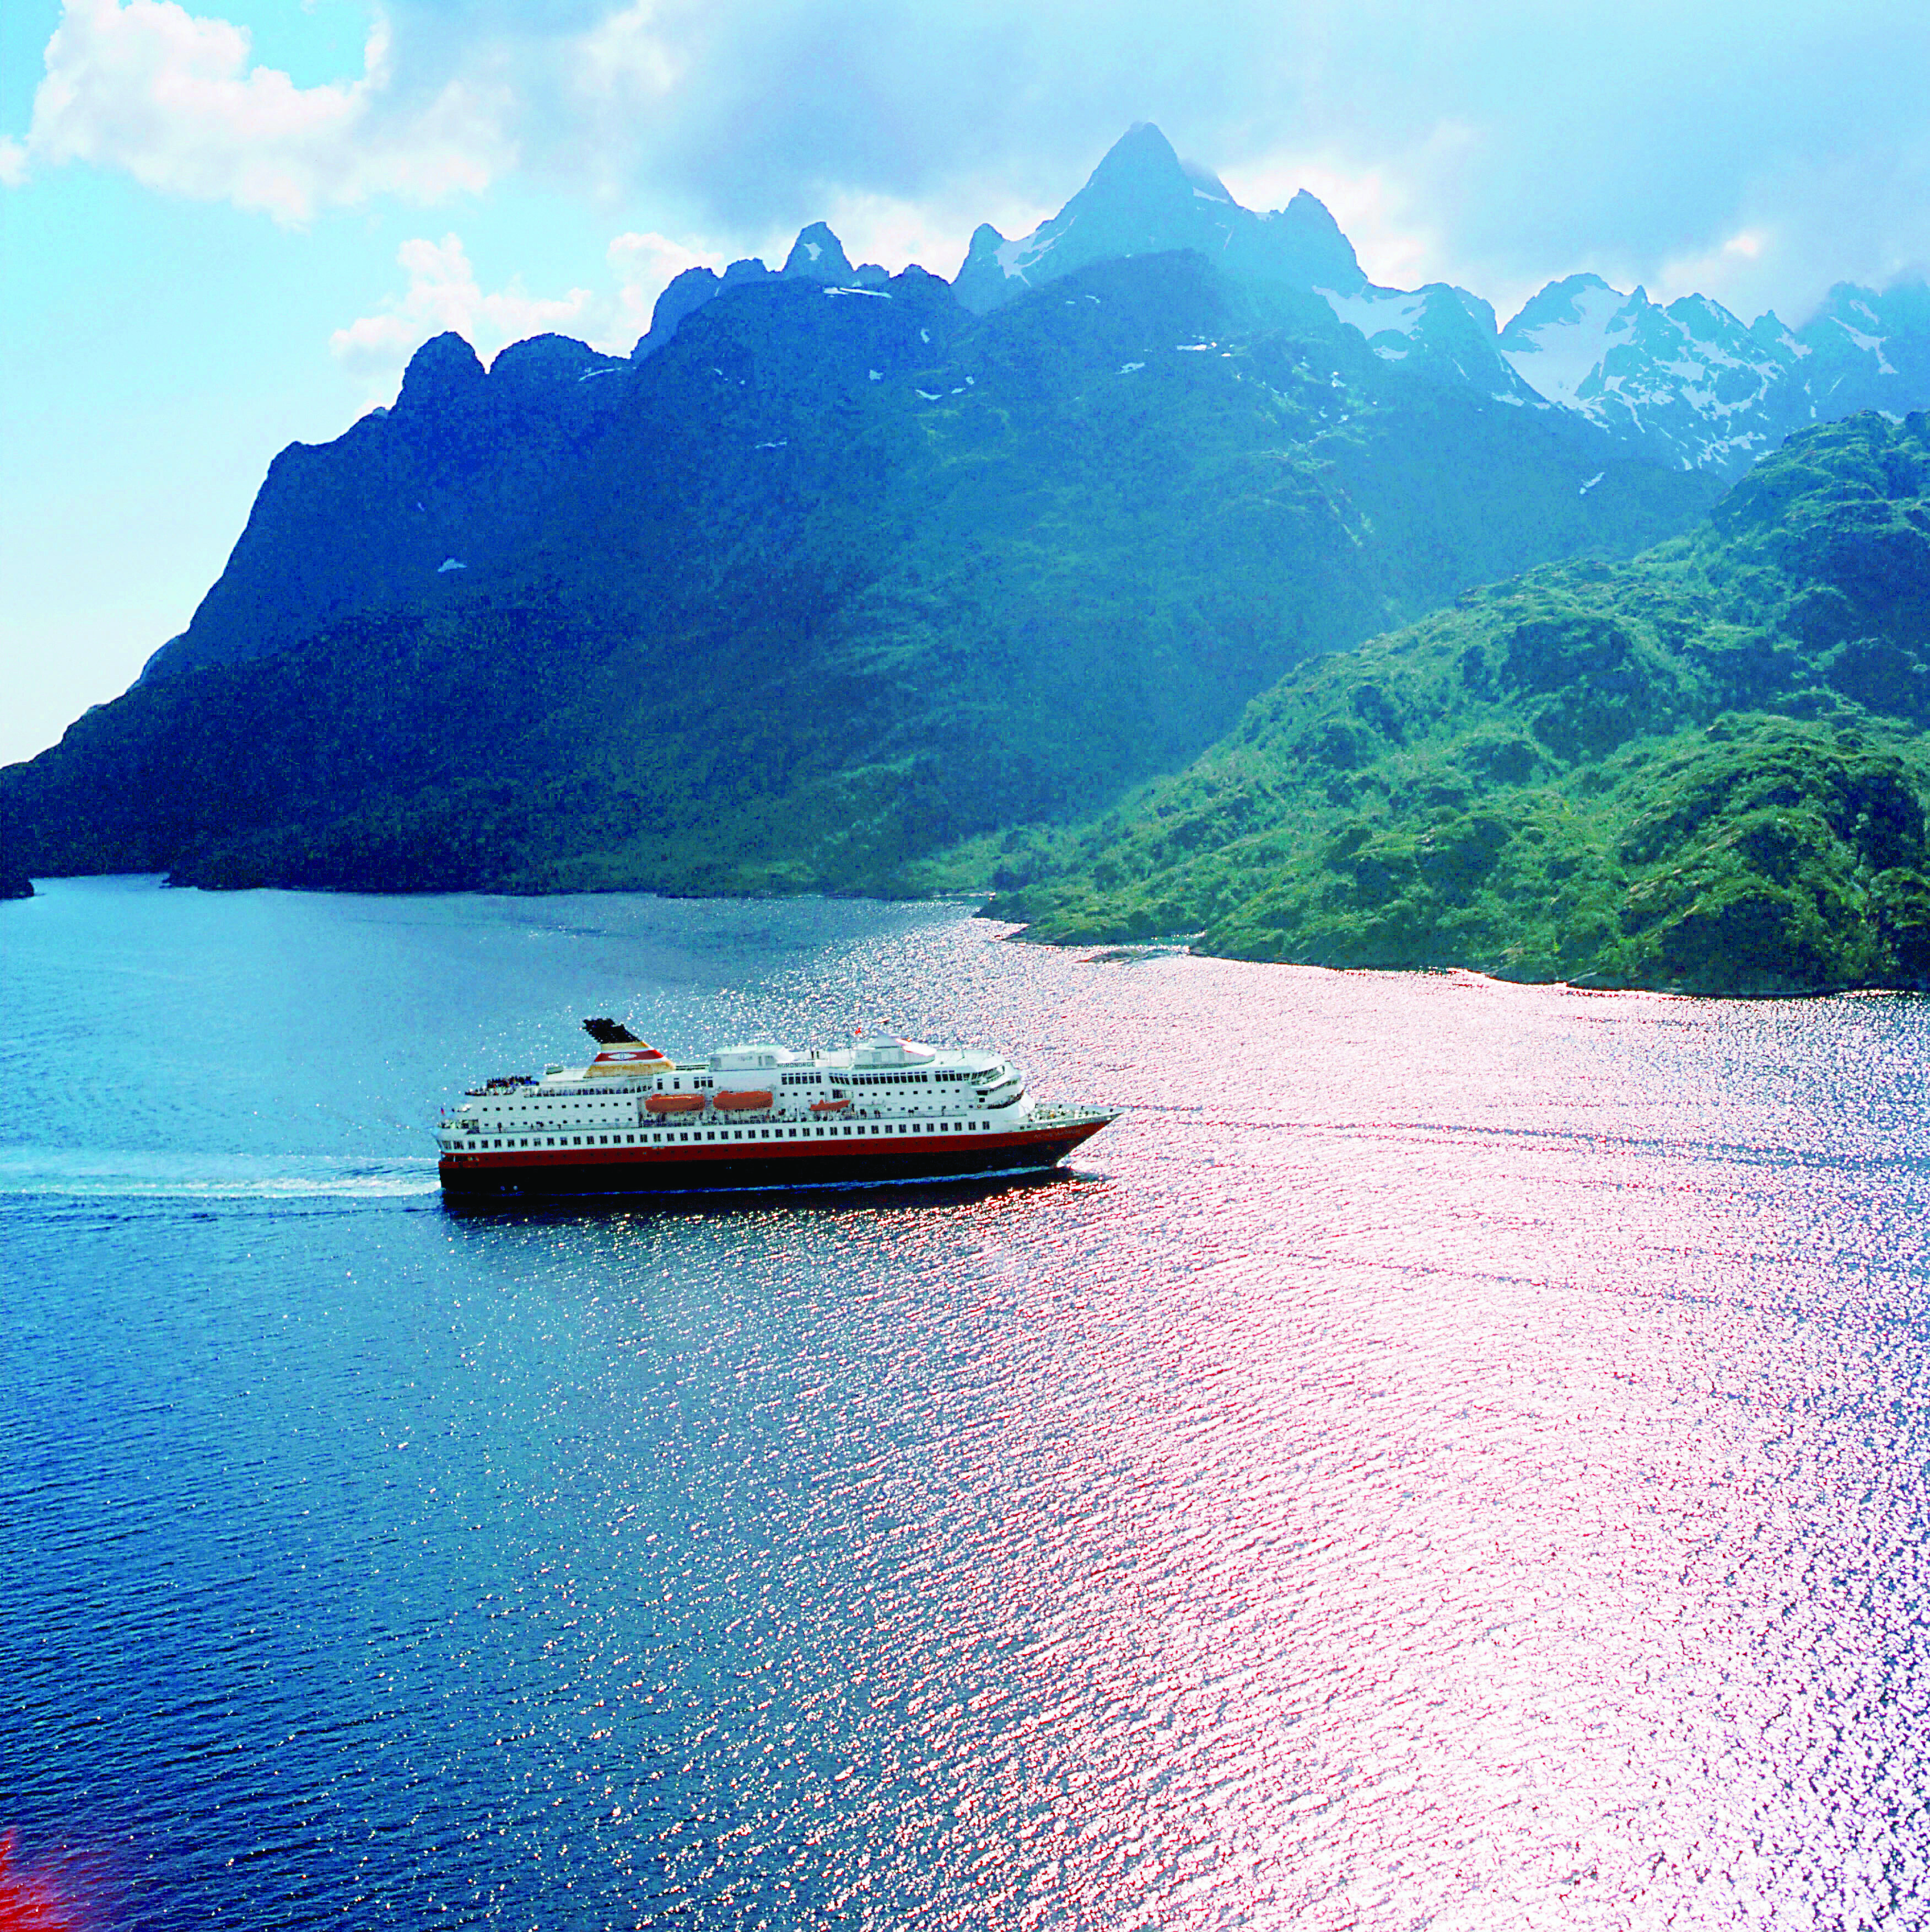
You may want to check out a Februay15, 2009 New York Times article regarding the Hurtigruten-HUhttp://travel.nytimes.com/2009/02/15/travel/15vesteraalen.htmlU

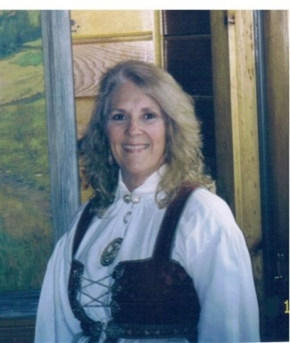
Fra Vise Presidenten Gail Ekloff

Membership — How are we doing?

As of February 1, 2009 we have 30% of the lodges stating they have active membership committees. We are striving for 70%; I hope this only means that many of you just have not sent the form or emailed me the information. We need to improve this statistic. After the March Board Meeting, information will start being sent to lodges with ideas for membership growth and retention.

Good to see that lodges are having membership drive events. Did you use the information provided by Sons of Norway headquarters “Membership Recruitment and Retention Kit”?

The kit is a good source of information whether this is your first event or your tenth. There is information on how to ADVERTISE the event and how to contact your local community paper to have an article published about the event. It also shows how to get articles about your lodges “doings” ― such as the bazaars, Adopt - A -School, etc. ― to the paper and how to follow-up to see that it actually makes the paper.

The “15 Helpful Hints for a Successful Event” is a good guide to use. One hint to use not only at the event but at every meeting: WEAR A NAME BADGE, SMILE AND GREET PEOPLE — it makes everyone feel welcome. Here are some other hints:

First impressions make or break us, so start by publicizing your event with the Sons of Norway event posters. They are the appropriate size to post and very eye-catching. (Posters are available for SON headquarters.) Keep a supply handy to advertise all your events and meetings.

Make sure you have the Sons of Norway banner hanging on the front of your membership table with information about your lodge and Sons of Norway.

Does your Lodge have a business card? Lodges who use them are seeing results.

Hope these suggestions help you have a successful event. Please let me know how your membership drive went, too. I’d love to hear from you.

Alt for denne gangen,

Gail

International Insights
By Barbara Berntsen, International Director

The February issue of the Viking magazine has the summary of the minutes from the November meeting of the International Board of Directors. If anyone has any concerns or questions, please do not hesitate to contact me or Audun for clarification. Many motions were passed and the international goals have begun. Members are still concerned, rightly so, about the cost for the up-coming convention in 2010 in Coeur D’Alene, but I want to assure you procedures were approved and in place. Specific details must be made available to the delegates, at the International Lodge Meeting, at the time when a host lodge, zone, and district places the bid. International President Dan Rude and CEO John Lund have met with the host committee several times and the committee is planning an exceptional convention.

I have been asked and agreed to be the liaison for the International Youth Director Christine Hicks, Youth Director from District 2. I have been in contact with Christine offering her my assistance. If anyone has any fun and interesting programs for our youth, please let me know and I will pass that on so she can share with the Youth Directors and learn what is happening in 3D.

The 17th of May Parade Committee is busy preparing for the parade and celebrations in the Brooklyn area. Just to give everyone a heads up the 2009 theme is “Norse Mythology.” It should be a fun parade and we are all hoping for a bright sunny day. This year’s pin features a rugged Thor wielding his hammer.

The Norwegian Immigration Association has a new exhibit at the Norwegian Christian Home and Health Center. For those in Brooklyn or plan to visit, you may wish to make a stop at the home to see “Norwegian-Americans at Work on the Waters around New York.” This is a wonderful exhibit. The exhibit features the harbor pilots, dock-builders, fishermen, and the barge workers. Dr. John Andresen, the President of Peconic Lodge, has loaned many oil paintings by his father and grandfather. There are many artifacts and stories featuring these workers who serviced the harbors in New York. I am sure that most families had a father, brother, grandfather or uncle who worked on these waters.

As many installations get underway, especially here in the north, some may have been postponed due of weather. I had the distinct pleasure to install five lodges plus a junior lodge. In February I installed Hartford Lodge at Land of the Vikings during their Vinterfest weekend. This is a fun filled weekend to raise money for their scholarship fund. It is such a worthwhile cause and everyone is invited to attend, so think about that for next year. I want to thank Luana Marie Jøsvold and Just Holm for their accompaniment, music makes a ceremony and evening special. I know installing lodge officers at LOV is a first or me and I think it might be a first for the district. I have asked others, especially those who have been involved with LOV and the district boards for more than my decade of involvement, if they knew of any other installation at LOV. The closest I heard was one response “there may have been scheduled but it never followed through” so this could be a groundbreaking ceremony. But most of all is we had such a fun weekend, sharing great fellowship with great friends.

A note from our International President Dan Rude asking for ideas:
UNew Membership Program:U During our Fall Board Meeting it was suggested that we look into coming up with a new membership program such as our Cultural Skills, Sports Medal, and Adopt a School Programs. The idea is not to replace these programs but to add to them.

Anyone who has a suggestion please let me know and I will bring your thoughts or ideas to the board meeting in April.
Kiss the Blarney Stone
Barbara

Our Secretary Says
By Marci Larson, District 3 Secretary, President Gateway to Florida Lodge

Just a reminder that the Form 17 Lodge Financial Statement must be sent to International with the yellow copy mailed to the District Secretary. Thanks to the many lodges who have mailed them to me. If you have not yet sent it, my mailing address is 4013 Moresburg Court, Jacksonville, FL 32257.

As I write this column, the 2009 Membership Directory is at the printer, so your copies should be forthcoming during the week of March 9, if not sooner. Each lodge receives one complimentary copy. If you are interested in ordering additional copies at $6 each, do so promptly since my quantity is limited. If you have questions, please e-mail me at HUmlarson@northfloridatpo.comUH.

Publicity
by Mary Andersen

Extract from a local lodge newsletter
One benefit of being Public Relations director is having the opportunity to see many of the great newsletters prepared by all of you!

Norumbega Lodge member Gary Johnson is Mattapoisett Man of the Year!
Whether you're searching for a breathtaking ocean view or a tranquil forest, a big part of what makes Mattapoisett special is its open spaces. And for the past six years, Gary Johnson has made it his mission to preserve as much of the town's natural resources as he possibly can. "We need to do everything we can now to protect this land for generations to come," said Mr. Johnson, the current president of the Mattapoisett Land Trust. Mr. Johnson was first introduced to the Land Trust by his neighbor, Bob Atkins, when he and his wife, Luana Marie Josvold, and daughter, Berit Johnson, permanently relocated to Mattapoisett from the Boston area in 1999. They had been summer residents since 1993. "The work Gary's done since he's been here is unbelievable," said Mr. Atkins, who served on the Land Trust Board for 25 years. "He's a very, very bright man who has a real ability to work with others."To read the complete article go to HUhttp://www.southcoasttoday.com/apps/pbcs.dll/article?AID=/20081224/NEWS/812240355/1009/TOWN08U

From the Nor-bu newsletter (Publicity Director’s note – this was too good to pass up!)
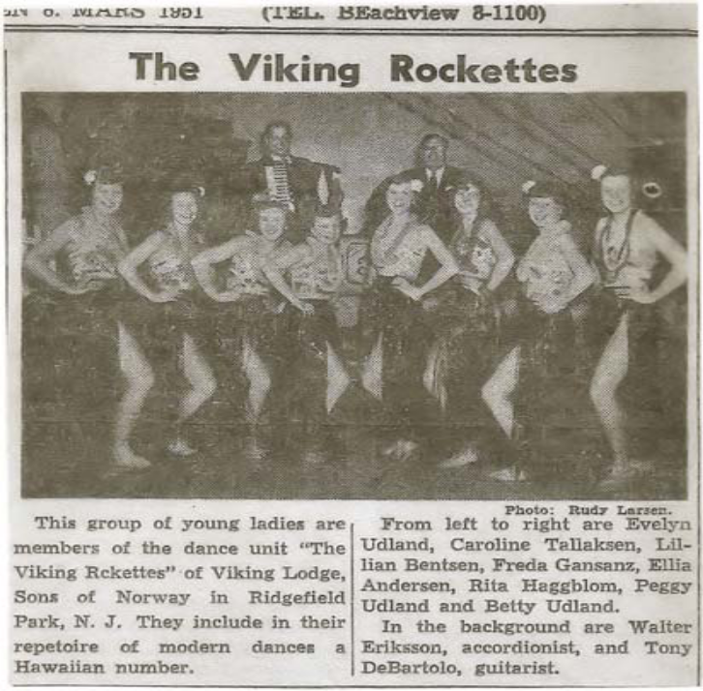
Several members from Nor-bu lodge. Can you find them?
Southern Star – taken from The Strand the newsletter of the Southern Star

Decorative sewing: a Norwegian tradition that has been particularly important throughout at least the last thousand years of Norway's history. It's an activity that most learn when they are young, and they continue to improve their technique and creativity throughout their lives. Aside from being an amusing hobby, it serves other functions as well, such as the expression of identity, sociability, and generosity. Learning how to sew in different styles, perfecting these, and making one's own designs becomes a life-long activity. Sewing serves a number of functions which are socially useful. Sewn products can become a signature of one’s own identity, an elaborate display of generosity, as well as serve as the centerpiece around which social interaction occurs.

As an expression of identity, sewn items can reflect nationalistic, regionalistic, or more personal allegiances, whether used on the body, in the home, or as gifts. A number of regions have their own distinctive style of stitching. Embroidery can signal stylishness or keeping-up-with-the times as well. They are particularly important as decorations within the home, as this is where much socializing takes place, since restaurants can be so expensive; it's more common to invite someone over than to invite someone out.

Sewn items constitute an important part of gift exchange practices. This is particularly true in cases where there is not a lot of money available, but a nice gift for a wedding or other occasion would be appropriate. Generosity toward others is something particularly valued toward many Norwegians, and social obligations can be fulfilled with a personalized and labor-intensive item.

*****************************

Don’t forget to:


“District Doings”

Attention RVers!!!
Anyone interested in a District 3 RV rally? Our President is putting together a list of members who might like to attend a rally if someone wants to organize one. If you are interested please email the following information to HUNODAKRALPH@aol.comUH , preferably on an excel spread sheet, in the following format.

Name, Lodge, Street Address, City, State, Zip, Telephone, email address, cell phone number, type of RV (Class a, B etc), length

Ralph will collect the info and if someone wants to run a rally we will have the info ready.

Get on Board!!!

Norsk Carolina is planning a bus trip to LOV in September! For more details read their February newsletter HUhttp://norskcarolina.org/News0209.pdfU

Gotta get going and GOLF!

Mark your calendars!!

HUFourth Annual LOV Golf TournamentUH in May (1st-3rd)

HUDistrict 3 Golf OutingUH in September (17th-20th)

Celebrate Culture

Traditional Norwegian HUDance WorkshopUH at Land of the Vikings May 29 - 31, 2009

HURosemaling ClassesUH at LOV March 16-20st, 23rd -27th

What’s LOV got to do with us?

Hartford Lodge Vinterfest By Art Thorsen, Vice President Hartford Lodge 3-474
Hartford Lodge 3-474 celebrated their Vinterfest at Land of the Vikings the first weekend in February. Vinterfest Weekend chairmen Johnny Delin and Nancy Thorsen organized a fun-filled weekend for Hartford Lodge consisting of winter outdoor sports such a kubb ,skiing, spark races and starbaerring and indoor games such as Viking Bingo and a scavenger hunt. Saturday evening featured Luana and Just leading the group in singing Norwegian songs and dancing.This was a special weekend for many reasons. This year is Hartford Lodge’s 45th anniversary as well as Land of the Viking’s 30th anniversary
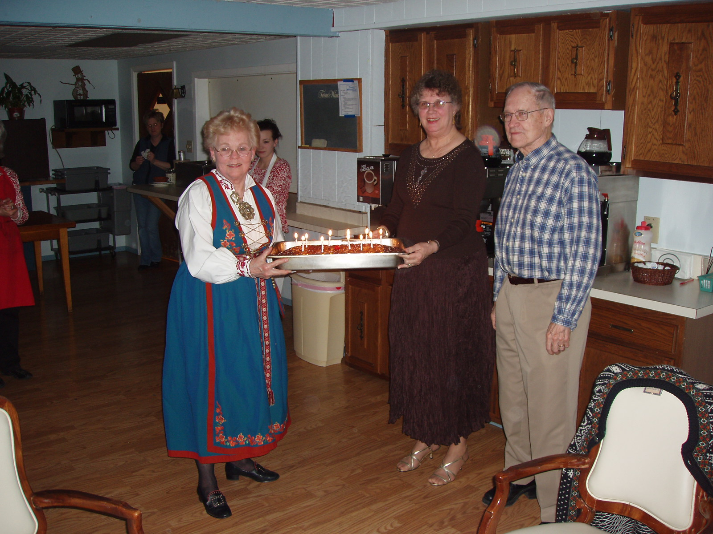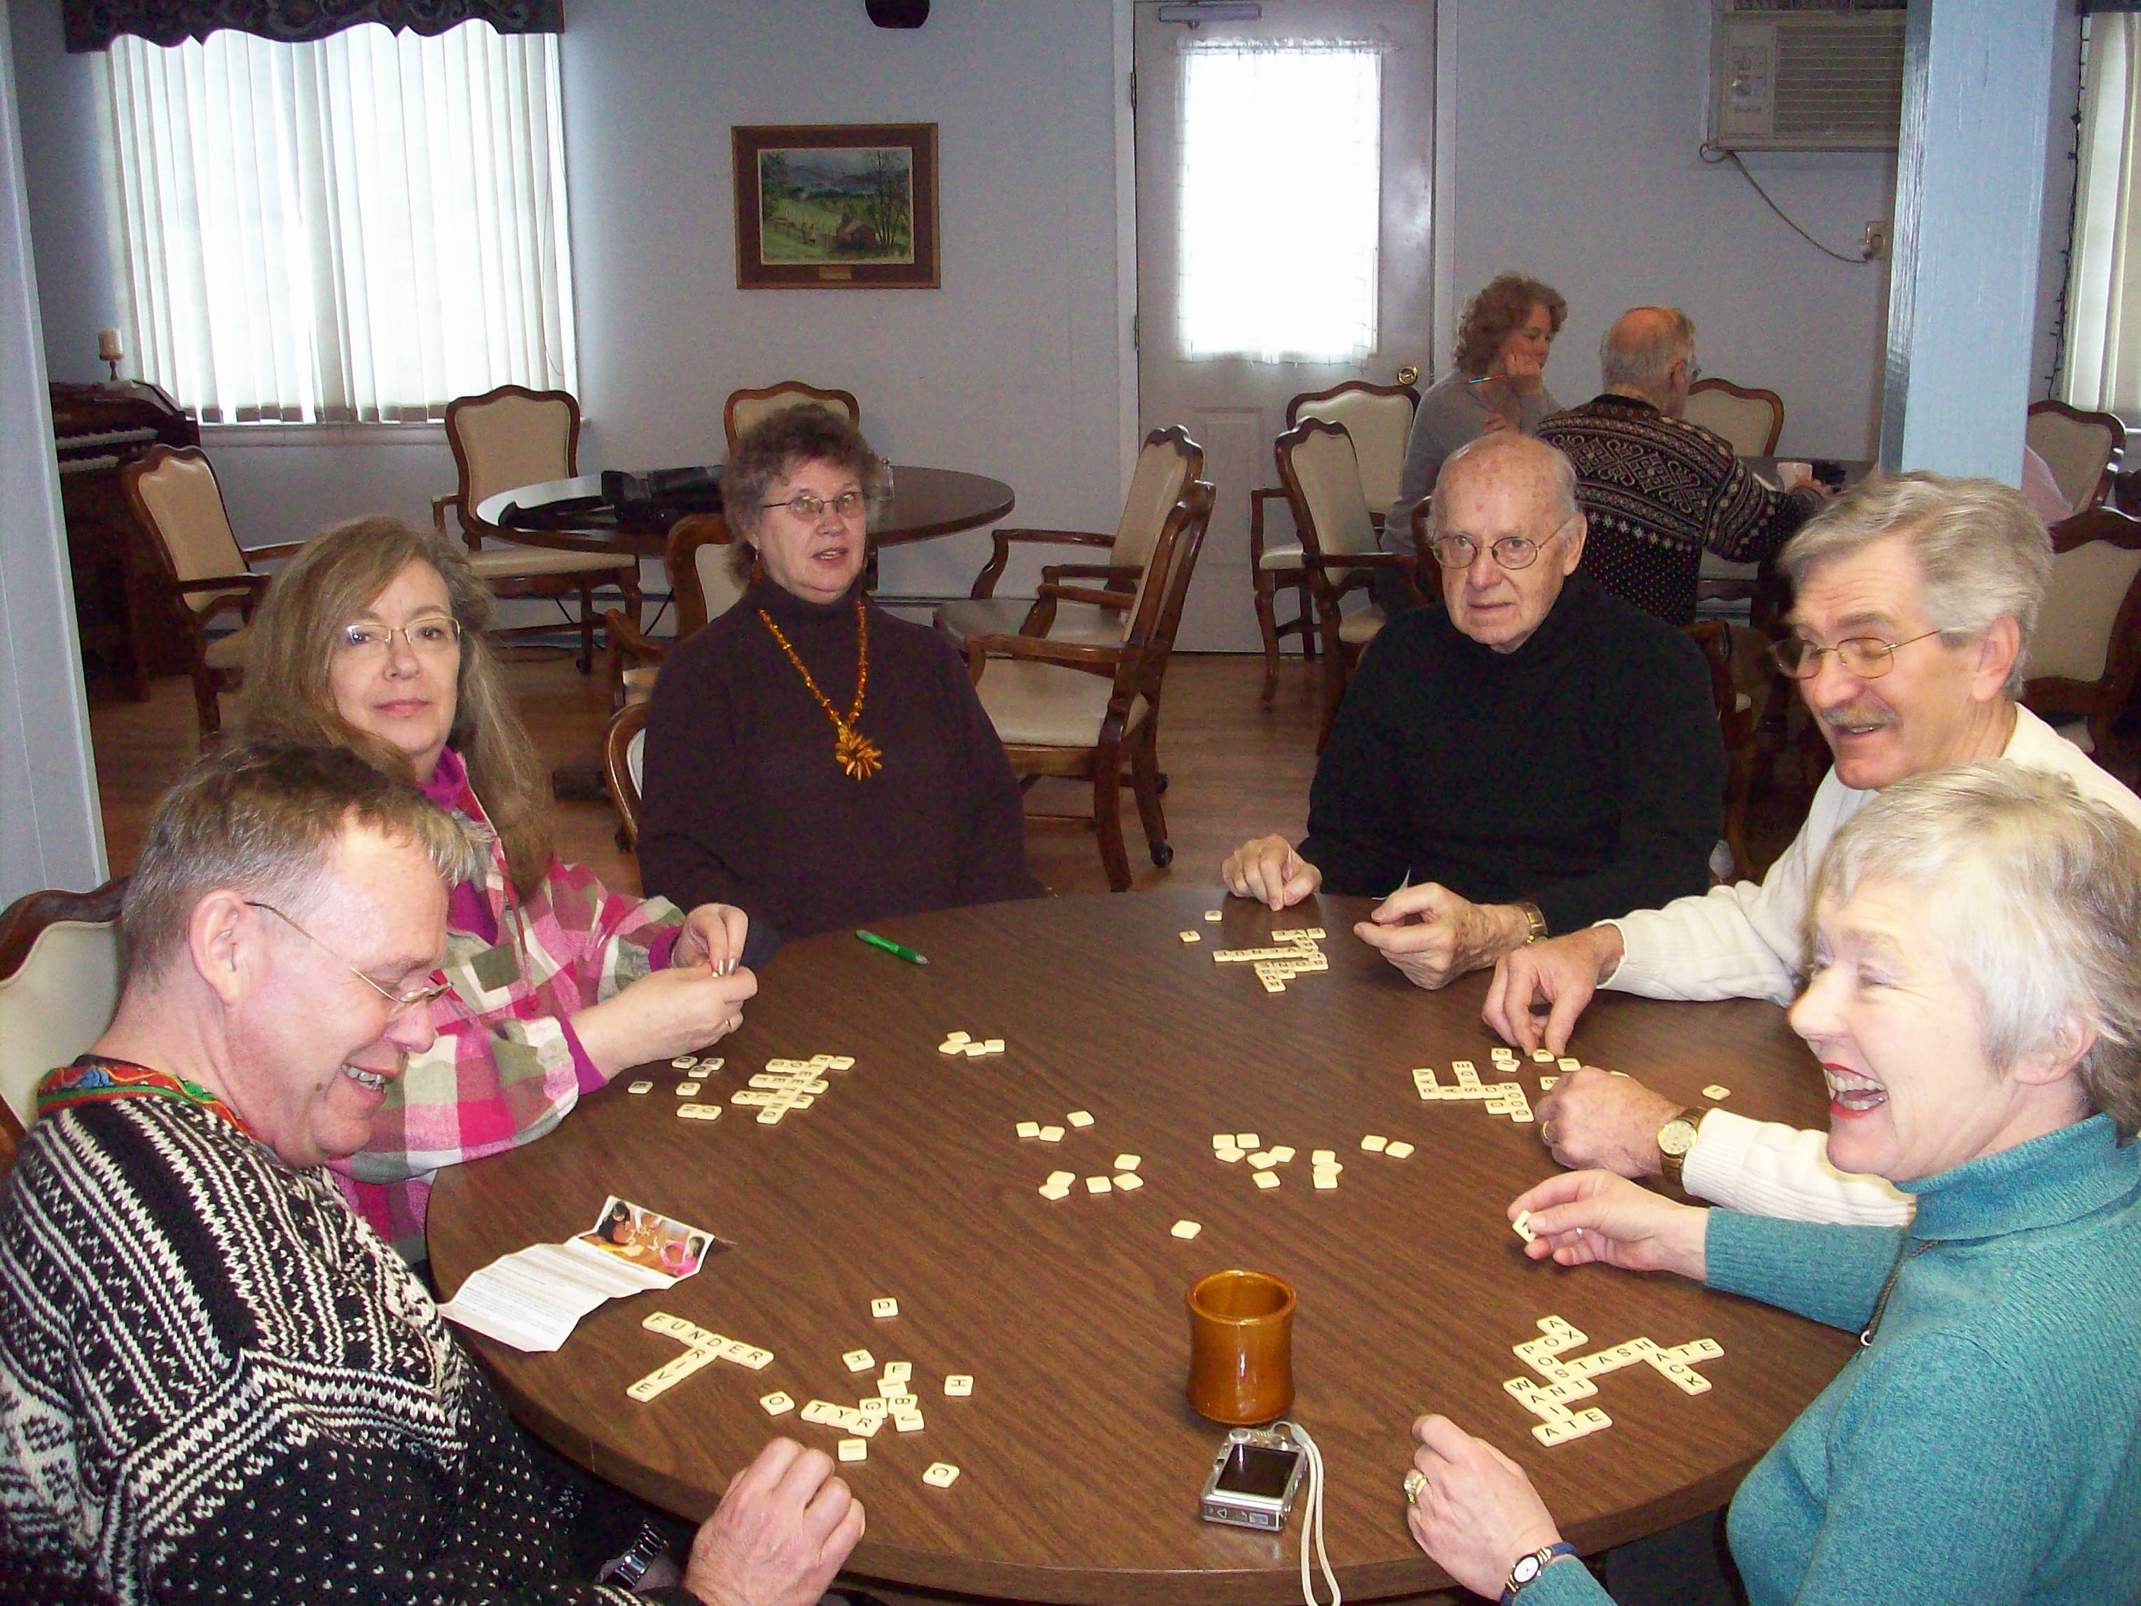

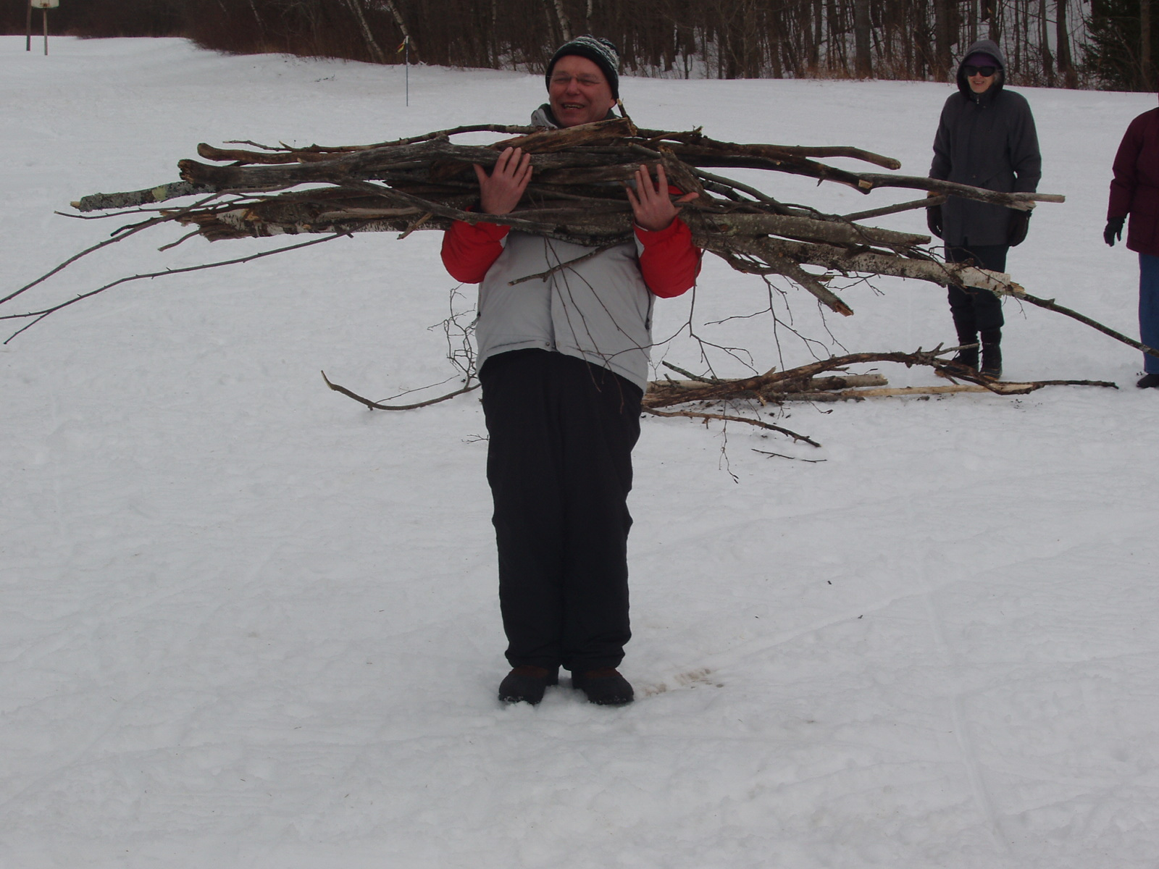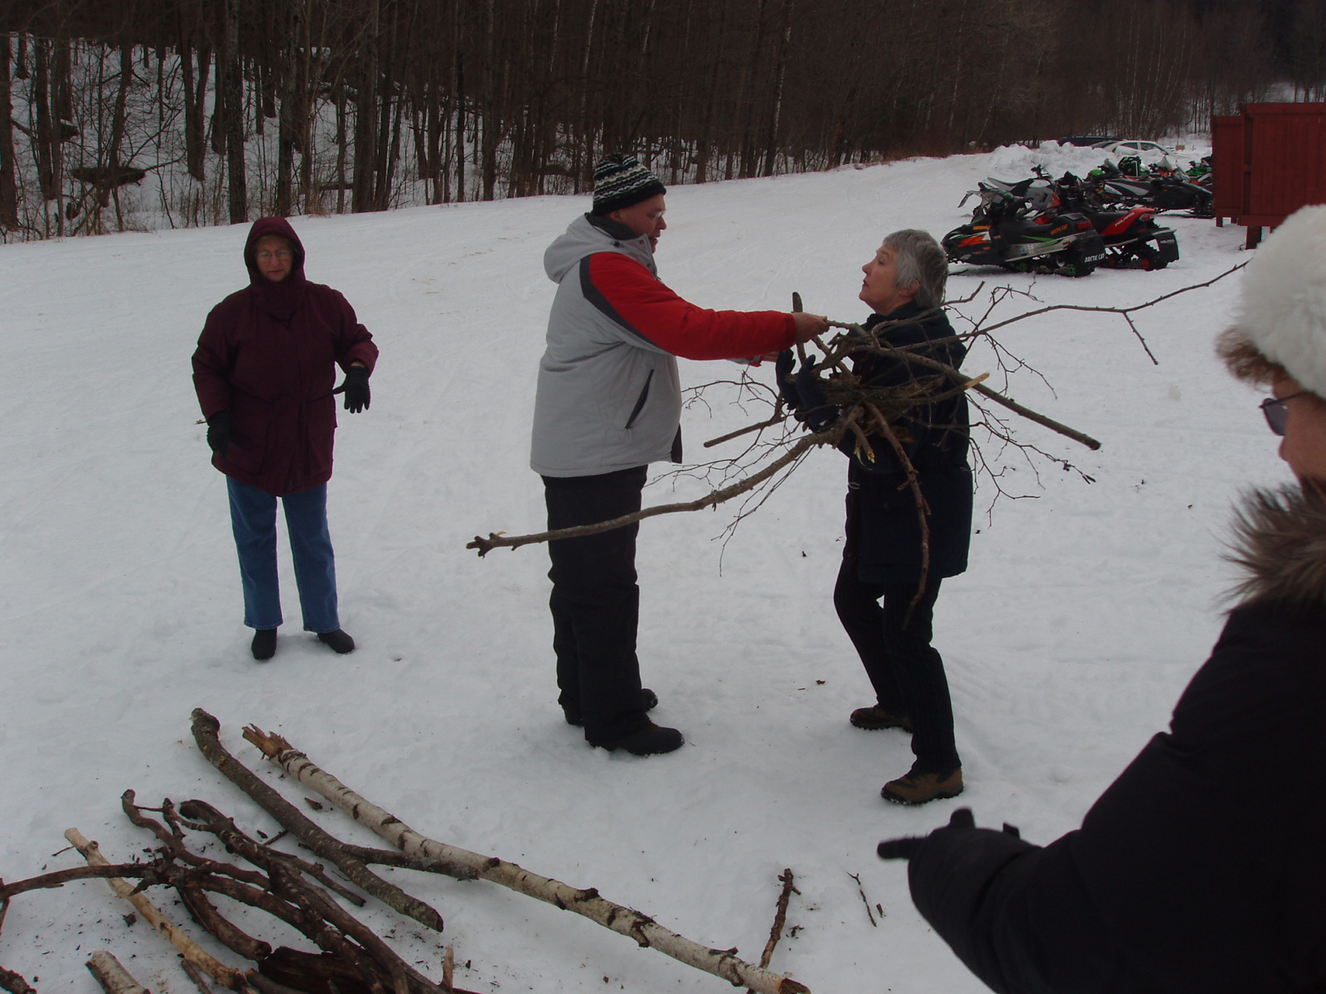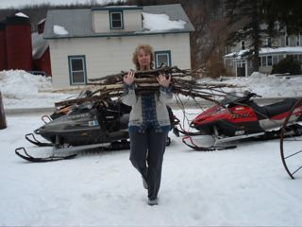

“In the Zone”
Zone 1 by Kris Rasmussen, Zone 1 Director and President Loyal Lodge

The first few months of the year have been busy! Four lodges held installations of new officers - Færder, Henrik Ibsen, Loyal and Norden Lodges.

Færder’s Installation
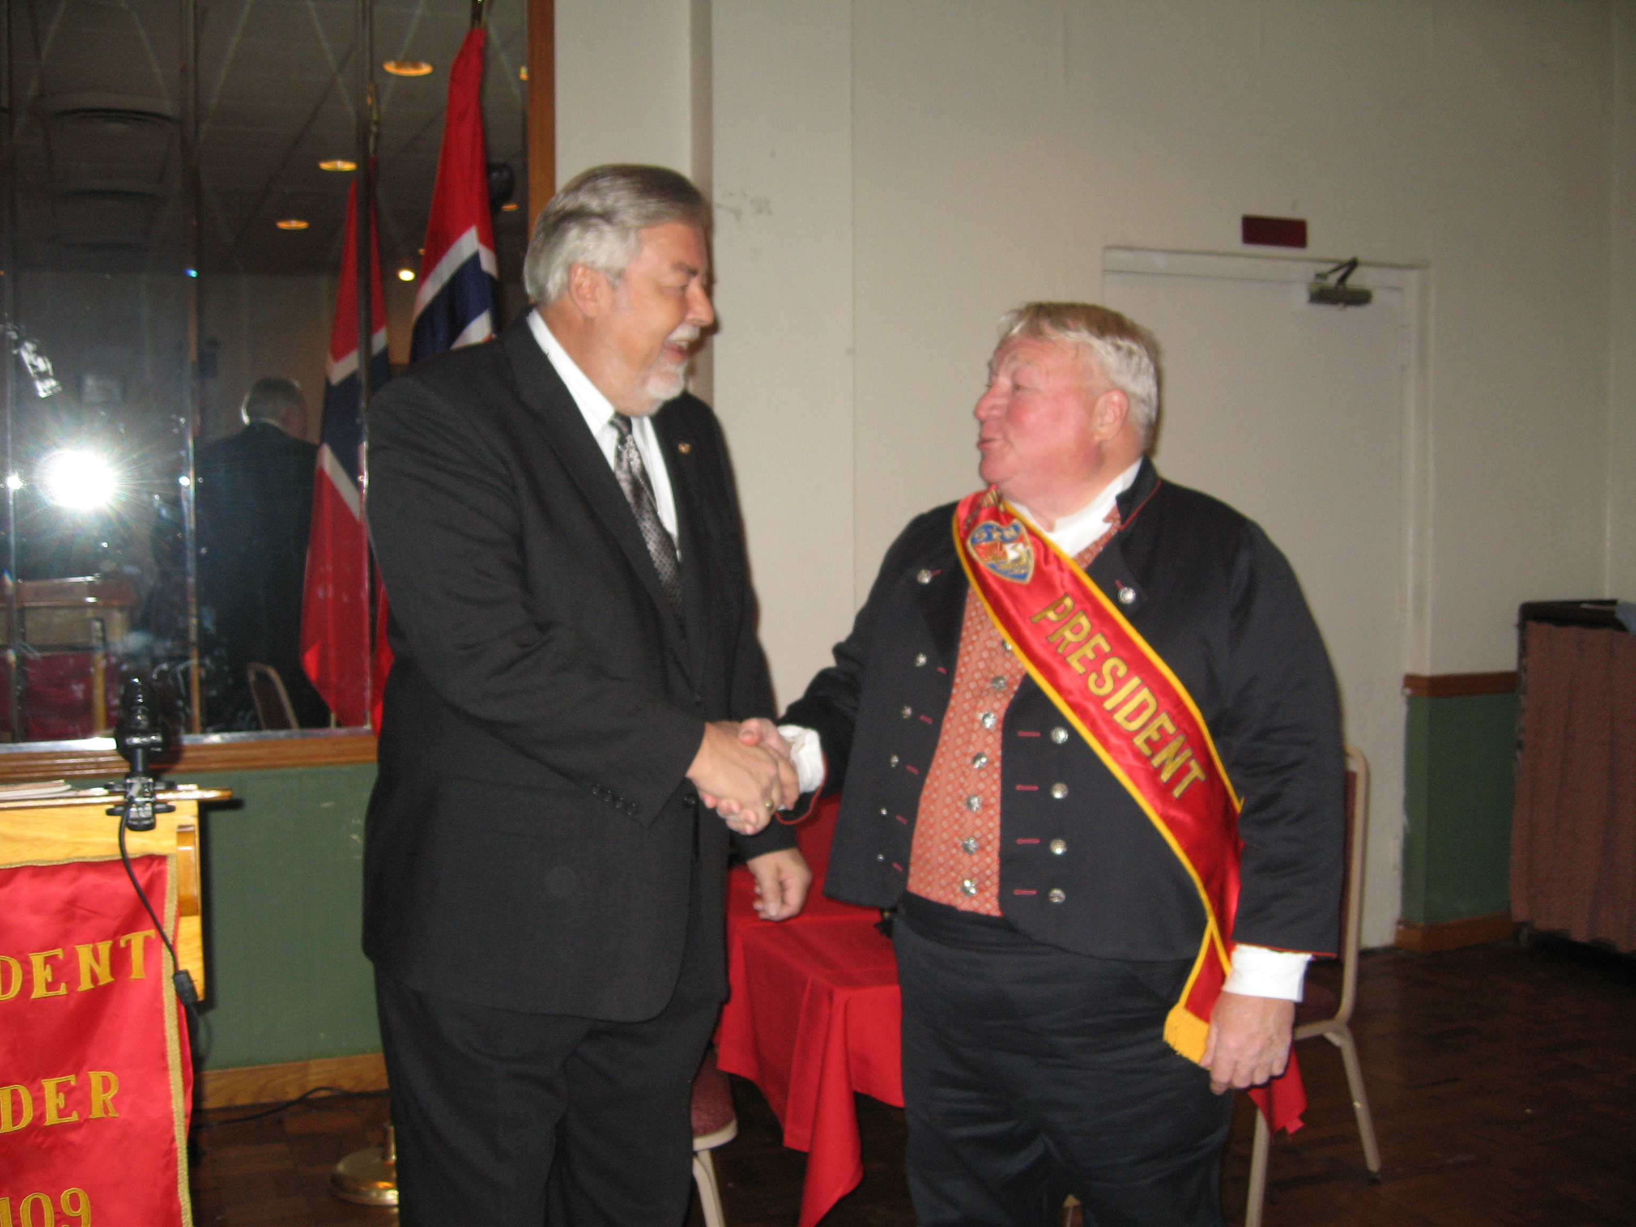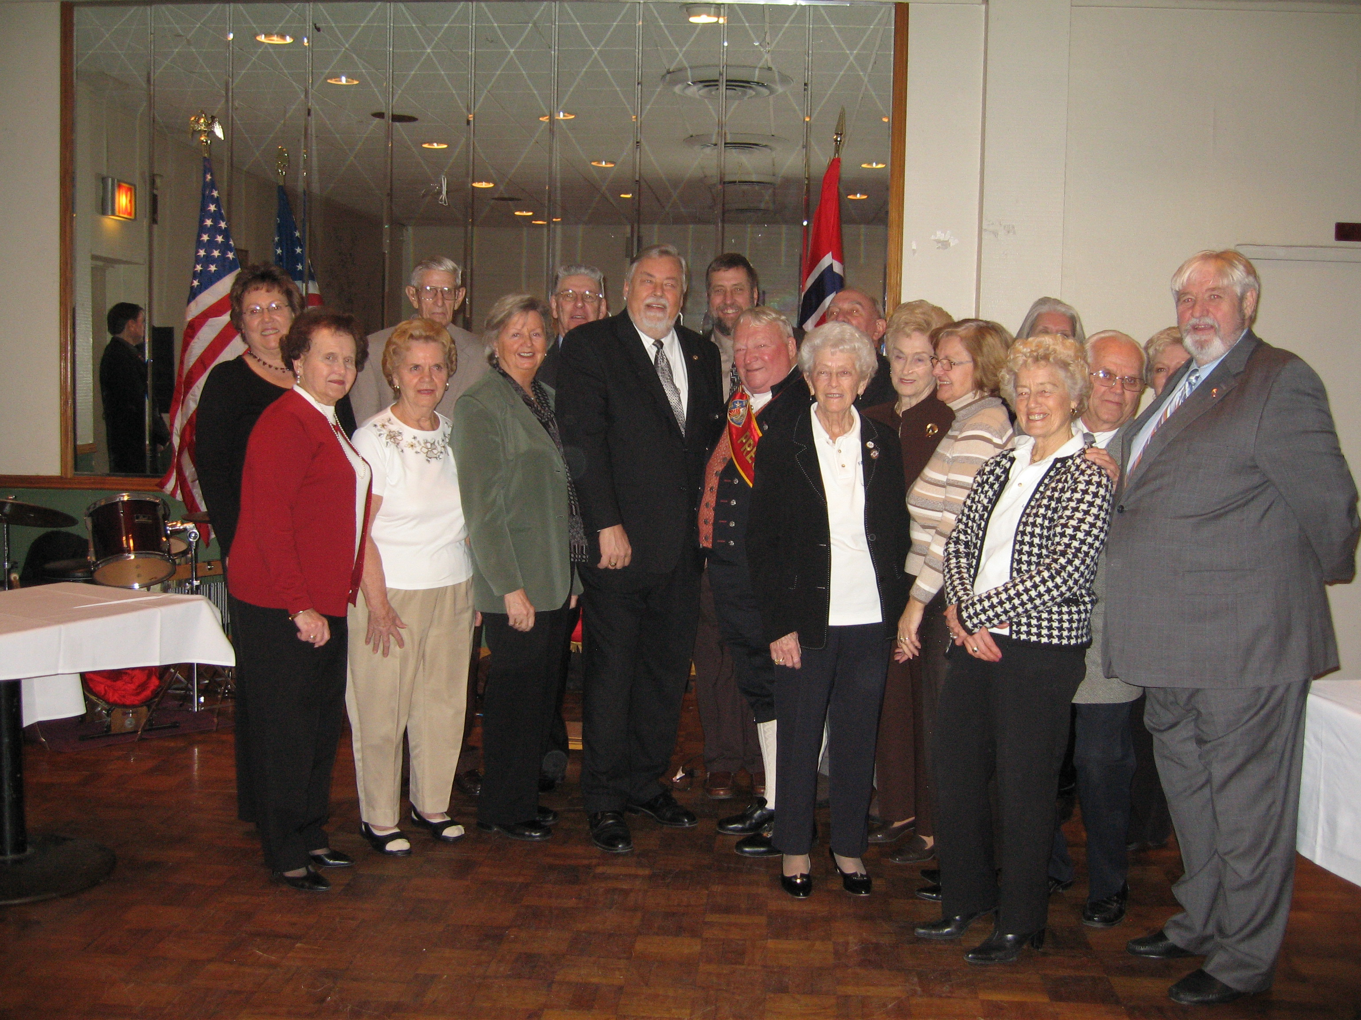
Our Zone’s annual Children’s Heritage Fair was held with over 60 children in attendance with their families (31 of those children had no current affiliation with Sons of Norway.) Claire Olsen of Norden did another outstanding job as chairwoman of the event and this year, for the first time, recruited the cultural directors of several of the lodges to serve on her committee for the event. The children had a great time with troll making, uffda bingo, waffles and other treats. They were also treated to a display of Swedish folk dancing by a children’s group.

Leadership III training was held at Loyal’s Norway Hall for the lodges in the mid to eastern areas of the Zone. Four of the five lodges in the area sent members for the training. Ken Johnson was the trainer and he provided breakfast as well. Loyal provided a lapskaus luncheon afterwards. Barbara Berntsen will be the trainer for the next Leadership III training in the Zone which will target the five lodges in the western portion of the Zone on April 4th.

Upcoming Zone 1 events include our annual bowling competition on 3/29/09 at the Bay Shore Lanes hosted by Henrik Ibsen. The Brooklyn Memorial Service will be 4/26/09 at 4 PM in Our Saviour’s Lutheran Church located at 8001 4th Avenue in Brooklyn. The Long Island Memorial Service will be held 5/3/09 at 3:00 in St. Mark’s Church, 754 Montauk Hwy. Islip, NY. Last year the Zone presented the church with a five foot wooden replica of a Viking longship that was hung in the nave of the church in the manner of North Sea coastal communities’ churches. This will be our first service with the longship which you might have seen in the January issue of the Viking magazine in the Third District photos. On 5/31/09 the Zone will hold its annual scholarship fundraising play at the Star Playhouse in Commack. The scholarship recipients will be honored at a wine and cheese reception at 1:00 with the play starting at 2:00. At the conclusion of the play raffles will be drawn for several prizes to be awarded. Afterwards, we will retreat to a local restaurant for dinner. 6/13/09 will be the date of our Joint Zone Social event this year hosted by Norden at the Long Island Ducks triple-A ballpark located on Carlton Avenue in Central Islip (by the federal courthouse.) The event will start at 5:30 with an all-you-can-eat barbeque buffet behind third base and the game itself will start at 7:05 against the Newark Bears. There will be a Zone picnic this summer on 8/23/09 and it will be a “hummerfest”. Details will be worked out at the next Zone meeting.

Zone 2

Hartford Lodge By Art Thorsen, Vice President Hartford Lodge 3-474
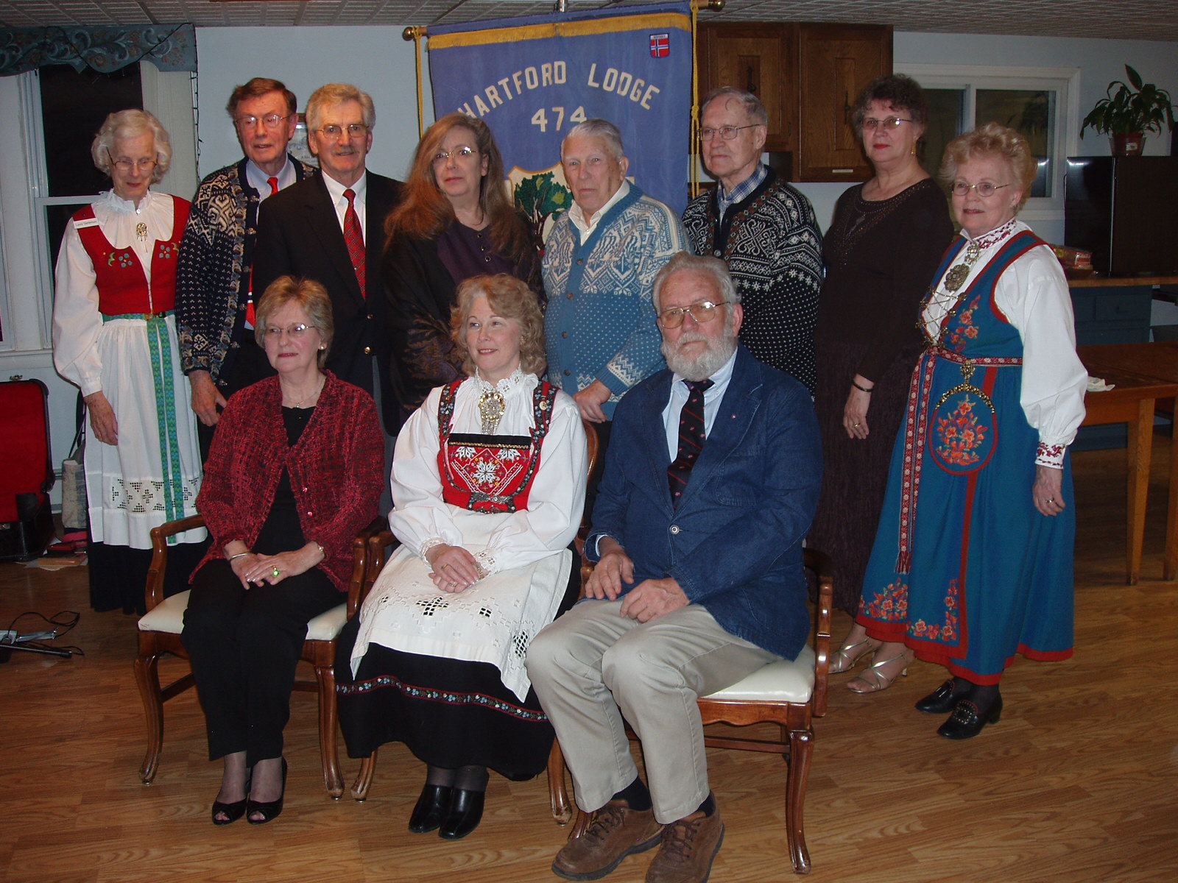
This year is Hartford Lodge’s 45th anniversary as well as Land of the Viking’s 30th anniversary. To commemorate these dates the lodge’s installation of officers was held at Land of the Vikings with Barbara Berntsen, Past President Third District & International Director, installing officer. The lodge was honored to have as visitors Helen Timoney, LOV Board treasurer; Gail Ekloff, Vice President Third District and her husband Rolf; Roy Berntsen, director of Buildings and Grounds, Land of the Vikings; George Beck, past president of the LOV board and his wife Doris; Luana Josvold and Just Holm, Norumbega Lodge , providing music for the Installation and for the weekend.

Zone 4

Norrøna’s 50th Anniversary Celebration - Congratulations!!!
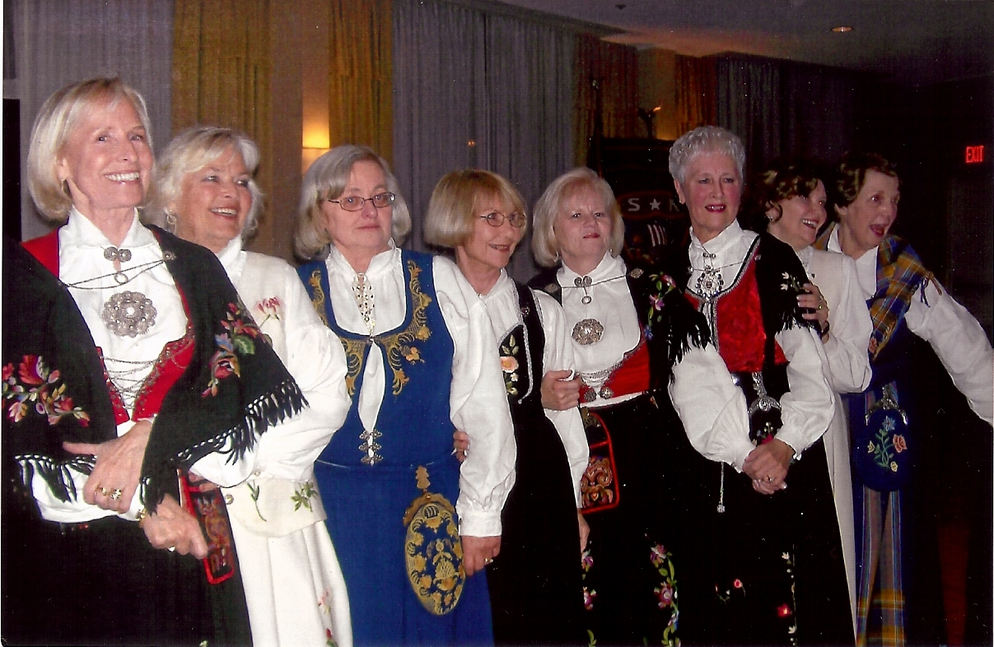

Zone 5

Southern Star by Karen McIlrath, President Southern Star
Southern Star Lodge hosted a membership drive Sunday February 8, 2009. The program featured a folk art exhibit, bake sale, dessert table and storytelling. We made the folk art exhibit ourselves by asking lodge members to bring in any items they wanted to display. The response was amazing allowing our lodge to put on a very impressive exhibit. These were items that had been passed through generations or purchased by members during trips to Norway or Scandinavian stores here in the United States. The hardanger pieces on display were made by members.

This event was well advertised by the lodge so we had 120 people in attendance of which 100 were guests. We received two completed new member applications that day; the event was highly successful!
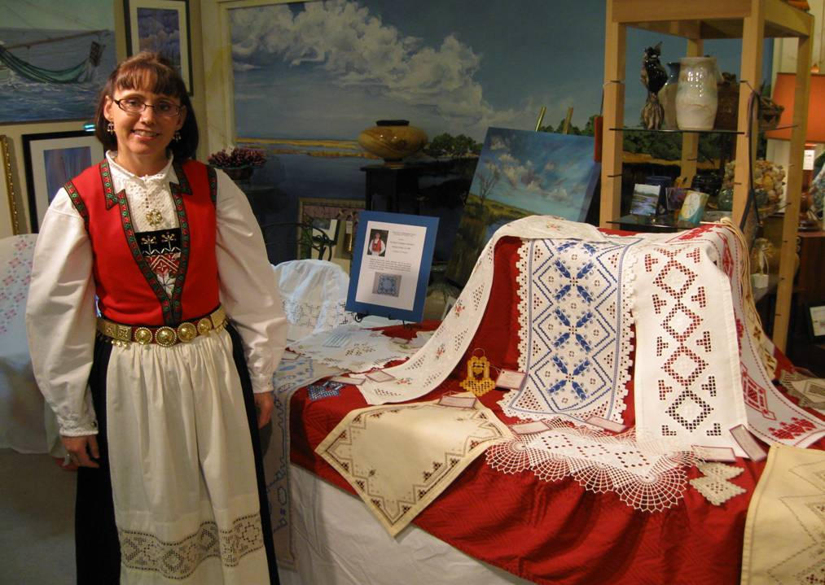
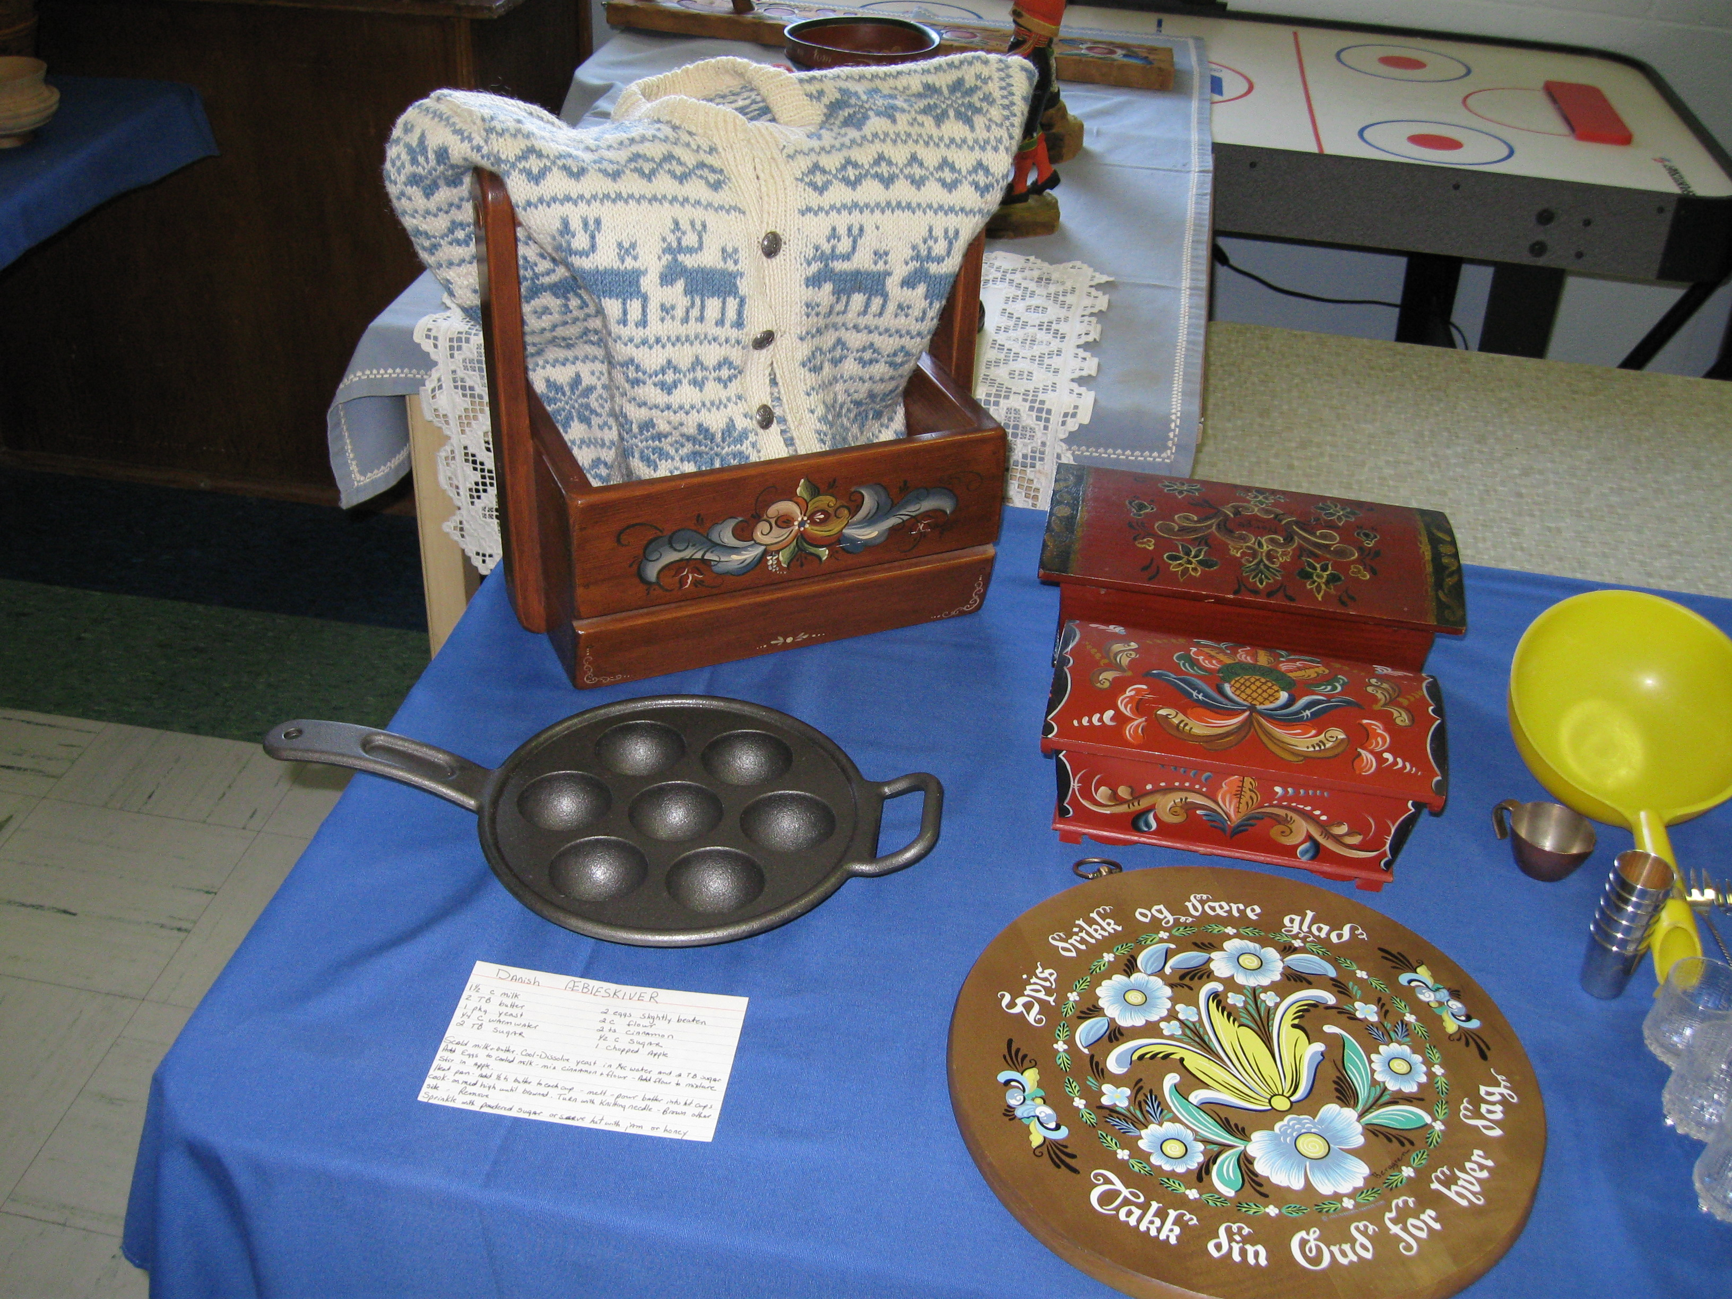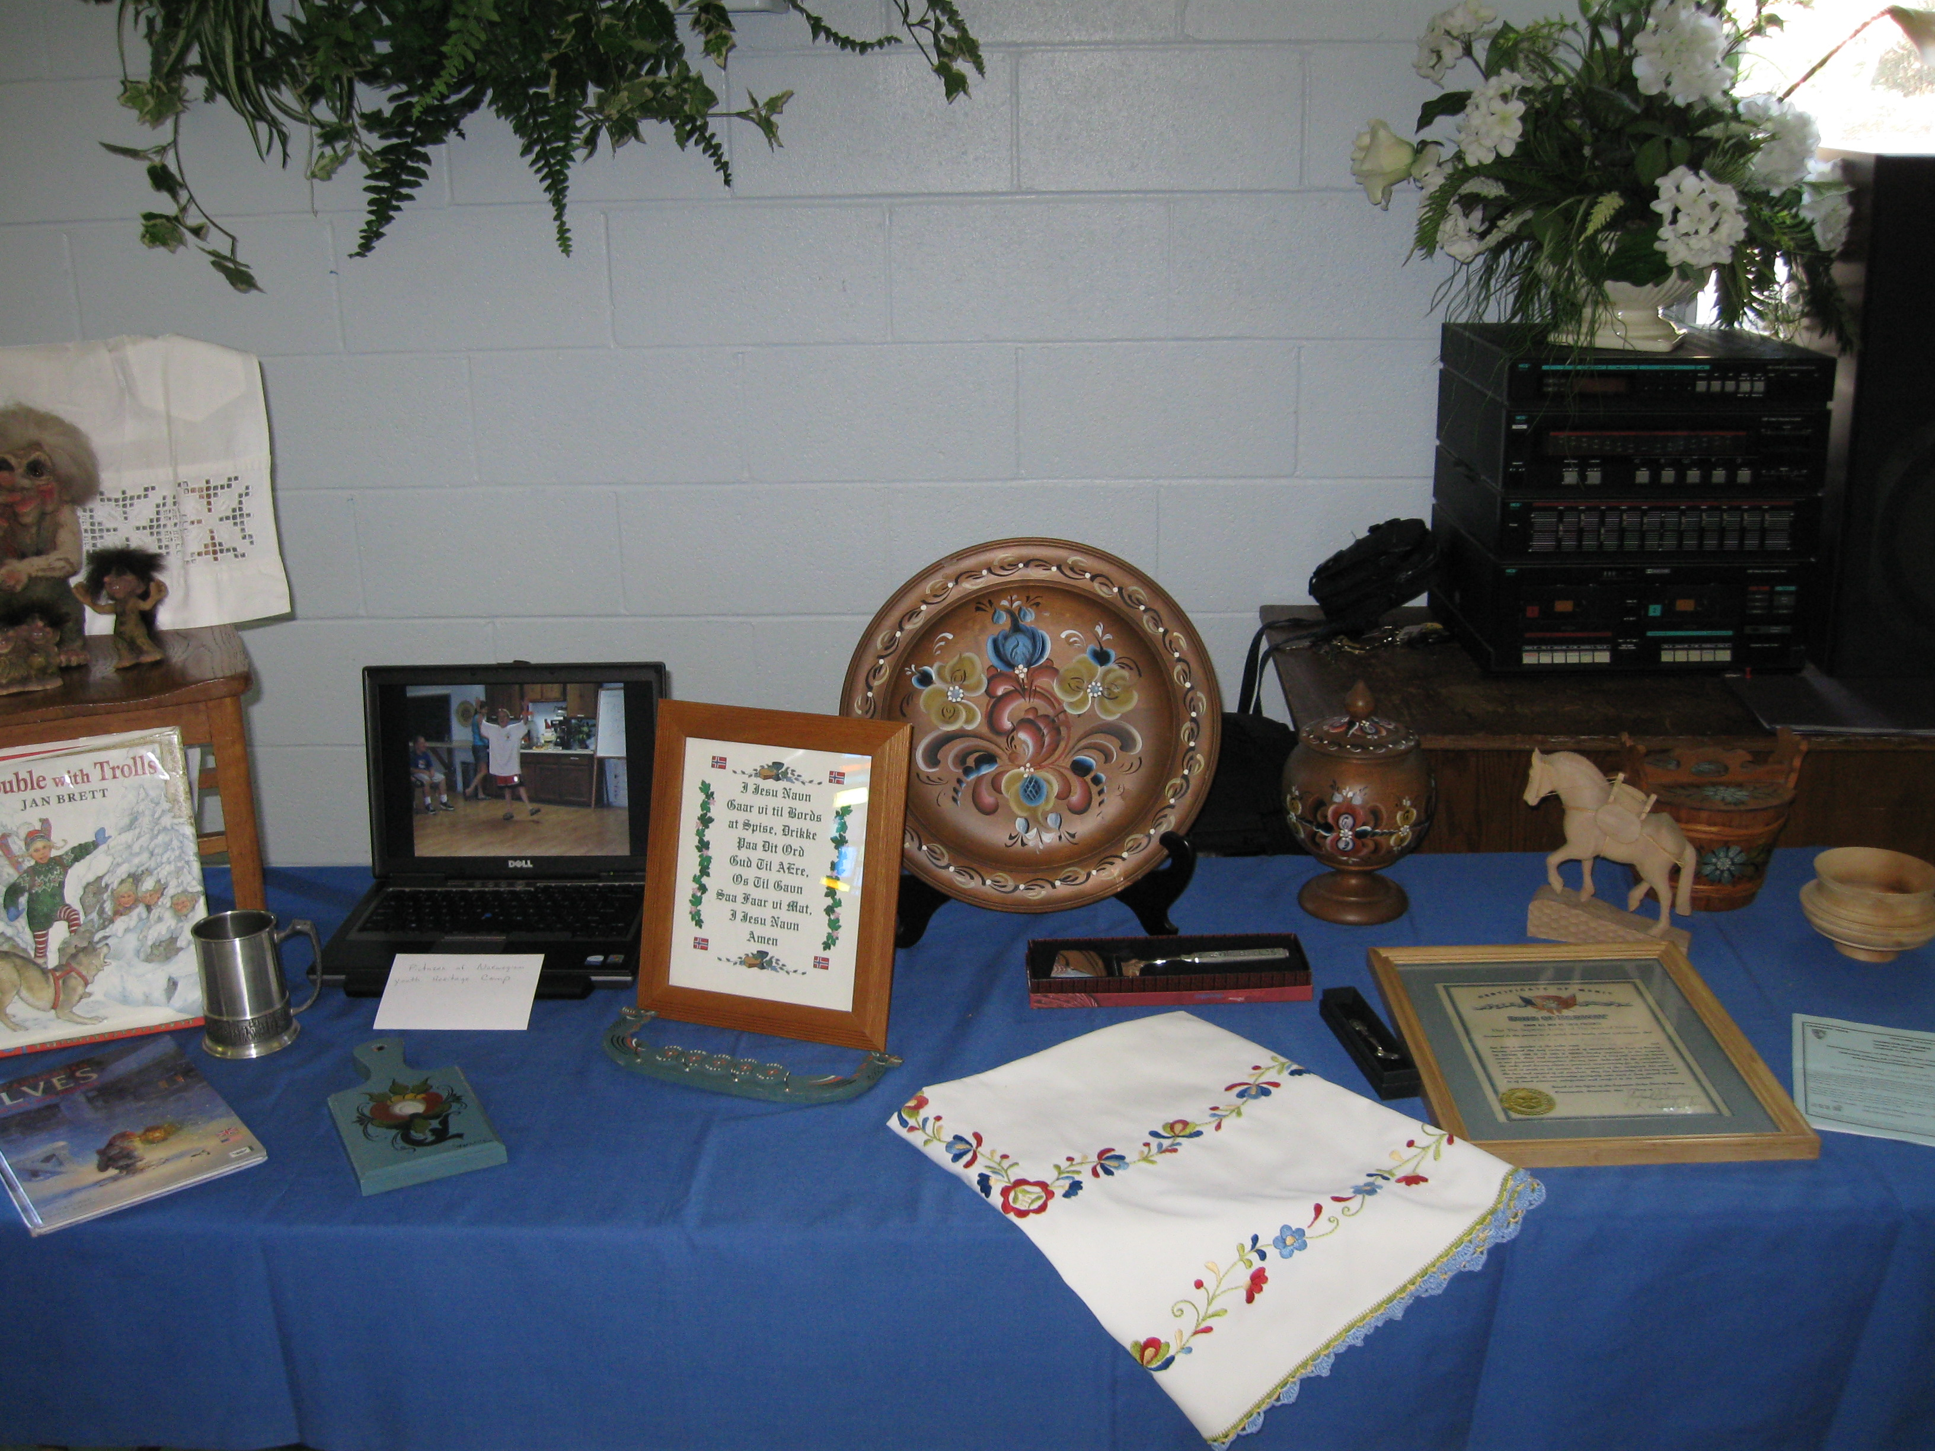

Gateway to Florida
Lodge members exhibited their folk costumes at a recent lodge meeting. Left to right: Jan Hilyard, Gail Yerkes, Mariah Morrison, Frank Morrison, Ruth Morrison, Charlotte Fluker, Anna-Rita Perkins.
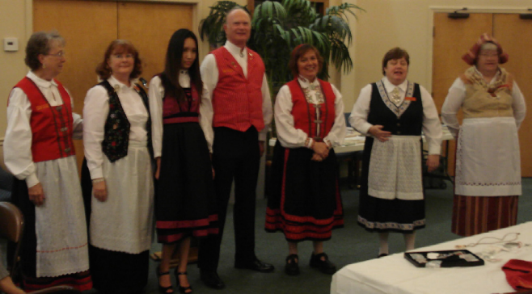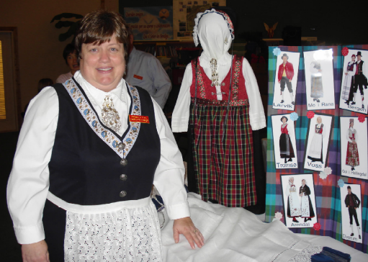

Zone 6
Frederiksten Soup Night
12 delicious soups were served at soup night! They were all delish! Below, the chefs stand by their soups.

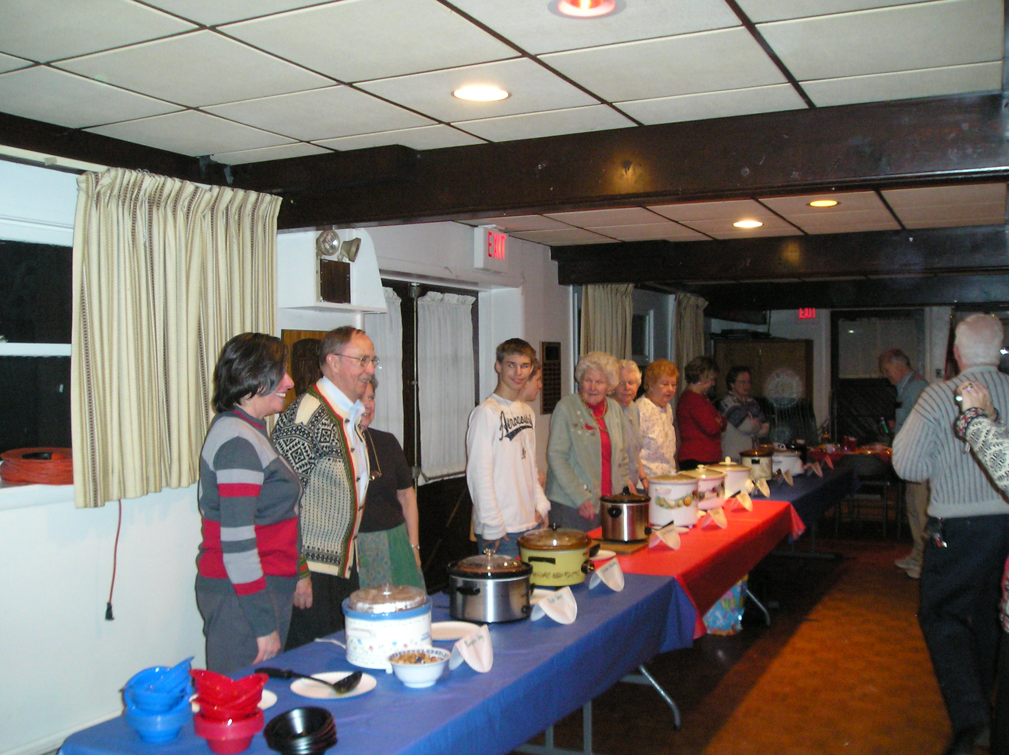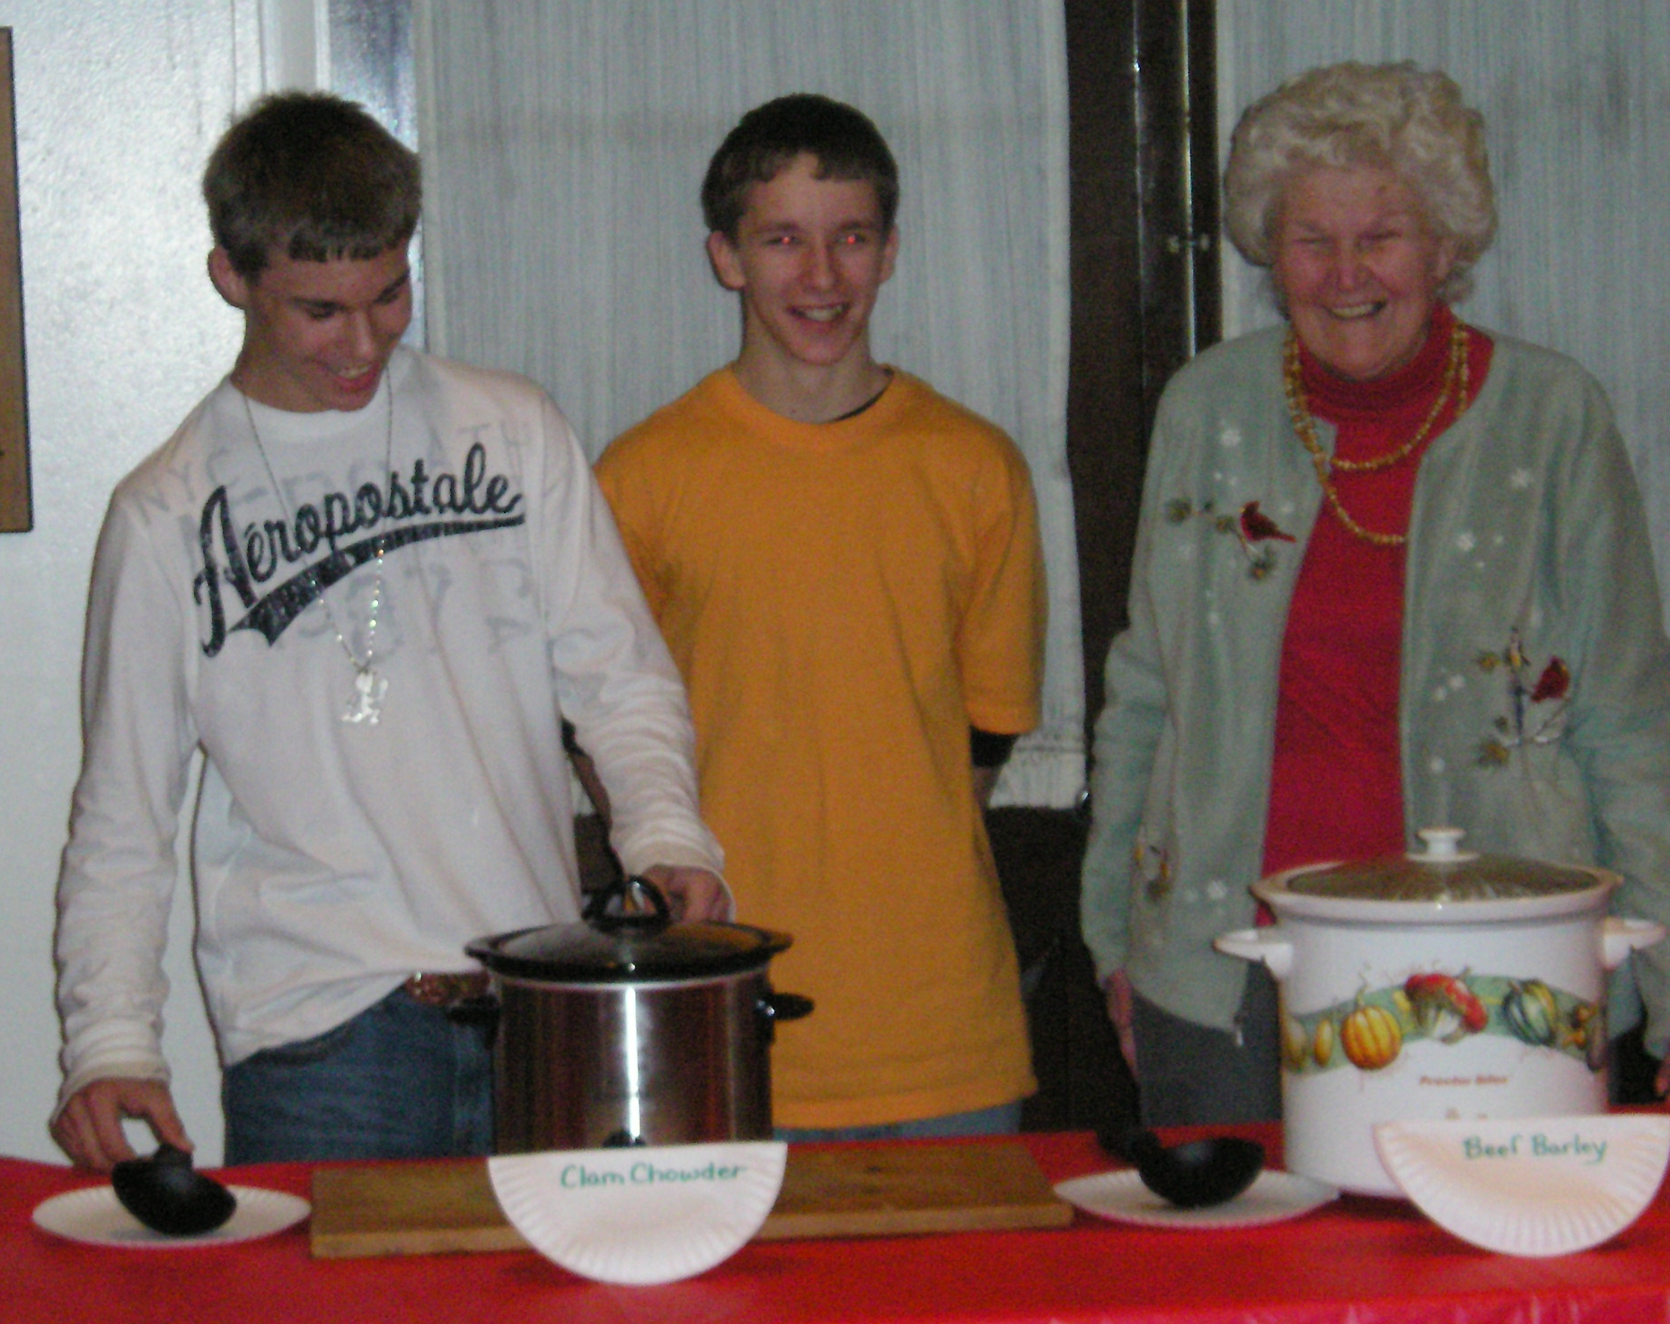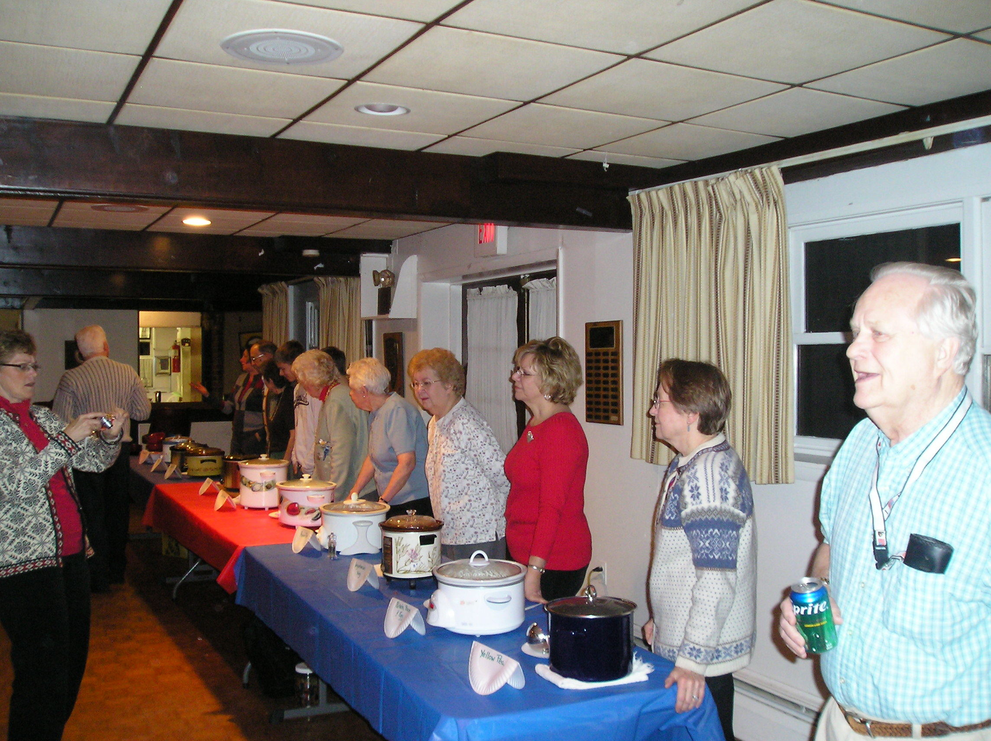

Norsk Carolina (excerpts from Lodge President Carol King’s article in the Norsk Carolina –Nyheter)
What a day! We started with a full afternoon session of “Idea Exchange” led by the wonderful Barbara Berntsen, 3rd District International Director and former District President. Officers from International SON and the District came together to share ideas on programs, resources available, boosting membership and retention as well as how we can learn from each other with participation in events or activities with other Lodges. Many Lodges across the District were with us. The North Carolina Vikings-Raleigh, the Southern Star- Myrtle Beach, the Vennekretsen Lodge- Atlanta, Norsk Carolina—Charlotte were all in attendance. At 7:00 PM our Installation and Institution Ceremony took place. I’m just so proud of everyone and what we have accomplished, the support of Sons of Norway and especially District President Ralph Peterson to help make this happen. The swearing in of officers was a good reminder of our duties and expectations to help serve the Lodge and our members. There were several heartfelt speeches from the dignitaries and we received several gifts! We were able to use the “Traveling Gavel” for our ceremony as well as receiving a special engraved gavel from our sponsoring Washington Lodge to use for all our future Lodge meetings; very special.
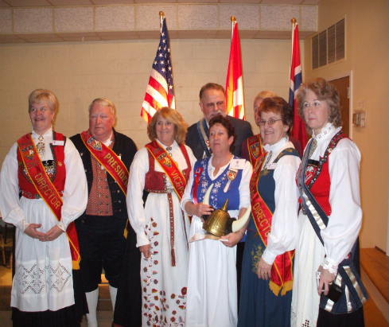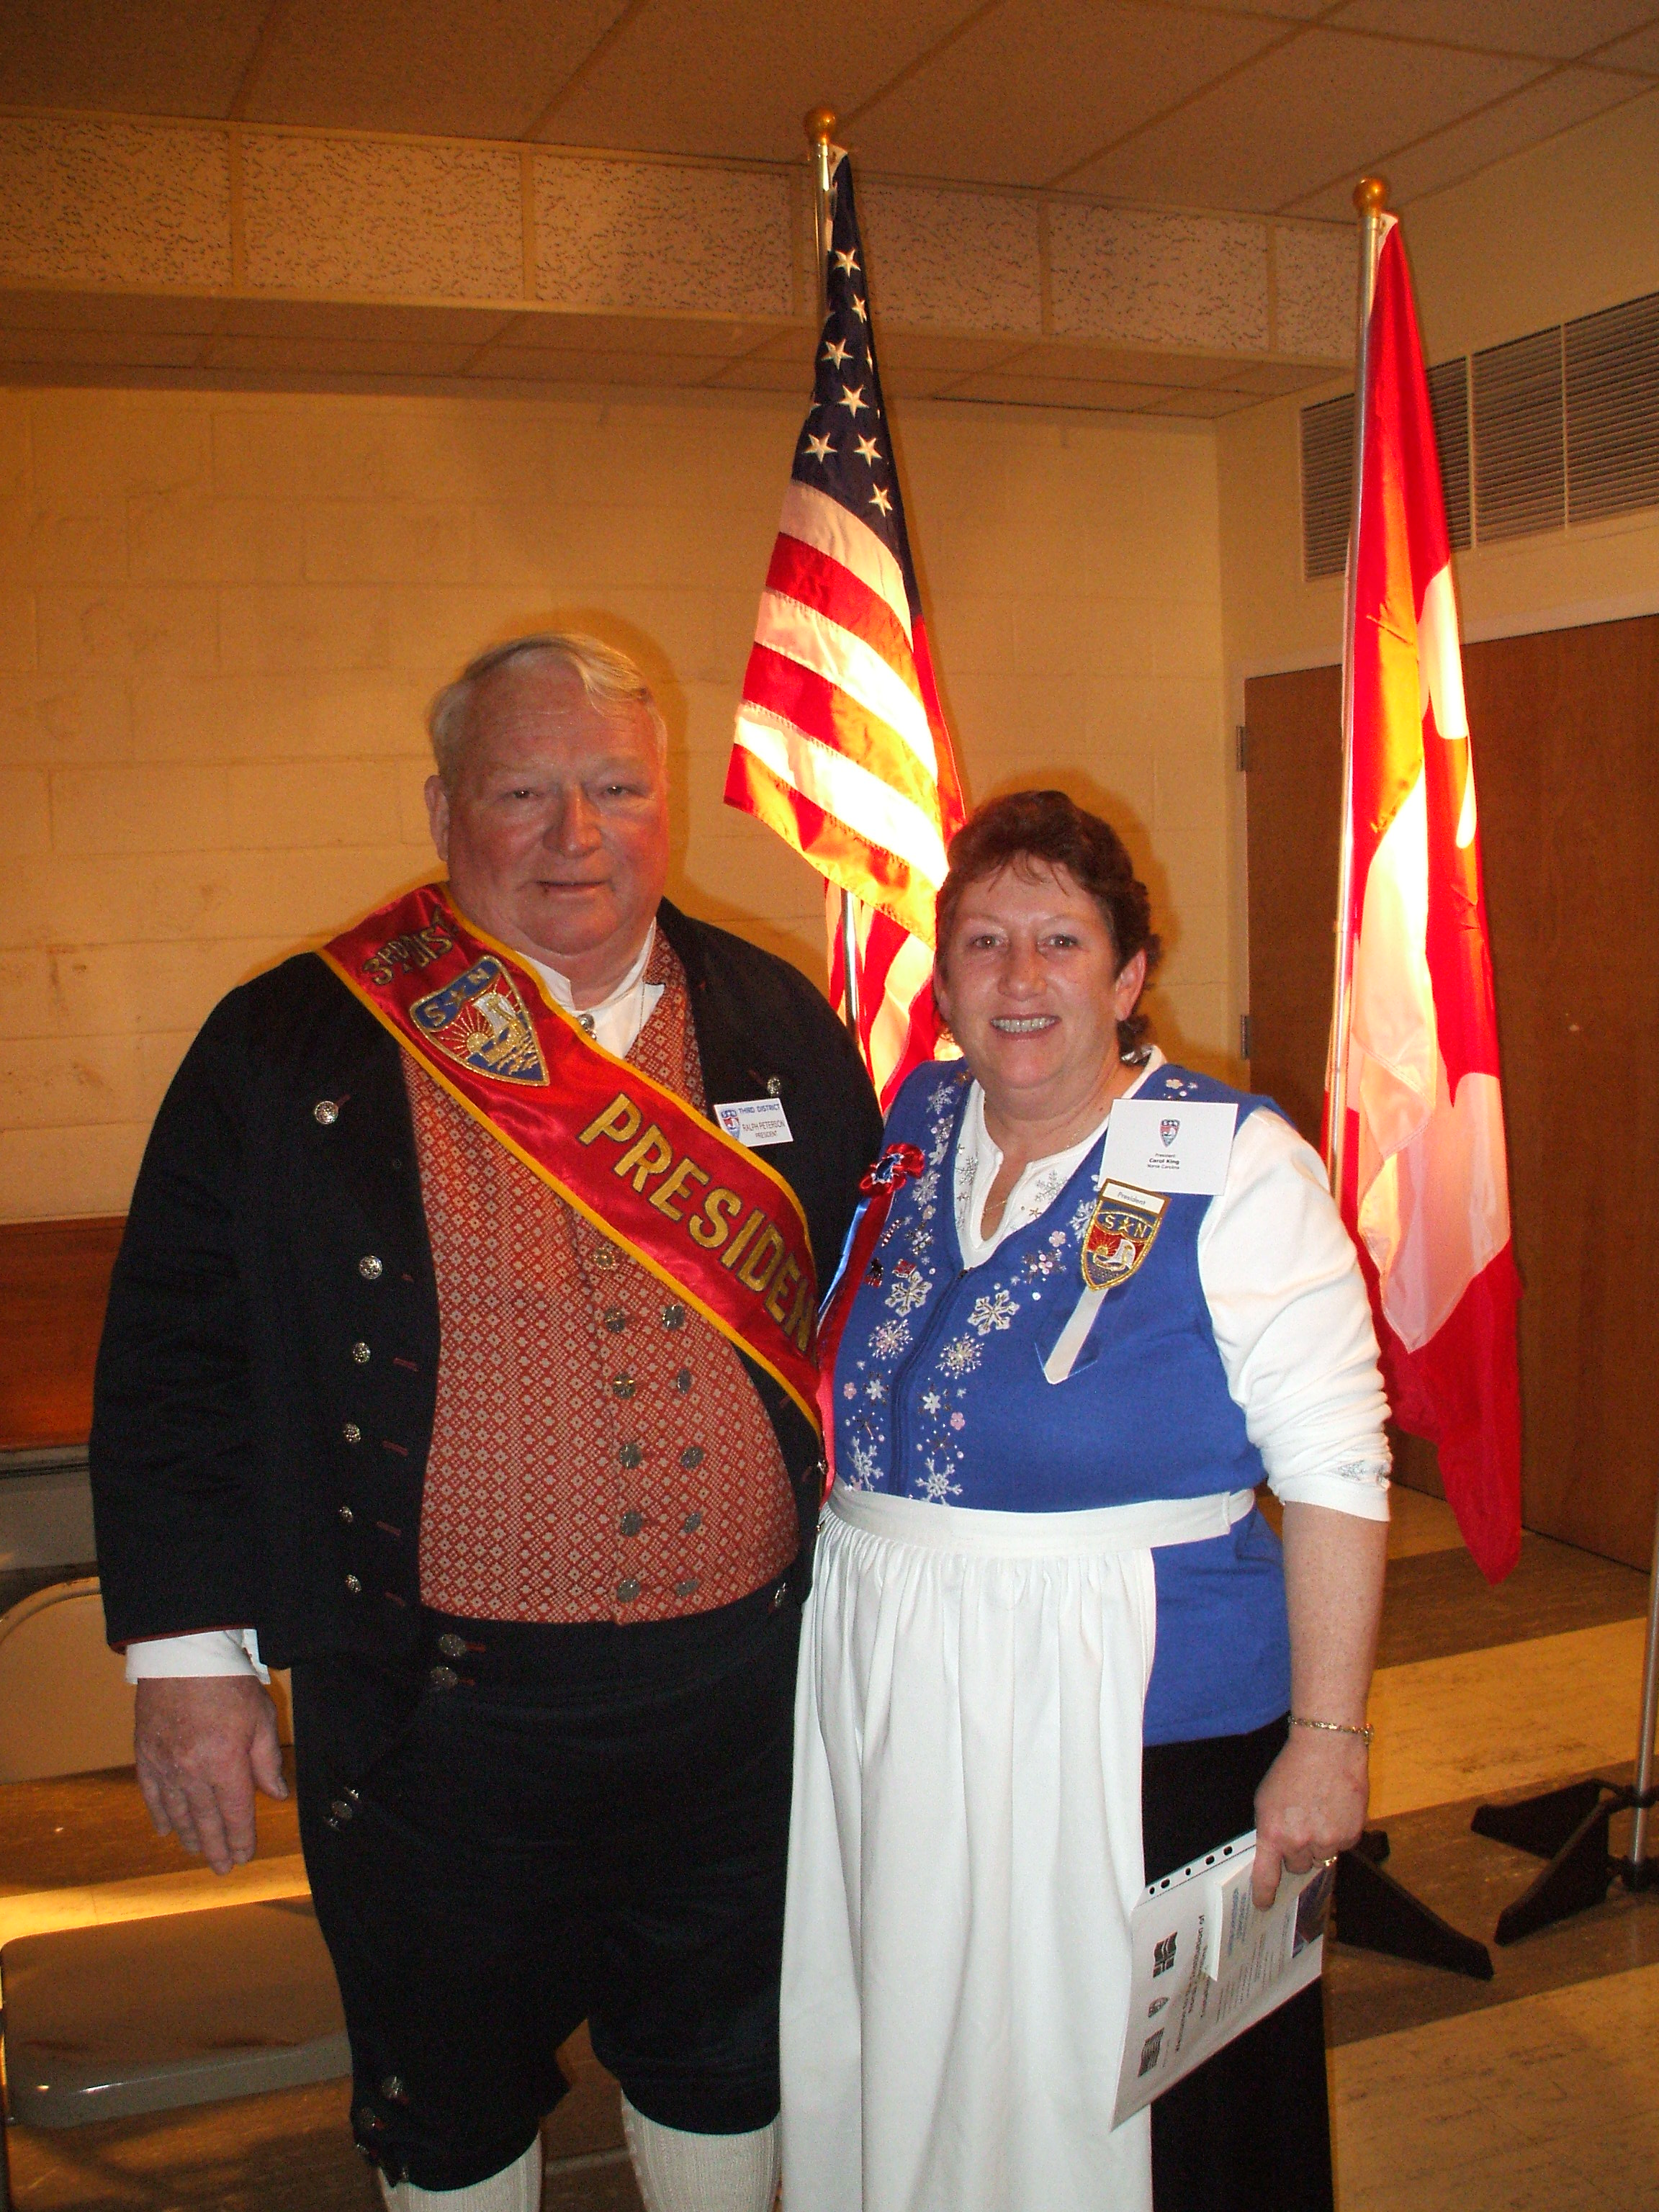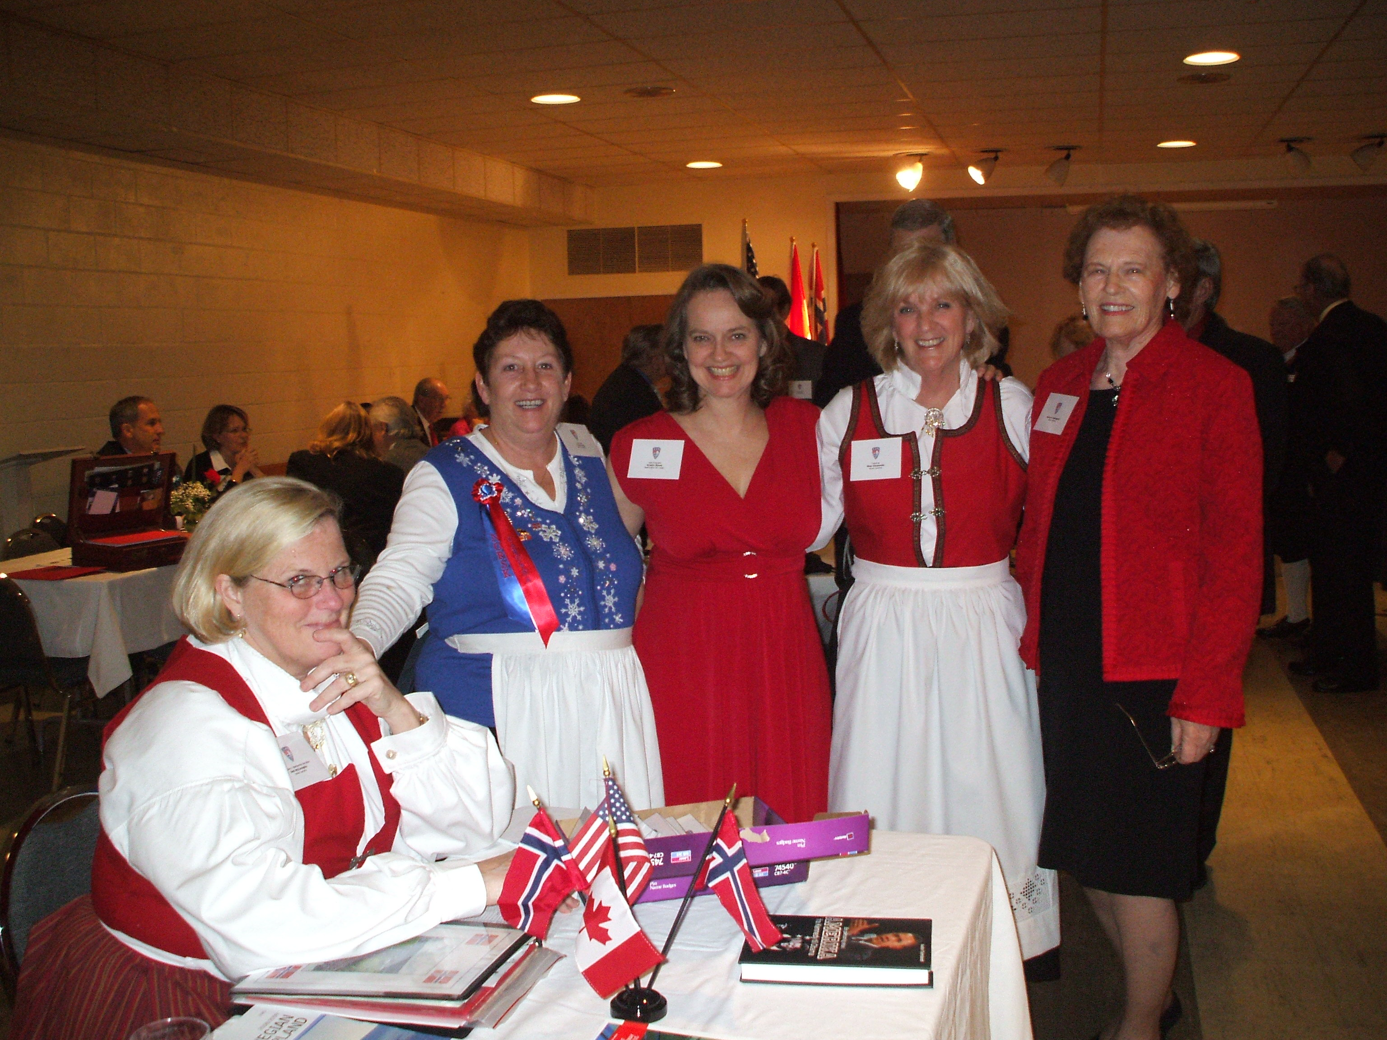
Institution!!! Congratulations!!

Hampton Roads

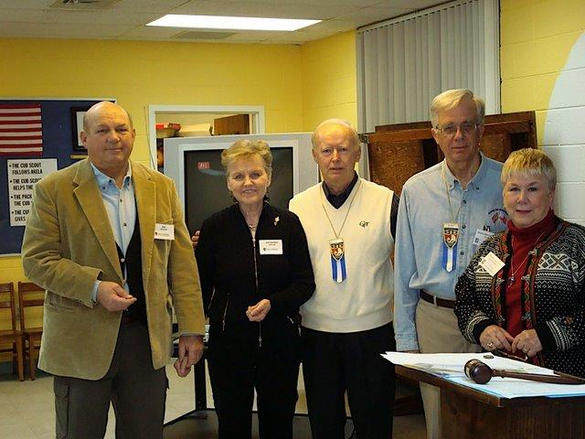
Sports Medals (gangmerke) : 4th Silver and Gold medal to Howard Johnson; a first Gold and Enamel medal to Ragnhild Zingler, a first Bronze, Silver and Gold to Jim Zingler, and a 1st Silver Medal to Deanna Rumney. Larry Atkinson was not present but won a 1st Bronze medal and Alex Dahl, also not present, won Bronze, Silver, Gold and Enamel medals, his fourth set in 4 years.

Congratulations to all!!!

***********
Parting shots!

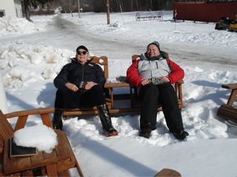

Ahhhhhhhhh, just for the LOV of it!

Upcoming Events

March
1st – Roald – Pot Luck luncheon
1st Morgensolen - Installation
6th Nansen – Pizza and beer
7th Lauderdale – Walk for the Animals
7th Fram – Girl Scout International Day
7th Peconic – Codfish dinner
8th Færder – St. Patrick’s Day Party
8th Oslo – Cultural Madness
13th Norge – Sister’s souper supper night
13th Sun Viking – Corned Beef Dinner
14th Frederiksten – Social
14th Southern Star –St. Patrick’s Day parade
14th Hudson Valley – Installation
14th Blåfjell-St. Patrick’s Day parade
15th Hudson Valley – Garrison Keillor at UPAC
16th-20th LOV - Rosemaling
19th Bernt Balchen – Installation
20th Nansen – Social; Western Night
20th Norrøna – St. Patrick’s Day dinner/dance
20th-21st Gateway to Florida –HUViking RegattaUH
22nd Gateway to Florida – Knut Eric Jensen HUconcertUH
21st Nor-bu – St Patrick’s Celebration
22nd Norge – Family bowling
22nd Henrik Ibsen – Bowling for Fun
23rd-27th LOV - Rosemaling
28th Nansen – Viking Auction
28th Zone 6 Memorial Service
28th Sarasota -35th Anniversary Celebration
28th Blåfjell- Sweet Sweeden
29th Zone 3 Scholarship Dinner Dance
29th Norsk Carolina – your grandmother’s pancakes

April
3rd Loyal- Ham Dinner
3rd Sun Viking – Easter Program
4th – Zone 4 Scholarship Dinner at LOV
5th Færder – Sister’s night and Easter Parade
10th Morgensolen – Stan’s Auction
11th Hudson Valley – Yutes night
17th Loyal – Viking Auction
17th Nansen – Do Wop Night
17th Norrøna – Candle Lights
17th-19th HUZone 2 weekendUH at LOV
18th Hampton Roads – International Children’s Festival
18th Nor-bu – Brothers Night
18th Southern Star – Brookgreen Gardens Picnic
19th Henrik Ibsen – 75th Anniversary Celebration
24th Loyal – Little Vikings
25th Oslo – 60th Anniversary Celebration at LOV
25th Loyal – New Member open house
25th Blåfjell – Land of Fire and Ice/Iceland
26th Zone 1 (Brooklyn) Memorial Service
26th Zone 4 Memorial Service

May
1st Loyal – Cultural Dinner
1st-3rd HULOV Golf tournamentU
1st Roald – Syttende Mai Fest
2nd Hampton Roads – Azalea parade
2nd Southern Star- Lodge Anniversary Cruise
2nd Hudson Valley – clean up day at Elvedal
3rd Zone 1 (Long Island) Memorial Service
3rd Færder – 17th of May Fest
8th Morgensolen – Syttende Mai
8th Norge – ice cream social
15th Norrøna – Syttende Mai Dinner Dance
16th Nor-bu – Syttende Mai Party
16th Nansen – Syttende Mai Picnic
16th Blåfjell – Local Colors
17th Syttende Mai Parade in Brooklyn, NY
22nd -23rd Suncoast Lodge – Syttende Mai Viking boat Regatta and Dinner Dance
28th Loyal – Ladies Auxiliary
29th Loyal – Little Vikings

June
5th-8th Norge – Sunny Hill weekend
5th Loyal – Barbeque and St. Hans celebration
5th Roald – Ice Cream Social
6th Garbog – Atlantic City trip
7th Fram – Pot Luck Luncheon
14th Loyal – Lobster Party
14th Færder – dinner and Bingo
16th Nansen – St. Hans
20th Hudson Valley – St. Hans Celebration at Elvedal
20th Norrøna – St. Hans Day at Budd Lake
20th Morgensolen – Midsommer Dag
23rd Nor-bu – St. Hans (midsummer bonfire)
27th Blåfjell –Annual Smith Mountain Lake Picnic

3D Officers

President, Ralph Peterson President@sofn3d.org
Vice President, Gail Ekloff VicePresident@sofn3d.org
Secretary, Marci Larson Secretary@sofn3d.org
Treasurer, John Gregg Treasurer@sofn3d.org
Counselor, Louis Olsen Counselor@sofn3d.org
Youth Director, Evelyn Karpack Youth@sofn3d.org
Sports/Recreation Director – Phil Nelsen Sports@sofn3d.org
Publicity Director, Mary Andersen Publicity@sofn3.org
Cultural Director, Karen Doty Cultural@sofn3d.org

Zone 1 Director, Kris Rasmussen Zone1@sofn3d.org
Zone 2 Director, Judith Mack Zone2@sofn3d.org
Zone 3 Director, Joan McKillop Zone3@sofn3d.org
Zone 4 Director, Arnold Johnsen Zone4@sofn3d.org
Zone 5 Director, Carol Anderson Zone5@sofn3d.org
Zone 6 Director, Kathy Dollymore Zone6@sofn3d.org

PRIVACY NOTICE: This information is for official Sons of Norway business use only. Use of this information for solicitation or commercial purposes is a violation of the Sons of Norway privacy policy and is strictly prohibited.

