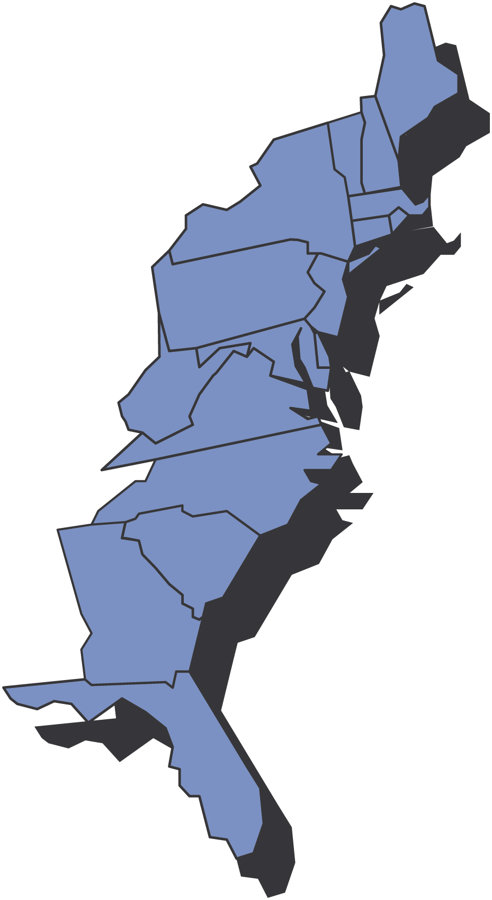
God jul og godt nyttår!

December, 2009

Third District Today

0BFra Presidenten Ralph Peterson

Hei alle sammen,

Well after several months of slow new member sign up D3 had a great month with 62 new members. Our hats are off to Maine Nordmenn who signed up 18 new members last month. Many of those were out of state members so don’t think that your next new member has to be living next door to you. Thirty two of our lodges still have a requirement to vote in new members. In some lodges there is a reason for that but in many lodges a bylaw change could eliminate that requirement thus allowing new members to join on line. In one study we had 15 notices of prospective members going on line telling headquarters that they wanted to join a specific lodge. Headquarters notified the lodges however only 2 of the 15 became members within 3 months. We need to do better with this group of prospective members. With all the bazaars and fairs our lodges will be holding this fall I have high hopes that we will be signing up many more new members in the next few weeks; don’t forget to put your events on our website.
I have some great news for all of us in the race to convert 999/000 members to local lodges. Local lodge officers now have access to the 999/000 data base located in the members only section of the SON web site. Vice President Gail will continue to send information on new 999/000 members to those local lodges in the area of the new members. I will continue to send the 999/000 members a link to our TDT after it has been posted to our website.
Our web site continues to attract more viewers. The site http://www.3dsofn.org/home.html averaged almost 80 viewers a day and that is a 7% increase over the last 4 months.
D3 has arranged with Hurtigruten Inc to provide special rates on MS Midnatsol which departs Bergen, Norway on 17 July 2010. The trip will be a fund raiser for D3 as the District will receive part of the commission normally received by the travel agent. You can get more info on our web site (shortly) or you can call Jensen Beach Travel (772-334-1300) for more information on the trip. You can book a one way trip or a round trip. The amount of spaces allocated to District 3 is limited so call quickly.
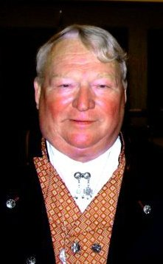
The Norsk Carolina lodge will receive their charter on 21 November 11, 2009 in Charlotte NC and congratulations to the Drammen Lodge in New Bern NC as they are now up to 47 members including 6 in October. We are working on an installation date.
We want to welcome Oslo member Jim Dunagan to Mary Andersen’s Publicity team. Jim is going to take over as our webmaster and I know he will do a great job. Thank you Jim!
At the past two District Board meetings each board member was asked to provide a statement on how to improve the Sons of Norway. The leading choices were having an active membership committee and a membership mentoring program. Very good advice!!!!!
Let’s push to get those new members and hold on to those we have.
If AnneGrete and I don’t see you before the end of the year we would like to wish you all a most happy and joyful Christmas and a most prosperous New Year

Fraternally
Ralph Peterson
President
District Three
Sons of Norway
*****************************

Don’t forget to:

Fra Vise Presidenten Gail Ekloff

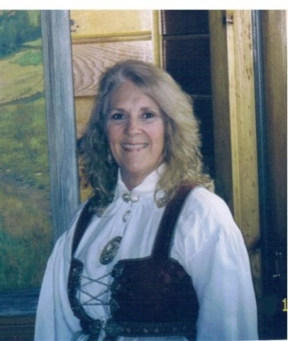
An article I read last year in the District 4 newsletter sums up how to approach your lodge’s New Year:

“January is typically when new officers are installed. Are you an outgoing officer? How you handle the transition of your position to your successor is extremely important. Plan to: meet with the new officer to explain the position and go over the materials; Pass on organized files; Provide detailed notes on deadlines and procedures. Provide samples of any forms. Hand over the appropriate and most recent section from the Guide to Leadership, congratulate your replacement, and provide an enthusiastic offer of ongoing assistance. Your lodge is counting on you to provide a smooth transition for your successor.”

Let’s communicate the ideas and experiences we have to our fellow officers and make the robe of officership less daunting.

When making up your New Year events calendar, incorporate these two events for membership drives. Set aside March for “March Membership Madness” Have a membership event. Let’s see what creative ideas your membership has to bring new people out to see what Sons of Norway and your lodge has to offer. Advertise these events in your local paper and on all the websites— lodge, 3D, SON. Follow this up with an article and pictures on these sites so we know how your event went.

In addition to “March Membership Madness” try a “Fall Family Frenzy” concentrating on Unge Venner and Heritage members, along with Mom and Dads. Many lodges have fall bazaars and celebrate the Jul season. What a perfect way to introduce children of all ages to Norwegian/Scandinavian traditions. Station a greeter at a membership table at your bazaar and you will have your “Fall Family Frenzy” membership drive done.

At the recent Board meeting, the 3D-Membership Committee decided to initiate a Membership Packet. It will contain information on membership issues such as advertising, use of media, reviewing monthly membership activity reports, and an overview of 000-999 membership lists. The packet will be ready for January so the new and returning officers can start the new term with this information. Zone Directors are willing to meet with any group of lodges and review the packet. Please contact them if you are interested. If you have any question regarding the Membership Packet contact me ( rege882@catskill.net ), Kris Rasmussen (araszoo@aol.com ) Judi Mack (judimaxsmom@rcn.com ), Carol Anderson ( carolnphil@juno.com ) or Arnie Johnsen (johnsens@hvc.rr.com ).

Rolf and I wish everyone Happy Holidays and a prosperous and healthy New Year.
God Jul og Godt Nyttår

Alt for denne gangen,

Gail

Medlemskap scorer bord*

LODGE | 1 | 2 | 3 | 4 | 5 | 6 | 7 | 8 | 9 | tOTAL
Nansen # 410 | 1
Washington # 428 | 1
Oslo #438 |  | 1
Hampton Rd. #522 |  | 1
Scandia #617 |  |  |  | 1
*number 0f 999 members that transfer to a lodge- source activity report/Minneapolis

REMEMBER THE 2 A’S TO GET NEW MEMBERS--- ASK AND ADVERTISE
AND, TO KEEP MEMBERS, THE 2 M’S -----------------MENTOR AND MINGLE

Our Secretary Says
By Marci Larson – Gateway to Florida, President and Third District Secretary

Reminder – it’s time for individuals or lodges to think about a nominee for the prestigious Leif Erikson Award, which District 3 presents to a recipient who promotes the ideals of Norwegian culture and heritage. Many dedicated and deserving persons could be honored by this award and certainly have been since its origination in 1967 by the Hartford Lodge.

The criteria is as follows: Candidates may be any person or persons who has/have made major or significant contributions
- as humanitarians
- in public or charitable services
- in the fields of sports, education, medicine or the sciences
- for cultural advancement

- Nominations may be made by any member of the Third District, Sons of Norway. They must include reasons for the nomination and factual evidence supporting the same. (Pictures, newspaper or news media articles, etc.)

- A committee composed of members of the Third District, who have been appointed by the Third District Board, will make preliminary selections from the list of nominees and choose three (3) finalists.

- The Third District Board will elect, by a ballot vote, the award recipient and the first and second alternates.

Your lodge has several months to gather the necessary information and proof of the nominee’s accomplishments. When you have completed your nomination, mail it to Marci Larson, District Secretary, 4013 Moresburg Court, Jacksonville, FL 32257. The nomination must be received no later than Friday, Feb. 19, 2010.

The Cultural Director and her committee will review the nominations submitted and will present them to the District Board at the spring board meeting in March. The District Board in turn will select the winner.

If you have any questions, please let contact Cultural Director Karen Doty or Marci Larson.

For the lodges installing new officers in 2010 and wishing to have a district board member as the installing officer, I need the details as quickly as possible to create a master schedule. The 2010 Officers Installation Request Form is on the district web site under forms and downloads. If you have any questions, please e-mail me at mlarson@northfloridatpo.com. And remember to send me a copy of the Officers Change Form which you must complete even if you are not changing officers so I can update your lodge information for the 2010 Membership Directory.

Charitable Trust
By Louis O. Olsen, M.D., Counselor

As we near the end of 2009 and look ahead to 2010, many of us try to get a fix on our monetary needs for the year ahead. This often is a daunting task, but we seem to push ahead in hopes of understanding more completely our income and expense position.
While we go through this exercise, I would like to offer a suggestion regarding another means to satisfy ones wish to continue to support the Third District Lodge No. 3 Charitable Trust.

A recent article in the edition of the “Advisor” describes a method to employ life insurance as a vehicle to satisfy this goal. One can use a currently owned life insurance policy that has perhaps outlived its need by assigning ownership directly to the charitable trust. Or, one can purchase a policy, naming the trust as the beneficiary. Either one provides money for the trust, proceeds are paid promptly without probate costs, other assets are not affected and if there are premiums, they may be tax deductible as a charitable donation. When properly implemented, you should receive charitable deductions for the value of the insurance contract and any future premium payments.
Needless to say, your Financial Benefits Counselor would be tickled pink to assist you!

I hope this allows another method to consider in your quest to continue to support our Charitable Trust. Thank you for your support this year and I hope we can still count on you in 2010.

God Jul og Godt Nytt Aar,
Louis
Check to-Charitable Trust 3D Lodge
Mail to - Louis O. Olsen, 7 Farnham Way, Timonium, MD 21093

Financial
New interest rates effective 12/1/2009!
Contact your Financial Benefits Advisor for more information
FLEXIBLE PREMIUM DEFERRED ANNUITY
Current Interest Rate |  | 1st Year Interest Bonus |  | Total 1st Year Return
$ 0 - 1,999 | 3.00% |  | 0% |  | 3.00%
$ 2,000 - 9,999 | 3.00% |  | 0% |  | 3.00%
$ 10,000 - 24,999 | 3.50% |  | 1.00% |  | 4.50%
$ 25,000 - 49,999 | 3.70% |  | 1.00% |  | 4.70%
$ 50,000 - 99,999 | 3.95% |  | 1.00% |  | 4.95%
$100,000 and over | 4.05% |  | 1.00% |  | 5.05%

SINGLE PREMIUM DEFERRED ANNUITY
Current Interest Rate |  | 1st Year Interest Bonus |  | Total 1st Year Return
$ 10,000 - 24,999 | 3.60% |  | 1.00% |  | 4.60%
$ 25,000 - 49,999 | 3.80% |  | 1.00% |  | 4.80%
$ 50,000 - 99,999 | 4.05% |  | 1.00% |  | 5.05%
$ 100,000 - 249,999 | 4.15% |  | * 1.15% |  | 5.30%
$250,000 and over | 4.15% |  | * 1.60% |  | 5.75%
* Denotes 1st Year Interest Bonus Change
Please keep in mind that interest rates are subject to change.

Adopt A School
By Nalda & Gene Olson, Bondelandet 3-612, Adopt A School Coordinators

ADOPT A SCHOOL

“It’s the most wonderful time of the year!”

So the song goes and Norwegians certainly know how to celebrate Christmas. What a wonderful time to share the Norwegian customs through our Adopt A School program. Dancing around the tree, making heart shaped baskets, the stories of the Nisse, lutefisk (just kidding) and lefse. Norwegians do it best!

Tusen takk to those dedicated persons who so faithfully visit their schools regularly to help with school work or read to the children. You’re commitment has made an impact on your community.

Good Luck to the new VP, Dave Thorsen, Nansen Lodge. How fortunate you are to have a “historically Scandinavian neighborhood” in your area! Here in Lancaster, Pa, Scandinavians are few and far between. It’s all new to them, so I guess that is to our advantage. Please feel free to contact us at maisnr@comcast.net for any help. Also, Nicole Newman at International, adoptaschool@sofn.com will answer any questions.

Gateway to Florida lodge participated in a book fair at their adopted school. The fair had groups representing various countries. What a unique idea! Another “IN” for Adopt A School.

2010 is knocking at our door. Knock, Knock, who’s there? Third District Convention! Start taking pictures of your involvement in the Adopt A School program. We want to have an ongoing digital presentation and table at the convention. Any ideas are accepted.

Keep up the good work.

God Jul
Adopt A School “Encouragers”
Nalda & Gene Olson

Publicity
by Mary Andersen, 3D Publicity Director

We have a webmaster!!
I am thrilled to announce that Jim Dunagan, Oslo Lodge has agreed to become the webmaster for the Third District!

Jim’s initial responsibilities include:

- approve events on the Events page of the 3D;
- manage our blog;
- add lodge websites to our web;
- analyze our website analytics and
- explore any major updates (e.g., member section) to the web

For now, you can contact Jim at publicity@sofn3d.org; we will let you know when his webmaster email address is up and running!

Thank you Jim!!!!

The Viking

I mentioned in the September 2008 TDT that my goal for submissions to the Viking would be to have a picture from each section of our district as well as a group picture each month. Also, those lodges that haven’t had a picture in the Viking for awhile would get priority. Over the past few months, I have had to scrounge for pictures. I mentioned this at a recent Board meeting and was told by the Zone Directors that people send in pictures and they never get in the Viking. Yes there are some pictures that I receive for the Viking that aren’t selected. So, I this is what I look for in selecting pictures:

  - a lodge that hasn’t had a picture in the Viking for awhile;
  - lodge events;
  - multi generational pictures;
  - pictures with happy faces;
  - pictures with activity and
  - event related pictures (e.g., hummerfest, LOV weekends, regattas)

Photo composition is important and it is sometimes hard to see the flaws in our own pictures! I and previous publicity directors have received pictures where:
- two people, who were the focus of the picture, were facing forward and behind them was someone with their back to the camera
- two people in beautiful Norwegian sweaters standing next to a soda machine and under a tv; the tv had a nascar race playing!
- A few people in the foreground with someone in the rear bending over to get something out of the trunk of a car with a roll of paper towels between her knees!!!

It happens, we all do it!! Pictures like the above will not be submitted to the Viking!!! The unfortunate part for the submitters is that I am not able to respond to everyone, especially if sent via US mail. Don’t get discouraged; watch the photo composition in your submissions!!

For more information on submitting Viking photos, I posted a guide just received from Sons of Norway on the 3D website. http://www.3dsofn.org/forms/documents/photo_guide_final.pdf

Vi blogger
The following was taken from the Sons of Norway blog:

Friday, November 13, 2009

Norwegian Time Machine: 1924 Recipe for Lapskaus
It's the time of year when we are all thinking about food. With Thanksgiving right around the corner it's hard not to, right? As the weather gets colder and the days get shorter, I turn more and more to comfort foods when planning meals at home. I love good hot meals, heavy stews and thick, fragrant sauces. So, today I give you a recipe from 1924 for one of my favorite Norwegian foods, Lapskaus. I first came across this delicacy 8 or 9 years ago when I was visiting the Vegas Viking 6-152 lodge. They made an absolutely wonderful lapskaus with potatoes, and large chunks of meat in a sauce that was beyond belief. I'll never forget that when I asked for the recipe I was told they didn't really use one beyond the various type of ingredients. Too bad for me, right?
Well, in any case, when made correctly it can be the finest, yet most simple meal to enjoy on a cold November night. So, with that, I give you the 1924 recipe and a link to a more current recipe as the one below may be hard to replicate (can you even get "salt meat" anymore?).
Ingredients:
1 soup plate of boiled salt meat
1 soup plate of fresh raw meat
1/2 lb pork
1 qt potatoes
1 small onion
1/2 tsp pepper
Salt
Water
Cut the fresh meat, pork and potatoes into small cubes. Place over the fire in water. Add finely chopped onion, pepper and salt to taste. Boil under cover for about one and one-half hours. Add the salt meat after the fresh meat has boiled for half an hour. Serve.
Posted by Erik Evans at 9:51 AM 0 comments
Labels: Food, History, Sons of Norway

Vi blogger
Speaking of blogs, the Third District has its own blog!! It is currently being tested by a few brave souls; it will be live by Thanksgiving; check it out and start blogging http://www.3dsofn.org/blog.

Finally
A great big thank you to Doris Beck, Restauration! I can always count on Doris for a picture when called upon. Also, thanks to Dirk Hansen, Southern Star, whose articles I frequently “borrow” for the TDT.

Sports
LEIF ERIKSON REGATTA RESULTS
Heat 1: Jacksonville's Hagar-1st Place, Ft Lauderdale's Thor- 2nd Place.
Heat 2: Ft Pierce's Falken-1st Place, Orlando's Valhalla-2nd Place.
Final Men's Race: Ft Pierce-1st Place, Jacksonville-2nd Place, Ft Lauderdale-3rd Place.
Women's Race: Jacksonville-1st Place, Ft Pierce-2nd Place.

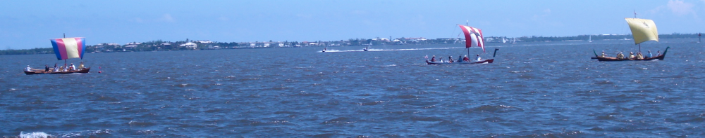
Final Men's Race: Hagar was in the lead with Falken close behind and Thor trailing in the sailing leg. Falken passed Hagar in the final rowing segment to win the race.
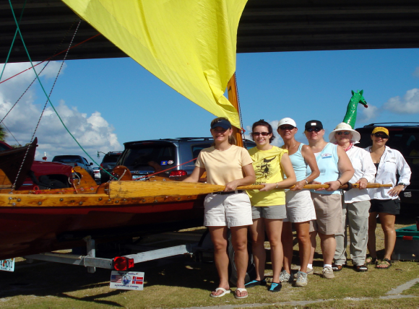
Women's Crew Left to Right: Tiffany Jordahl, Rita Tweed, Patricia Bakke, Ida Iverson, NeenaGuidi, Marianne Gruber.
Not in picture: Barbara Berntsen (tiller)

Celebrate Culture or 3D’s got talent!!!
Hmmmmm, do I see a joint lodge vendor table at the 2010 Convention; it would be a sell out!

Southern Star #630
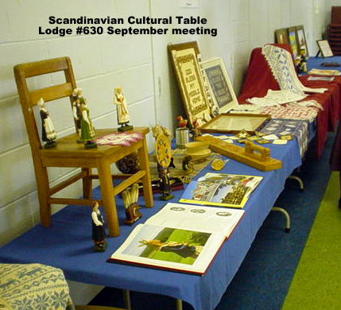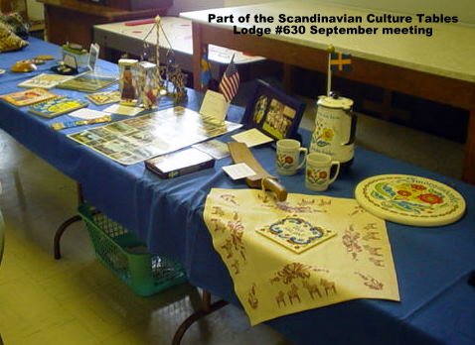

Fram #564 The Fram Fair – fantastic!
Artisans – Else Andersen, Greta Heindenberg,Debbie Welde, Bjorg Dunlop
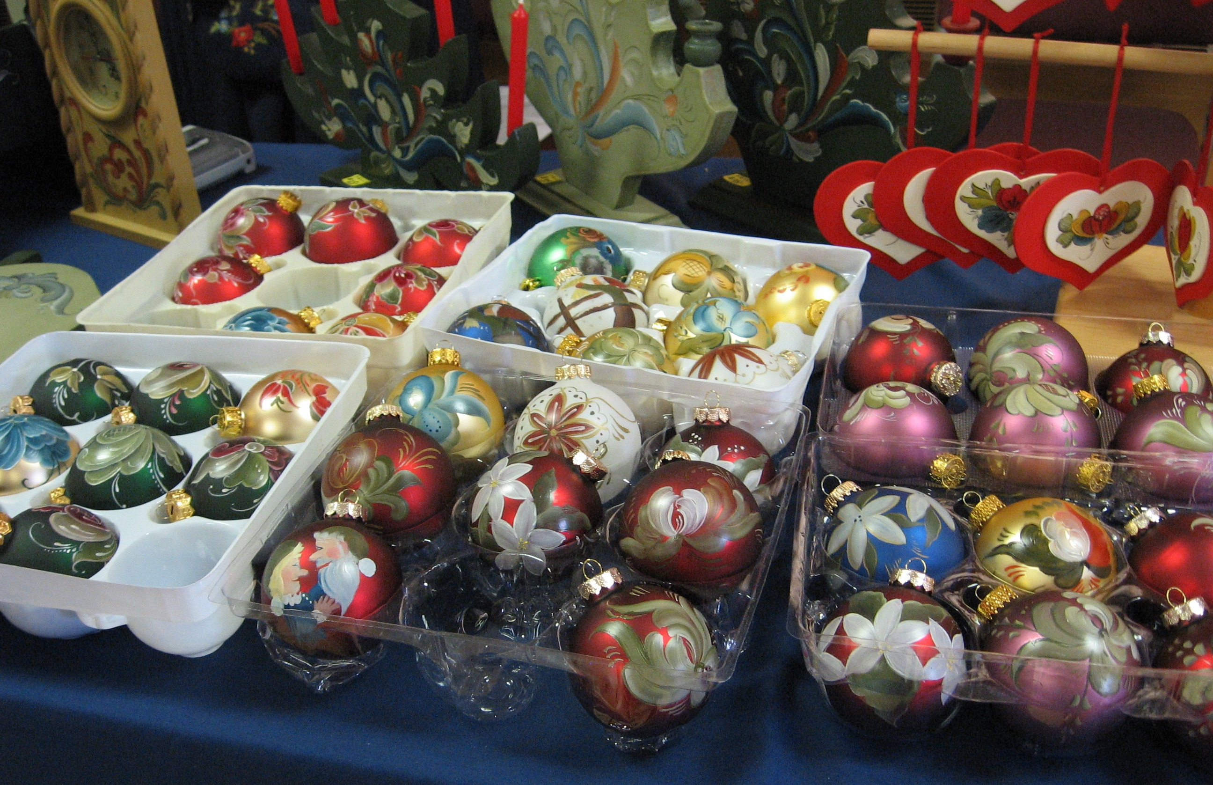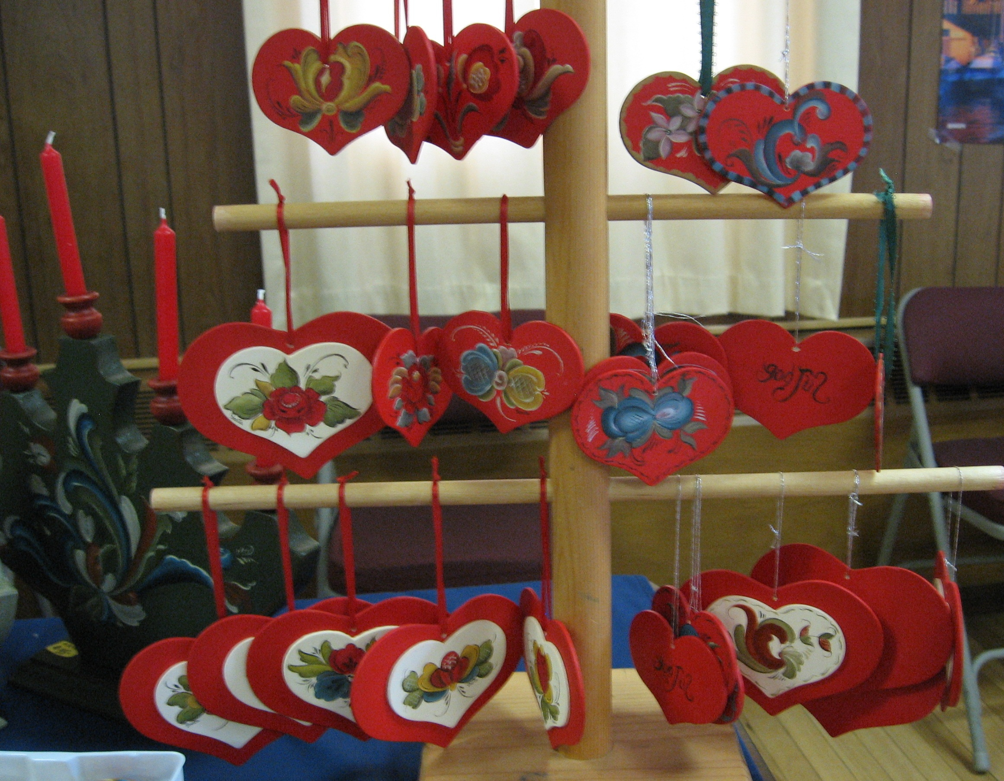

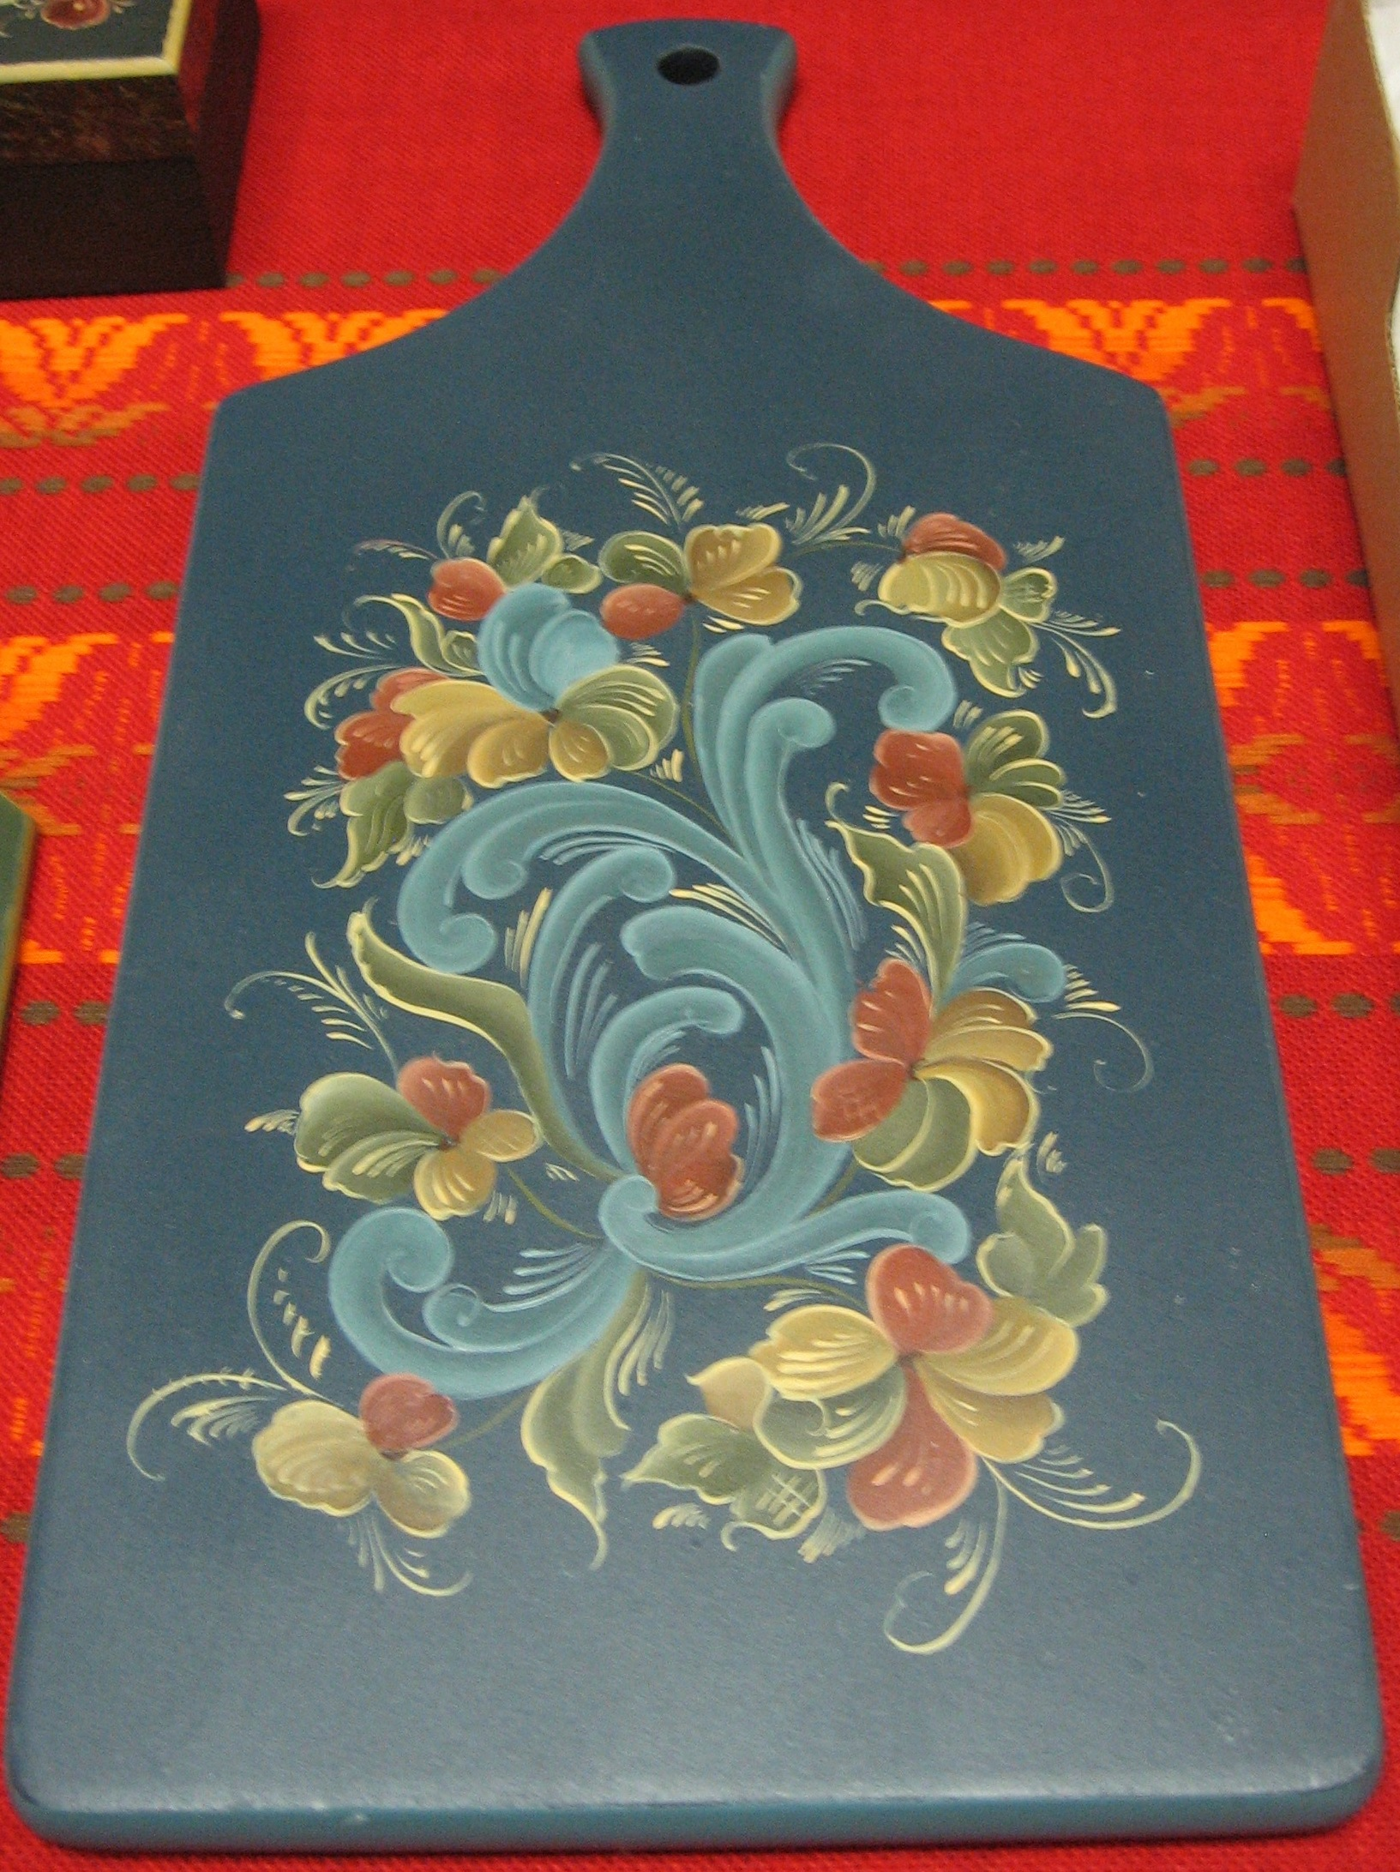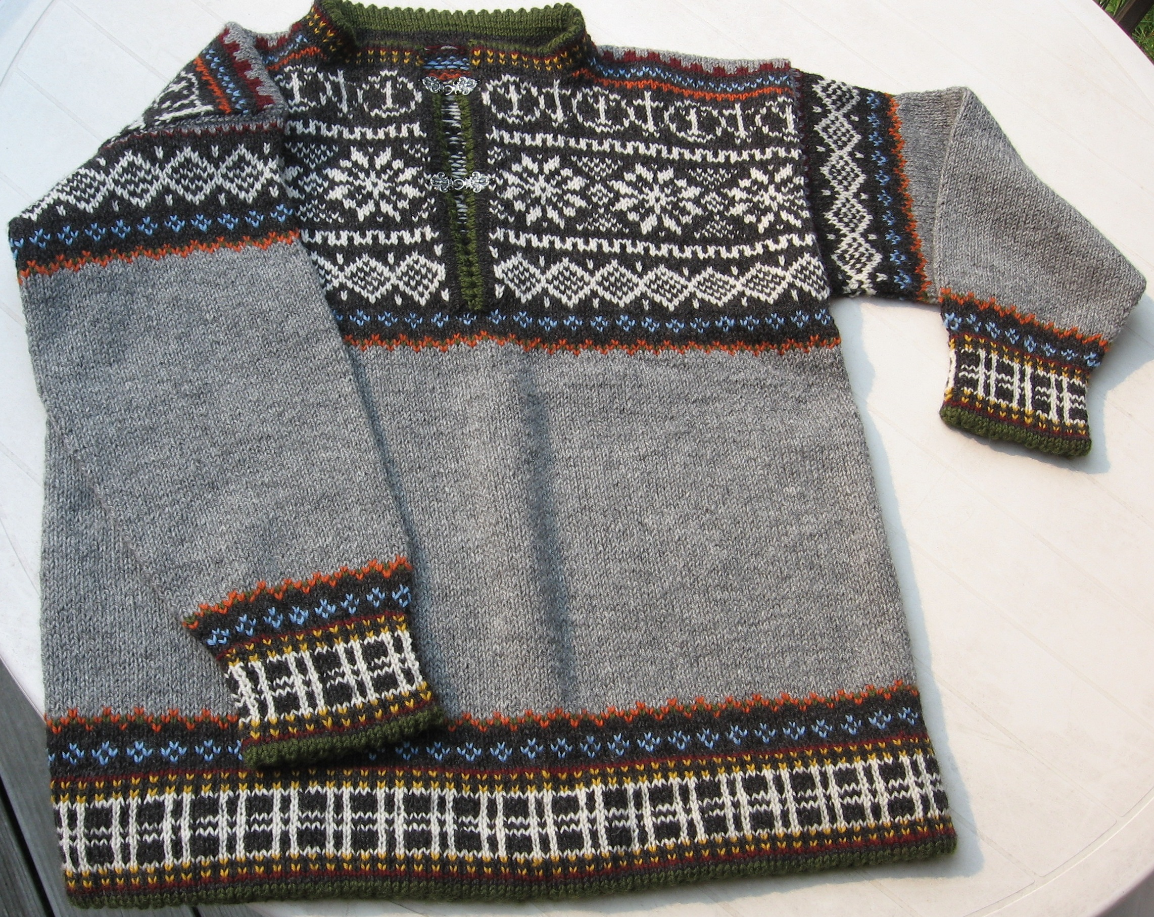

What’s LOV got to do with us?
LAND OF THE VIKINGS
A District 3 Cultural and Recreational Center
You still have time

Basket Social
By Luana Marie Jøsvold, LOV Marketing Director

The people who live in the area around Land of the Vikings enjoy basket socials, known to Sons of Norway members as Viking auctions. In order to bring in a little extra revenue and to make Land of the Vikings known to local residents who might never have been there, we have scheduled a basket social the weekend of December 6th.

We are asking that Third District lodges consider donating a basket of goodies or other items (or money to buy a basket of goodies) to support the event.

The basket social will give us an opportunity to bring in some funds from the local community and to introduce the facility to people we would like to encourage to schedule weddings, business seminars, birthday celebrations, holiday celebrations, and other events at LOV. I hope your lodge will consider making a donation of some kind to help us do so.

Tusen takk!!

Make your reservations for New Year’s Eve now!!! Over 90 people attended the festivities last year

“In the Zone”
Did you know you can find out what is going on in other lodges by clicking on About Us and then lodges on the 3D website. This will take you to the Sons of Norway page which contains all of our lodges. Lodge names highlighted in blue means they have their own website; check out what they are doing and if you are travelling in the area, drop in and say hello!!

Zone 2
Maine Nordmenn #644
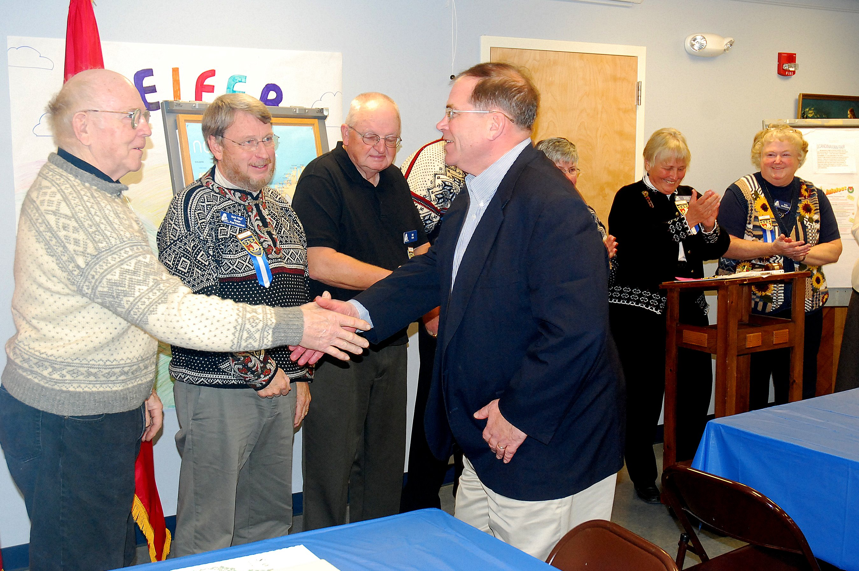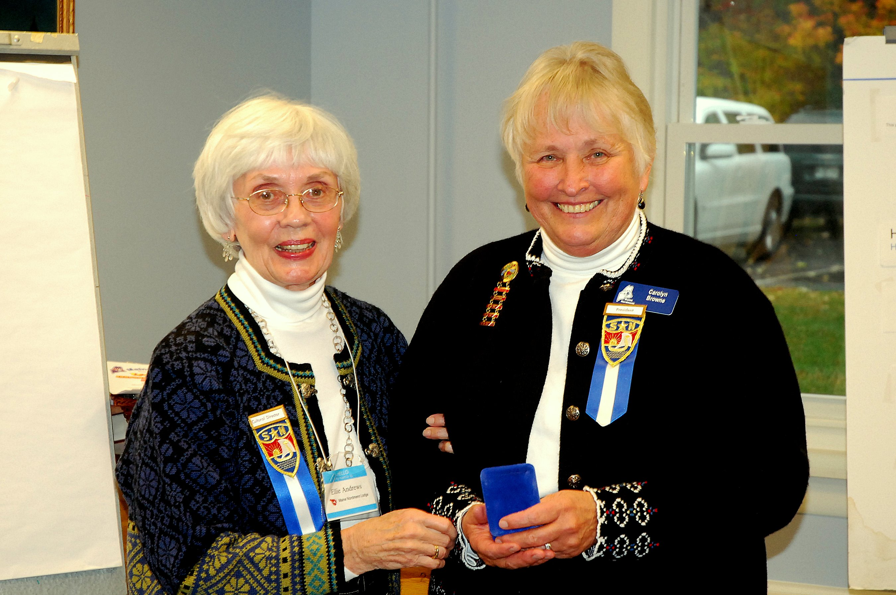
First Picture: New member Dean Jackson is greeted by Maine Nordmenn Board members

Second Picture : Ellie Andrews, Cultural Heritage Director, presents Maine Nordmenn President Carolyn Browne with her Master's pin for completing all three levels of the Genealogy, Knitting, and Cooking Units of the Norwegian Cultural Skills Program.

Way to go Carolyn!!!!

Zone 3
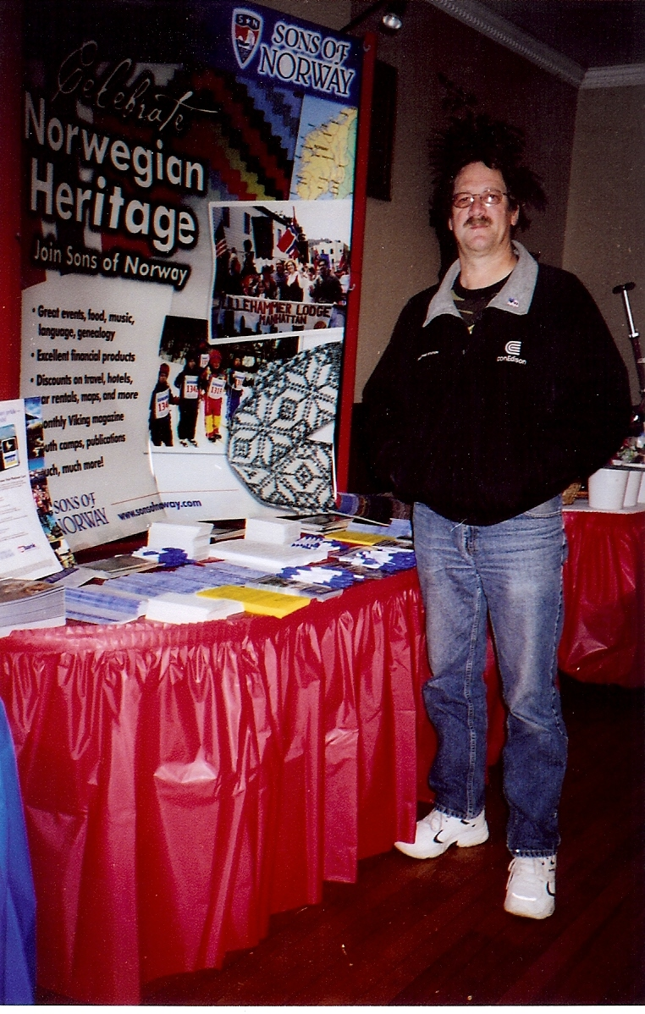
By Doris Pawlicki
Thor Kongvold stands next to a Norwegian Heritage display
Zone 5

Gateway to Florida #541

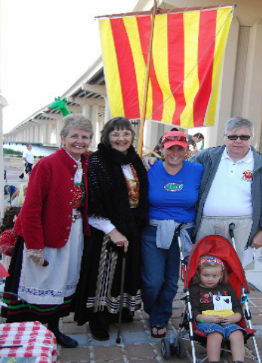
River Arts Market
Stewart Svendsen, Marty Iverson, Frank Morrison,
Frank Morrison III, Eugene Yerkes Marci Larson,Jay Vogeley,
Amy Ohnstad with Isabella,
Kent Larson

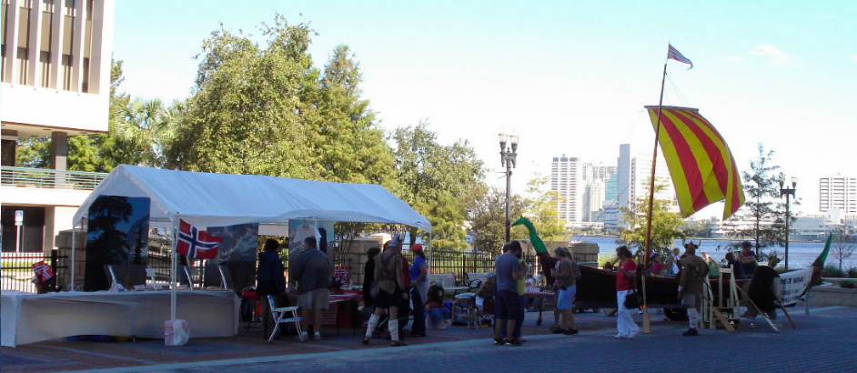
Gateway to Florida Lodge tables laden with fresh Norwegian bakery and merchandise; Loki the lundehund, a live viola concert, Hagar the Viking boat & Vikings attracted hundreds of curious people to their Norway display.

Suncoast Lodge #562
Fun in the Sun!!!
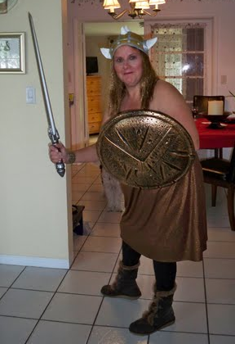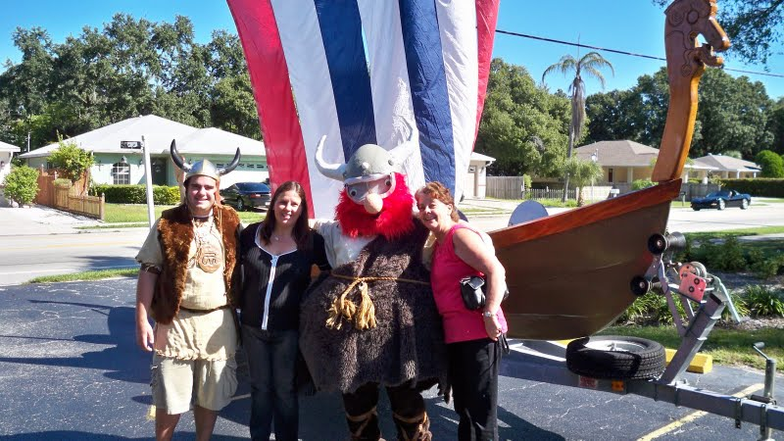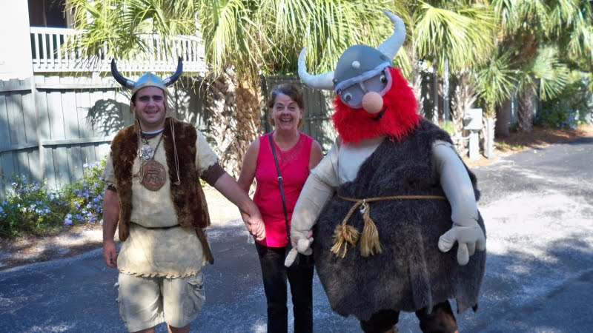

 O Lutefisk, O Lutefisk

To The Tune of O Christmas Tree
Original Words: O Tannenbaum, Ernst Gebhard Anschutz, 1824
Adaptation by Red Stangeland
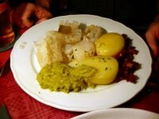
O Lutefisk, O Lutefisk, how fragrant your aroma,
O Lutefisk, O Lutefisk, you put me in a coma.
You smell so strong, you look like glue,
You taste just like an overshoe,
But lutefisk, come Saturday,
I tink I eat you anyvay
O Lutefisk, O lutefisk, I put you in the doorvay.
I wanted you to ripen up just like they do in Norvay.
A dog came by and sprinkled you.
I hit him with my overshoe.
O lutefisk, now I suppose
I'll eat you while I hold my nose.
O Lutefisk, O lutefisk, how well I do remember.
On Christmas Eve how we'd receive our big treat of December.
It wasn't turkey or fried ham.
It wasn't even pickled Spam.
My mother knew there was no risk
In serving buttered lutefisk.
O Lutefisk, O lutefisk, now everyone discovers
That lutefisk and lefse make Norvegians better lovers.
Now all the world can have a ball.
You're better than that Yeritol.
O lutefisk, with brennevin [Norwegian brandy]
You make me feel like Errol Flynn.
O Lutefisk, O lutefisk, you have a special flavor.
O Lutefisk, O lutefisk, all good Norvegians savor.
That slimy slab we know so well
Identified by ghastly smell.
O Lutefisk, O lutefisk,
Our loyalty won't waver.
Upcoming Events
November
21st Nor-bu –rosemaling & carving (tentative date)
21st Noreg – Bazaar in Old Bridge, NJ
21st Norumbega – Scandinavian Fair
21st Nor-Bu – Fall Dance
21st Blåfjell – Grandin Holiday Parade (10 am)
21st Blåfjell – Traditional Seven Cookies exchange (3pm)
21st Southern Star – Christmas Bazaar
21st Gateway to Florida – Breast Cancer Row
23rd Nor-bu – folk dancing
28th Gateway to Florida – City of Jacksonville Light Parade
29th Nansen – Deck the Hall for Christmastime

December
4th Loyal – Initiation
4th Nansen – First Christmas Party
4th Norumbega – Juletrefest
4th Suncoast - Julefest
4th Tampa Bay - Julefest
5th Bernt Balchen – Annual Christmas Party
5th Loyal – Deck the Halls Glogg Party
5th Lauderdale – Christmas Party
5th Southern Star - Jultrefest
6th Færder – Children’s Christmas Party
6th Fram – Holiday Dinner
6th Gateway to Florida - Julefest
6th Loyal – Children’s Christmas Party
6th Nor-bu – annual food sale
10th Norge –Children’s Christmas party
11th Sun Viking – Juletrefest
12th Fredriksten – Christmas Party
12th Hampton Roads – Norwegian Christmas Dinner
12th Hudson Valley – Christmas Dinner
12th Lauderdale – Winterfest Boat Parade
12th Loyal – Adult Christmas Party
12th Henrik Ibsen – Children’s Christmas Party at 1
12th Henrik Ibsen – Adult’s Christmas Party at 7:30
12th Nor-bu – rosemaling & carving (tentative date)
13th Hudson Valley – Children’s Christmas Party
13th Nansen – Children’s Christmas Party
13th Norden – Christmas Party
13th Restauration – Christmas/JulFest
13th Roald – Christmas Luncheon
14th Nor-bu – folk dancing
17th North Carolina Vikings – Christmas Dinner
18th Nansen-Jultrefest – St. Lucia
18th Suncoast – Christmas Smorgasbord
19th Blåfjell – Julefest
19th Færder – Christmas Party
19th Norumbega – Juletrefest for children
19th Nor-Bu – Julefest
20th Hartford - Jultrefest

January 2010
6th Fram – Installation of Officers
8th Gateway to Florida – Installation of Officers
10th Færder – Installation of Officers
10th Southern Star – Installation of Officers
11th Nor-bu – folk dancing
25th Nor-bu – folk dancing

February
7th Southern Star – Super Bowl Party
7th Fram – Annual cod fish dinner
8th Nor-bu – folk dancing
22nd Nor-bu – folk dancing

March
8th Nor-bu – folk dancing
12th Troll – Installation of Officers
13th Southern Star – St. Patrick’s Day Parade
19th-20th Gateway to Florida - Viking Boat Regatta
22nd Nor-bu – folk dancing

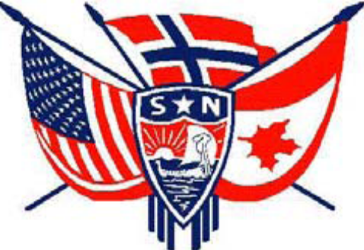

3D Officers

President, Ralph Peterson President@sofn3d.org
Vice President, Gail Ekloff VicePresident@sofn3d.org
Secretary, Marci Larson Secretary@sofn3d.org
Treasurer, John Gregg Treasurer@sofn3d.org
Counselor, Louis Olsen Counselor@sofn3d.org
Youth Director, Evelyn Karpack Youth@sofn3d.org
Sports/Recreation Director – Phil Nelsen Sports@sofn3d.org
Publicity Director, Mary Andersen Publicity@sofn3d.org
Cultural Director, Karen Doty Cultural@sofn3d.org
Adopt A School Coordinators, The Olson’s adoptaschool@d3sofn.org

Zone 1 Director, Kris Rasmussen Zone1@sofn3d.org
Zone 2 Director, Judith Mack Zone2@sofn3d.org
Zone 3 Director, Joan McKillop Zone3@sofn3d.org
Zone 4 Director, Arnold Johnsen Zone4@sofn3d.org
Zone 5 Director, Carol Anderson Zone5@sofn3d.org
Zone 6 Director, Kathy Dollymore Zone6@sofn3d.org

PRIVACY NOTICE: This information is for official Sons of Norway business use only. Use of this information for solicitation or commercial purposes is a violation of the Sons of Norway privacy policy and is strictly prohibited.

