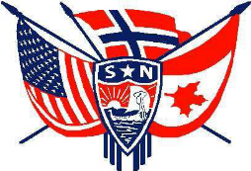

SEPTEMBER 2011

Third District Today

The mission of Sons of Norway is to promote and to preserve the heritage and culture of Norway, to celebrate our relationship with other Nordic countries, and to provide quality insurance and financial products to its members.

Fra Presidenten Ralph Peterson
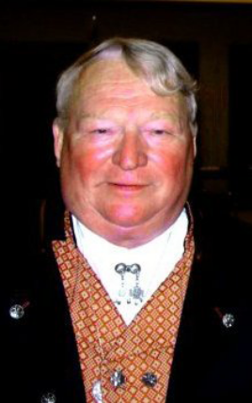
Well this is a bit unique as my last letter was written in Bergen and this letter is being written in L’Anse Aux Meadows, Newfoundland. Both trips were/are fantastic Norwegian experiences. Check our web site www.sofn3d.org for more info on the Newfoundland trip.
Our lucky winners of the Hurtigruten trip were Ian Pate from Gulfstream and Joan Sullivan from Maine Nordmenn. This is the second Hurtigruten winner in a row from Maine Nordmenn and her uncle won the big trip from the Sons of Norway last year so any ticket I buy from now on will be from Maine. I know that these folks will enjoy the trip. It is a great trip and I highly recommend it despite being a bit pricy.
There is a lot of stuff happening in LOV so please check out the web site for the events that are scheduled. We are bringing in Rosemaling and Genealogy instructors that are recognized internationally so don’t miss out on these opportunities.
Planning for the Convention and Centennial celebration continues. You can expect to receive periodic updates as we progress with the planning and events become firm. It looks like a great schedule of entertainment and events will be available. If you don’t have your email registered with the Sons of Norway please do so. You can email SON or call them at 800-945-8851 to update your personal information including your email. You can expect the first email early in September. We are hoping for a large delegate turnout and an even larger of number of non-delegates. We have negotiated the same hotel rates for 3 days prior to the convention and 3 days after the convention so you can make it a real family vacation.
One of the Centennial programs will be an update of the Third District History. We need an update from each lodge for this book so if your update is not already sent in please get it to our editor Asbjorn Lageraaen asbjorn44@msn.com ASAP.
For those lodges that will be electing officers this year it is not too early to begin advising your members of the upcoming elections. Our members not only need to be aware of the upcoming elections but what are the obligations and responsibilities of each position.
I earlier challenged the District Board to each sign up a new member in June. I am extending this challenge to the entire district and it will go to the end of the year. If you can’t find someone to sign up then give a gift membership to a family member or a friend. No matter how you do it please sign up a new member before the end of the year as we should have at least 10,000 members in D3 and currently we are less than 8,000 so we need a significant push.
Despite a lot of looking I have yet to see a Moose here in Newfoundland. Sally Abrahamson saw one yesterday but not me. Hopefully I will see one in the ditch and not in my headlights. I will let you know how that goes.

Vice President Gail Ekloff
Remember: 2 A’s - Ask & Advertise - to get a member.

2 M’s - Mentor and Mingle - to keep a member.


Don’t forget to:

Kathy Dollymore, 3D Public Relations
check out the blog on the 3D web site for ideas and notes from your board

Now that summer is winding down, kids are back at school and we are all thinking about the upcoming meetings at our local lodge, it is time to get serious about bringing your friends and family out to the meetings. We are not a “braggy” people in general but there is so much going on at the SON meetings that is almost unfair not to include our comrades, friends and colleagues in the festivities.
The Julfests are coming, the organizing for the Convention is underway, new members can add so much to an organization. Make this the year your lodge will shine. The 3D today is a bit abrieviated this month due to my computer is in the “Techno Hospital” with a very bad virus. We don’t think it is fatal but it will take some time for it to be back to normal.
In the meantime I would still like to see some photo’s from around the Third. Any items you would like to include in the TDT let me have ‘em.
As always my thanks to those who do send me information and pictures- I know I’m not the only one who gets a kick out of seeing what is going on in the District.
<><><><><><><><><><><><><><><><><><><><><><><><><><><><><><><><><><><><><><><><><><><><><>
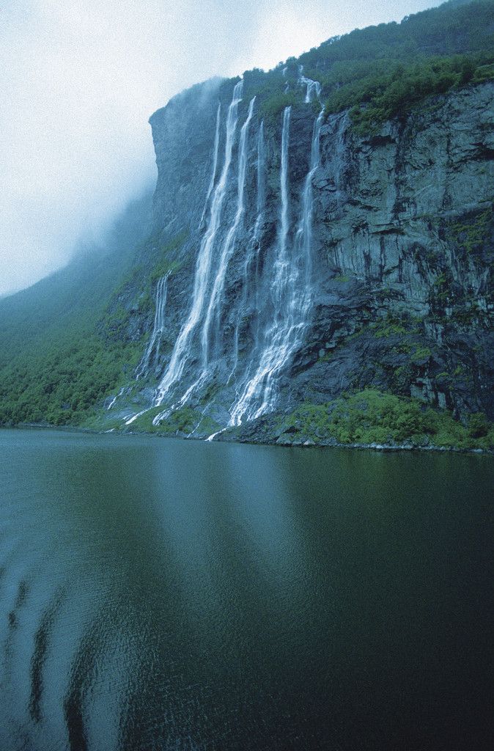
Third District - Norway Trip Fund Raiser:

The happy winners of the Hurtigruten cruise are: (fanfare please)
Jane Sullivan from Maine Nordmenn and Ian Pate from Gulfstream.
Needless to say both were excited beyond belief.

<><><><><><><><><><><><><><><><><><><><><><><><><><><><><><><><><><><><><><><><><><><><><>
ADOPT A SCHOOL
Nalda Olson maisnr@comcast.net Cheerleader for Adopt A School
The papers are full of back to school ads – notebooks, pens, backpacks, smart phones, the latest fashions – you name it. Now is a good time to advertise the Adopt A School program!

A recent series of TV commercials promoting adoption stated that “If you can listen, love and cheer, you can parent.” If you can listen, love and cheer, you are the person/s Adopt A School program is looking for! What a wonderful opportunity to share your Norwegian Heritage.
Schools are suffering major financial cutbacks and volunteers are needed. There is the extra added benefit of a Helping Hands grant.
Check the 3D Adopt A School web and share your success stories. Now is the time to start collecting/gathering pictures, etc for our 2012 Third District Convention Adopt A School display. I need your creative ideas!
Our granddaughter received a wonderful scholarship through the Sons of Norway Foundation. When Grandma presented her with a certificate, there were strings hanging from it. Grandma said, “Dear, there are strings attached to this scholarship – as a future teacher, remember the Adopt A School program AND can Grandma adopt your senior class?” It’s worth a try!
So hop on the Adopt A School bus and get started!
Keep me posted.
Nalda

3 D Sports Director
Gene Olson
Summer is over. How many members do we have who kept track of their activity this summer as far as recording their backpacking/ hiking mileage, bowling, golf, swimming,kayaking,running, jogging, rowing,weightlifting,tennis,dancing,aerobics and even more where you can earn SPORTS MEDALS.
The new Sports Medal Challenge is now on until May 31, 2012. ASK YOUR LOCAL LODGE SPORTS DIRECTOR, LODGE PRESIDENT OR YOUR ZONE DIRECTOR WHO IS UP ON ALL INFORMATION.

The 2011 3D Bowling tournament is over and the results are known however, not published until the trophys have been engraved. They are currently at the engravers.
2011 Tournament was disappointing as to the number of Lodges competing. We have 53 Lodges in the District and only had 11% showing. WE CAN DO MUCH BETTER THEN THIS. The 2012 Bowling Tournament will be held from 1/1/12 – 3/31/12 so talk this up in your Lodges NOW. We must do better in 2012.
LOOK AT 3D WEB SITE
GET READY SET GO

***********************************************
ZONE NEWS
ZONE 1: Kris Rasmussen Director
ZONE 2: Judy Mack, Director
Zone 2 notes
Members of Zone 2 have been busy this summer.
Hartford Lodge started the summer with an Ice Cream Social. They were well represented at the Hummerfest in Maine. They will start the fall season with a Soup and Sandwich social.
Maine Nordmenn Lodge kicked off the summer season with a family cook out on Sebago Lake. Their Hummerfest held July 30 was well attended by members of 5 of the lodges in Zone 2 as well as numerous lodges throughout the district.
After the Hummerfest lodge members from Norumbega, Maine Nordmenn, and Hampton Roads left for a trip to L'Anse aux Meadows in Newfoundland. They traveled over 2400 miles. Contact them for a possible program presentation.
Norumbega Lodge will have a Welcome Back Potluck Supper and KUBB Tournament on September 10.
All of the lodges are in the process of nominating officers for their lodges. Members are encouraged to visit the other lodges in the order to meet new friends and experience different programs.

Zone 3: Barbara Bensen, Director
ZONE 3 THIS N THAT'S
As I turned the calendar page today, I saw September looming on the horizon. The leisure days we looked forward in June are all but gone, and the year 2011 is rapidly ebbing. Where did the summer go?
Lodges in Zone 3 have been active during the summer months. Nansen Lodge held their St. Han's Picnic on June 17th, and their Family Night at Nansen Park on August 14th. Bernt Balchen Lodge marched in the Hawley Parade on July 4th, and held it's annual picnic at the Promised Land State Park on August 18th. Their Scandinavian Craft Fair is September 10th. Noreg Lodge had it's first Strawberry Festival in July and the event was a huge success. They also had a delicious Prime Rib Dinner on August 21st. Noreg's Sister's Social is Saturday afternoon, September 17th. Nor-Bu Lodge held their annual picnic on August 21st and has a Seafood Linguini Dinner planned for September 11th. Their Shoprite Gift Card fundraiser continues to be a success. Both Fredheim and Pleasant Point Lodges had planned summer activities, as well.
So for now, sit back, kick the shoes off, relax, and have fun, because the year-end frenzy is about to begin!

ZONE 4: Karin Gudbranson McCadam, Director
In upstate New York we have both summer sun and rain, but have appreciated it all. Now we look forward to a beautiful September with gorgeous colorful fall weather.
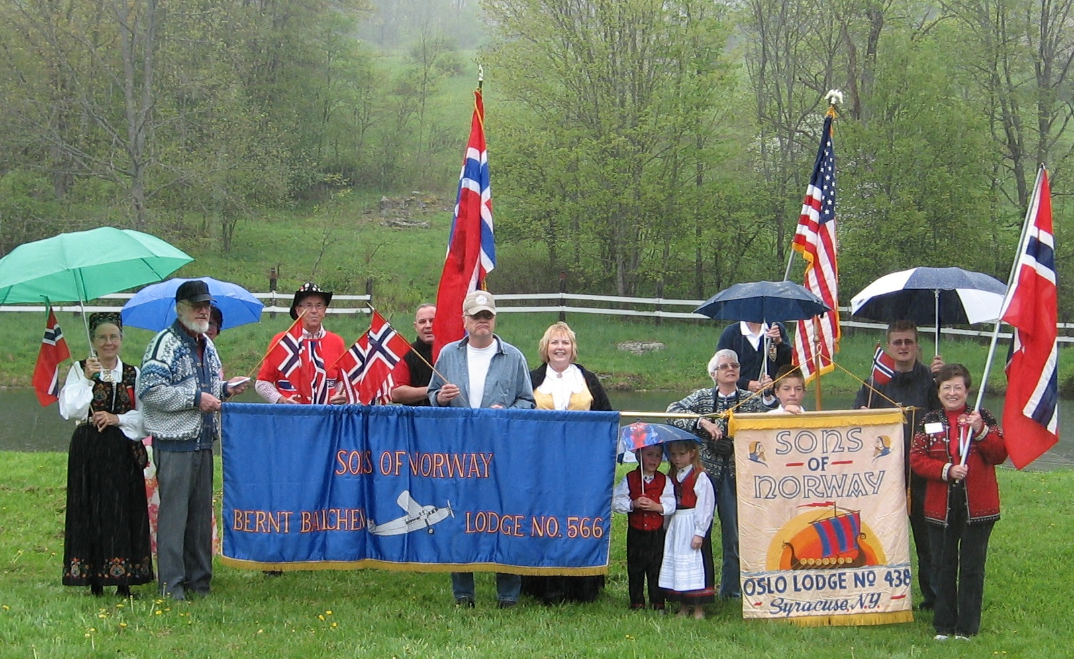
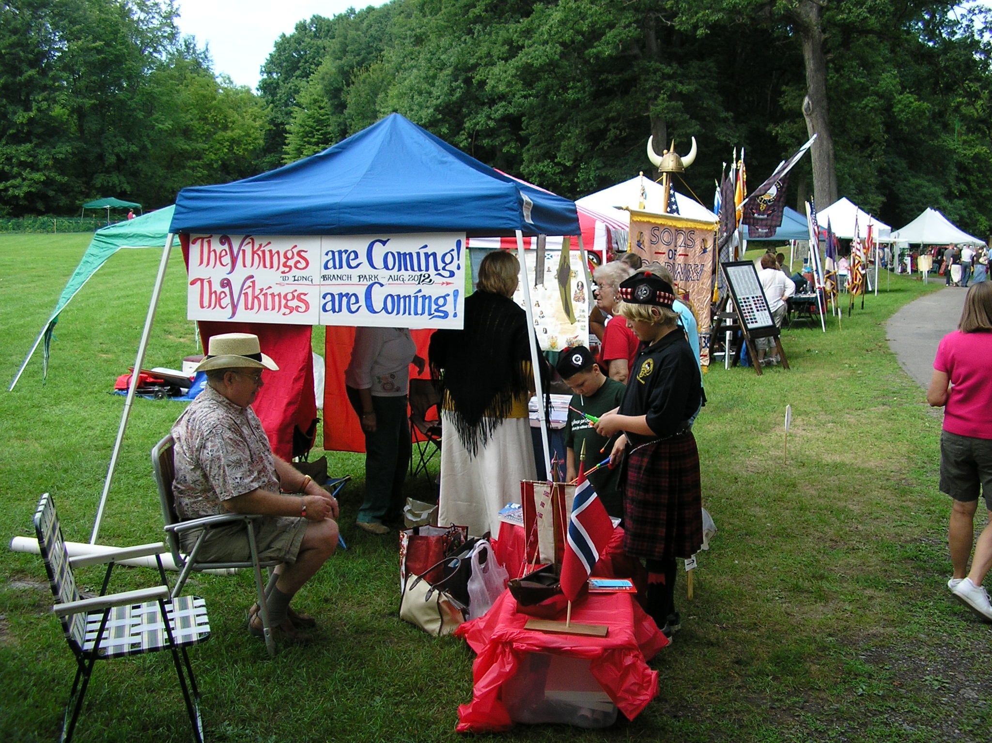
We have had two zone events recently but only one photo. We include it here as it did not make it into the June newsletter. In this photo taken at Land of the Vikings we have several members from Zone 4 lodges as well as Bernt Balchen Lodge (Pennsylvania) and even someone visiting from Norway. We had close to 60 in attendance that rainy day for lunch.
Over the summer our Zone 4 lodges have been busy with lobster dinners, picnics, and parades. The reports and photos are not in yet from the respective lodges but the buzz we are hearing about it has been all good.
On a new note, Oslo.Lodge (Syracuse) has entered the arena of cultural fairs. On Saturday August 13th Oslo participated in the Central New York Scottish Games and Celtic Festival. It was a gorgeous sunny day and here is the synopsis:
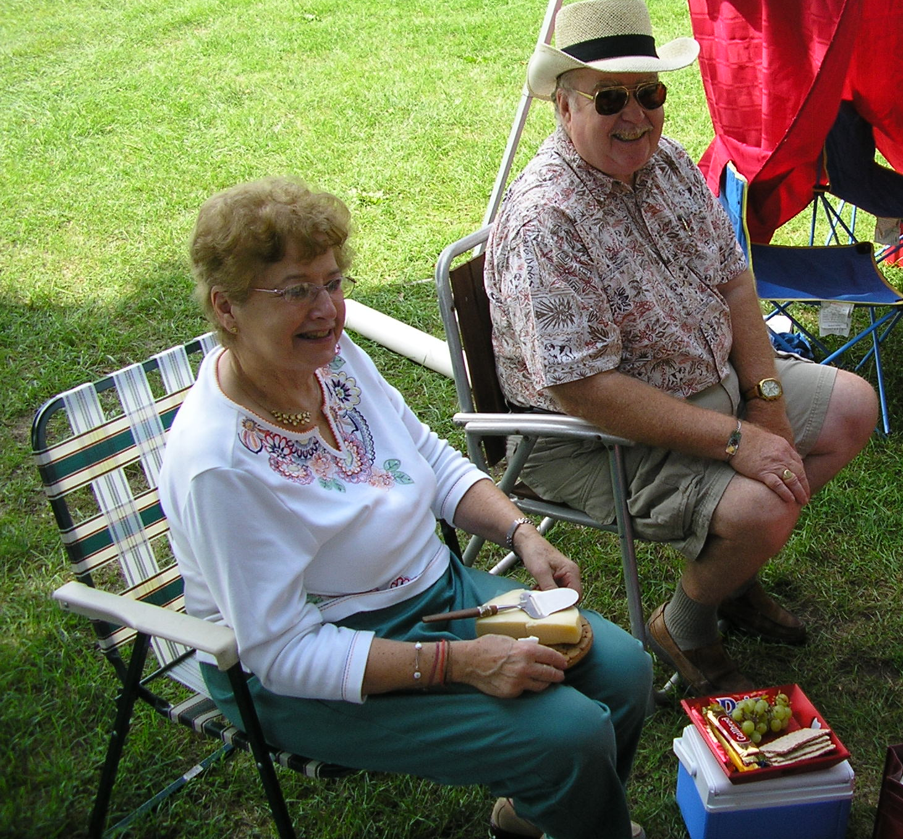
During the opening march, the clans with their flags and emblems were followed by affiliated societies. We were the last to march onto the parade ground, surrounded by thousands of people in the audience. After the National Anthem was sung, the clans and societies were introduced. Each clan stood forward as their clan name was called and they gave a shout. When it was our turn, we expected to hear just “Oslo Lodge” announced. Instead we were pleasantly surprised by the very gracious introduction we received from the Master of Ceremonies. With great warmth he said, “And for the first time ever in the history of the CNY Scottish Games and for as long as I can remember, we have with us for the first time, Oslo Lodge representing the Vikings. As you know we share a grand history with the Vikings as they populated much of the British Isles and Scotland and a number of our clans are descended from the Vikings. So, welcome!” Then we stepped forward with our shout of “The Vikings are coming! The Vikings are coming!”
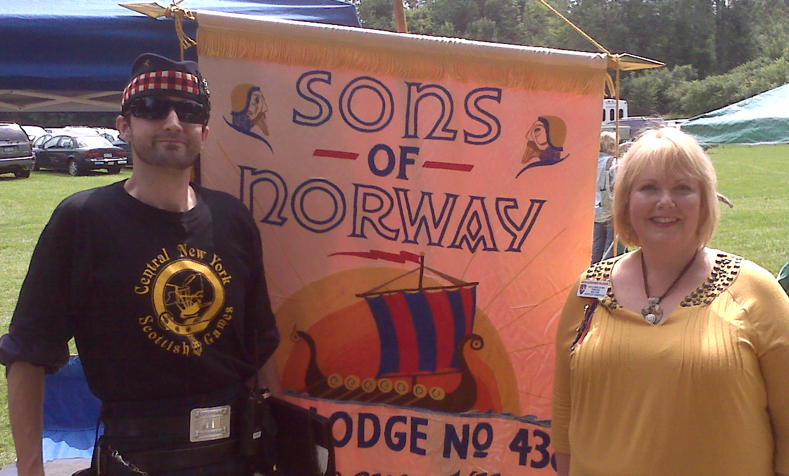
Chris Morrison of Clan Morrison & Karin McCadam Oslo Lodge members had a wonderful and productive day. Numerous people stopped to share their Nordic connections and learn about Sons of Norway. Many gave their email addresses to receive the Oslo Times newsletter and make plans to visit Oslo Lodge.
As always, the fall promises much activity. Please know that you are always welcome at any Zone 4 Lodge (Fram, Hudson Valley, Norrøna, Norsemen, Oslo, Scandinavian Heritage Society, and Troll). Hope to see you soon!

ZONE 5: Gail Martinsen, Director
Here in Zone 5…
Most of the lodges in Florida had a summer vacation in July & August. Many of our members went up north to visit family & friends and enjoy the "cooler weather. Guess what?? Many days this summer were cooler here in Florida than up north! Gateway to Florida celebrated their 37th Anniversary in June with a Luncheon Cruise aboard a paddle boat. The old time paddle boat rode down the Saint John's River. The scenery & weather were beautiful, food good and company fabulous! 4 Sun Viking members joined in the celebration, myself, Ron Martinsen, Sun Viking Editor, Nellie Larson, Sun Viking President & Odd Pedersen. Kent Larson, Gateway to Florida President was a great host. I really enjoyed the chance to get to talk to the many friendly Gateway to Florida members. In July, Gateway to Florida got together for a lodge picnic. Sun Viking had meetings in both July & August. In July, we celebrated 4th of July with an Indoor Hot Dog Picnic and in August, we had a Pizza Night. At our July meeting one of our Past Presidents, Carole Woodruff attended with her daughter, Kim and her granddaughter, Sierra Rose. Carole announced at the meeting that she was moving up to Staten Island to be with her family and for healthcare reasons. It is with sorrow that I report, she passed away last week. We will all miss her. The Sun Viking members sang Happy Birthday at the August meeting to Finn Solberg for his 90th birthday! All of the Florida lodges are gearing up for a very busy fall season starting with the September meetings.
Have a very Happy Labor Day!

ZONE 6: Carol Goral, Director

ZONE 7: Edward McCarthy, Director
Greetings from Virginia Beach!
All the zone seven lodges held 17th of May celebrations with dinners, parades, etc. Most of the lodges had their annual summer picnics as well. Blafjell Lodge in Salem issued a newsletter for July and August which kept me up on their upcoming activities. These will include a Nordic Auction on September 24th featuring Nordic baked goods, artifacts, etc. On 21 October they will be part of a city celebration of different cultures in which Norway will be the featured country. This will be followed by a 15th Anniversary dinner on the 22nd.

I am trying to plan a zone meeting in the near future but have run into a few problems involving not only an appropriate date but also a place to actually hold it. The meeting is planned to be in Raleigh since that is the most central location for most of the lodges. I will be sending out particulars on the meeting including how many delegates each lodge should be sending to it.

sOME ACTIVITIES AROUND THE THIRD
Did you know you can find out what is going on in other lodges by clicking on About Us and then lodges on the 3D website. This will take you to the Sons of Norway page which contains all of our lodges. Lodge names highlighted in blue means they have their own website; check out what they are doing and if you are travelling in the area, drop in and say hello!!

Join us for a true Scandinavian “Seafaring Tradition” September 24th
Meet at Northwest Creek Marina at 10:00 am Cast-off 10:30 am
1st Annual CRABFEST at Union Pointe Park, Downtown New Bern
Land Lubbers join the sailors at 12:00 noon
RSVP Arty Ellison 637-7547 or email artywarwick@yahoo.com Bring a picnic dish to share
Thank you -Anita English -Drammen Lodge- New Bern, NC (252-670-4263)
4rd Annual


Scrapbooking Weekend
at
Land of the Vikings
September 23 – 25, 2011
For Novice & Experienced Scrappers
Cutting Tools & Some Templates Available for Use
Free Assistance for Beginners
Any Questions call:- Doris L. Beck at 215-542-7374
or e-mail at:- DLB1716@verizon.net

Make your reservation at L.O.V. now
Call Bev at:- 570-461-3500
Or E-mail to:- vikingland@tds.net
Gulfstream Lodge’s 40th Annual Leif Erikson Festival & Viking Boat Regatta - 2011
Friday & Saturday, October 7 & 8, 2011 in Jensen Beach, FL
Lodging: Courtyard by Marriott, 10978 South Ocean Drive, Jensen Beach, FL
(772) 229-1000 or 877-905-4502 or visit www.courtyardhutchinsonisland.com
Rate: $89.99 per night + tax for river view standard rooms w/o balcony
$109.99 per night + tax for river view standard rooms w/balcony
$119.00 per night + tax for ocean view standard rooms
$139.99 riverside standard rooms w/balcony (Small fee upgrades at check-in – not in advance)
PLEASE BE SURE TO ASK FOR “SONS OF NORWAY” PRICING. You may stay nights before and/or after the weekend for the same rate. These rooms will be reserved until October 1st. Any room reserved after this date, is subject to the Marriott’s full pricing.
Friday, October 7, 2011 Saturday, October 8, 2011 Sunday, October 9, 2011
Hospitality Room Viking Boat Regatta Zone 5 Meeting- 9 a.m.
Courtyard by Marriott Jensen Beach Causeway Park Courtyard by Marriott
10978 South Ocean Drive Food, cake wheel & rosemaling 10978 South Ocean Dr.
Jensen Beach, FL Scandinavian jewelry Jensen Beach, FL
5:00 p.m. – 7:00 p.m. Mini flea market – starting 9:30 a.m. Delegates & guests
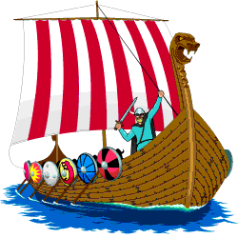
Captains’ Meeting - 11 a.m.
Sail by 12:00 p.m.; Races – 12:30 p.m.
Banquet: Pietro’s on the River @
Island Dunes Country Club
8735 South Ocean Drive
Jensen Beach, FL 34957
(3 miles from the Marriott)
Cocktail Hour - Cash Bar - 5 p.m.
Dinner, Dancing, Awards - 7 p.m.
Buffet Dinner $36.00 per person
Banquet Buffet Menu: Roast Beef, Mahi Mahi with Lemon Butter & Chicken Forestiere
Please make checks payable to: Gulfstream Lodge #3-514 and MAIL by October 1st TO: JAY WISE, 2829 Rainbow
Drive, Ft. Pierce, FL 34981. Tickets will be held for pick up at the hospitality room, park or at the banquet.
Please reserve ______ Buffet Dinner(s) @ $36.00/pp
Name: ______________________________________________ Phone: _______________________
Address: ___________________________________ City _________________ State: _____ Zip:_____
Lodge: ___________________________ Amount Enclosed: ___________________ Check # _______
Email:__________________________________________________
If you wish a specific seating arrangement, send request with reservation form.

Mark your calendars! Invite your friends.

Annual Crab Feast At Norse Park

Sponsored by,  Nordkap Lodge, Baltimore, MD
Saturday, September 3, 2011 1:00 – 5:00 pm Park opens at noon

Hot Steamed Crabs Corn on the Cob Maryland Crab Soup
Eastern Shore BBQ Chicken Carolina Pulled Park BBQ Hot Dogs and Hamburgers
Cole Slaw, and sides Cold Beverages Desserts
Lots of Other Good Eats and Great Camaraderie!!
Advance Purchase Ticket Prices
$40.00 per adult (all you can eat)
$20.00 per adult (everything but crabs)
$5.00 for children ages 6 -16
No charge for Children 5 and under

Purchase your tickets in advance (checks must be received by September 2nd)
Mail your check, payable to “Norse Park” and send to:
Shirley Knutsen – Crab Feast Treasurer
205 St. Mark Lane, Apt. 320
Westminster, MD 21158

For information or Questions, or to volunteer to help out, call: Shirley Knutsen at 410-871-3047 or
Paul Vikestad at 410-879-6289.

Directions to Norse Park: From I-695, take I-83 North to exit 31, Middletown Road. Turn left (west), go 6.7 miles and make a right on West Ruhl Road. Go 0.8 miles and make a left on North Ruhl Road. Proceed 0.3 miles and make a left on Chickentown Road. Norse Park will be on the left at the bottom of the hill. Please park on the grass field, just past the park entrance.
Proceeds to support Norse Park

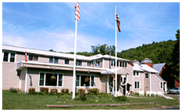
This land is your land, this land is my land. Come and enjoy, bring your family & friends. You don’t have to be a member to enjoy all that LOV has to offer. Be sure to check out Lov on the 3d web site www.3dsofn.org
We are working on getting woodcarvers back the same 2 weeks so many of you can car pool or share rooms. If you have a friend or mate that would like to come and work on another craft such as quilting, woodcarving, or any other craft there is room for most anything. Just check with Bev when you call.
Managers: Beverly and Rick Budrick 457 Big Valley Road Susquehanna, PA 18847
Phone 570-461-3500 http://lov.3dsofn.org vikingland@tds.net
Lov’s new Rates- $65single/n for the 1st 2 night’s lodging then $40 single/n for each additional night. ($10 extra for additional adults) Meals extra.

Vesterheim comes East To LOV
Lois Mueller, Vesterheim Gold Medalist, teacher and writer, will be teaching the Telemark style of Rosemaling this September.

Call Vesterheim to reserve - as classes are limited Classes are 9 am -5 pm with an hour for lunch There will be an additional materials fee for each class that will be paid directly to Lois Students have the option to earn their Cultural Skills Medal for Rosemaling in these classes
Diane Weston - 563-382-9681 dweston@vesterheim.org
September 12 -3 day Beginner class $250 for members
September 15 - 4 day all level class $300 for members

September 23-25 4th Annual Scrapbooking Weekend
Be sure to also call LOV to reserve your room 570-461-3500

DOES FAIR HAVE TO MEAN EQUAL?
Many times when a family is thinking about estate planning they run into a roadblock about the family business. Often one or two of the kids are still active in the operation and want to continue on after their parents have passed.
Let’s consider Ole and Lena who have 4 grown kids and a beautiful farm. Their son Leif is farming with them and wants to buy the farm, but he cannot afford to borrow the money to buy it. His sister Ingrid has moved to the city and is working, married and has children. His brother Lars is a pilot for a private company and loves to be on the go. His other sister, Randi, lives nearby, is married to a farmer and shares the farming duties with her husband Sven on their farm.
Ole and Lena want to be fair to all the kids. They also know that the farm will remain a farm only if it stays in one piece. They worry that if they give each child one fourth of the farm, Leif will not be rewarded for all the sweat equity he has put into the farm over the past 15years.Ole and Lena called their Sons of Norway Financial Benefits Counselor. They invited Leif to join the planning discussion. After a complete financial review, they concluded that a buy-sell agreement between Ole and Lena as sellers and Leif as buyer would keep the farm in one piece and that Leif would eventually own the whole farm. The buy – sell agreement obligates Leif to buy 3/4s of the farm from Ole or from Lena’s estate if Ole passes before Lena. But where does Leif get the money to buy the farm which is worth $400,000? Leif buys a life insurance contract on Lena’s life; she is younger and healthier than Ole. Leif pays the premium and when Lena dies there will be $300,000 in cash to pay to the siblings. Ingrid is happy to get the cash, her kids are off to college soon, Lars likes the money too and Randi and Sven can buy land that wasn’t in the family. This is fair to Leif because he is spending far less to buy the entire farm with life insurance, discounted dollars than if he were to take out a loan for $300,000 or worse yet, have to agree with his siblings on all of their wishes. Mom and Dad are happy with this. They know Leif will be a good steward of the land and feel everyone has been treated fairly. This is one of many types of cases that your Financial Benefits Counselors can help you and your family work through. Call today to have your free financial review and rest easy that your plans can be fulfilled.
Ann Krause, FIC, LUTCF, Financial Benefits Counselor Sons of Norway 701-852-5508 Email: boat@srt.com


********************************************************************************************************
TUBFRIM: Please remember to save used postage stamps for Tubfrim. Please cut the stamps from envelopes with scissors, leaving a 1/4 inch margin of paper around the stamp for ease of handling. Picture post cards should be left whole. Tubfrim also collects used telephone cards. The money realized from the sale of stamps benefits disabled children and youth in Norway.
********************************************************************************************************
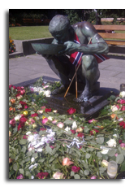
I kveld er gatene fylt av kjærlighet
Tonight the Streets are Filled with Love
In his speech to the people of Norway after the brutal July 22nd attacks, Crown Prince Haakon Magnus thrice affirmed "I kveld er gatene fylt av kjærlighet" (in English "tonight the streets are filled with love"). In no way did he understate the Norwegian people's response. Roses honoring the fallen painted Oslo's streets and monuments. Quickly, white and red roses became a symbol of the city's response to the tragedy, kjærlighet. As the crown prince addressed the thousands of listeners, they lifted their roses in unison to support and honor the victims of the attacks Aside from flowers being an expression of condolences the rose has an extra significance that can be missed by a foreign eye. Arbeiderpartiet’s (the Norwegian Labor Party, the political party targeted during the July 22nd attacks) symbol is a red rose. This, according to Arbeiderpartiet’s website, is a symbol of solidarity and freedom. Though it has varied throughout the years its symbolism has remained steady. For party supporters it has represented the interests of the labor movement and their efforts against material poverty and cultural destruction. During the campaign season, it is expected and common to see Arbeiderpartiet members handing out roses on the streets and even as they canvass door to door. It should be noted that Oslo has not been alone in its sorrow. Norwegians throughout the country, the world and throughout Sons of Norway have united and displayed their support for those fallen in Oslo and at Utøya. Stunning flower memorials and torch parades were organized throughout Norway. Youth from all corners of the country attended the camp at Utøya and the impacts of the attacks were felt in every Norwegian county, city and home. Gifts of flowers, notes and candles covered the exteriors of Norwegian Embassies around the world showing support for Norway and Norwegians. Within Sons of Norway there have been many memorial services and displays of condolences. If you would like to contribute with a memorial of your own, reach out to your local lodge or Norwegian Embassy/consulate general for additional information.

