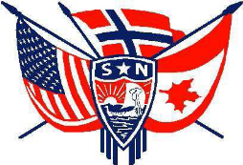

June -August 2011

Third District Today

The mission of Sons of Norway is to promote and to preserve the heritage and culture of Norway, to celebrate our relationship with other Nordic countries, and to provide quality insurance and financial products to its members.

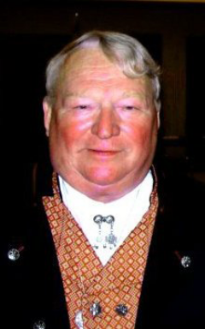
Fra Presidenten
Ralph Peterson
This is the second time I have written to you from Norway but the first from Bergen. I have attended a lot of Syttende Mai parades but none like yesterday. Looking out of our hotel room window at 8am the streets were already full of bunad clad peoples going somewhere. At 10 am we had found a place along the street and started people watching while the parade formed up in front of us. At 10:30 the streets were lined up 8 deep on both sides of the street and the cannons started blasting signaling the beginning of the 2 hour parade. It was a great parade. We actually saw two people we knew but we were so surprised that they were gone before we could yell to them. After the parade we had lunch about one of Norway’s “tall ships”, the Statraad Lehmkuhl. This is a ship that annually calls Norfolk so we did know a few folks onboard including the Captain who was kind enough to have us as his guests. The evening was topped off with a visit to one of the NATO couples we had met during their tour in Norfolk. The rømmegrøut, fenalør, aquavit, Hansa øl and great company as we sat high on a mountain overlooking the city was a great finish to the day and a great start on our trip.
I want to thank all the lodges that completed and forwarded their Lodge Achievement Forms. Not only is it important that each lodge be recognized for their work but the information collected is very important to the SON in maintaining our tax position with the government. I hope we can have more lodges complete the form next year and if for some reason you don’t want to give recognition to your lodge at least fill out the first section of the form as that information is used to help justify our tax status.
One thing that is very important to each of us and to the order is our insurance business. While we have shown some growth in past years we need to expand the number of members holding certificates. Not only is it good for our member’s individual financial futures but each lodge receives a financial return based on insurance participation. This year my lodge got a significant check. We need to make sure our Financial Benefit Counselors get to our lodges and get the information out on the various products we have available and those products coming.
We (D3 and the entire order) are having significant problems with our membership. Our numbers, both in recruitment and in retention, are significantly below last year’s numbers which were not good. We do have some lodges that are doing well so we know it is not impossible. We need to talk to those members who are not regularly in attendance, call those who are about to be removed from our rolls or have recently been removed, increase our recruiting efforts and keep those members in the order who are thinking of leaving. If we each brought in just one member next month it would be phenomenal and it is not that hard to do. I am going to sign up at least one new member in June and I challenge you to do the same. If each of us do this we will not only slow the runaway train down but we will turn it around. Let’s do it. We may have to sign up a family member(I am) to meet this goal but that is fine. Perhaps I will find a new member while heading North on the Hurtigruten. Your new greeting to another D3 member in June should be something like this, “how many new members did you sign up this month”? Just one new member from each of us and we will shortly be in tall cotton!!!!!!!!!
Have a great summer.
Fraternally,
Ralph Peterson, President, District Three, Sons of Norway

Vice President Gail Ekloff
Do you know about Fraternal Funds? Well here is what they are and how to get them.
Fraternal Funds
As per our Charter and Constitution: “Each District will receive from the International Lodge District Fraternal Program Funds to support cultural, youth, and sports related program and leadership seminars.”
Our District distributes Fraternal Funds to lodges which request funds for non-profit activities. To obtain these funds, use the District Fraternal Fund form, available from the District Secretary. Send receipts and a brief description of the event, and return them to the District Secretary. The Executive Board will review the request. If the event qualifies (remember, it must be NON PROFIT) some monies will be sent to help defray the expense for the event. The funds are used for events during the period of January 1st through Dec. 31st.
Some examples of expenses: Floats for parades, buses used to go to cultural events, a cultural performance, or a speaker who comes to the lodge.
Please utilize these Funds!!!! (you can use the form on the website and email it to the secretary)
Your lodge could use these funds to help off-set expenses for cultural events! Culture is what keeps the members interested in Sons of Norway. Members want to learn about their heritage. Tap into the resource's available at the International Sons of Norway Website. Log-in to the website and enjoy the skits, films, music and articles about Norway.
This Fall I would like to try new idea involving all the lodges in the District. I hope to see everyone participate; Information will be coming to your lodges in June!
Have a great summer. Enjoy the weather and visit some other lodge or zone over the summer... most have picnics or special events such as Hummer fest, etc. Also, don't forget all the great happenings at LOV. Alt for denne gangen, Gail
Remember: 2 A’s - Ask & Advertise - to get a member.

2 M’s - Mentor and Mingle - to keep a member.


Don’t forget to:

Kathy Dollymore, 3D Public Relations
check out the blog on the 3D web ste for ideas and notes from your board

This issue of the TDT will comprise June, July and August. Here’s hoping you all have a wonderful summer whether you are traveling, having visitors or just finding a shady quiet spot
to read a good book. Come back in September and bring a friend to share the joys of Sons of Norway. Special Congratulations to all our Graduates and June 19th is Father’s Day- No cutting the grass or “Job Jars” that day. Remember June 14th is Flag Day and a Happy 4th of July – Picnics, Pools, And Parties. Happy Summer…

Many English words actually come from old Norse language – brought by Vikings to England in medieval times. Here are some words you have probably uttered without realizing you are speaking Norwegian!
- Anger – from angr (“trouble, affliction”)
- Bag – from baggi. Norwegians use the word bag today but, ironically, with an English pronounciation. The word has actually been re-imported from English!
- Berserk – from berserkr (“bare shirt”). Fierce warriors who fought without armor (and ate magic mushrooms for courage).
- Crawl – from krafla (“to claw”).
- Dirt – from drit (“feces”).
- Gun – from gunn (“war, battle”)
- Hell – from Hel, the ruler of the Underworld in Norse mythology.
- Hit – from hitta (“find”). Another example of a re-imported word.
- Husband – from husbondi (“master of the house”).
- Knife – from kniv, kvifr. You may have guessed this one already. In fact, any word starting with kn- is probably from old Norse.
- Raft – from raptr (“log”). Today we use the (English) word rafting in Norway when talking about the popular sport.
- Reindeer – from hreindyri. In modern Norwegian: reinsdyr.
- Scare – from skirra (“to frighten”).
- Steak – from steik, steikja (“to cook, roast”). Curiously, the word steak house is common in Norway today.
- Town – from tun, referring to the open space between buildings.
- Ugly – from uggligr (“dreadful”).
Did you know you can find out what is going on in other lodges by clicking on About Us and then lodges on the 3D website. This will take you to the Sons of Norway page which contains all of our lodges. Lodge names highlighted in blue means they have their own website; check out what they are doing and if you are travelling in the area, drop in and say hello!!

Marci Larson District Secretary
Fraternal Funds are Available to Lodges Contact District Secretary for Information
Each year, Sons of Norway Headquarters distributes District Fraternal Program funds. These funds are to support cultural, youth, sports-related programs and leadership seminars. Each District receives $1 per adult dues paying member or $4,500 whichever amount is higher and is based on Dec. 31 membership of the previous year. The activity categories are outlined as follows:
District Cultural Programs are intended to provide cultural activities for all ages. Activities pertain to cultural ideas, customs, skills, arts, etc. and can include rosemaling, woodcarving, ethnic cooking, stitchery, folk dancing, language classes and camps, crafts and other activities that are expressly Norwegian or Norwegian-American in origin or practice.
District Youth Programs are intended to provide youth under the age of 25 with activities that stimulate interest in the physical, intellectual and social aspects of the Norwegian culture. These include junior lodge activities, heritage/language camps, youth sports and recreation events, etc.
District Sports-Related Programs include activities that promote fitness, health, family and social interaction involving all ages such as skiing, hiking, bowling, orienteering and, in general, any activities listed in the Sons of Norway Sports Medal Program.
District Leadership Seminars are intended to provide lodge officers with the means to effectively carry out their duties and give them opportunities to ask questions regarding their responsibilities as lodge officers. Expenses ordinarily include travel, reimbursements for district officers attending the seminar, materials, refreshment costs and rent/locale expenses, etc.

Based on annual funds available, the District 3 Executive Committee develops a budget. The District Secretary facilitates the requests which are reviewed and approved by the Executive Committee with the dollar amount. Requests with accompanying receipts must be submitted following an event that did not make a profit. For questions and to submit a request, contact District Secretary Marci Larson at mlarson@northfloridatpo.com or call at 904-306-7513 or 904-260-4064. For easy access the Fraternal Funds Request form is on the District 3 website under Forms.
Mary Andersen District Counselor
Counselor’s Corner
By Mary B. Andersen, 3D Counselor

In a previous issue of the TDT, I mentioned that April would be the month for the annual Charitable Trust fund raiser. The logistics of getting the mailing out the door obviously made it impossible for the letters to go out in April; but by the time you read this column you will have either already received the letter or you will receive it shortly. In an effort to reduce expenses, there will be one letter per household.
I was able to march in the 17th of May Parade in Brooklyn (my home town) again this year, it was a great event and it was well attended despite the threatening weather and as always Brooklyn pizza can’t be beat. I join Fredriksten Lodge on their bus into Brooklyn each year; they are a great group who will be celebrating their 100th anniversary next year. On the bus ride back I looked through the 17th of May Parade journal and my attention was drawn to a poem by Ralph Waldo Emerson titled The Meaning of Success:
“To laugh often and much; to win the respect of intelligent people and the affection of children; to earn the appreciation of honest critics and endure the betrayal of false friends; to appreciate beauty, to find the best in others; to leave the world a little better; whether by a healthy child, a garden patch or a redeemed social condition; to know even one life has breathed easier because you have lived. (Italics added) This is the meaning of success!”
2011 marks the 40th anniversary of the founding of the Charitable Trust. Over these 40 years the members of the Third District have achieved Emerson’s definition of success because your contributions have made the lives of your fellow Third District breathe easier.
The Charitable Trust and its beneficiaries depend on your generosity; so if you are able, please contribute to our annual fund drive, remember that no contribution is too small.
Thank you!


********************************************************************************************************
TUBFRIM: Please remember to save used postage stamps for Tubfrim. Please cut the stamps from envelopes with scissors, leaving a 1/4 inch margin of paper around the stamp for ease of handling. Picture post cards should be left whole. Tubfrim also collects used telephone cards. The money realized from the sale of stamps benefits disabled children and youth in Norway.
********************************************************************************************************
ZONE NEWS
ZONE 1: Kris Rasmussen Director
ZONE 2: Judy Mack Director
Spring in Zone 2
In April Zone 2 had their Memorial Service and Spring Zone meeting in South Windham, CT. Rev. Nilsen conducted the service with recognition of all who had passed in the zone.
Syttende Mai was celebrated throughout the zone. Maine Nordmenn had an outing and parade at Pineland, New Gloucester, ME. Hartford Lodge was joined at their Children’s Day by Skaugum Lodge for a parade, speeches, children’s games, and vendors. They were accompanied by the Windsor High School Brass Choir. They also had a Norwegian Faering Boat and two “Vikings” in attendance. Norumbega Lodge sponsored a bus to the Brooklyn parade, a Syttende Mai dinner, and a children’s day.
Mike Arnum, an arborist at Tower Hill Arboretum, shared with Norumbega Lodge members a powerpoint presentation comparing plant life in Norway and New England.
Mark your calendars for these coming events;
Skaugum Lodge - Ice Cream Social
Hartford Lodge - Ice Cream Social
Norumbega Lodge - June 3, will honor their scholarship recipients.
Maine Nordmenn Lodge - June 4, will participate in a Cultural/Heritage Festival in Berlin, NH and June 25, will . have a Family Outing at Sebago Lake. JULY 30, WILL HOLD THEIR FAMOUS HUMMERFEST ON BAILEY . ISLAND, MAINE.
Wishes to all for a restful summer and rejuvenate for the fall.

Zone 3: Barbara Bensen, Director
ZONE 3 TIDBITS
Two of Noreg Lodge members and I attended the 40th Anniversary Dinner/Dance of Nansen's Junior Lodge. About 80 plus people joined in the festivities of the evening. I must say, those Nansen members love to dance because the dance floor was in constant motion. Perhaps, it was all of that "Oldies But Goodies" music the band played!!! Hats off to the cooks! The food was delicious and the three of us enjoyed the evening.
Kudu's to the Bernt Balchen members who participated in the 10 mile cleanup of the Towpath along the Lackawaxen River. They worked side-by-side with the Men's Club of Bethel Lutheran Church and the Lackawaxen Conservancy. After the cleanup, everyone enjoyed lunch at the Rowland Cafe in Rowland, PA. A great "Adopt - A - Highway" effort. Their Reading Circle just finished and discussed "Growth of the Soil" by Knut Hamsun, and everyone gave it a thumbs up.
Wow! June already!! It's time to roll out those lazy hazy days of summer, the days of soda, pretzels and beer. Do the words sound familiar? Of course they do! What does June mean? Longer days, picnics, vacations, and no more school. And don't forget our Graduates and Father's Day. June also has another important day, Flag Day - June 14th. Let's wave OUR FLAG proudly for our country, the U.S.A. because:

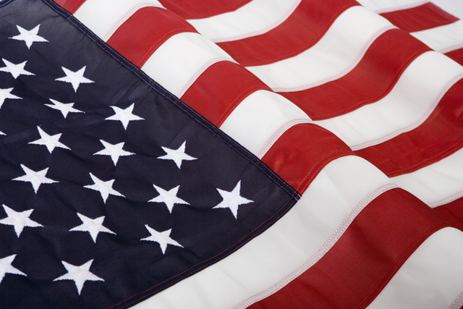
Tossed by the wind against the blue sky, the flag of our country waves gently on high. Long, long ago when our country was new, men thought up this flag of red, white and blue.
They thought of the stripes and the field of blue, with the white pointed stars that shine brightly through.
They gave us this flag for all to see, it stands for our country the land of the free.

Be safe, and enjoy your summer. Congratulations to all of the Grads and Happy Father's Day to all of the Dads.
ZONE 4: Karin Gudbranson McCadam, Director
Welcome Spring and Summer! The warmer weather came just in time for those of us in Zone 4. We are grateful, even though many of us suffer with allergies – so we take the good with the bad! This spring I was privileged to visit Scandinavian Heritage Society, Fram, Troll and Norsemen Lodges. If you have the opportunity to visit an upstate New York lodge, you can be assured of a warm welcome, great cultural activities and delectable food with good coffee. On Saturday May 14th fifty people defied heavy rain to meet at Land of the Vikings for the 17de Mai celebration. Members from Scandinavian Heritage, Fram, Troll, Oslo and Norsemen lodges in New York and from Bernt Balchen in Pennsylvania were in attendance. We happily welcomed a visitor from Cooperstown, New York who brought her mother from Oklahoma (originally from Norway). Janet Boye (Norsemen) brought a cousin visiting from Norway!
Children and women wore traditional bunads and festdrakts. Many adults wore Nordic colors, Nordic inspired T-shirts or beautiful Norwegian sweaters. Despite a downpour, a few brave souls with flags, lodge banners and umbrellas gathered near the pond for a photo opportunity. Once inside again, the 17de Mai Proclamation was read by Rev. Eddie Nelsen (Bernt Balchen) before we sang Ja Vi Elsker.
There was much laughter, a few tears and some delightful surprises (three people discovered they are shirt-tail relatives) as members took turns stating their Norwegian family names and the areas from which they and/or their relatives came from in Norway. We were very happy to recognize all members who have belonged to Sons of Norway for 5, 10, 15, 20, 25, 30, 35, 40, 45, 50, 55 years each and three people who have belonged for 57 years each!
After an indoor picnic and ice cream, the fun continued. Some learned to write their names in Nordic Rune, while others translated Norwegian sayings. Everyone participated in an amusing parlor game with a winner at each table. Then two teams had 5 minutes to use plastic tableware and tablecloths, raffia and cardboard to transform two team members into fierce Vikings. It was a hilarious activity and you can imagine their surprise when each player was awarded a one million dollar bill for their participation! It was so much fun.
In June, July, and August, Zone 4 lodges are busy with picnics, pig roasts and parades. As always, come join us. You are Velkommen.

ZONE 5: Gail Martinsen, Director
Here in Zone 5…
The month of May started off with a special celebration! On Sunday, May 1st, Gulfstream celebrated their 40th Anniversary. They had a roomful of members at the event. Several of their members have been in Sons of Norway over 60 years! In attendance as guests were myself, my husband Ron, Marci Larson, 3D Secretary, Kent Larson, President of Gateway to Florida and Janet Carlin, President of Space Coast Vikings. President, Ingrid Hammen and her officers made us all feel welcome. It was a very pleasant Day! Suncoast members went to the ball park this month. About 12 of their members attended a game at Brighthouse Field for a fun evening! Many of our Florida Lodges celebrated Syttende Mai at their meetings. Gateway to FL celebrated with a delicious dinner of frikadeller (Danish meatballs), lingonberries, etc. and krumkake with whipped cream & berries for dessert. Their member, Eileen Erikson spoke about her experiences writing children’s books. She, also, had some of her published works on display. After which the members were entertained by their choral group the Viking Voices and members danced around the May Pole. Scandia had a delicious Scandinavian dinner at a local Clubhouse. One of Scandia’s members, Norman Reinertsen is the Great-Grandson of Theis Jacob Thordkildsen Lundegaard. He was one of the Fathers of the Constitution of Norway!!! Vikingworld served a pot luck dinner for Syttende Mai, after which they had a presentation on the History of the 17th of May. Norseman Harbour served sandwiches and desserts for the 17th of May and everyone dressed in red, white and blue. Tampa Bay served hot dogs wrapped in lefse, salads and delicious desserts for the day. After the meeting they had a special speaker, Brigadier General Per Arne Five, a Norwegian Coalition Officer stationed at MacDill. He spoke of the history of Norway from before the Vikings to present time. His presentation was very interesting, informative and inspiring. Sun Viking’s members enjoyed open-faced sandwiches and wonderful desserts for their Syttende Mai celebration. After the meeting the children and many members participated in a Syttende Mai parade with flags flying around the room. This weekend Suncoast will host their Annual Syttende Mai Regatta. Hopefully we will have great weather for the day! All of the Florida lodges look forward to this fun weekend. It is a good place to meet many members of the other lodges. This Sunday we will have our Zone meeting. Have a very Happy Father’s Day!!
ZONE 6: Carol Goral, Director Our zone has had many activities to celebrate Syttende Mai. Bondelandet, Nordkap, Restauration, and Washington have celebrated with picnics in their areas. Fredriksten took a bus to march in the Brooklyn Parade. The weather was cooperative during the parade but much of the day was rainy. It did not take away from the festivities. Mary Andersen, District Counselor joined us and marched with the district officers. Fredriksten took first place for marching. After the oparade a party was held in their lodge hall. Authors have been a big part of our cultural activities. Jorgen Flood was at Restauration and Fredriksten with his two historical fictions about the Vikings (“To Live and Die in 1030” and “The Twilight of the North: From Byzantium to Stamford Bridge”. They are great reading and very interesting. Washington will host Ms Berman, author of," We are going to Pick Potatoes," a story of a Norwegian family during the war. These events have been well attended and enjoyable. All our lodges are planning summer activities and events to keep our members busy and happy as the summer season arrives

ZONE 7: Edward McCarthy, Director
Greetings from Virginia Beach!
This has been a busy time for the lodges within zone seven. Everyone is looking forward to the summer with all lodges planning a summer picnic. Southern Star #639 has a joint celebration of Syttende Mai with Norsk Carolina #679 on May 15th. It will have all the traditional summer picnic food along with a celebration of all thing Norsk. This will be in addition to the lodge barbeque on the 8th of May.
Norsk Carolina #679 had a Norwegian celebration of Easter with traditional holiday foods. They will have their joint picnic with Southern Star #630 on the 15th of May. Members are also given the chance to attend a concert by the Charlotte Symphony featuring the works of Grieg and Sibelius. The lodge will be hosting a "Going-Away" party for past president Carol King who is moving to Norway. Carol has been a spark plug for her lodge and I know that we will all miss her but wish her all the best in this new phase of her life.
Blafjell #646 will be taking part in their local fair called "Local Colors" The lodge will have a booth which will highlight Norwegian Culture including a wide variety of baked goods done Norwegian Style. The booth will also have a section dedicated to recruiting. This is a prime way to make the lodge known to the general public and hopefully result in new members. The lodge will also have a beginers Folk dance class in June. The lodge picnic will be on St Hans Day and will feature Norwegian dance and music.
Hampton Roads #522 has been busy with a variety of activities. Membership pins were awarded to several members ranging from five years to 40 years in membership. The lodge received a Certificate of Appreciation from the City of Virginia Beach for its Adopt-A-School program. The lodge took part in the annual Norwegian Lady Ceremony and reception and had the lodge singers perform during the Sister Cities ceremony as part of the Japanes Cherry Blosson Festival in Virginia Beach. On 16 April the lodge participated in the International Childrens Festival in Hampton, Virginia staffing a booth which featured Norwegian culture. It was estimated that about 7000 people attended the festival and the lodge booth was very busy. Lodge members also attended the NATO Flag Raising Ceremony honoring Norway and then marched with the lodge float in the Norfolk,Virginia NATO Festival Parade. The lodge book club is now well underway and finally, the lodge picnic is scheduled for the 23rd of July after which a rest is much needed.
Have a great summer and come back in the fall ready to have another banner year for the Sons of Norway!

ARE FRATERNAL BENEFIT SOCIETIES STILL REVELEVANT?
A recent article in a life insurance journal written by Joseph J. Annotti, discussed fraternal organizations. I feel that our members could use a reminder on what makes us unique.
Fraternals, created over 100 years ago were originally meant to help the USA’s large number of immigrants unite through their common bond. In Sons of Norway’s case this was ethnicity. They were to solve common problems, the biggest one being helping families financially if the bread winner died.
Over time, fraternals evolved. Members became more successful and grew into the nation’s middle class. Today the need to take care of our own has broadened and the over 9 million members are some of the best volunteer networks in the country. Yearly 91 million hours of volunteer hours and $400million go to help local communities and people through community service projects.
The increasing role fraternals play in providing life insurance, annuities and other financial benefits to their members (to the tune of $363billion) still harkens back to the early mission of taking care of each other. The fraternal bonds are still strong and very relevant in today’s America. We can be proud to be part of Sons of Norway and continue on in the dreams and goals of our immigrant forefathers.
Ann Krause, FIC, LUTCF, Financial Benefits Counselor
Sons of Norway 701-852-5508 Email: boat@srt.com <><><><><><><><><><><><><><><><><><><><><><><><><><><><><><><><><><><><><><><><><><><><><>
Third District - Norway Trip Fund Raiser:
Raffle Tickets now on sale to win a Hurtigruten cruise to Norway later this year.
support this District Three fund raiser by contacting your President or Zone Director
The winning tickets of the two winners will be drawn, July 15, 2011, at the Land of the Vikings camp.
A single ticket costs $ 5.00.
A book of five tickets costs $ 20.00
Checks preferred, payable to "District Lodge # 3 Sons of Norway"
The Hurtigruten cruise company has donated two trips of a cabin for two people on either the seven day northern voyage from Bergen to Kirkenes or the six day southbound Kirkenes to Bergen trip.
The winners need to travel between October 1, 2011 and December 14, 2011. Each of the two trips has an approximate value of $2,000.
Diane Eiker, Main Nordmenn Lodge # 3-664 Secretary, was one of the previous Hurtigruten trip winners in 2009. A copy of her account of her trip is posted on the Third District blog website http://3dsofn.org/blog/?p=268.

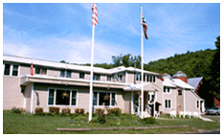
This land is your land, this land is my land. Come and enjoy, bring your family & friends. You don’t have to be a member to enjoy all that LOV has to offer. Be sure to check out Lov on the 3d web site www.3dsofn.org
We are working on getting woodcarvers back the same 2 weeks so many of you can car pool or share rooms. If you have a friend or mate that would like to come and work on another craft such as quilting, woodcarving, or any other craft there is room for most anything. Just check with Bev when you call.
Omholt Reunion June 17-19
Berntsen Reunion June 17-19
Youth camp July 4th –10th And 11th-16th
Applications on line http://3dsofn.org/forms/documents/youthcampapplication.pdf
Fly Fishing Camp July 18-23rd
Sports for health July 24th –31st

If you have information you would like to see in future LOV letters for your event please contact me
Sally Abrahamson uffdamobile@yahoo.com
Land of the Vikings 1st Lobsterfest June 3-5, 2011
Stay for the weekend and the Lobsterfest is included in your food package. The Lobsterfest will be held on Saturday the 4th at 1:30 Meal will include potato, corn on the cob, salad and rolls and of course dessert
Extra Lobsters will be $10 each Don’t eat Lobster? Ask for a steak or chicken on the BBQ Hot dogs and Hamburgers available for the kids Take advantage of our extra day rate ($40/n + $10 extra adult) and
come a day early or stay an extra day Please make your reservations early and let Bev know if you want Lobster, (and how many) Steak or Chicken Also how many adults or kids are coming
Managers: Beverly and Rick Budrick 457 Big Valley Road Susquehanna, PA 18847
Phone 570-461-3500 http://lov.3dsofn.org vikingland@tds.net
Lov’s new Rates- $65single/n for the 1st 2 night’s lodging then $40 single/n for each additional night. ($10 extra for additional adults) Meals extra.
Vesterheim comes East To LOV
Lois Mueller, Vesterheim Gold Medalist, teacher and writer, will be teaching the Telemark style of Rosemaling this September.

Call Vesterheim to reserve - as classes are limited
Diane Weston - 563-382-9681 dweston@vesterheim.org
September 12 -3 day Beginner class $250 for members
September 15 - 4 day all level class $300 for members
Be sure to also call LOV to reserve your room 570-461-3500
Classes are 9 am -5 pm with an hour for lunch There will be an additional materials fee for each class that will be paid directly to Lois Students have the option to earn their Cultural Skills Medal for Rosemaling in these classes

PICTURES: WHO WE ARE AND WHAT WE DO

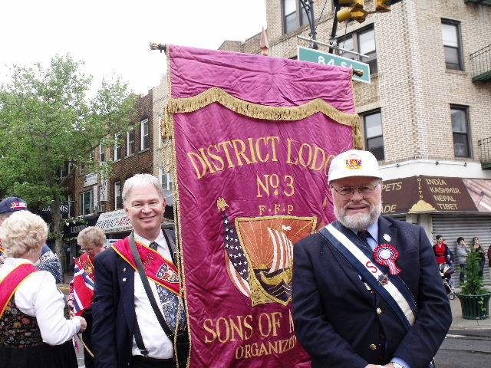
District Three Board Member Peter Vatne carries the Banner while International Secretary Audun Gythfeldt gets ready to march in Brooklyn, NY. "Hipp, hipp, hurra" for Syttende Mai!!!!!
15 lodges from the Third District marched in the Parade.

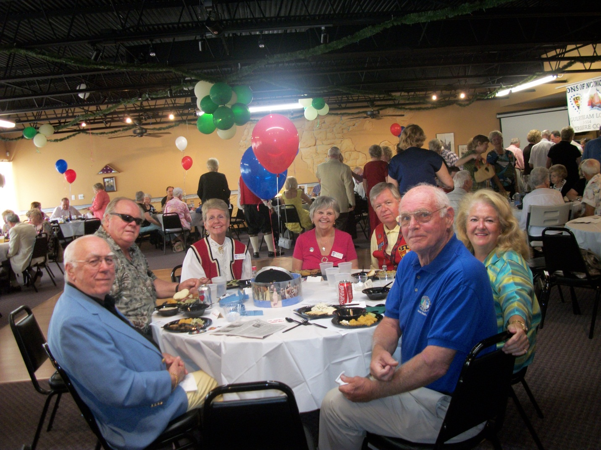

Gulfstream’s 40th Anniversary Party – From Left - A Gulfstream member - Ron Martinsen, Sun Viking Editor - Gail Martinsen, Zone 5 Dir. - Marci Larson, 3D Secretary - Kent Larson, President, Gateway to FL- Sally Burkwist, Gulfstream member and Tom Evinrude – Gulfstream member & Grandson of Ole Evinrude.

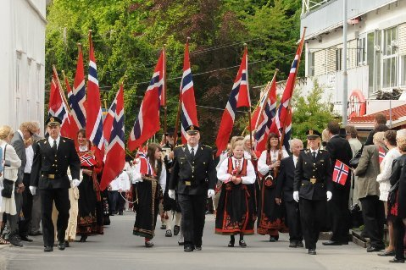
Thanks to Barbara Bensen
"SYTTENDE MAI GREETINGS FROM KRAGERO, NORWAY"
Sonja Bensen, spent time in the sourthern part of Norway researching family history. The journalist, who helped with her research in Kragero, sent these Syttende Mai celebration photos to her.

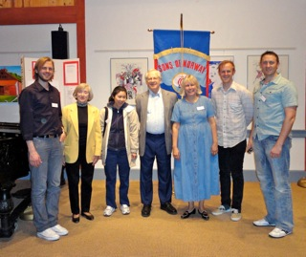
Norumbega's initiation of new members on May 6th. Pictured in front of the lodge banner are: Eleanor Weintraub, Judith McCarthy, Suhjak Moy, Alan Lokensgard, Kyle Henricksen, Karl Henricksen, and Craig Henricksen

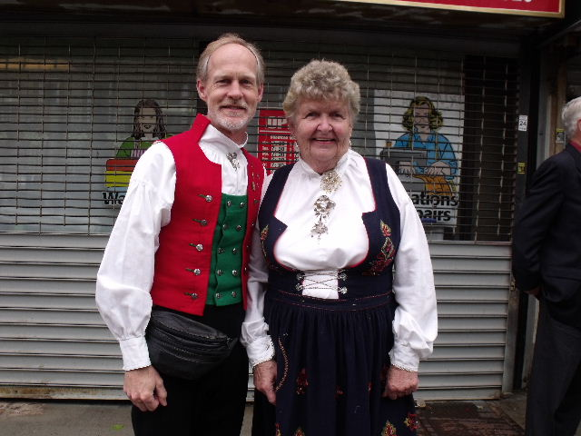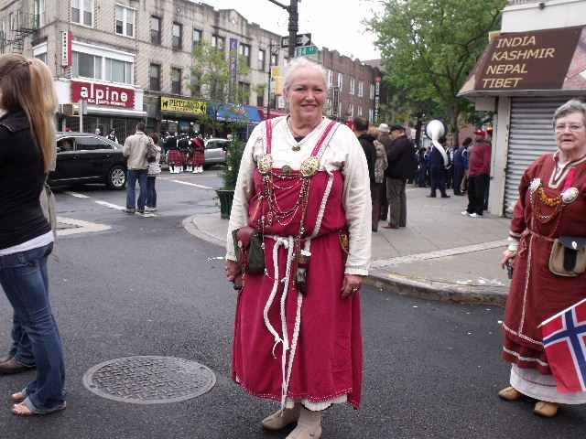
Syttende Mai Parade in Brooklyn

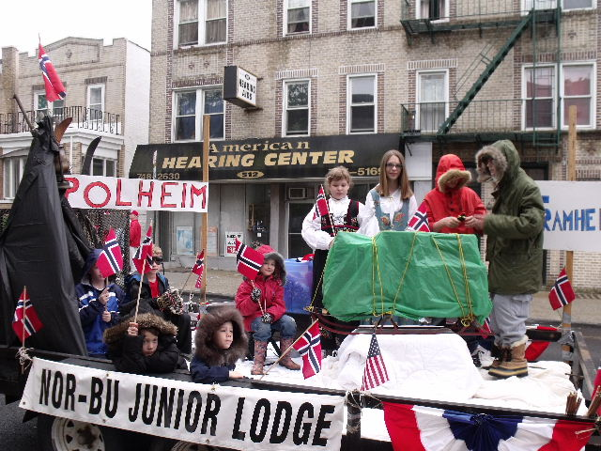
The parade theme “Honoring Roald Amundsen” was proudly
demonstrated by the Nor-Bu Junior Lodge

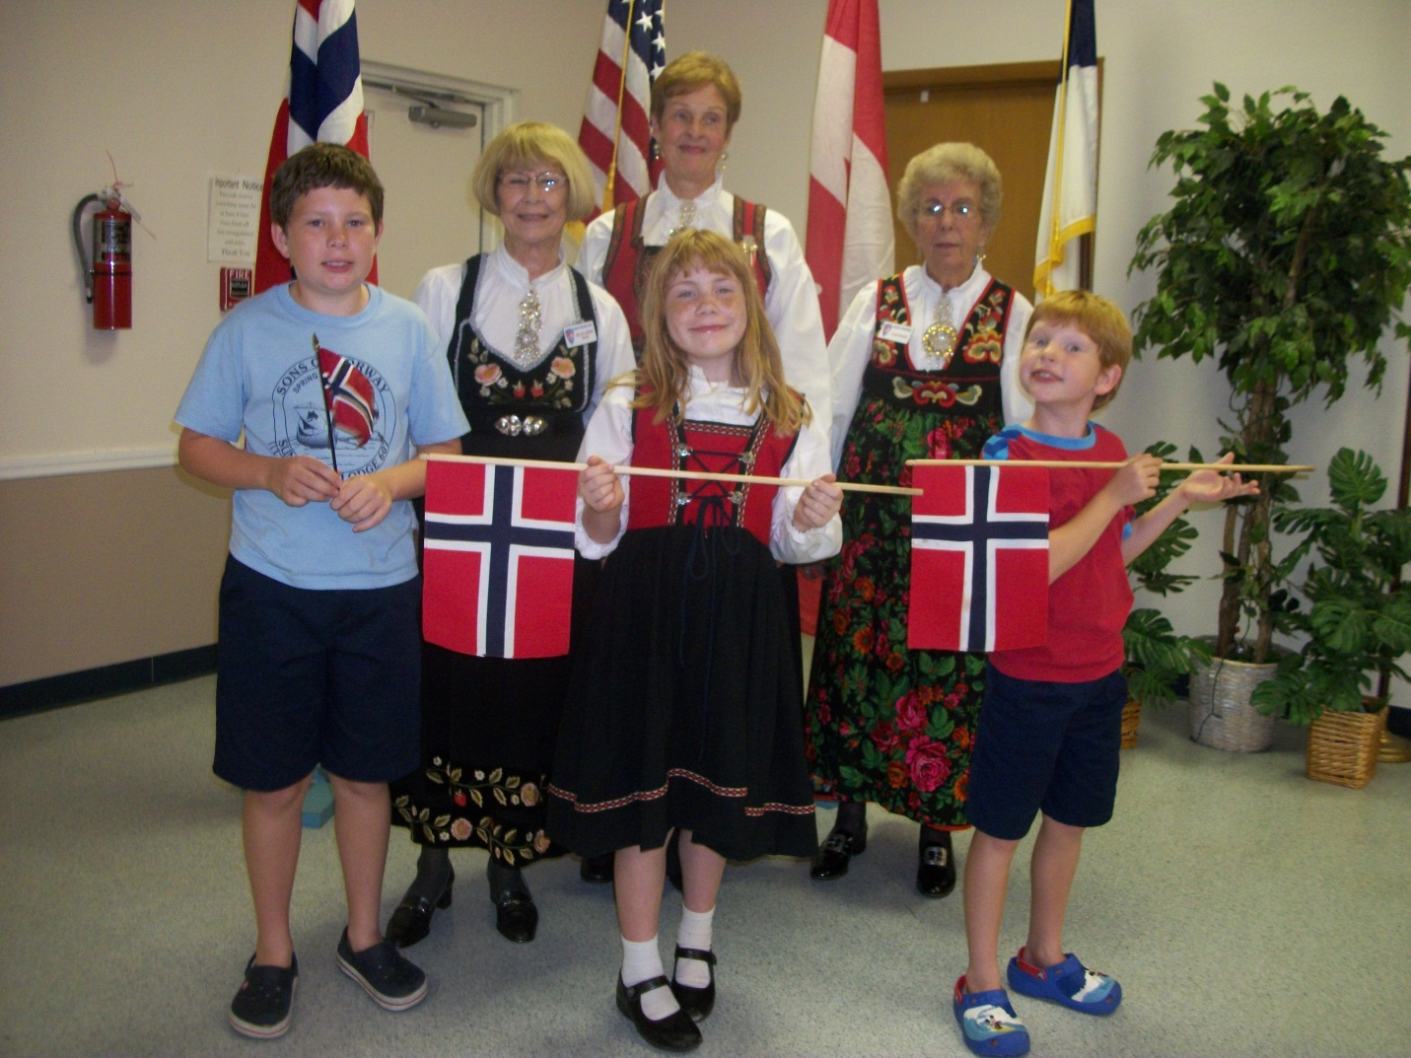
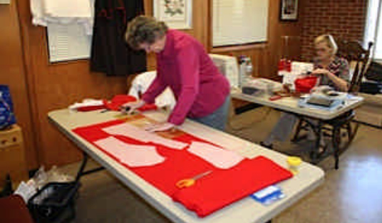
Else Grady cutting out her new Folk Costume at the workshop

Britt, Mette and Ellen in Sandefjord, Norway at the Syttende Mai Parade
Sun Viking’s Syttende Mai celebration – From Left: Christian Welsh, Nellie La rson (President), Olivia Haaland, Erin Link (in front), Clair Eriksen and Lukas Welsh

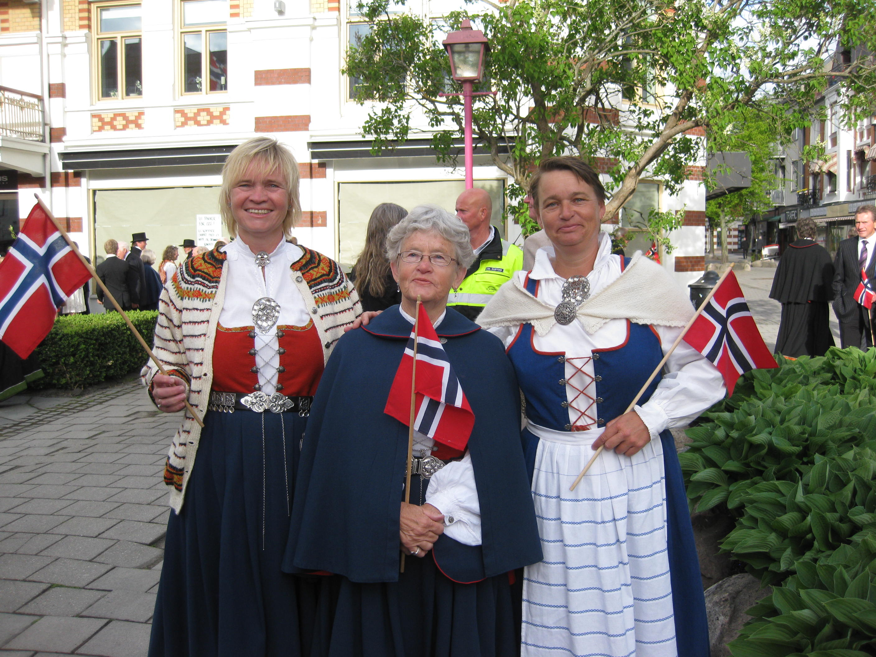

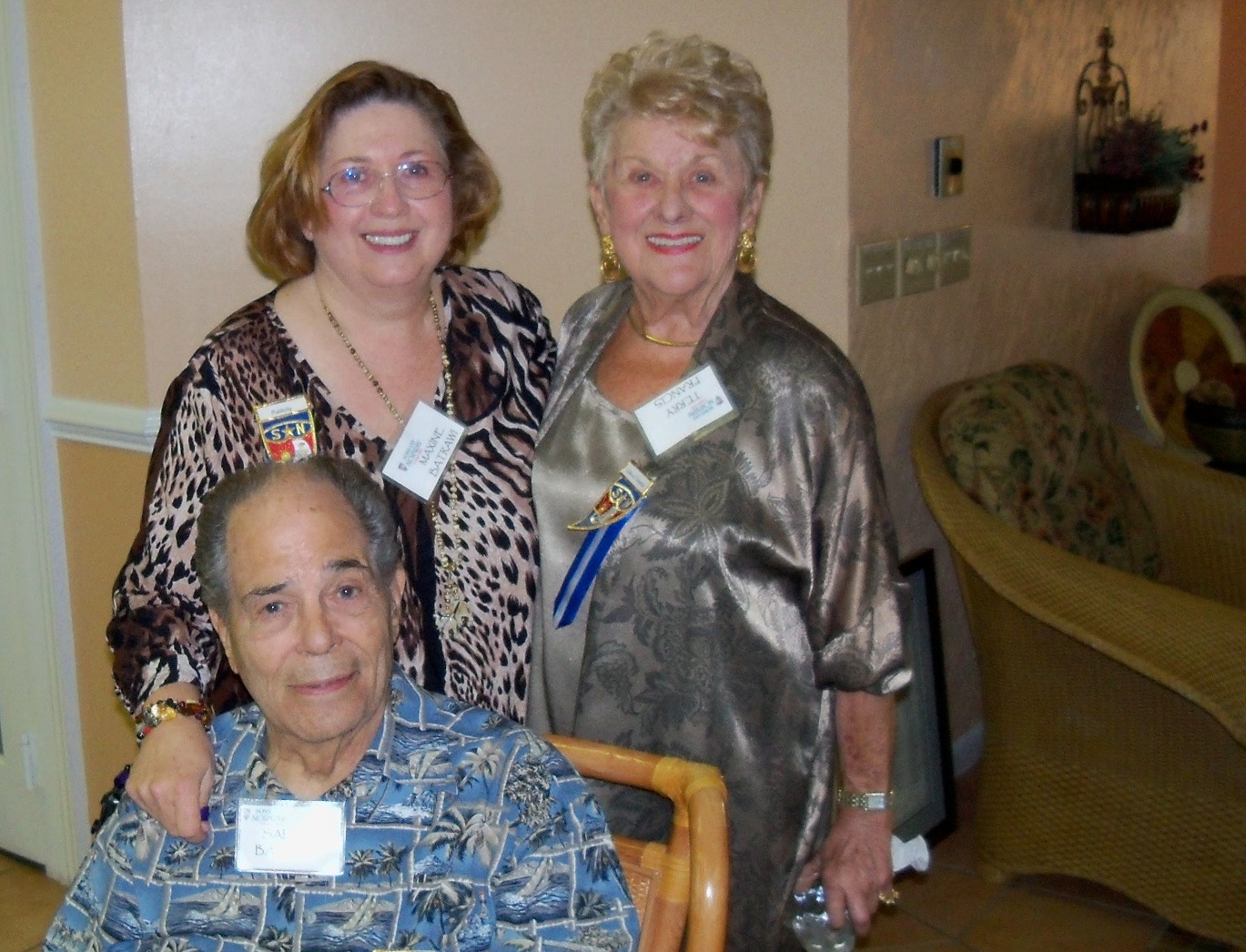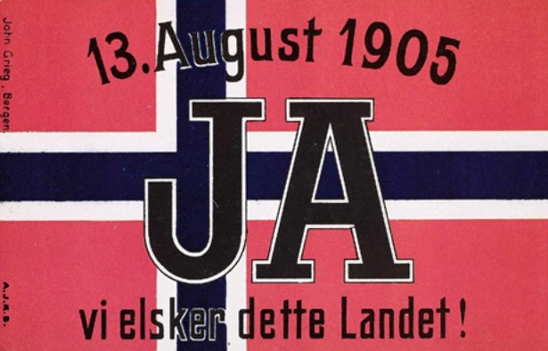
Salah Batrawi, Marshall, seated, Maxine Batrawi, Publicity & Terry Francis, Woman of the Year Sons of Norway
3-683 Gulf Coast Vikings

