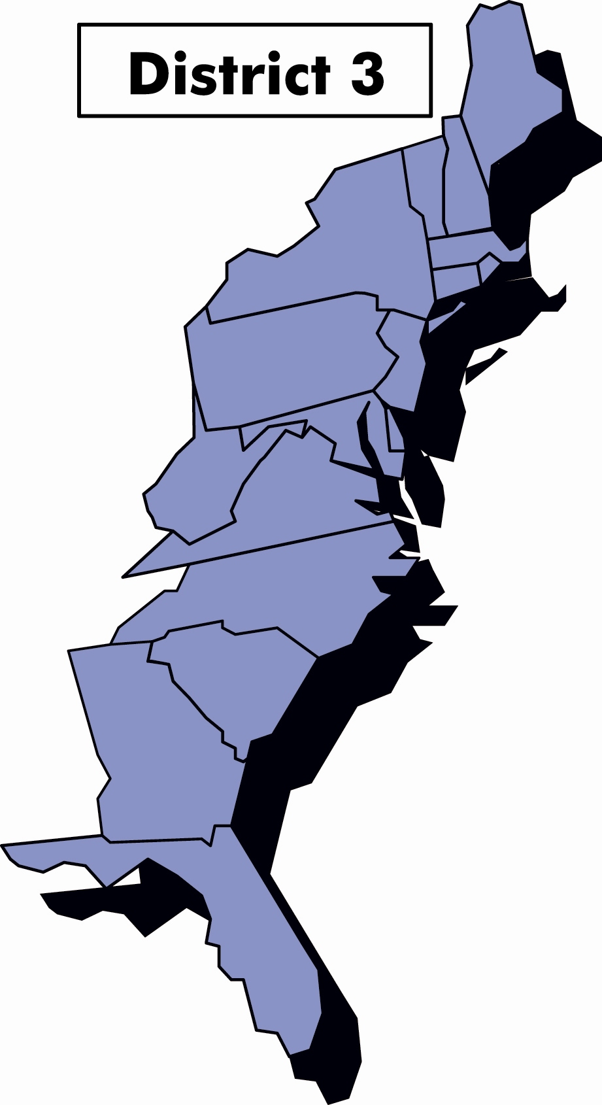
God jul og godt nyttår!

December, 2008

Third District Today

Fra Presidenten Ralph Peterson

Hei Alle Sammen,
This has been a couple of exciting weeks for me. I conducted my first District Board Meeting and attended my first District Council Meeting in Minneapolis.
While the meetings are a bit different both in location and scope, there is one distinct similarity and that is fraternalism. The new friends you meet at these meetings and those friendships that you renew are one of the best things about the SON and we have many reasons to be proud. While I know that we have great friends and fellowship in our local lodges, I encourage you to reach beyond our local lodges and enjoy the friendship and fellowship that is found through the entire order.
Many of you have asked about the 2009 Høstfest trip. Thanks to the oil boom in North Dakota, hotel rooms are in short supply in Minot all year and during Høstfest even tighter. We were unable to get enough hotel rooms so we will try for another year.
Our Publicity Director has put together a RFP (request for proposal) to develop a new District Website Site. Four companies have responded and we have a committee in place that will review the proposals. We have also received some great advice and help from headquarters on this project. We hope to have the new website on line during the first quarter of 2009.
Inside This Issue

President’s message
Vice President’s message
Financial News
Our Secretary Says
Foundation News
Publicity
International Insights
LOV
“In the Zone”
Events

We have news concerning the 2010 District Convention, Restauration and Fredriksten Lodges submitted a bid to host the 2010 Convention. The District Board has accepted their bid and the convention will be held in Harrisburg, PA June 7-13. It looks like an excellent facility and we look forward to a great convention. More information will be posted on our website as it becomes available.
The 2008 convention committee announced that they will be donating money from their convention profits to both the District Lodge and the Charitable Trust. In addition money was raised for the Foundation. On behalf of all I would like to thank the two lodges for their generous donations.

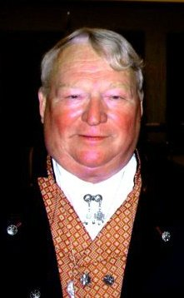
The International Board announced that the 2012 convention will be held in Fargo, ND. In addition, the International Board announced three goals for the period 1 July 2008 to 30 June 2010:
1. Increase net membership of adult and juvenile members.
2. Reduce the number of members leaving voluntarily.
3. Add 750 benefit members
The District goals will be announced shortly.
I hope that all your bazaars went well; if there was something special about your bazaar please share it with the rest of us.
It is amazing but the Christmas season will soon be with us. By the time you get this message Thanksgiving will most likely have come and gone. If AnneGrete and I don’t see you before the end of the year we would like to wish you all a most happy and joyful Christmas and a most prosperous New Year
God Jul
Ralph Peterson
President District 3

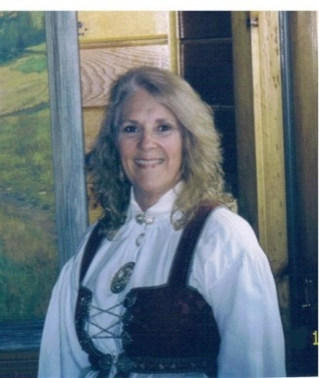
Fra Vise Presidenten Gail Ekloff

District Membership Committee Goals

The District Membership Committee consists of me, Kris Rasmussen - Zone 1 Director, Judi Mack - Zone 2 Director, and Arnold Johnsen - Zone 4 Director. Consistent with the International’s goals, we have decided to focus on the following goals for the Third District:
- Retention of members leaving voluntarily and
- An active Membership Committee in 70% of the Lodges

Let’s look at each of these goals more closely starting with member retention. Although the District Committee didn’t assign a percentage to goal #1, I hope each lodge will reduce this number by 5%. Membership involves more than just obtaining new members; it means concentrating on retention of current members. Monthly reports are sent to each lodge informing them of members who have not renewed their membership. The Financial Secretary and the VP should be contacting these members to remind them to renew; if the member chooses not to renew, try to find out why. This will give us an idea of why they are leaving and where we have to improve.

For goal #2, a list requesting each lodge’s Membership Committee was sent to all Lodges providing the District VP a contact person in each lodge. When developing your lodge’s Membership Committee, have both new and “time honored” members on the Committee. In this way you get a good representation of your lodge members, plus both new and veteran members feel like they are a part of the lodge’s future. Have the Membership Committee work with the Social and Cultural Directors to have a “mini presentation” at your meeting. Members enjoy learning about their Scandinavian Heritage and Culture. Be sure to let the District Membership Committee know what presentations your members liked so we can share them with other lodges throughout the District.

Together we can make the order grow and become stronger. Please feel free to contact any Membership Committee member with your questions or ideas.

Rolf and I wish you all a God jul og godt nyttår’

Alt for denne gangen,
Gail

Financial News
By Sverre Aasgaarden, Financial Benefits Counselor
WHY PURCHASE INSURANCE AND ANNUITY PRODUCTS FROM SONS OF NORWAY?
Whatever stage of life you’re in, Life Insurance can help secure your family’s financial future. If you are like most people, you probably don’t know how much Life Insurance you need or what kind you should buy. Because everyone’s needs are different, the best way to develop a plan that’s right for you is to talk to your Financial Benefits Counselor. Proper planning can generate a secure financial future for you and your loved ones, no matter what happens. Call your Sons of Norway Financial Benefits Counselor for more information.

Our Secretary Says
By Marci Larson

It's that time of the lodge year when we are concentrating on elections, installations, updating our officers list and submitting the appropriate 990 form to Sons of Norway. For our District 3 lodges, I want to remind you to notify me about your installation needs so a district officer can be assigned as your installing officer if requested. In order to schedule district officers, I would appreciate your providing the pertinent information on the form I e-mailed to you in mid-October. Make sure you update your officers list, which can be done on line or using the D63 form and then submitting to SON. It's extremely important to get this handled. In addition, the form to apply for Fraternal Funds has been updated so if you need a copy please let me know.

Foundation News
Your Sons of Norway Foundation is doing great things. Donations from our members and lodges play an important role in keeping us growing to provide more and more offerings.
Our five scholarship opportunities and three grants are allowing us to fund students and programming designed to showcase our unique Norwegian heritage and culture to wider audiences.
Visit www.sonsofnorway.com and click on Foundation to see where your donations are making a difference.
Cindy Olson
Director
Sons of Norway Foundation
Grant opportunities
What is your lodge planning for 2009? Perhaps you will be participating in a community festival, offering a special cultural activity, doing an Adopt A School program, or doing some other exciting lodge or community activity. If so, check out the Sons of Norway Foundation for grant opportunities. Lodges may apply for three grants. Find out about grant requirements and application procedures at www.sonsofnorway.com/foundation

Sons of Norway Foundation Scholarship & Grant Applications Deadline
All applications must be post-marked by the following dates, no exceptions:

General Heritage & Culture Grants due January 15th
Helping Hands to Children Grants due February 1st
Local Lodge Partnership Grants due April 1st
Astrid Cates/Myrtle Beinhauer Scholarships due March 1st
Oslo International Summer School Scholarships due March 1st
Nancy Lorraine Jensen Memorial Scholarships due April 1st
King Olav V Norwegian-American Scholarships due March 1st
Tronvold Norwegian Folk High School Scholarships due March 1st

All the qualifying information for grant and scholarships as well as the application forms for each are updated by November 1 annually. Please use the most current application form which is available on our web site at www.sonsofnorway.com/foundation. Scholarships and grants are

awarded in the spring. Students should be thinking a year ahead. Grants are for upcoming events and are to be spent within one calendar of receiving them. For questions email foundation@sofn.com or call Cindy Olson, Director, Sons of Norway Foundation at 1-800-945-8851.

Publicity
by Mary Andersen

It’s time for the annual newsletter contest! Publicity Directors and newsletter editors watch your emails; you will receive more information shortly!

Remember – when submitting pictures for the Viking, please send them via email to publicity@sofn3d.org. Digital photos at a very large scale, with low pixel resolution are acceptable for use in Viking (e.g. 21” X 28” at 72 dpi). Smaller scale photos with higher pixel resolution can also be submitted (e.g. 3” X 5” at 300 dpi). Photos taken and saved at a small size with small resolution are not useable (e.g. 3” X 5” at 72 dpi)

Extract from a local lodge newsletter
One benefit of being Public Relations director is having the opportunity to see many of the great newsletters prepared by all of you! The following article was copied from The Strand; the newsletter for members and friends of Sons of Norway Southern Star Lodge #630.

The wooden Viking lur
The earliest references to a wooden instrument called the lur come from Icelandic sagas, where they are described as war instruments, used to marshal troops and frighten the enemy. These lurs, several examples of which have been discovered in longboats, are straight, end-blown wooden tubes, around one meter long. The viking lur parts were held together with willow rings.

At Oseberg, Norway they found a grave with a Viking ship. Excavated in 1904, the 21.5 metres long Oseberg ship is the most magnificent of the Viking ship finds. The ship can be seen at the Vikingskiphuset in Oslo. In this grave find there was a wooden lur, 1 meter long in 2 parts (longitudinal). From literature one can guess that the lur has been used as a war instrument. The Oseberg instrument dates back to 850 A.D. In 1996 a lur made of wood was found in Herning, Denmark that dates back to the Viking age.

The shepherd's or dairy maid's lur:

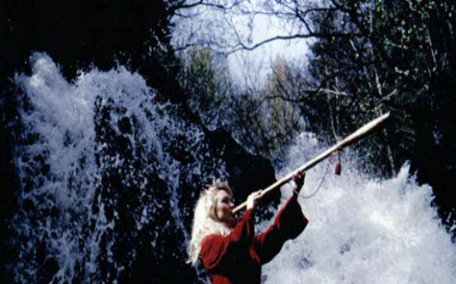
A lur similar to the Viking war instruments has been played by farmers and milkmaids in Nordic countries since at least the Middle Ages (probably longer). These lurs were used mainly for calling cattle, communication and signaling - it was the instrument of the dairy maid. In Norway these lurs are called Neverlur (Birch bark lur).

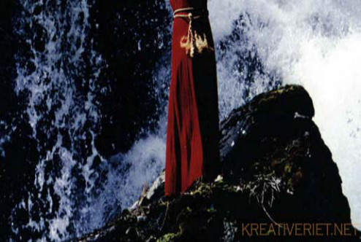
The neverlur is an overblown instrument with no finger holes. Within a range of 7-8 notes one can play simple songs and signals. The instrument is made from two long halves (pine or fir) which are hollowed out and glued together, then smoothened on the outside and wound with birch bark. The longer the lur, the easier it is to produce notes higher up in the harmonic scale.

The main difference between the Oseberg Viking lur and the shepherd's lur today is that the last one is held together with birch bark. But older lurs were held together by willow rings, often 5 rings.

The lur used today
The lur is still in use today in the folk music tradition. Egil Storbekken who died in 2002, was famous for his work with the lur, the ram's horn and the selje ("willow") flute. He kind of "blew" a new life into these folk instruments. An excellent player is Odd Sylvarnes Lund. He performed on the opening ceremony of the 1994 Olympic Game in Lillehammer, and on the Nordic Ski World Championship, 1997 in Trondheim. He has made a CD where he plays both the lur and other natural instruments like the ram's horn. Other lur players in Norway are Eilif Gundersen and Jørn Simenstad.

International News

Check out the following link and read an interview with our own Barbara Berntsen!

http://sonsofnorwayblog.blogspot.com/2008/10/getting-to-knowdistrict-3-international.html

International Insights
By Barbara Berntsen, International Director
Hei everyone! I attended my first International Board meeting in early November; it was informative and productive. Sharing of information through this column is my best way to keep everyone “part of the big picture.” The newly designed message board is up and running for members to ask and share questions. Take a look at what there is to offer; all you have to do is log into the members section of www.sonsofnorway.com and select “Message Boards” under the Member Resources Link. Once there, you can register as a user and begin to post questions, If you have a suggestion for a new subject/category on the message board, please let me know (bberntsen1@aol.com) and I will be glad to pass on your thoughts. You may also wish to check out the Sons of Norway blog at http://www.sonsofnorwayblog.blogspot.com/ I have it as one of my icons on my desktop so I can click right to the page. The Viking Resource is another great informative tool.

There are three standing committees of the International Board: Benefits, Corporate Matters, and Finance. The issues or concerns of the order and those received from members are assigned to one of the standing committees. The appropriate Committee reviews, researches and discusses each item and decisions are made for the good of the order. We then bring these recommendations to the Board for further discussion and approval. For example, a concern raised by a Third District member was to have a lodge program sharing of ideas. This topic will become an item on the message board where you can write in your lodge experiences to share. In early
January the lodges will receive “Lodge Programming Resources Guide”, a new flier that speaks to the sharing of programs and what headquarters has to offer.

As a Board, we set goals plus the strategic committees set actions and goals for this biennium. The membership goal set by the International Board of Directors for the period from July 1, 2008 to June 30, 2010 is:
- Increase net growth in adult and juvenile membership.
- Reduce members voluntarily leaving by 10%.
- Issue life and annuity certificate holders to 750 new insurance members.

I am happy to announce that the 2012 International Convention will be held in Fargo, North Dakota. The sponsoring lodge is Kringen Lodge and they have proposed the Ramada Inn Plaza Suites for the cost of $99.00 + tax per night with the package approximately $248.00. John Lund and Eivind Heiberg are planning to meet with a convention consultant to ensure we secure the best contracts with the hotels. John and Eivind will report back their findings in early December.

I think having been a trustee of the 3D District Charitable Trust gave me insight to the financials at the International level. After reviewing the Charitable Trust finances it was an easy transition. The Foundation and the Sons of Norway finances were reviewed; we understood from the fluctuation in the market our finances were affected, but the Sons of Norway is sound. Our Financial Benefits Counselors are doing a great job by signing (as per the third quarter) 1.19 million total Life PCs (Production Credits). This is an increase of 408,000 PCs over the 2007 figure of 97,000 PCs. The Annuity production has more than doubled from 2007, and we still have the fourth quarter to go. Congratulations to the Insurance/Benefits Department and our Financial Benefit Counselors for all their hard work.
Gledelig Jul og riktig Godt Nytt År!

Barbara

****************************



What’s LOV got to do with us?
Land of the Vikings belongs to all members of Sons of Norway, District Three. Located
in the tiny village of Sherman, PA, eight miles south of Deposit, NY, and 25 miles south of
Binghamton, NY, it has served as a Norwegian Cultural and Recreational Center for over 25 years.

Land of the Vikings (generally known simply as LOV) can accommodate more than 70 overnight guests. The rooms are simple but comfortable, and all have private baths. There is a dining room, a lounge area with a circular fireplace, a game room and a library/conference room.
The property consists of 150 acres surrounded by 5000 acres of state game land. In addition to the main lodge, a large barn and several smaller buildings serve as a reminder of the property’s former existence as a Dude Ranch.
The buildings and grounds needed repair, and, over the years, 3/D members have donated hundreds of hours of skills, energy, and time. Each room was upgraded and given a private bath, roofs have been repaired, windows replaced, and new heating and septic systems installed. Rosemaling has been added to furniture and window cornices and, in 1986, a bar shaped like a Viking ship, built by 3/D member Bjarne Livolden, made a unique and beautiful addition to the lounge. The old and impractical kitchen was replaced in 1997 when an addition containing a large kitchen, library and offices, was completed. In 2005, the dining room floor was redone, and a room restoration project was begun.
The Look of LOV
Because our District covers such a large geographical area, many of you are unable to visit LOV. Since this is the 30th anniversary of LOV, we would like to share some pictures with you in this and future editions of TDT. If you are ever in the area and your plans permit, stop in for a visit!
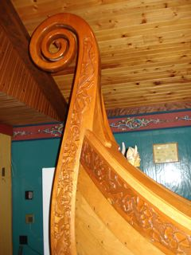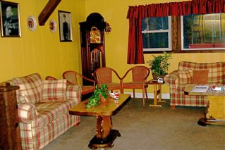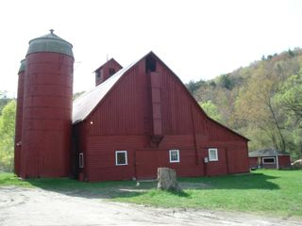
The Viking Bar The Lobby Our Historic Barn

“In the Zone”

Zone 3
Bernt Balchen
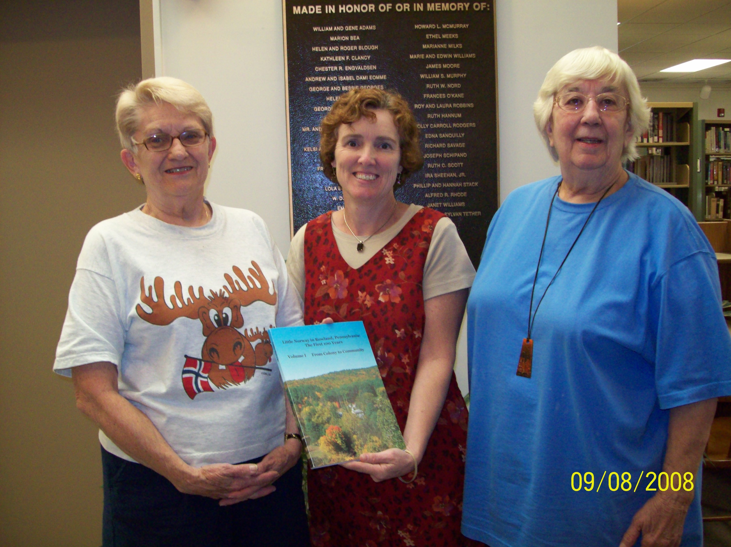
Lorraine Bentley and Joan Nilsen of Bernt Balchen Lodge 3-566 presented a copy of the first volume of "Little Norway in Rowland PA" to Maura Rottman (center) librarian at the Hawley Library.

Noreg
(stopped in at the Bazaar while in NJ; from the size of the crowds, looked like a successful day!)
All hands on deck at the Christmas Bazaar!!
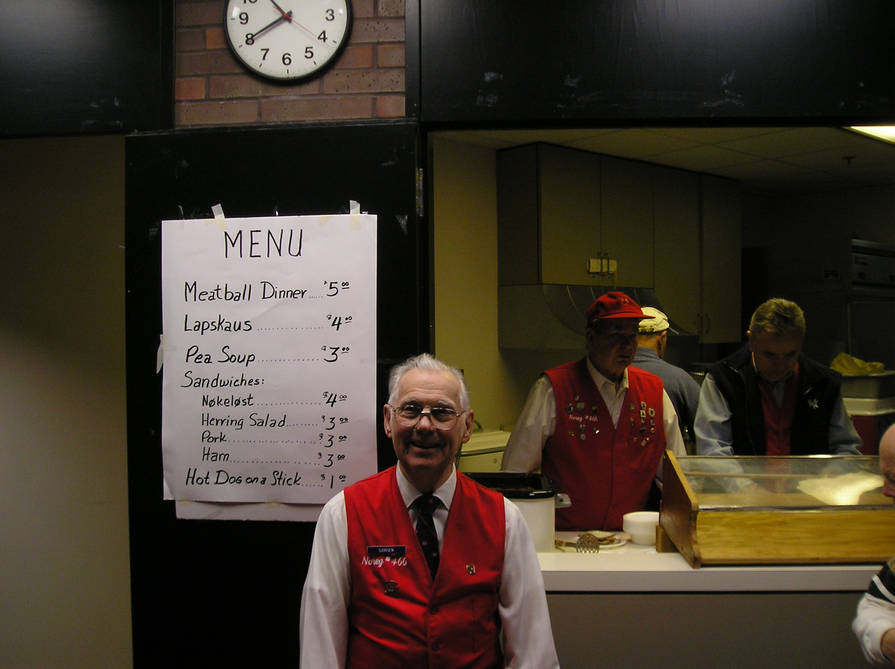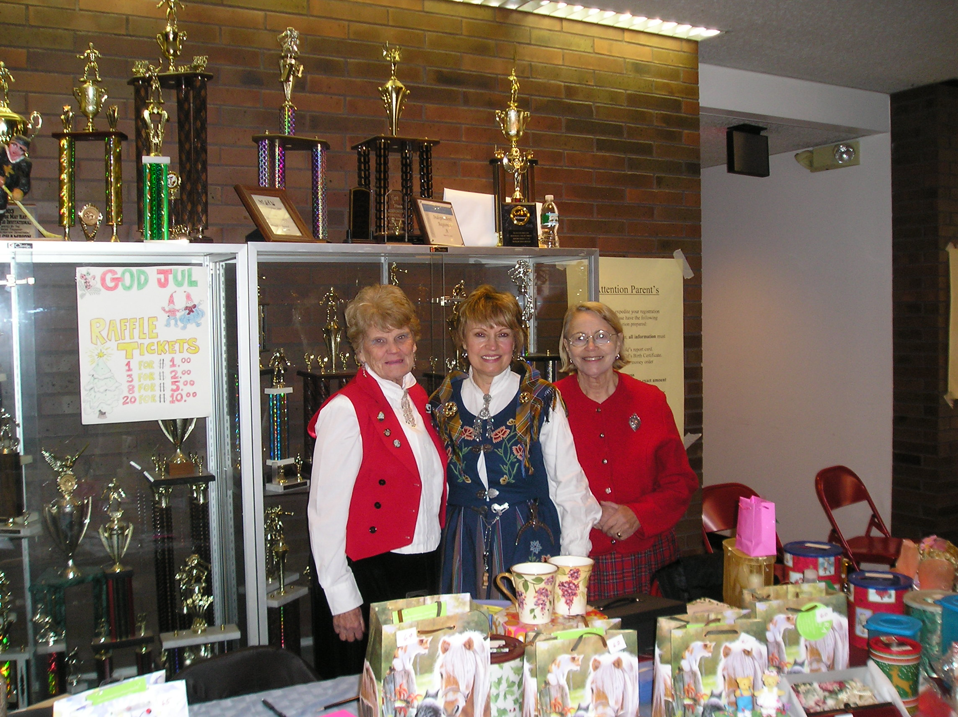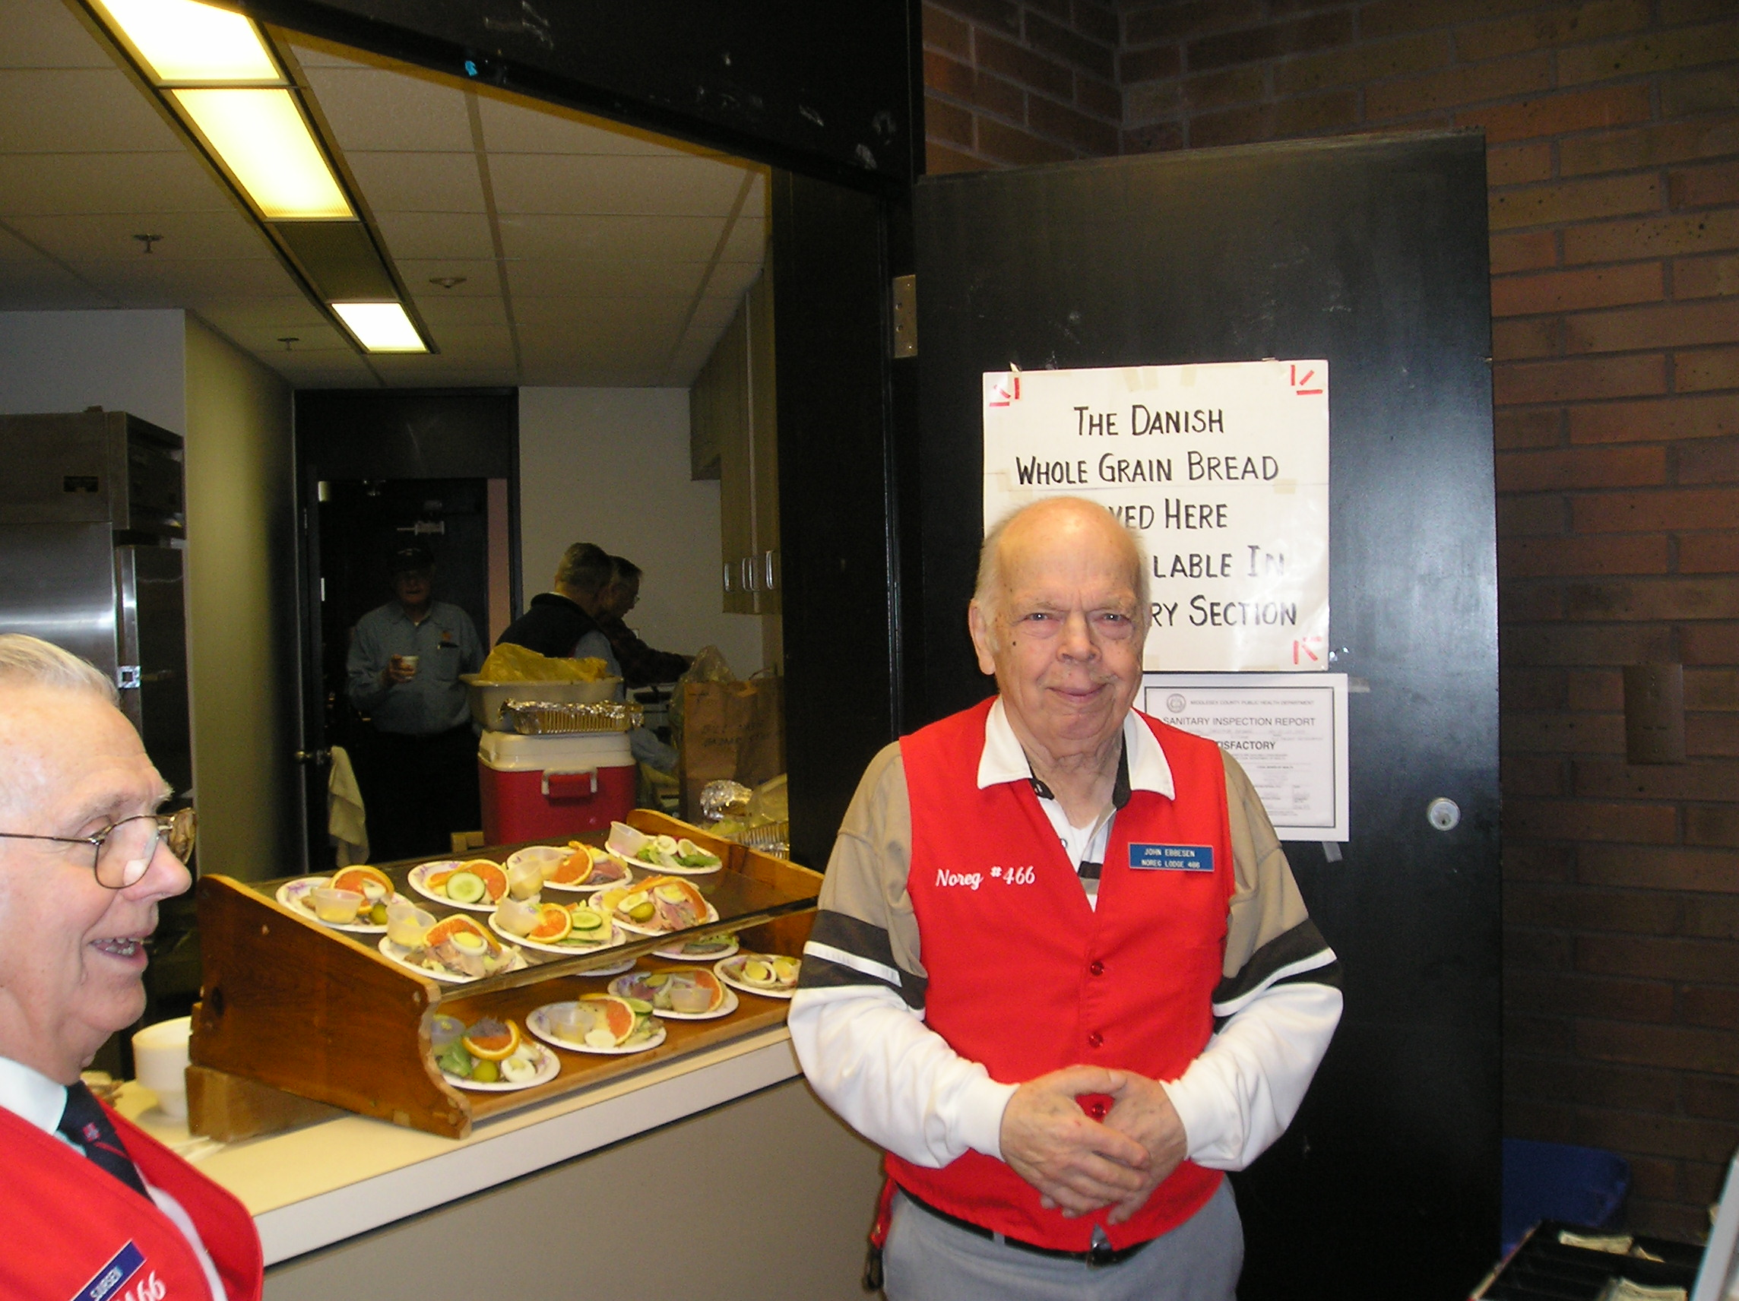
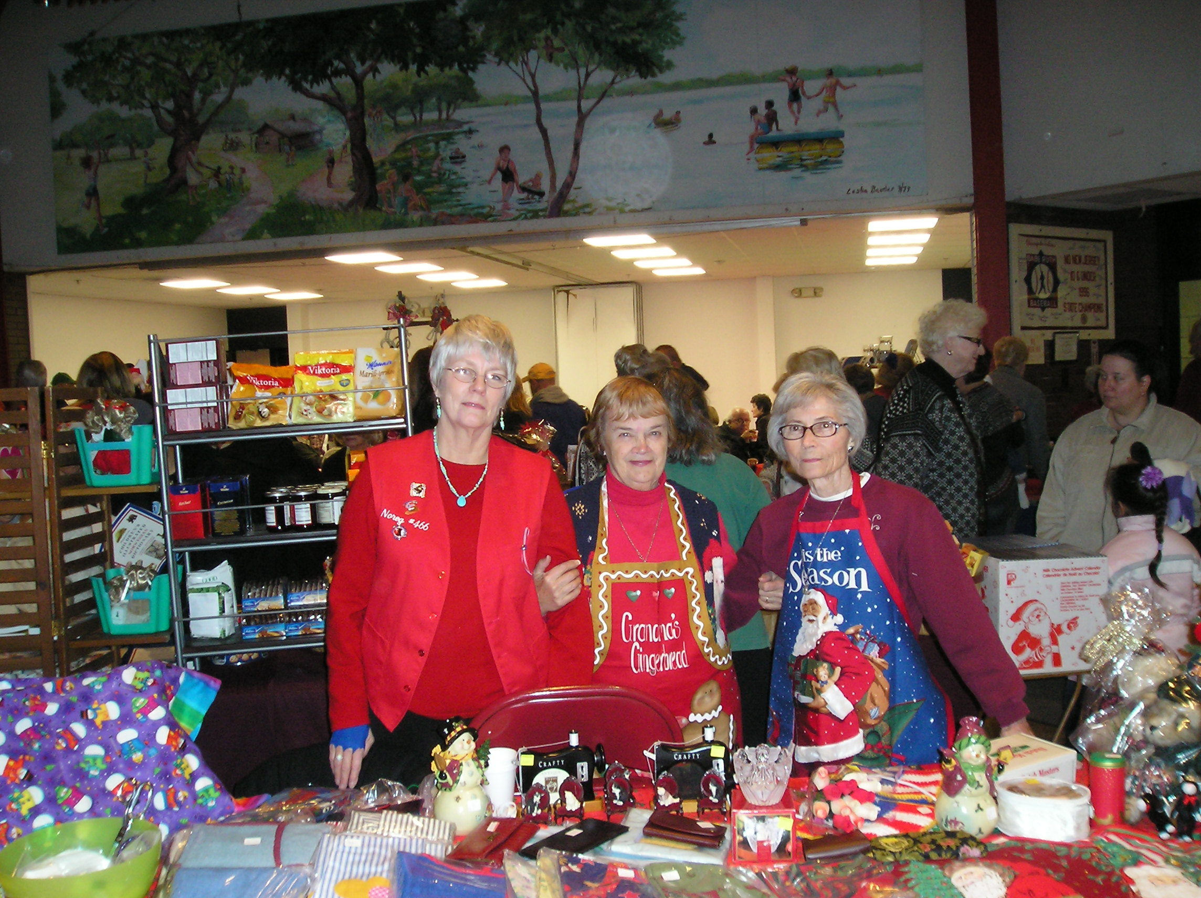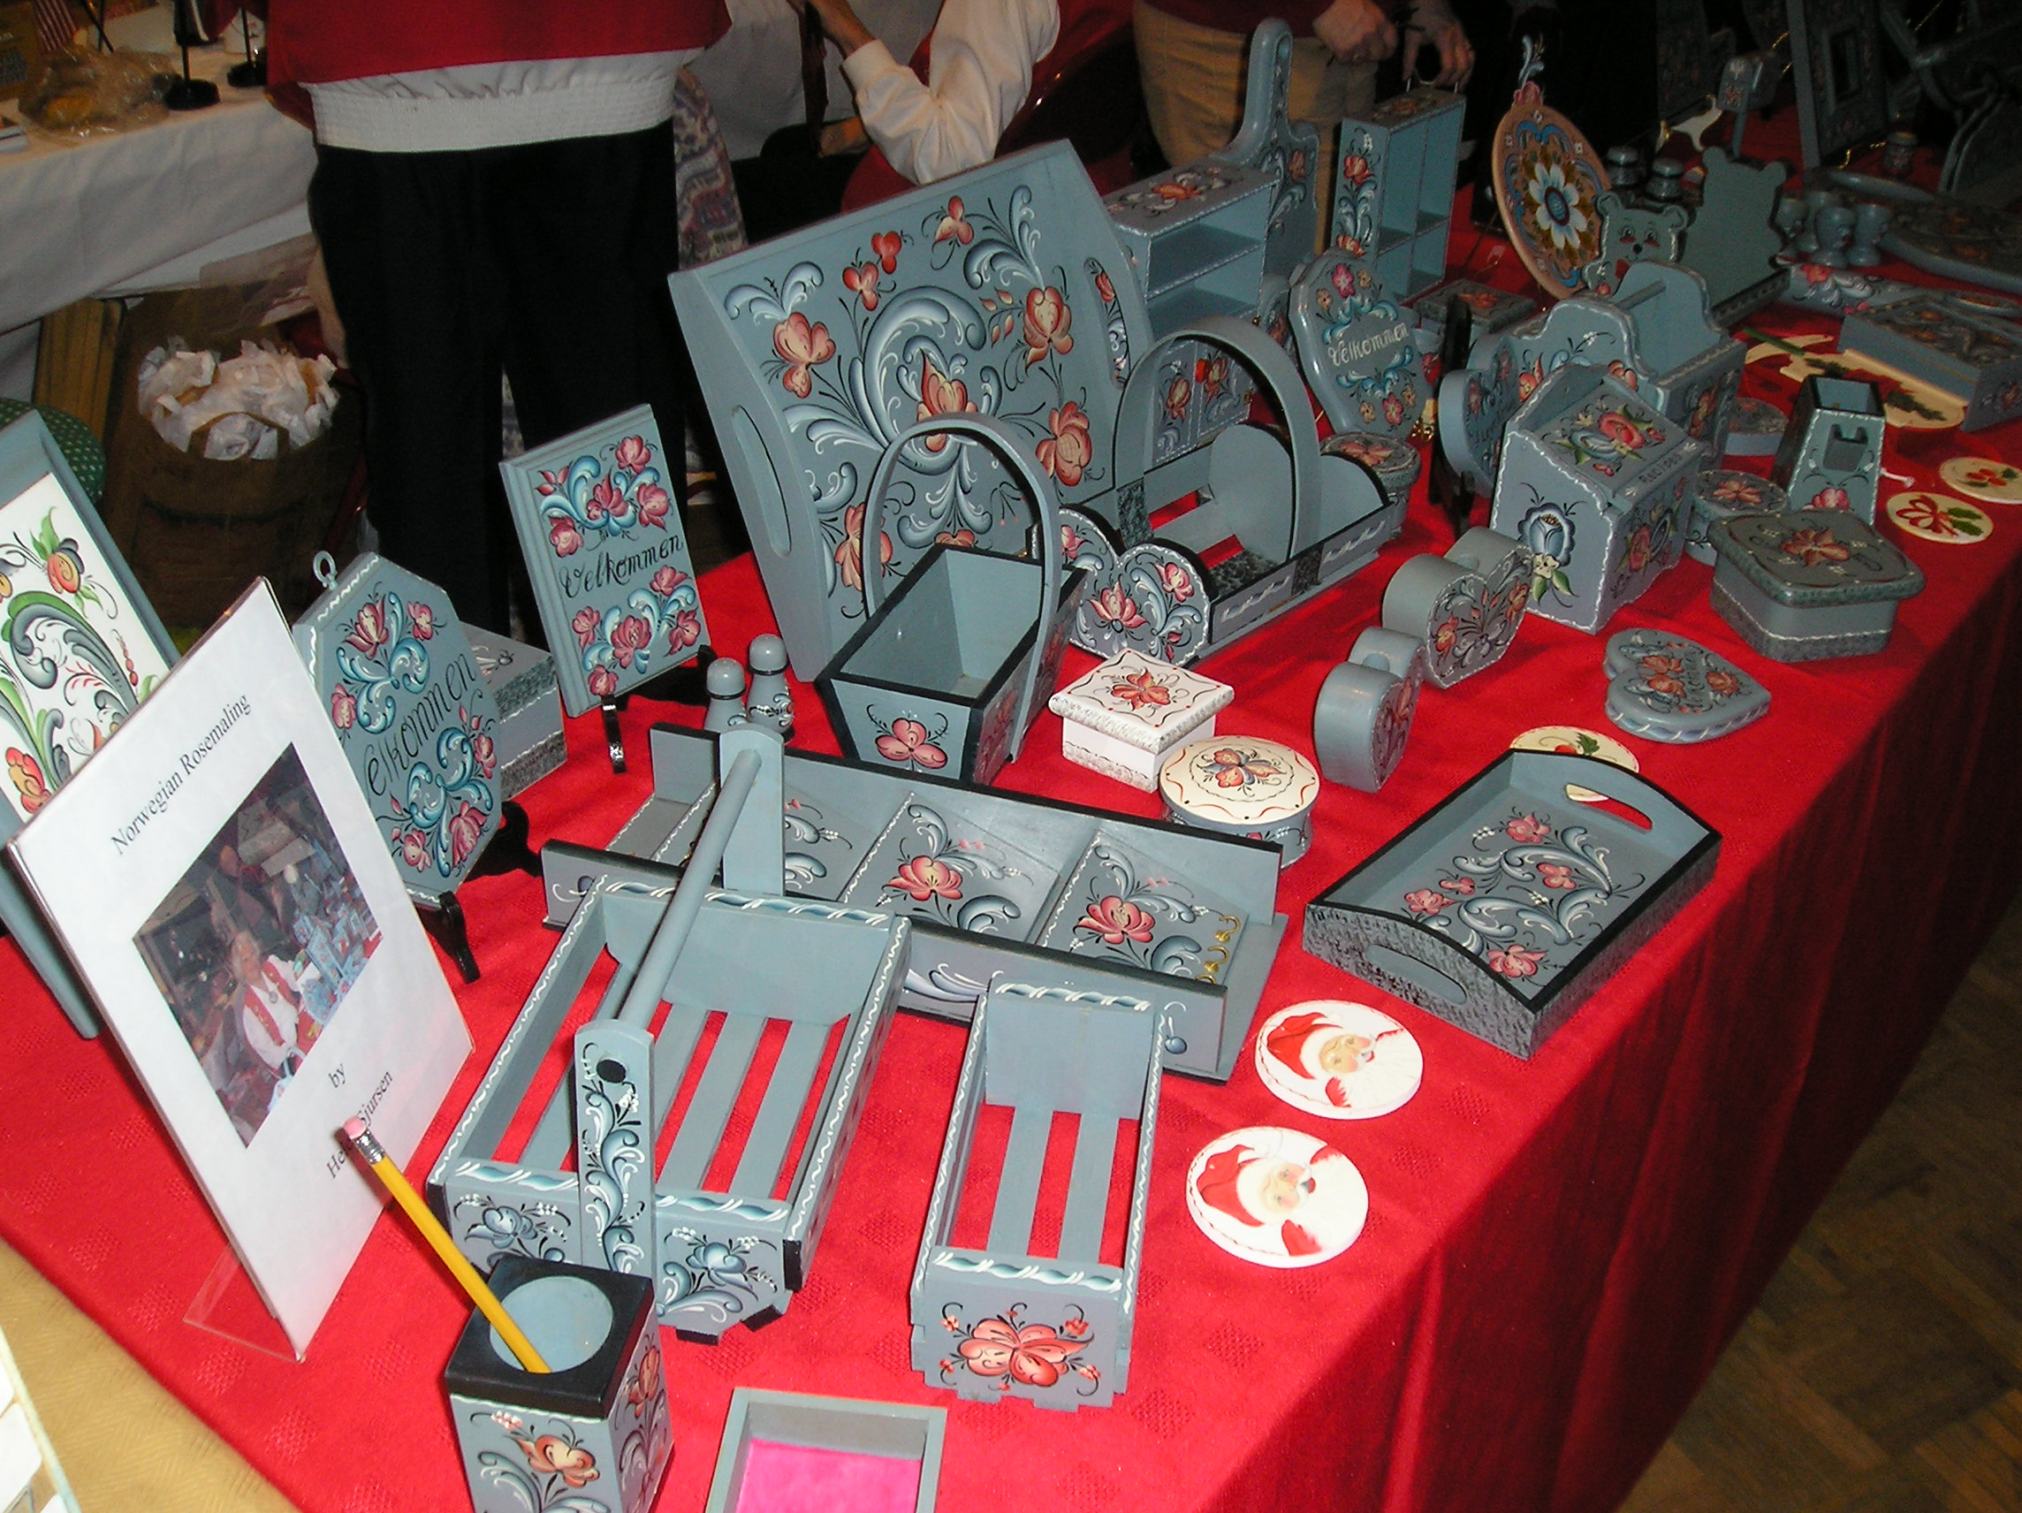
Zone 5

More pictures of the Leif Erikson Regatta! Congratulations to all who participated as well as their fans!

The Boats
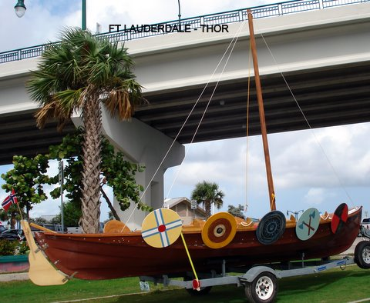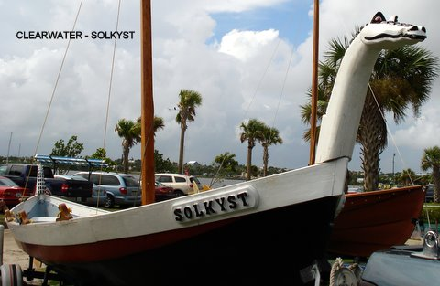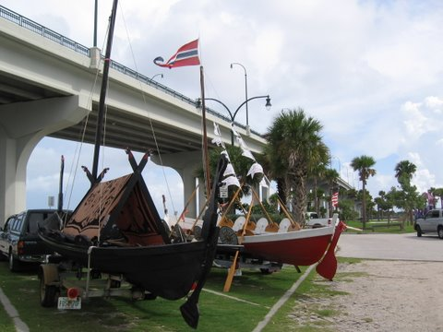

The Race
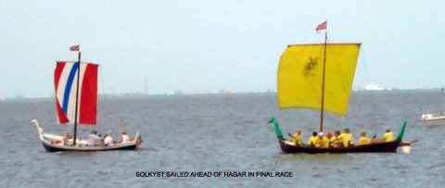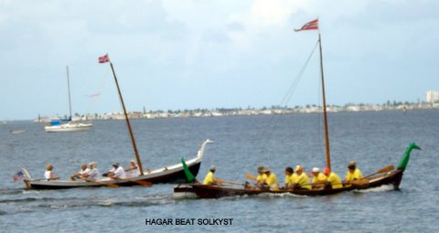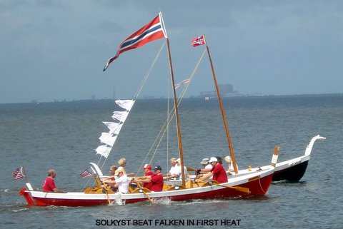

The Winners

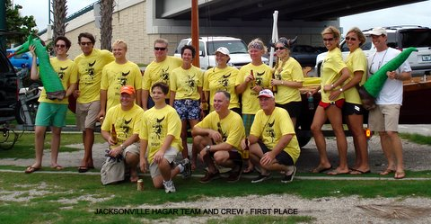

Other news from Zone 5
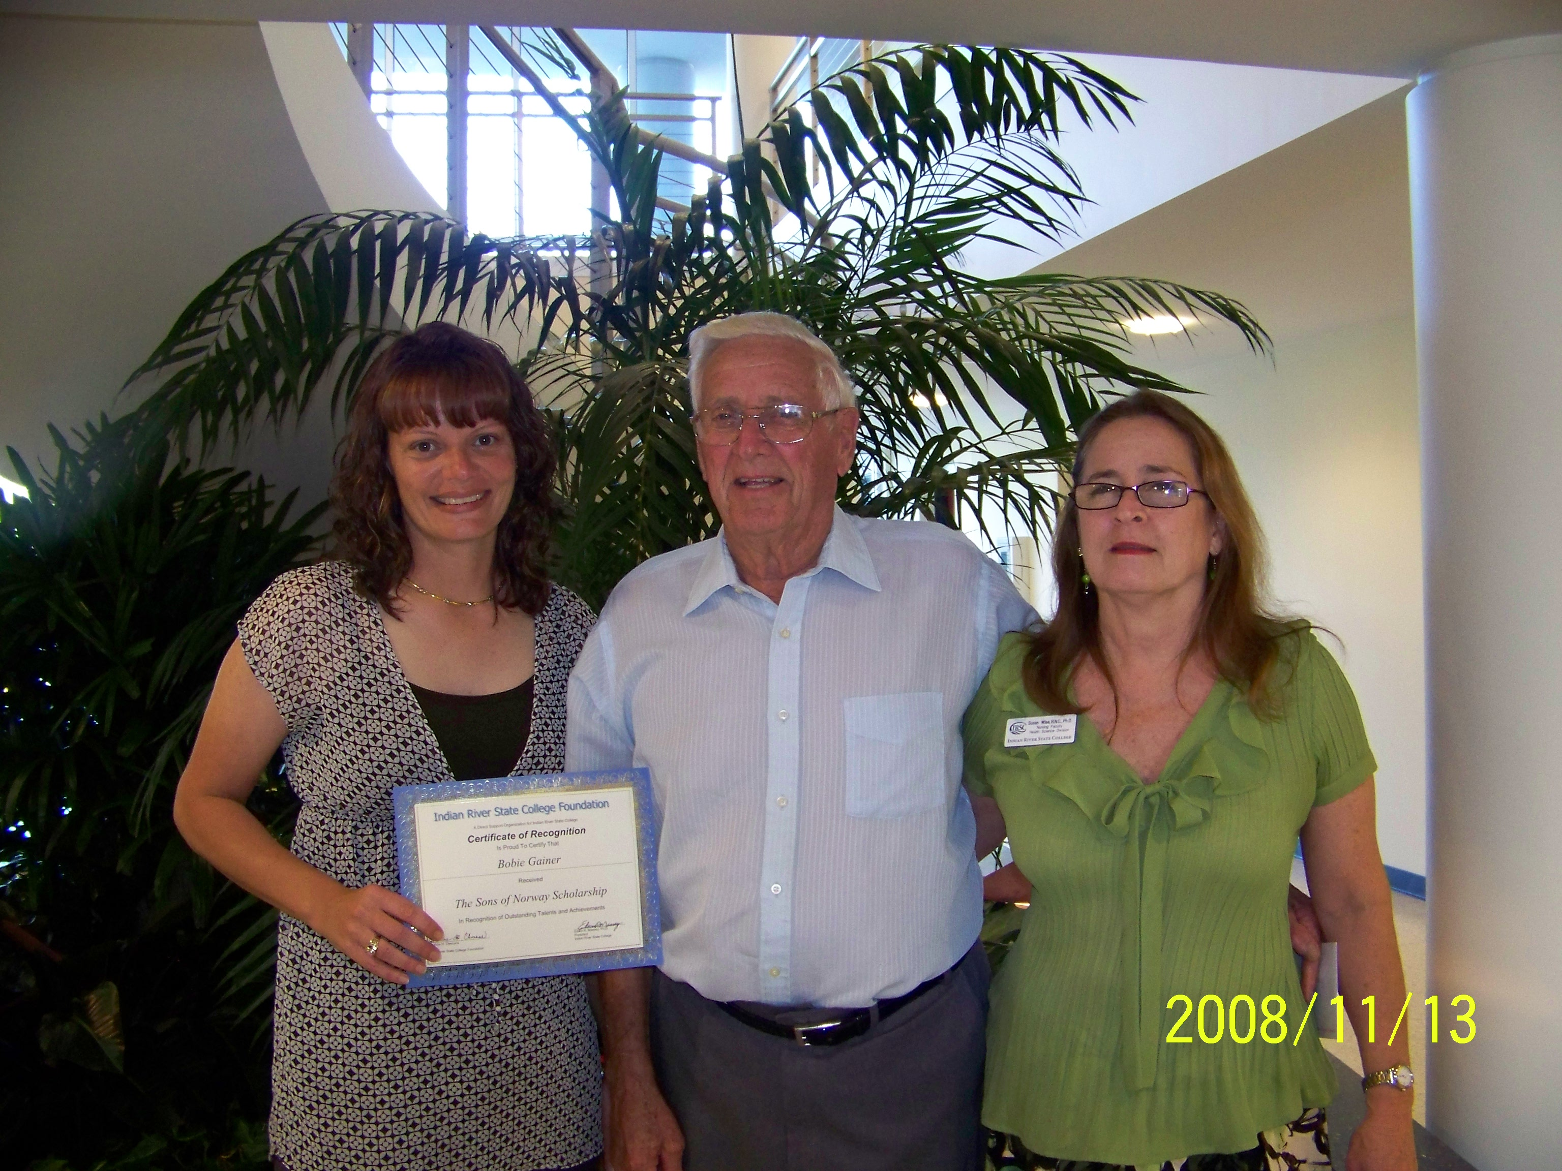
Lodge Gulfstream 3-514 awards a $750 scholarship annually to a student in the nursing program at Indian River State College on the Treasure Coast of Florida. The recipient for the 2008/2009 academic year is Bobie Gainer IRSC student on the left, Jay Wise, Treasurer center and Dr. Susan Wise, Associate Professor IRSC on the right. Jay and Susan are both members of our Lodge.

Congratulations Bobie!

Zone 6
Ode to Lutefisk
By Mary Andersen, Public Relations Director Third District and Bondelandet Lodge

‘Tis the time for caroling; found this definition on the web while searching for the Ode to Lutefisk (attached at the end of the TDT) song; Lutefisk - A piece of cod which passeth all understanding.

At a recent Bondelandet Lodge meeting, we got up close and personal with a soon to be lutefisk meal savored by many of our members; all I can say is whew, an aroma not soon forgotten. Arne Solbak, a charter member of Bondelandet, went fishing in Norway recently and lovingly shared his soon-to-be delicacy.

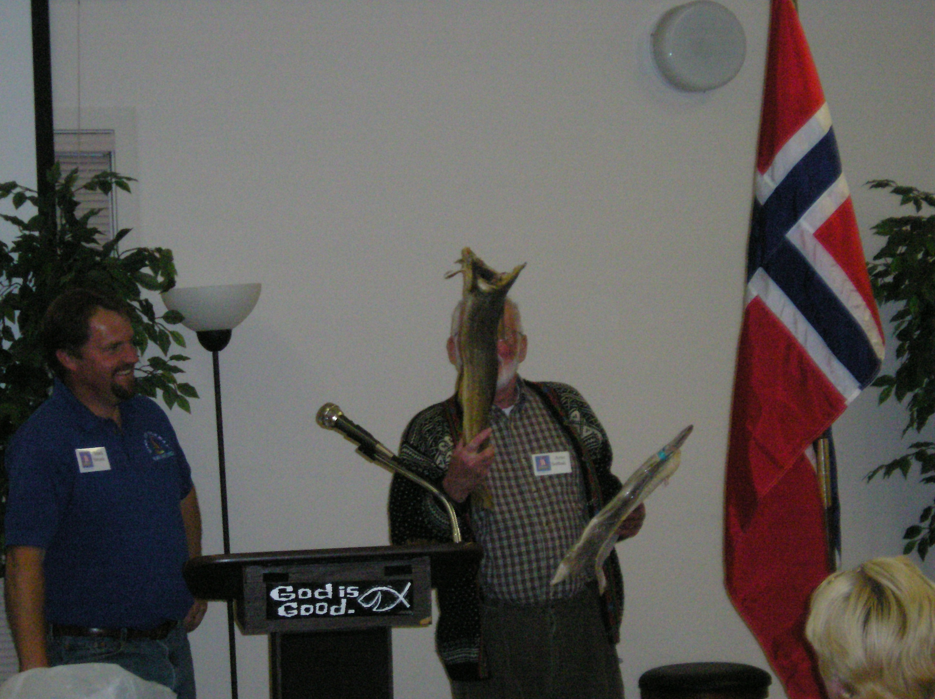
Arne inhaling the essence of his lutefisk while Vice President Mark Strunk keeps his distance

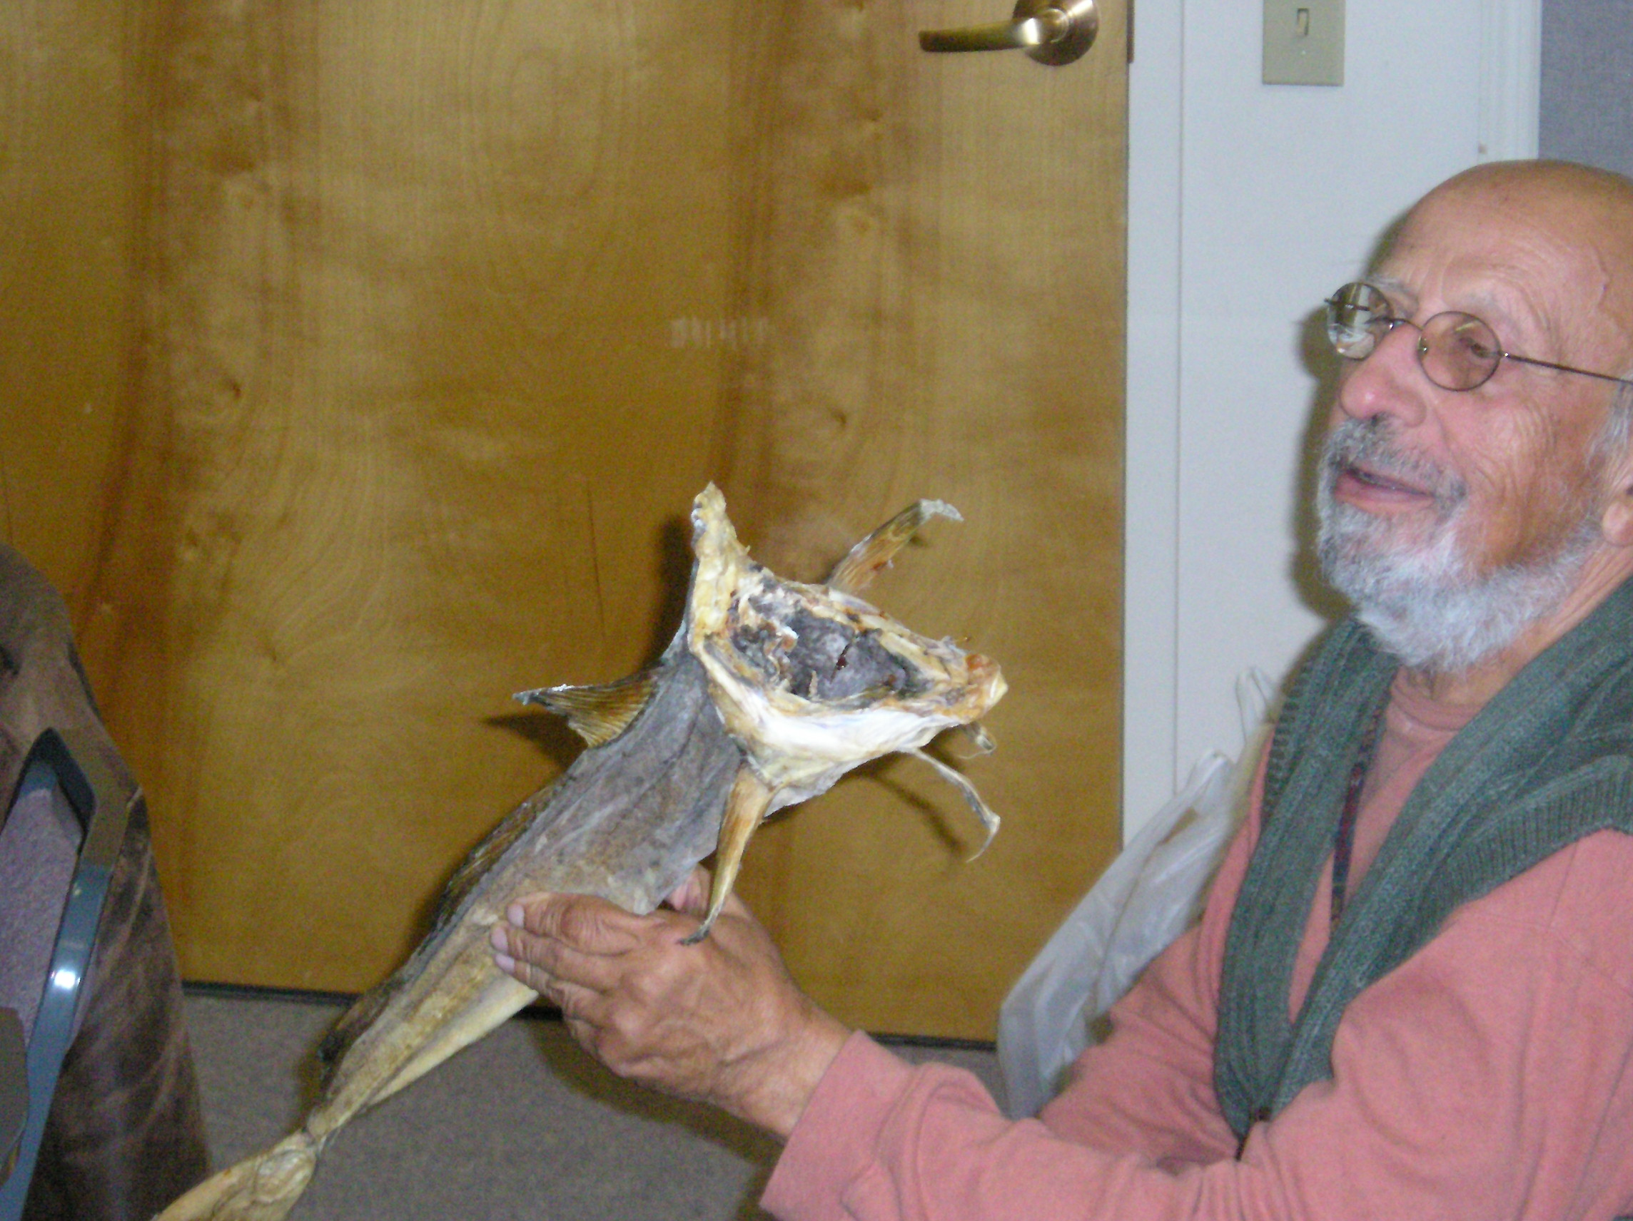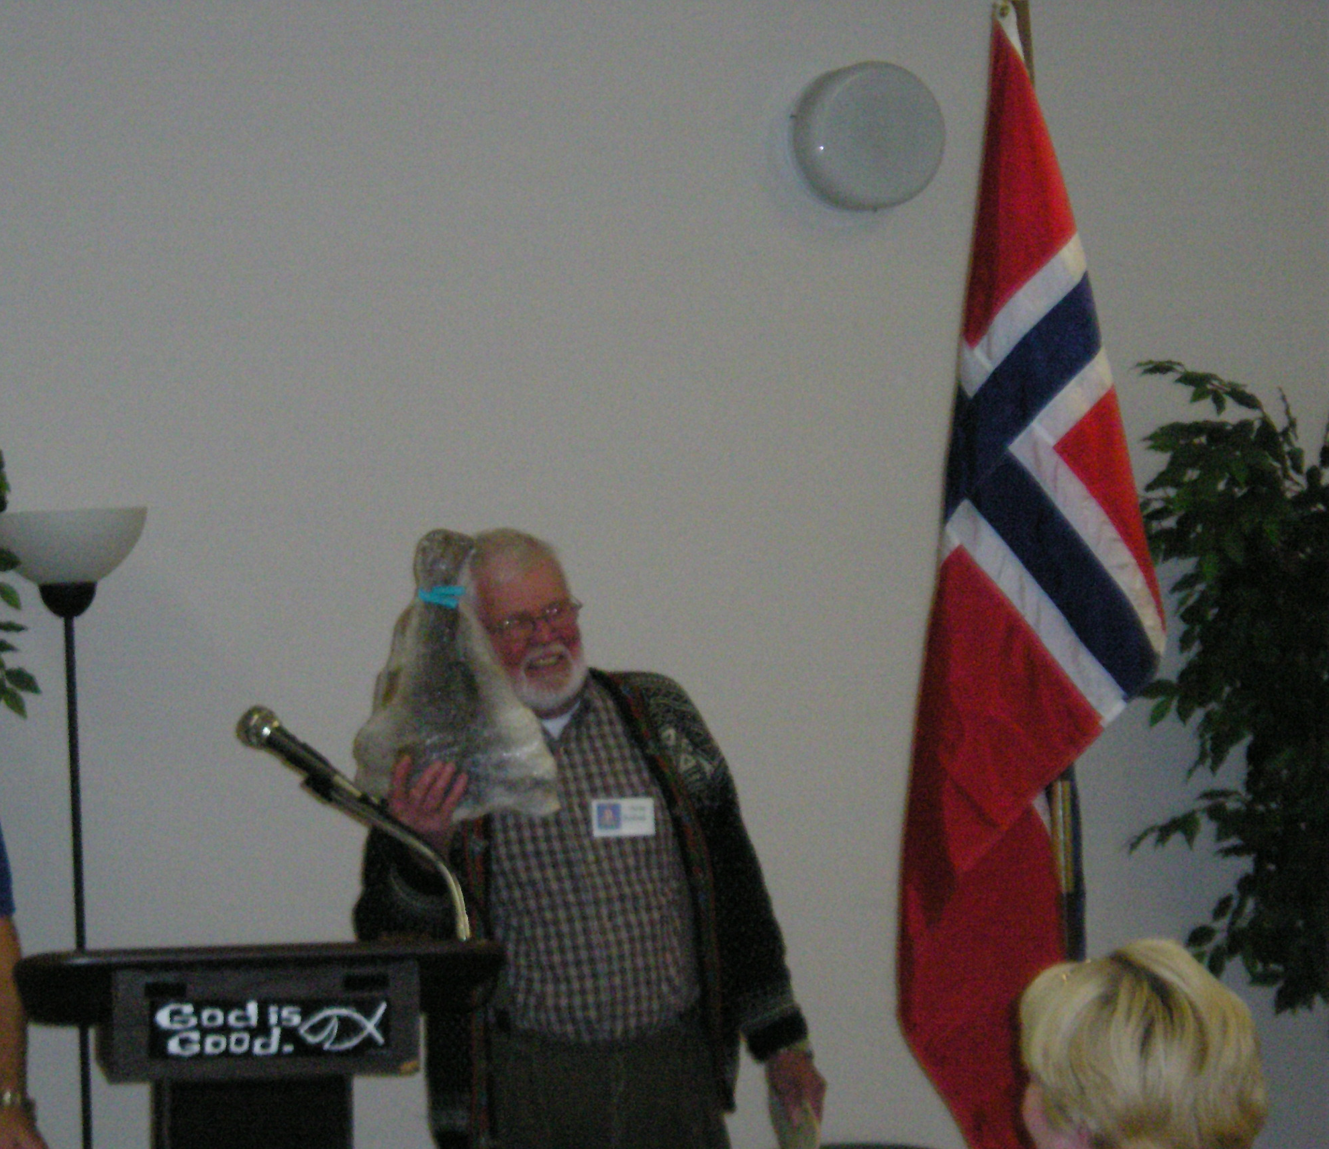
Hmm....... I have to be polite Arne smiles broadly in anticipation of his lutefisk

The final product

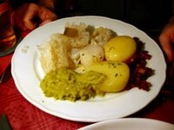


Upcoming Events

November
21st SunCoast presents a Medieval Viking Fest
21st Henrik Ibsen – Pot Luck Dinner
22nd Norrøna 50th Anniversary at Marriot Hotel, Park Ridge, NJ
22nd Norumbega – Scandinavian Fair, Acton
23-23 Noreg - Bazaar, Old Bridge, NJ
25th Washington – Lutefisk dinner
28th Port Orange – Turkey dinner
29th Gateway to Florida – Boat Light Parade,
Downtown Jacksonville

December
5th – 7th - 30th Anniversary of LOV
5th Gateway to Florida –Jul Fest Italian American Club
5th Tampa Bay – Annual Julefest
5th & 6th Washington – Holiday Bazaar
6th Hampton Roads bus trip to Raleigh for Scandinavian Christmas Festival
6th Loyal Lodge Juletrefest
6th Norsk Carolina –Scandinavian Christmas Fair, Raleigh
6th Gateway to Florida Palm Valley Light Parade
7th Hartford – Juletrefest
7th Nor-bu – Christmas Food Sale
7th Oslo Lodge - Juletre Fest. Come bring in the holidays the Nordic way by celebrating all Nordic cultures.
7th Gulfstream – Julefest
7th Loyal – Children’s Christmas Party – St. Lucia Pageant
12th Norge Juletrefest
12th Norumbega – Juletrefest
12th Washington – Juletrefest
12th Sun Viking – Juletrefest
13th Bernt Balchen – Norwegian Christmas Julebord
13th Fredriksten - Adult’s Christmas Party
13th Hudson Valley - Christmas Party at Maennorchor
13th Henrik Ibsen – Christmas Party

13th Norsk Carolina Jule Dinner and Festival with Juletre
13th Hampton Roads Christmas Party/Dinner at 67th Street Officers Club
13th Nordkap – Christmas Party
13th Maine Nordmenn – Julefest
13th Southern Star – Christmas caroling
14th Restauration – Juletrefest at Springhaven Country Club, Wallingford
14th Hudson Valley Children’s Christmas Party at Maennorchor
14th Norden –Family Christmas Party
14th Nansen – Children’s Christmas Party
14th Roald – Christmas Luncheon
19th Suncoast - Julefest
20th Norumbega Children’s Christmas Party
20th Nor-bu – Julefest
28th Bondelandet - Juletrefest
29th Nor-bu – Children’s Christmas Party
31st LOV – New Year’s Eve Party

2009
January
16th Bondelandet – Lutefisk dinner

February
6th-8th Hartford – Vinterfest 2009 at LOV for the benefit of the Hartford Lodge Scholarship Fund

3D Officers

President, Ralph Peterson President@sofn3d.org
Vice President, Gail Ekloff VicePresident@sofn3d.org
Secretary, Marci Larson Secretary@sofn3d.org
Treasurer, John Gregg Treasurer@sofn3d.org
Counselor, Louis Olsen Counselor@sofn3d.org
Youth Director, Evelyn Karpack Youth@sofn3d.org
Sports/Recreation Director – Phil Nelson Sports@sofn3d.org
Publicity Director, Mary Andersen Publicity@sofn3.org
Cultural Director, Karen Doty Cultural@sofn3d.org

Zone 1 Director, Kris Rasmussen Zone1@sofn3d.org
Zone 2 Director, Judith Mack Zone2@sofn3d.org
Zone 3 Director, Joan McKillop Zone3@sofn3d.org
Zone 4 Director, Arnold Johnsen Zone4@sofn3d.org
Zone 5 Director, Carol Anderson Zone5@sofn3d.org
Zone 6 Director, Kathy Dollymore Zone6@sofn3d.org

PRIVACY NOTICE: This information is for official Sons of Norway business use only. Use of this information for solicitation or commercial purposes is a violation of the Sons of Norway privacy policy and is strictly prohibited.

O Lutefisk, O Lutefisk

To The Tune of O Christmas Tree
Original Words: O Tannenbaum, Ernst Gebhard Anschutz, 1824
Adaptation by Red Stangeland
O Lutefisk, O Lutefisk, how fragrant your aroma,
O Lutefisk, O Lutefisk, you put me in a coma.
You smell so strong, you look like glue,
You taste just like an overshoe,
But lutefisk, come Saturday,
I tink I eat you anyvay
O Lutefisk, O lutefisk, I put you in the doorvay.
I wanted you to ripen up just like they do in Norvay.
A dog came by and sprinkled you.
I hit him with my overshoe.
O lutefisk, now I suppose
I'll eat you while I hold my nose.
O Lutefisk, O lutefisk, how well I do remember.
On Christmas Eve how we'd receive our big treat of December.
It wasn't turkey or fried ham.
It wasn't even pickled Spam.
My mother knew there was no risk
In serving buttered lutefisk.
O Lutefisk, O lutefisk, now everyone discovers
That lutefisk and lefse make Norvegians better lovers.
Now all the world can have a ball.
You're better than that Yeritol.
O lutefisk, with brennevin [Norwegian brandy]
You make me feel like Errol Flynn.
O Lutefisk, O lutefisk, you have a special flavor.
O Lutefisk, O lutefisk, all good Norvegians savor.
That slimy slab we know so well
Identified by ghastly smell.
O Lutefisk, O lutefisk,
Our loyalty won't waver.

