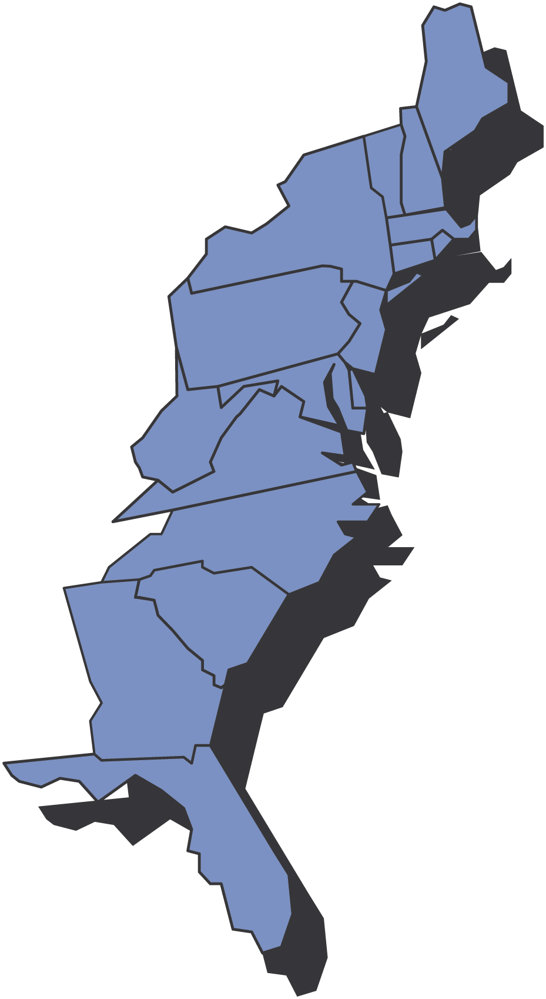
Gratulerer med Dagen
May, 2009

Third District Today

0BFra Presidenten Ralph Peterson

Hei Alle Sammen,
The last time I wrote to you I was in Tampa, Fl; today I am on the Cape May Ferry heading back to Virginia. It was much warmer in Tampa and the ferry is really rocking and rolling today.
I had the opportunity to attend some great SON events this the past month. I was able to attend Sarasota’s 35th and Henrik Ibsen’s 75th anniversaries. Both events were great. There was a lot of energy, enthusiasm and pride in evidence at both events as the past was revisited and the future planned. My congratulations to both lodges for the great job they have done and are continuing to do for the District and the Sons of Norway!
AnneGrete and I attended the regatta hosted by Gateway to Florida in St. Augustine, FL. It was a superb event. The planning and execution was flawless despite the winds which caused a change in location. President Larson and her large, hardworking crew did a magnificent job and I thank them on behalf of all of us who had such a great time. For those of you who have not yet attended a Florida regatta you are missing out on great events. The next one is in Clearwater, FL 22-23 May so put it on your calendar.
We have had a bit of a problem getting our District raffle tickets to you but hopefully you will have them by the time you read this. Remember we will be giving away two rooms (4 tickets) on the Hutrigruten Coastal Cruise so we will draw two winning tickets. For more information on the cruise check out our web site http://www.3dsofn.org/home.html for the link to the Hurtigruten home web page.
Our web site is improving each month. We do need your help if it is to be as useful for the lodges as we hope it will be. We need you to add your events and information so we can keep the site current. We will shortly be able to host your web site on our server. If your lodge is interested in transferring a current site or starting up a new site please let us know.
It appears that the sports medal program is doing well in the District. Please keep the Sports Director informed as to the number, type and level of medals won.
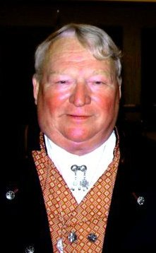
We have received some new Financial Benefit Counselors in the District. Among them is our own Publicity Director, Mary Andersen. Congratulations Mary!!!!!!!!!!!!!!! We wish all of them well and look forward to working with them in the future. You can link to contact information for all the Financial Benefit Counselors from our web site.
The District Board is in the process of reviewing our current District goals. We will have a status report for our September newsletter. We are getting a lot of new members but we are still losing far too many. Normally we lose members over the summer and then pick up new members during the fall festivals. Let’s try to reduce our losses this summer.
Our Youth Camp is coming up. Applications have been sent out and more are available. One of our goals is to fill up the camp this summer so let’s get the applications in early. Many of the Lodges and Zones offer camperships. The District also offers camperships and has matching funds available so the already inexpensive tuition may become even more inexpensive. Check with the Youth Director for more information.
I know that many of you will be busy in May with your local celebrations. Have a great day and remember the reason for the celebration!
Fraternally
Ralph Peterson
President
District Three
Sons of Norway

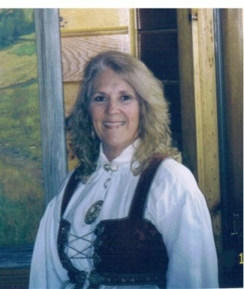
Fra Vise Presidenten Gail Ekloff

Gratulerer med Dagen---Syttende Mai…

The time all Norwegians commemorate Constitution Day!! Every lodge participates in some type of event. Whether it’s a parade or a picnic, multi- generations come together to celebrate this Norwegian holiday. What a perfect time for us to “strut our stuff” and remind people of our roots. Marching in a parade is great “advertising “ — it makes more people aware of the Sons of Norway.

Since families are together celebrating, this would be a good base for you to generate more family interest in Norway/Scandinavia. One vital way would be to make sure all our children, grandchildren and great grandchildren are members.

Any child 15 and younger is eligible to become a Heritage Member if they are a family member of at least one Sons of Norway member in good standing. Each Heritage Member will receive a quarterly newsletter that explores their culture and gives insight into Norway. There is a pen pal section where they can get a friend with similar interests to write to. Make sure you sign them up! It’s free and you will have a topic to discuss with your children, nieces, nephews, grandchildren or great grandchildren after he/she receives it. What an easy way to talk to your family about their heritage.

Every lodge should have Heritage Members---they are the future of our order. If your kids 15 and under aren’t members, sign them up!!

Alt for denne gangen,

Gail

REMEMBER THE 2 A’S TO GET NEW MEMBERS--- ASK AND ADVERTISE
AND, TO KEEP MEMBERS, THE 2 M’S -----------------MENTOR AND MINGLE

Financial News

Recently the second annual Lodge Revenue Sharing checks were prepared to be distributed to local lodges. How was the amount of your lodge’s check determined? Each year, a percentage of Sons of Norway’s net income is set aside for this. The amount each lodge receives is based on the percent of insurance premiums paid by your lodge members divided by the total insurance premiums paid by all lodge members (Central Lodge and Lodge 999 are excluded). In addition, the lodge also receives $4 for each new insurance member. This is a great source of revenue for your lodge without any effort. Lodge members merely visit with their assigned Financial Benefits Counselor about their needs, discover how our financial products can help provide for those needs and then purchase the appropriate product(s).

Lodge Revenue Sharing checks were either mailed to your Financial Benefits Counselor to deliver to your lodge at a meeting in March or April, or they were sent directly to your lodge president. If the check was mailed to the lodge, it should have been received prior to this issue of Resource. It’s a win-win situation — members purchase our products to help them realize a financial goal and the lodge receives revenue.

*****************************


Don’t forget to:

Publicity
by Mary Andersen
Our new website (www.sofn3d.org) has been up for almost one month!!!
Please take some to update the website for your lodge events and don’t forget to submit your lodge history.

Extract from a local lodge newsletter
One benefit of being Public Relations director is having the opportunity to see many of the great newsletters prepared by all of you!

Excerpts from Norumbega’s May Tidende
The Month of May
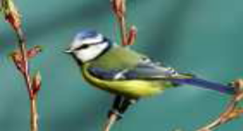
There are many traditions around the month of May in Norway. It is the month when birds return, and flowers cover the forest floor like carpets. The singing of the cuckoo bird is welcomed as the true sign that spring has arrived, and summer will not be far behind. Superstitions around the cuckoo bird are many. If you first hear the cuckoo bird singing from the south, you will have a good harvest. If it sings from the north, someone will die. If it sings from west, your wishes will be fulfilled, and if it sings from the east, there will be a wedding & good fortune.— From Hva dagene vet

Syttende Mai During the War
For more than 150 years Syttende Mai has been celebrated as a salute to tolerance and national unity. The day is truly a declaration of love to Norway’s most important values of peace, freedom and equality. But how was the day celebrated during the German occupation? The German authorities were quite clear over what this democracy-oriented national holiday meant for Norwegian loyalists, and put in place measures to fight and punish any rabble-rousers. On the first Syttende Mai after the German invasion, all celebration or display of the flag was banned by the Germans. The flag was used as a visual protest against the occupation, so the Germans kept issuing new orders to solve the problem. Singing the national song was forbidden and any flags had to be hidden away. In 1941 Syttende Mai was declared to be a normal workday in Norway, but it was nonetheless decided to allow flags to be flown from poles…but not at half mast, as many Norwegians decided to do as an expression of the country’s tragic situation under German rule. Afterwards the Germans instituted dozens of new restrictions on the flag. In effect, it became for-bidden to carry or wear the flag or its colors. In larger cities this meant that Syttende Mai was most commonly commemorated indoors. And so the situation persisted through the war. Next to the king’s monogram the flag was among the most important symbols of a free Norway, and the Germans fought an endless war against the obstinacy of the Norwegians. As the Germans enacted more and more restrictions, people started using more subtle symbols, like paper clips and nisse hats. It comes as no surprise then that the Syttende Mai celebration of 1945 – just a few days after the German surrender – became a an explosion of joy in the national colors in those feverish spring days.
Translated and adapted from: http://www.nrk.no/
magasin/17_mai/1.2317821
Frigjøringsdag - May 8, 1945,
Norway's Liberation Day
After five years under German occupation during World War II, Norway's long-awaited day of liberation came on May 8, 1945. At this time, Germany still had nearly 350,000 well-equipped and trained soldiers throughout Norway. But as the German army surrendered at several points on the European front, Norway at last received its liberation as well. Though Norway still feared that the German soldiers would not concede peacefully, hardly any incidents were reported during the liberation. Joy and gratitude swept through Norway and for several days the people celebrated. Never before had Syttende Mai been celebrated with such vigor as in 1945.

See the TDT May 2009 Special Edition for more excerpts from local newsletters and other articles

Youth Camp
By Evelyn Karpack, Youth Camp Director

Do you have a skill you can share?
Do you like working with children?
Looking to escape the heat and spend some time in the mountains?

We are finalizing our list of camp counselors for the 2009 Youth camp and there is always room for more!! Let me know if you can help in the following areas:

- Language- Young group- teach table prayer and anthem – with both groups can teach basic language, history, culture, games, etc.
- Wood carving- Actual wood carving with the older group and just simple wood working with the younger group.
- Archery – teach the basics.
- Hardanger – for beginners may use plastic canvas and then graduate to aida cloth according to the ability of the camper.
- Nurse – Mostly handle headaches, small bruises etc. and dispense medication as needed.

The classes are 40 minute periods each morning. Besides conducting classes in the morning, we all help prepare meals, clean up after meals and chaperone activities which include transporting campers to the movies and to go canoeing. Counselors also help organize games and crafts in the afternoon and plan activities for the evening.

If you are willing to do what is needed and want to have some fun at the same time, please contact me to find out which spots are open.

Thank you,

Evelyn Karpack Third District Youth Director farmorkar@msn.com or 973-627-563

Celebrate Culture

Talent abounds in the Third District!
The following pictures were taken from the Suncoast News. The rosemaling was done by Eva Anderson and the woodcarving was done by Jeff Stone; more pictures can be found at (http://www.suncoastlodge.com/newsletters)
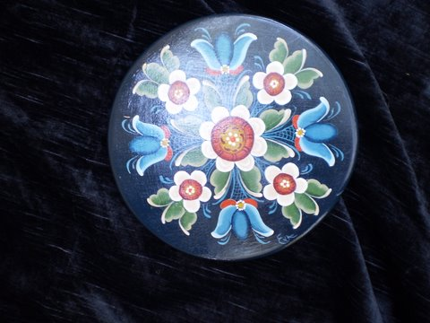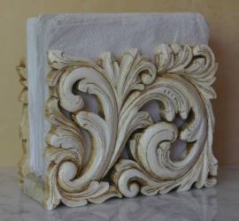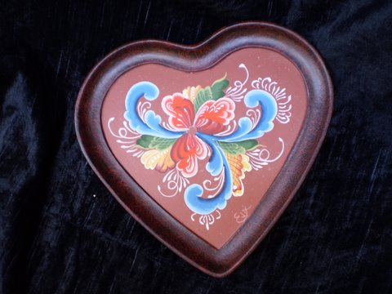

“District Doings”

Gotta get going and GOLF!

Mark your calendars!!

HUFourth Annual LOV Golf TournamentUH in May (1st-3rd)

Traditional Norwegian HUDance WorkshopUH at Land of the Vikings May 29 - 31, 2009
Speaking of dancing, the following was taken from

Are you travelling west for the Memorial Day Weekend? Hverdags Bunad Sewing Workshop at Trollhaugen Friday to Sunday - May 29 - 31 Call or email for information Phone - 509-452-9790 donnainwa@q.com

Will you be in the NYC area? Check out http://www.norway.org/ for some cultural activities.

HUDistrict 3 Golf OutingUH in September (17th-20th)

Scrapbooking at LOV September (25th-27th )
H
What’s LOV got to do with us?
Many hands make light work and have a lot of fun!
Come one come all!
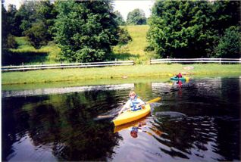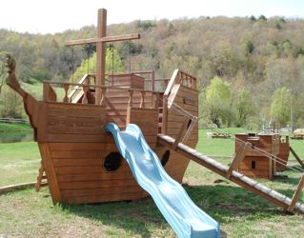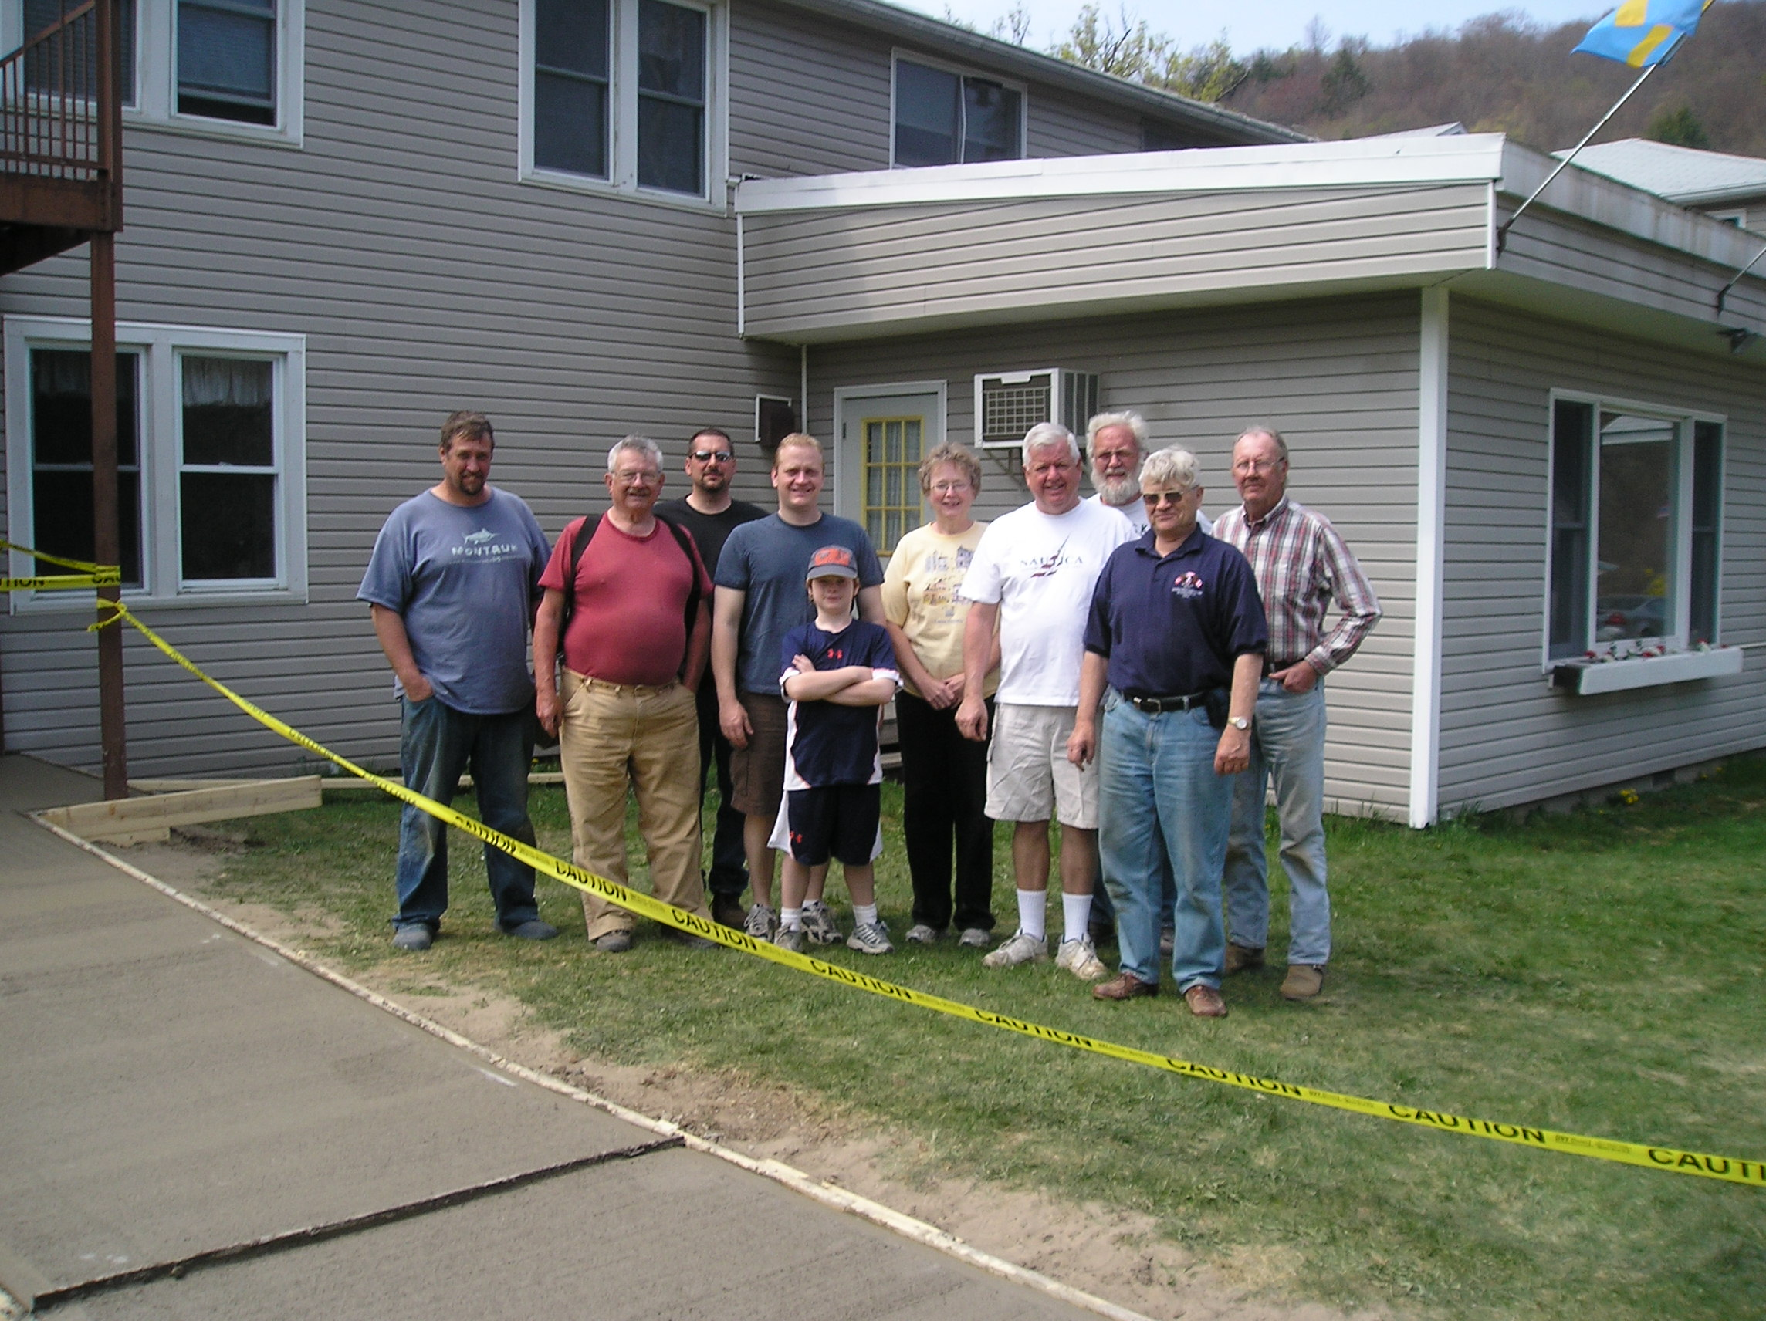

I want to welcome you to a fabulous weekend at Land of the Vikings.
Plan on joining many of my valued volunteers for a fun filled work weekend from June 26th to June 28th. You do not need to be a handy-man or have any expertise in repairs.
We are going to repair/replace and paint the white fence surrounding the property. We need 15 people to make the project run perfectly.

There are many projects on my agenda to begin or complete at LOV and everyone can join in, some are large projects and some are small projects.
The list of projects is:
- the dining room chairs cleaned
- the managers house –
- kitchen wall-paper to be removed and walls painted
- the downstairs bathroom painted
- floor tiling in downstairs bathroom
- stucco the outside foundation
  - remove the wood around the playground
  - remove the flower boxes under the dining room windows
  - power wash the white house
  - cut up the awning to dispose of
  - build shelves for Youth Camp items

All of these projects might not be completed, but many can be done that weekend if we have the volunteers to get the projects done. Remember this is a free weekend for those who come and work. You can become one of the comrades in arms whose friendships last a lifetime.
Please contact Roy at 516-791-3983 or 516-457-4893 or royb50@optonline.net and let me know you are coming and what project you would like to tackle so I can have the materials ready when you arrive.
We need you!!!
Roy
“In the Zone”
Zone 1

Henrik Ibsen
Henrik Ibsen celebrated their 75th anniversary – Congratulations!!

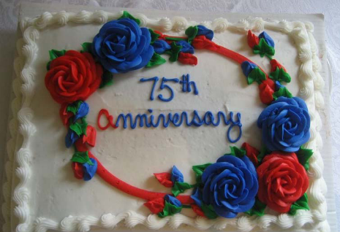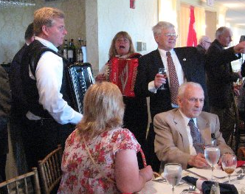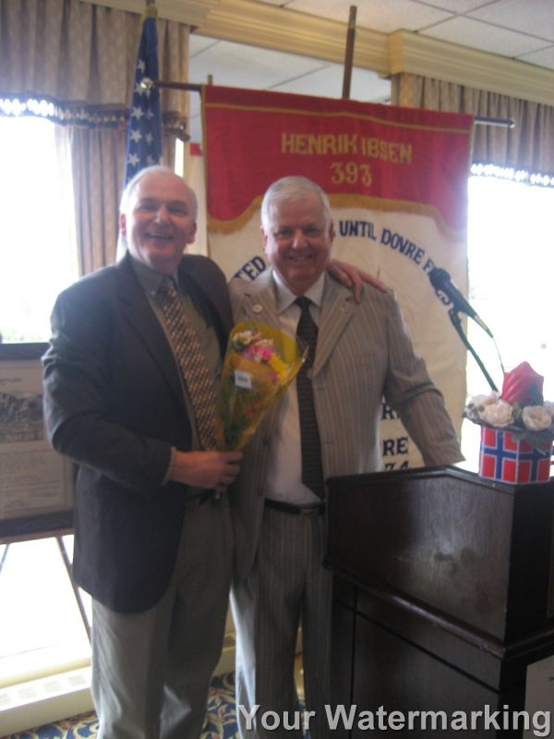

Zone 2
Maine Nordmenn hold a Craft and Culture night – lotta lefse!!

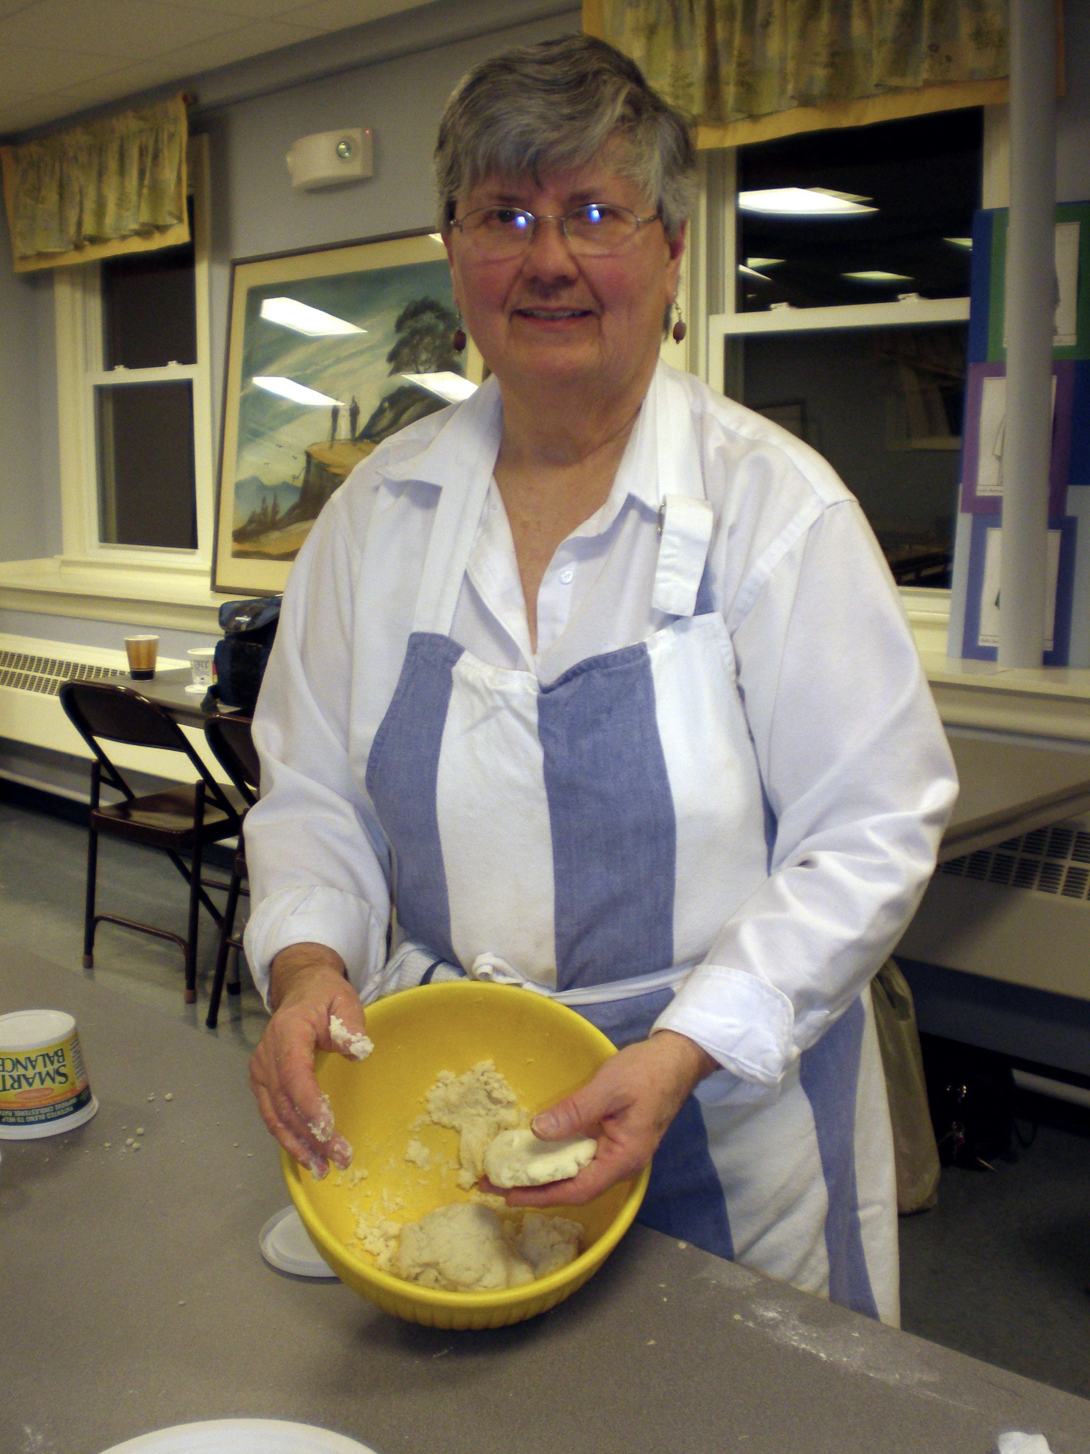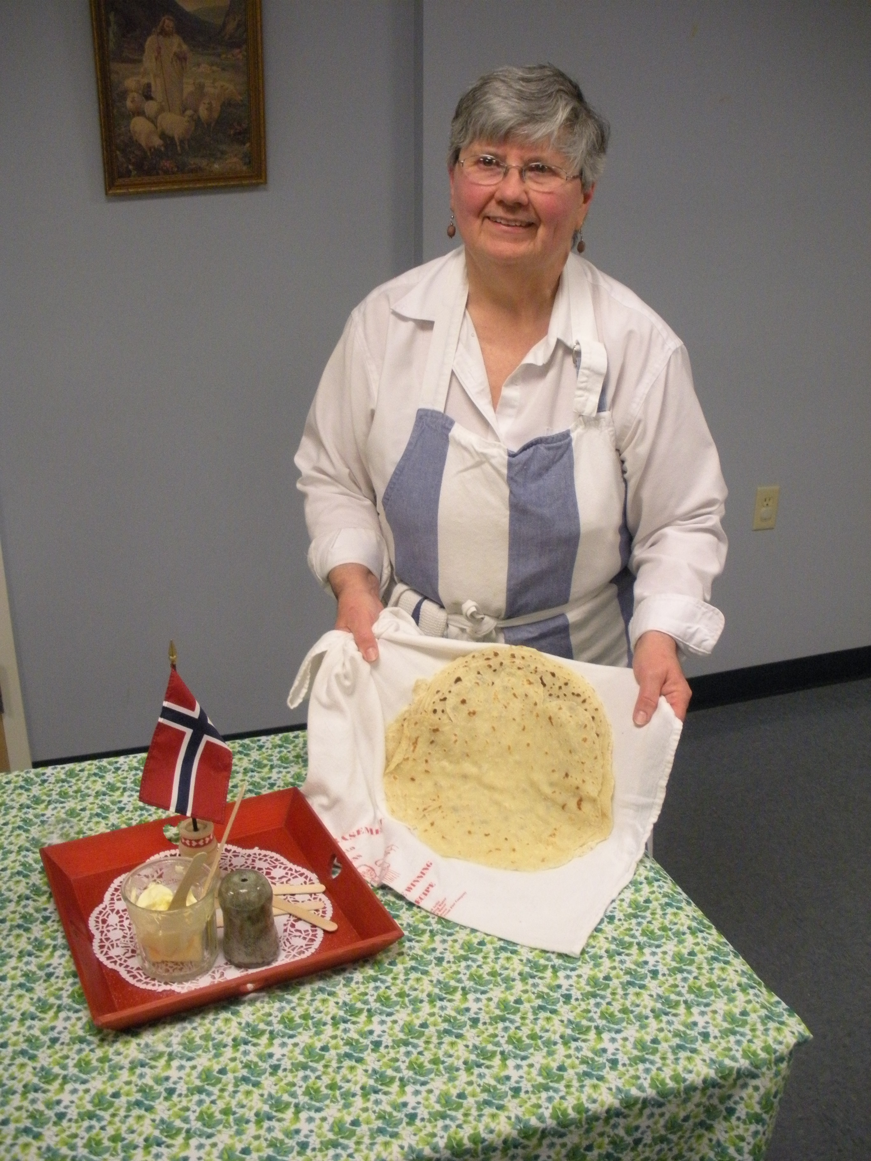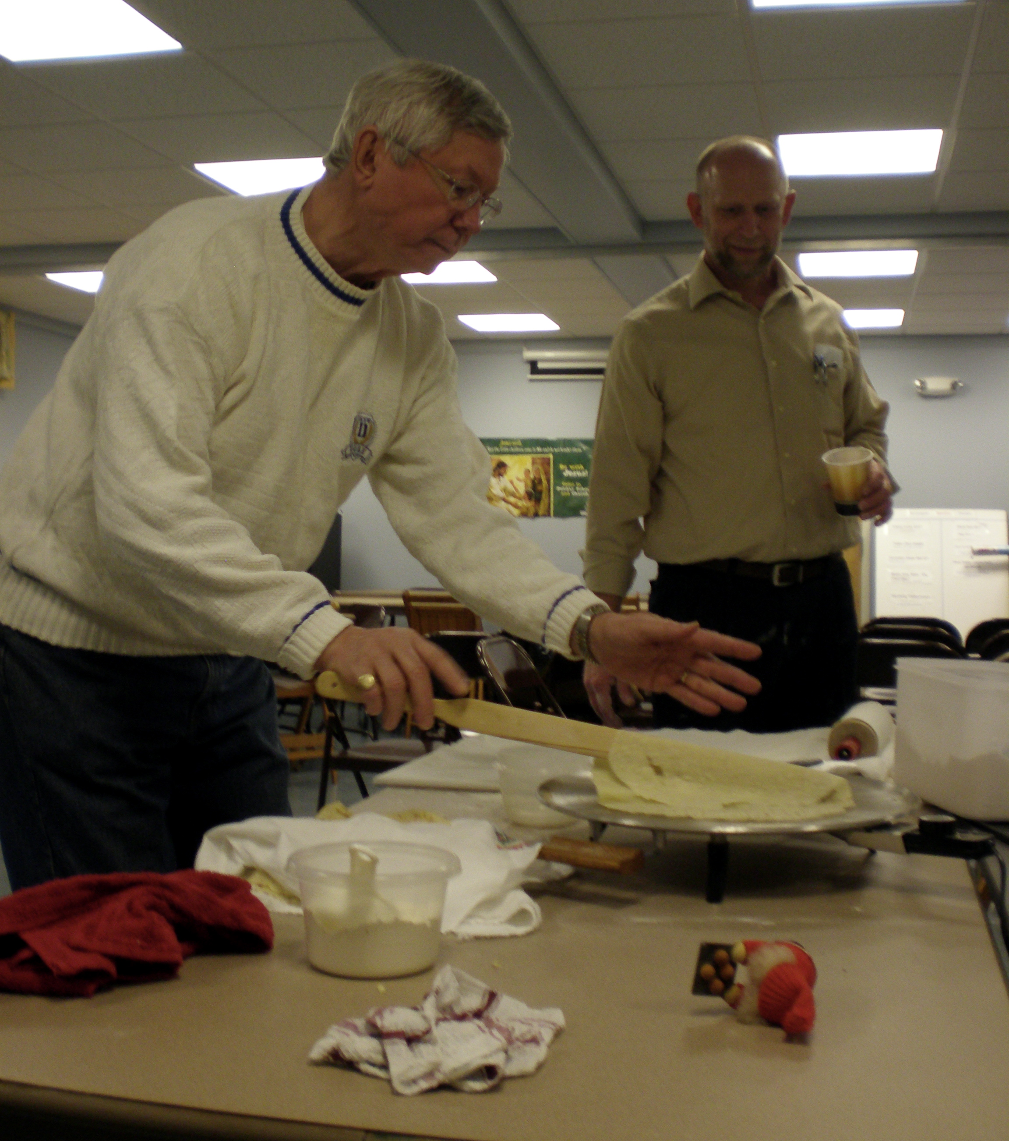

Zone 4
Oslo
Oslo celebrates their 60th Anniversary and a former President/Zone Director celebrates a birthday – congratulations!

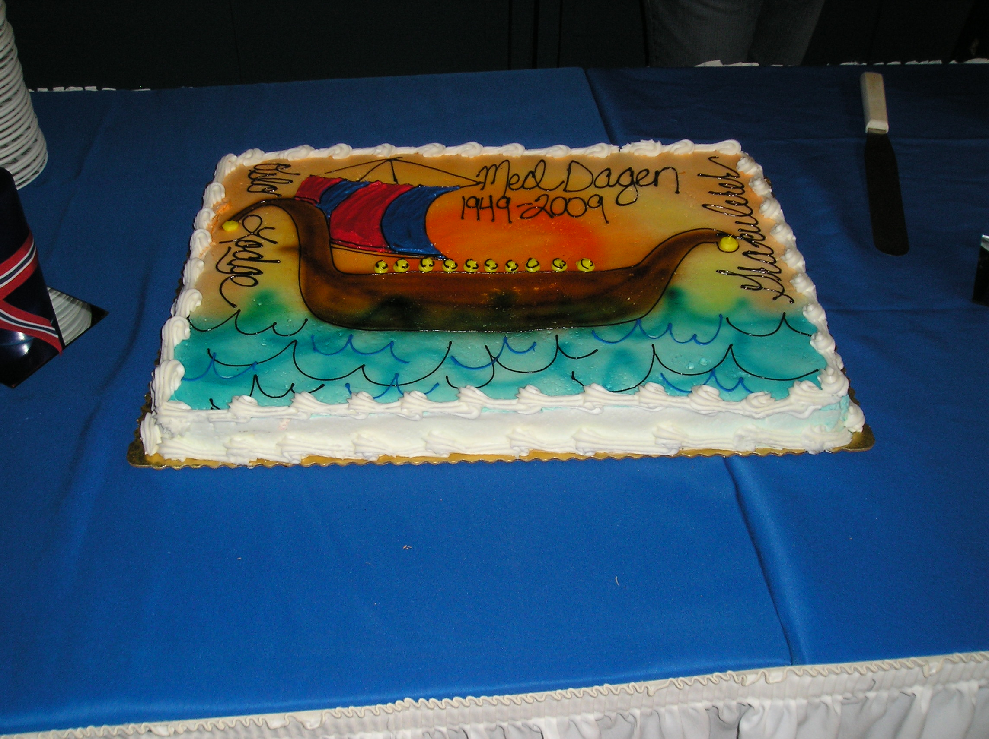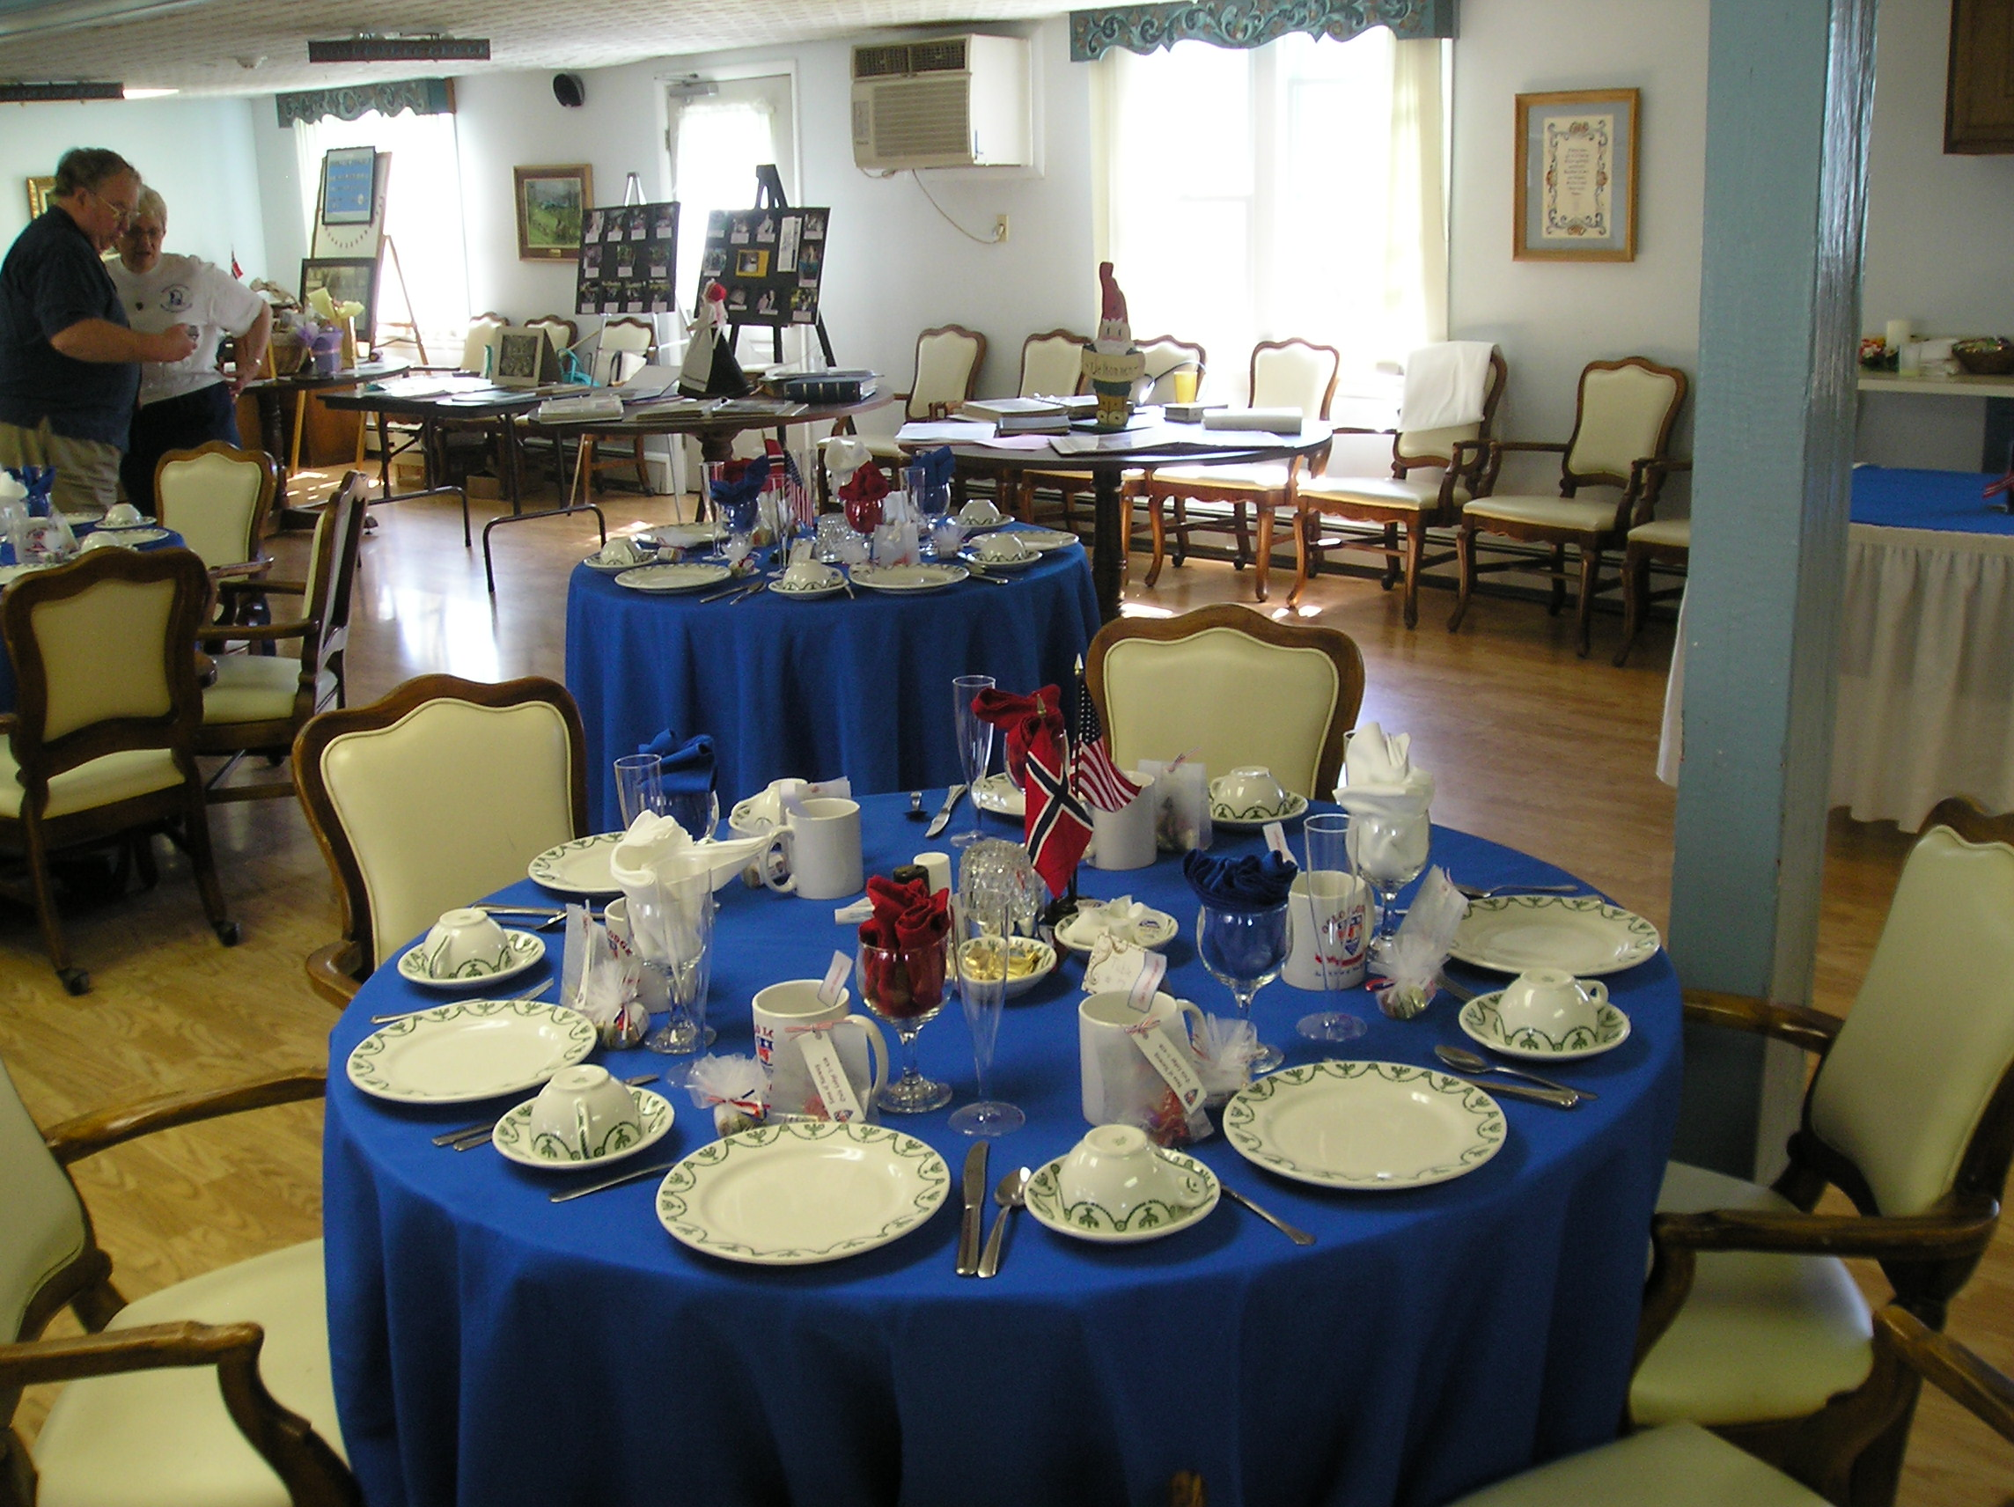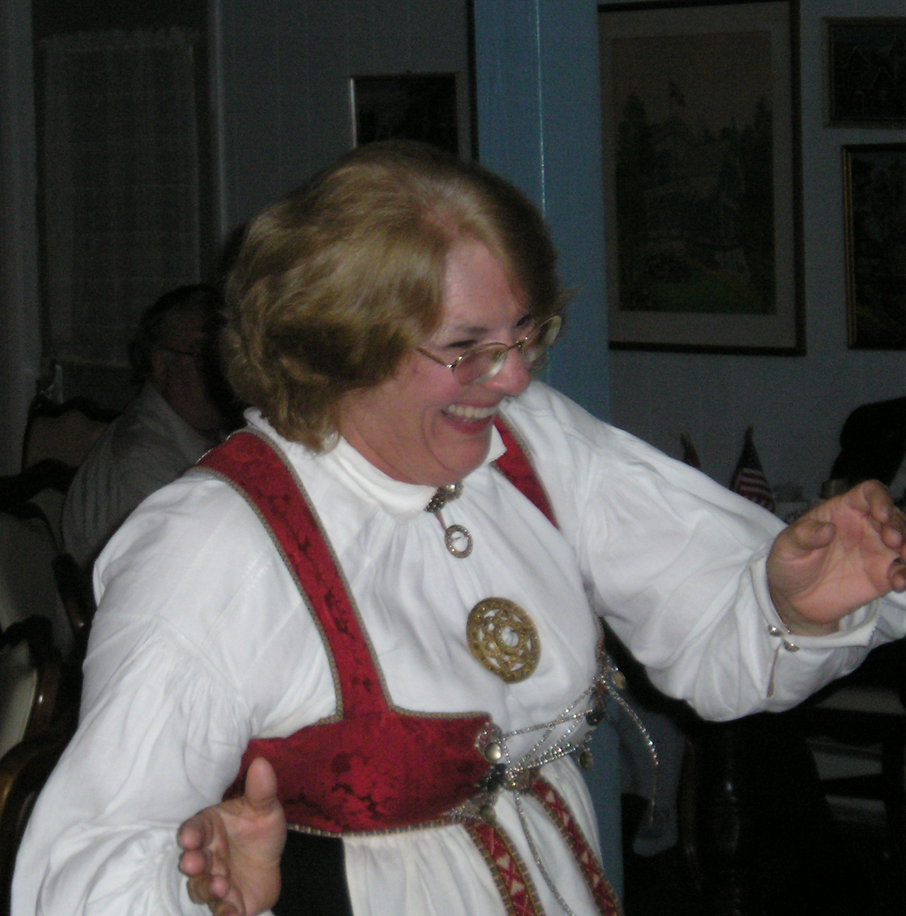

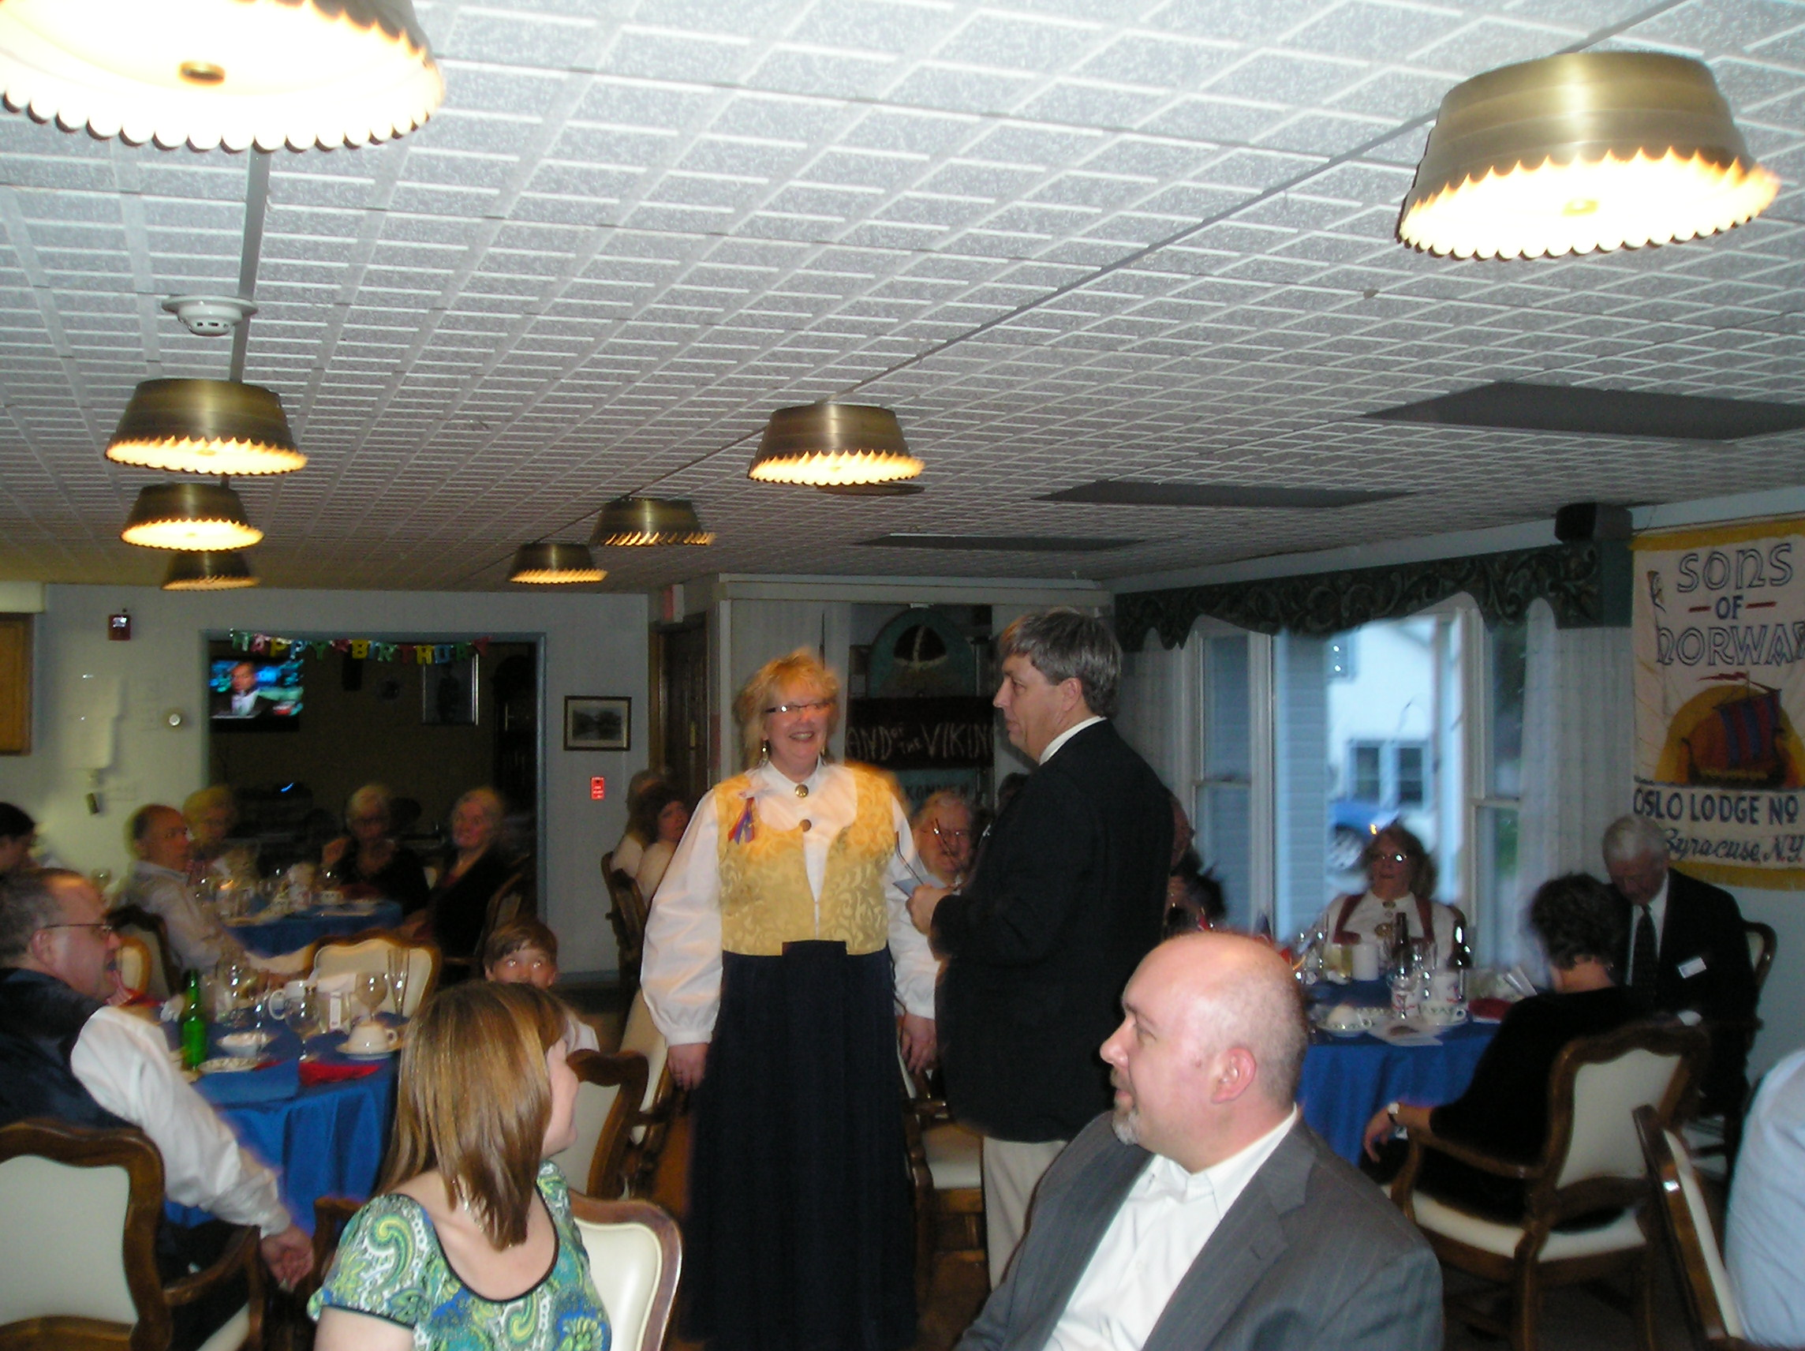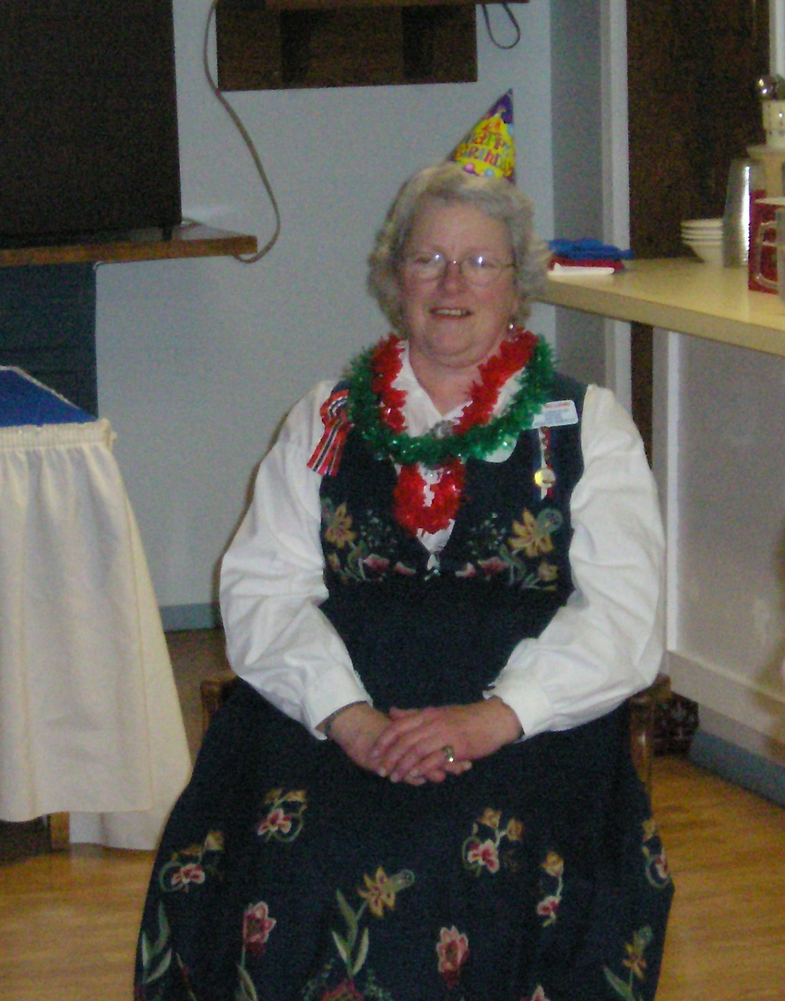

Zone 5
The Regatta
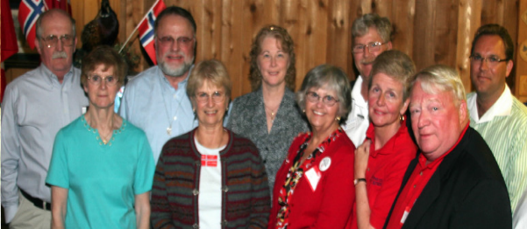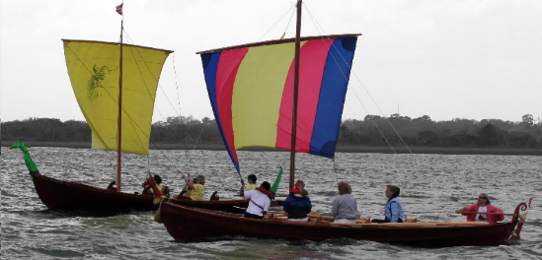

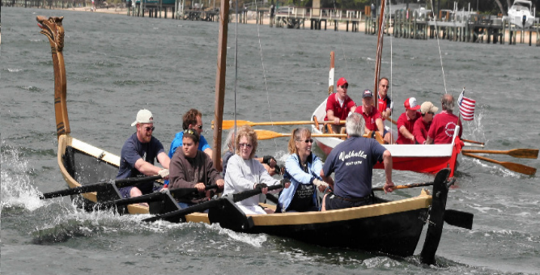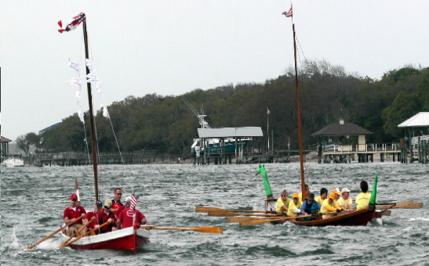

The Hurtigruten Raffle
Click on the link
Ask your lodge President for information about the Hurtigruten Raffle and support the 3D fund raising efforts!

Hurtigruten’s 2009 Theme Voyages
When in Norway, do as Norwegians do—and have done, for centuries. Hurtigruten‘s Theme Cruises exploring Norwegian heritage—gastronomy, folk music, and national costume—put cultural spins on the classic Norwegian Coastal Voyage. Learn to cook—and drink—the Norwegian way with a celebrity chef. Pick up a traditional instrument, or the steps to a regional dance, on a folk music cruise. Educate your inner clothes horse about local folk dress. Live Norway, learn Norway—at sea.

7-day national costume Cruise – September 24, 2009 aboard the MS Nordkapp from Bergen
Discover the poetry of Norway’s heritage as expressed in dress. Learn about the marvelous world of its national and regional folk costumes, with their luxuriant patterns and colors, and how Norwegians have drawn inspiration from abroad, working foreign designs and materials into their homegrown traditional garb. Meet experts on Norwegian folk costumes and enjoy lectures, films, and tailors’ workshops. Folk musicians and dancers perform on board, adding to the folkloric atmosphere.

Rates starting at $1,553* Promo code: COS09
*USD per person, double occupancy based on category I inside cabin.

Upcoming Events
May
1st Loyal – Cultural Dinner
1st Norumbega – Norwegian Singer Anette Haave Åsheim
1st-3rd HULOV Golf tournamentU
1st Roald – Syttende Mai Fest
2nd Norumbega – Peer Gynt
2nd Lauderdale – Worldfest in Coral Springs
2nd Hampton Roads – Azalea parade
2nd Southern Star- Lodge Anniversary Cruise
2nd Hudson Valley – clean up day at Elvedal
2nd Suncoast – 3D bowling torunament
3rd Zone 1 (Long Island) Memorial Service
3rd Færder – 17th of May Fest
3rd Fram – movie night
7th Norumbega – movie night
8th Morgensolen – Syttende Mai
8th Norge – ice cream social
8th Sun Viking – Constitution Day Smorgasbord
9th Hartford – 45th Anniversary Celebration
14th Bernt Balchen - 17th of May celebration
15th Norrøna – Syttende Mai Dinner Dance
15th Suncoast – Histor of Oslo
16th Nor-Bu – Syttende Mai Party
16th Nansen – Syttende Mai Picnic
16th Blåfjell – Local Colors
16th Norumbega – 17th of May family picnic
17th Syttende Mai Parade in Brooklyn, NY
17th Lauderdale – Constitution Day celebration
22nd -23rd Suncoast Lodge – Syttende Mai Viking boat Regatta and Dinner Dance
23rd Norden – garage sale
28th Loyal – Ladies Auxiliary
29th Loyal – Little Vikings
31st Zone 1 – scholarship play

June
4th Norumbega – movie night
5th Norumbega – Innovation Norway
5th-8th Norge – Sunny Hill weekend
5th Loyal – Barbeque and St. Hans celebration
5th Roald – Ice Cream Social
6th Garbog – Atlantic City trip
6th Bernt Balchen – Viking Pork Dinner
7th Fram – Norwegian covered dish luncheon
12th Sun Viking –Ice Cream Social
12th Peconic – Barbeque & Viking Sail
14th Loyal – Lobster Party
14th Færder – dinner and Bingo
16th Nansen – St. Hans
18th Bernt Balchen – Strawberry festival
19th Henrik Ibsen - Strawberry Festival
20th Hudson Valley – St. Hans Celebration at Elvedal
20th Norrøna – St. Hans Day at Budd Lake
20th Morgensolen – Midsommer Dag
23rd Nor-Bu – St. Hans (midsummer bonfire)
27th Blåfjell –Annual Smith Mountain Lake Picnic

July
4th Sun Viking – Indoor Picnic
4th Bern Balchen – march in Hawley July 4th parade
4th Hudson Valley – Saugerties parade
11th Fram – Annual Picnic/Lobster Fest
12th Zone 1 – LI Ducks baseball game
16th Bernt Balchen – Surprise Social
25th Zone 4 picnic at Elvedal

August
1st Maine Nordmenn Hummerfest
9th Garbog - Picnic
9th Hudson Valley – 3 month picnic at Elvedal
16th Loyal – Family Picnic
16th Nor-Bu – Annual Picnic
22nd Blåfjell – Scandinavian Culture/Norway
TBD Bernt Balchen – Annual Lodge Picnic

September
11th Loyal – Sister’s Eve
11th Norge – Game night
11th Sun Viking Cultural Night Viking Auction & Craft Fair
12th Bernt Balchen – Annual Scandinavian Craft Fair
13th Hudson Valley – Soup Day; close Elvedal
19th Nor-Bu – Anniversary Month (67th)
17th Bernt Balchen – Financial planning
24th Loyal – Ladies Auxiliary
25th Loyal – Little Vikings
27th Loyal – booth at St. James Fair

October
2nd Roald – Viking Auction
9th Loyal – Oktoberfest
9th Norge – Brother’s night
10th Hudson Valley – Leif Ericsson Dinner
11th Lauderdale – Jensen Beach Viking Ship Regatta
15th Bernt Balchen – Leif Erikson celebration
17th Nor-Bu – Heritage/Foundation Month
17th Henrik Ibsen – yard sale
18th Loyal – 85th Anniversary Dinner
22nd Loyal - Ladies Auxiliary
23rd Loyal – Little Vikings
24th Blåfjell – 13th Anniversary Dinner
24th Lauderdale – Halloween Party

November
6th Loyal – Thanksgiving dinner
9th Hartford – Scandinavian Heritage Day
14th Loyal - Bazaar
14th Bernt Balchen – membership drive luncheon
14th Hudson Valley – Men’s night at Maennerchor
19th Bernt Balchen – Ellis Island presentation
20th Loyal – Little Vikings
20th Henrik Ibsen – Sisters night
21st Nor-Bu – Fall Dance
21st Blåfjell – Grandin Holiday Parade (10 am)
21st Blåfjell – Traditional Seven Cookies (3pm)

December
4th Loyal - Initiation
5th Bernt Balchen – Annual Christmas Party
5th Loyal – Deck the Halls Glogg Party
5th Lauderdale – Christmas Party
6th Loyal – Children’s Christmas Party
11th Sun Viking – Juletrefest
12th Hudson Valley – Christmas Dinner
12th Loyal – Adult Christmas Party
12th Henrik Ibsen – Children’s Christmas Party at 1
12th Henrik Ibsen – Adult’s Christmas Party at 7:30
13th Hudson Valley – Children’s Christmas Party
19th Blåfjell – Julefest
19th Nor-Bu - Julefest

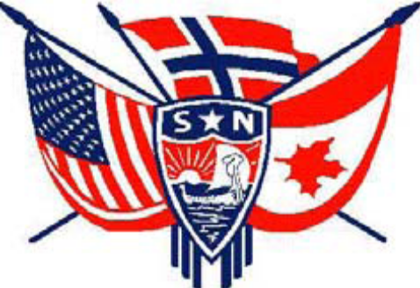

3D Officers

President, Ralph Peterson President@sofn3d.org
Vice President, Gail Ekloff VicePresident@sofn3d.org
Secretary, Marci Larson Secretary@sofn3d.org
Treasurer, John Gregg Treasurer@sofn3d.org
Counselor, Louis Olsen Counselor@sofn3d.org
Youth Director, Evelyn Karpack Youth@sofn3d.org
Sports/Recreation Director – Phil Nelsen Sports@sofn3d.org
Publicity Director, Mary Andersen Publicity@sofn3.org
Cultural Director, Karen Doty Cultural@sofn3d.org

Zone 1 Director, Kris Rasmussen Zone1@sofn3d.org
Zone 2 Director, Judith Mack Zone2@sofn3d.org
Zone 3 Director, Joan McKillop Zone3@sofn3d.org
Zone 4 Director, Arnold Johnsen Zone4@sofn3d.org
Zone 5 Director, Carol Anderson Zone5@sofn3d.org
Zone 6 Director, Kathy Dollymore Zone6@sofn3d.org

PRIVACY NOTICE: This information is for official Sons of Norway business use only. Use of this information for solicitation or commercial purposes is a violation of the Sons of Norway privacy policy and is strictly prohibited.

