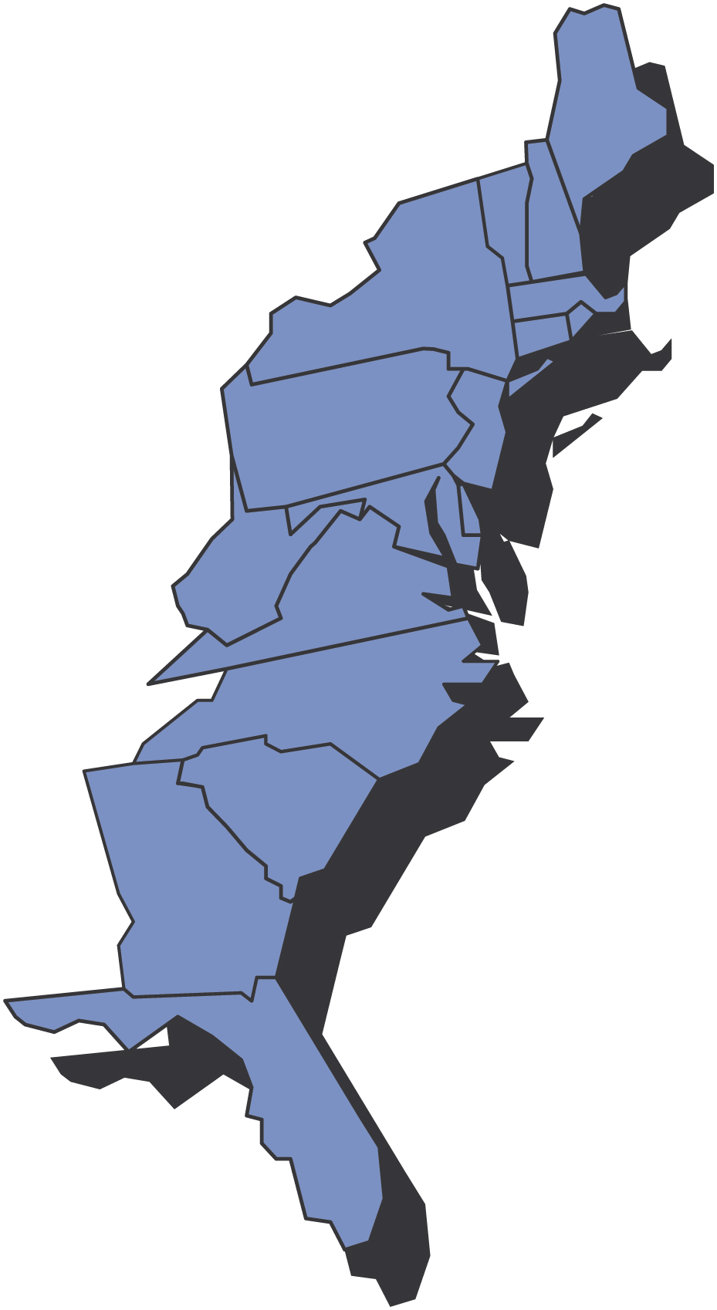

February 2010

Third District Today

0BFra Presidenten Ralph Peterson

Hei alle sammen,
For many of us the snow came and went but the cold weather stuck around a bit longer than many of us liked. The one good thing is we probably got rid of a few bugs that would have bothered us next summer.
Congratulations to Gateway to Florida 3-541 and Dovre 3-232 for winning the Fall SON membership competition. District Three swept both the large and small lodge categories. Each lodge will get a $500 check from SON headquarters and a lot of bragging rights. For both lodges it was a big step forward. For Gateway to Florida it was just a culmination of a lot of awards they have recently earned and for Dovre, it was one great giant step forward in their efforts to getting back on solid ground. .
January is always a great month. We have Officer Installation ceremonies all up and down the East Coast. We have new ideas being put forth and new members taking offices along with some experienced hands helping them along; it’s a great program. Let me offer my congratulations and thanks to all of our new and returning officers.
Some of these new ideas that will be proposed may not always be well received but let’s give them a chance. What kind of an organization would we be today if we didn’t have women in our ranks or use English in our meetings? Those are two changes that were probably tough for many to take when they were proposed but they have helped make our organization the great one it is. Above all, let’s not forget that we are a fraternal organization that is based on rules that apply to all of us.
District Three and the entire order had great positive membership months during November and December. January is doing ok but not as great as the past two months. Let’s get our Membership committees up and going and institute/improve our mentoring programs.
Our web site http://www.3dsofn.org/home.html averaged 97 visitors a day last month. As of Jan 18 the daily average for Jan was 138 visitors a day. That is a huge jump from our 64 a day in June 2009. Our D3 blog got a large uptick in traffic as well. Three of our Adopt a School lodges posted notes on their programs. I encourage more lodges to follow their lead. http://3dsofn.org/blog/2009/11/12/adopt-a-school/#comments We will be posting additional information on the convention as it becomes available. http://3dsofn.org/blog/category/convention
June Cooper, Hampton Roads 3-522, has produced a DVD of the 2008 convention. It is a great production, professionally done, 28 minutes long and covers all the events of the convention. The cost of the DVD including shipping, handling and taxes is $20. It will be a great program for your lodge as well as your own personal enjoyment. Additional information on ordering the DVD can be found on the web or you can email June at Junecooper@mindspring.com
LOV recently had a major upgrade to the heating system. The new equipment will improve reliability, safety and reduce the heating costs.
This is the time of year when we start electing Convention delegates, drafting resolutions and filling out Lodge of the Year forms. These are all important events for our lodges. They deserve our complete attention.
The Institution of the Drammen Lodge will take place at The Chelsea Restaurant, 335 Middle Street, New Bern, NC. Festivities start at 5:30 on 20 Feb 2010. Check the web site for full details or call Arty Ellis at 252 637 7547.
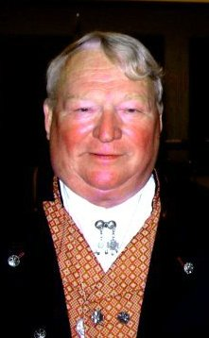
Med vennlig hilsen
Ralph Peterson
President
District Three
Sons of Norway
*****************************

Don’t forget to:

Fra Vise Presidenten Gail Ekloff

The 2009 yearend numbers are in and the total 3D membership is 8745 (7,041 adult and juvenile members, 764 insurance non-members and 940 heritage members) compared to the 2008 yearend total of 9,028 (7,302 adult and juvenile members, 782 insurance non-members and 944 heritage members). We had 26 members transfer out of 000-999 lodge to a local lodge. Ten lodges in the District experienced NET growth. Many lodges added new members but lost members the same month. The total number of new members is 545 for 2009.
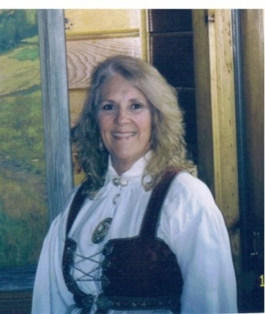
We must address the members voluntarily leaving, 671 in 2009. A concerted effort needs to be made by the lodge to contact these members and retain them as members of your lodge. This is an issue we should be able to turn around since lodges’ Vice President and Financial Secretary are sent monthly “Membership Activity Reports” Find out why they are not renewing their membership, is it cost, lack of programs, not feeling welcome? If you bring this information back to your lodge officers and your membership committee, they can see what has to be done to “fix” this issue.

I have discovered that only a handful of lodges utilize 000-999 reports sent to the VP and membership chairs every month. I will now send the names of the 000-999 members sorted by state to the appropriate lodges; this should enable a better follow-up effort in getting these members to join your local lodge. The home office has been providing lodge Vice-President contact information and names of individuals who have signed up on line wanting to join a local lodge; if your lodge requires a vote for membership. Surprisingly, even fewer of these have been contacted by the lodge! At last count, only 3 out 19 have been contacted by a lodge.

We must work out a different strategy so we don’t lose a person actually asking to join a lodge! I will be contacting the 2010 Vice Presidents and Membership Chairs on how to best go forward. This may be the time for lodges to rethink how they handle their membership and consider changing your by-laws so” no vote” is needed. People can then join directly on line and be put in your lodge membership.

Have you posted your event for “March Membership Madness” on the 3D web site? Let all the lodges know what the event will be and after it is over let us know how many members you got!

Alt for denne gangen,

Gail

REMEMBER THE 2 A’S TO GET NEW MEMBERS--- ASK AND ADVERTISE
AND, TO KEEP MEMBERS, THE 2 M’S -----------------MENTOR AND MINGLE

Medlemskap scorer bord*

LODGE | 1 | 2 | 3 | 4 | 5 | 6 | 7 | 8 | 9 | tOTAL
Nansen # 410 | 1 |  | x
Washington # 428 | 1 |  | x
Oslo #438 |  | 1 | x
Hampton Rd. #522 |  | 1 | x
Norumbega #506 |  |  | x | 1
Gateway to Fl. #541 |  |  | x |  | 1
 |  |  | x
*number 0f 999 members that transfer to a lodge- source activity report /Minneapolis


January 20, 2010
Greetings Sons of Norway Members,
We have all been watching the suffering and seen the utter devastation in Haiti following the January 12, 2010, 7.0 magnitude earthquake. Many of you have asked how you can make a difference.
President Joe Annotti of the National Fraternal Congress of America, of which Sons of Norway is a member, sent the following in his blog concerning the Haiti disaster:
“In times of disaster, the fraternal benefit industry historically has opened its collective heart and wallet to provide disaster relief funds and prayers. We again call on all fraternal organizations to provide whatever relief you can to the victims of this global disaster. If your society would like to join in this humanitarian relief effort, you can immediately by donating.”
The Sons of Norway Foundation is including links to the following organizations that are currently on the ground in Haiti and have had long term connections within Haiti. They are:
- Doctors Without Borders
- World Vision International
- Lutheran World Relief
- Save the Children
Rather than collect donations through the Foundation, which will take precious time, we prefer you donate directly to the charity of your choice or from the list above.
Fraternally,
Dan Rude
President, Sons of Norway

Our Secretary Says
By Marci Larson – Gateway to Florida, President and Third District Secretary

Membership Directory - I am updating the 2010 Membership Directory which will be available to lodges about March 1. Every lodge will receive one free copy and additional copies are $5 each. This is a $1 savings from last year. Lodges do not pay mailing, but you must send me your order form and check made payable to District 3 Sons of Norway for your requested number by Feb. 15, so I know how many directories to print. If I receive your order after Feb. 15, quantities will be available on a first come basis. The order form is on the District 3 web site in Forms and Downloads, plus I am sending a letter by e-mail and snail mail with the order form to lodge presidents and secretaries. If you receive this information and you are no longer the lodge president or secretary, please pass it along. If you have any questions, call me at 904-306-7513 or e-mail at mlarson@northfloridatpo.com.

Elect Your Convention Delegates - 2010 is our district convention year, so lodges should be discussing, nominating and electing their delegates in January or February to attend the convention June 9 – 13 in Harrisburg, PA. If your lodge has the financial means, provide dollars to support your delegates’ participation. My lodge always sends delegates and financially supports them. Your delegates represent your lodge! This is the lodge’s opportunity to participate in district business. Delegates can meet and greet members from around the District, share learning opportunities, see incredible cultural skills, help shape the future of the District. I will be sending information (e-mail and snail mail) once again to lodge presidents and secretaries re: the delegates’ election. Please reference the SON Charter, Constitutions and Procedures 2008-2010, page 44, re: the election of delegates and alternates. If you have questions in the meantime, please contact me.

2009 Lodge of the Year/Family Lodge of the Year Rating Forms – Here’s a great opportunity for your lodge to showcase the wonderful cultural, social, sports, youth, family and other activities and events that you planned and implemented during 2009 by completing the Lodge of the Year and Family Lodge of the Year Rating Forms by March 1 to your zone director. If your Lodge Secretary has not received a copy, the forms are available on the SON web site (www.sonsofnorway.com) under the members section, lodge management and forms. If you have any questions, let me know.

Reminder – individuals or lodges should be considering a nominee for the prestigious Leif Erikson Award, which District 3 presents to a recipient who promotes the ideals of Norwegian culture and heritage. Many dedicated and deserving persons could be honored by this award and certainly have been since its origination in 1967 by the Hartford Lodge.

The criteria is as follows: Candidates may be any person or persons who has/have made major or significant contributions
- as humanitarians
- in public or charitable services
- in the fields of sports, education, medicine or the sciences
- for cultural advancement

- Nominations may be made by any member of the Third District, Sons of Norway. They must include reasons for the nomination and factual evidence supporting the same. (Pictures, newspaper or news media articles, etc.)
- A committee composed of members of the Third District, who have been appointed by the Third District Board, will make preliminary selections from the list of nominees and choose three (3) finalists.
- The Third District Board will elect, by a ballot vote, the award recipient and the first and second alternates.

Completed nominations should be mailed to me at 4013 Moresburg Court, Jacksonville, FL 32257. The nomination must be received no later than Friday, Feb. 19, 2010. The Cultural Director and her committee will review the nominations submitted and will present them to the District Board at the spring board meeting in March. The District Board in turn will select the winner. If you have any questions about the process or need information please let me know. My e-mail is mlarson@northfloridatpo.com; my office phone is 904-306-7513; home is 904-260-4064.

Publicity
by Mary Andersen, 3D Publicity Director

What’s the Buzz?
We have added a new feature to the 3D website to enable you to get the latest news on events and happenings around the District. Click on What’s the Buzz? on the 3D website home page.
Here’s the catch; if you want your lodge news posted in What’s the Buzz?, you must be a regular contributor to the 3D Calendar of Events and the length of your post must be 140 characters or less! Send your posts to publicity@sofn3d.org ; we will retrieve emails on a weekly basis. Remember you must post your lodge events on the 3D Calendar of Events to be eligible to have you lodge news appear in What’s the Buzz?

The power of the internet
Mette Andersen from Norsk Carolina lodge is offering an on line Norwegian class for beginners that began January 17th. Mette reports that she had over 50 students from 3 continents, 8 countries, and at least 17 US states. Talk about the power of the Internet!

Our Harrisburg Convention

Website page dedicated to Convention News
There is a new page on our website dedicated to information regarding the 2010 Convention; visit it frequently as we will be adding more information regarding the Convention.

Vendor and advertising opportunities
As I read the lodge newsletters I am in awe of all our talented members!! Please seriously consider joining forces and sponsor a lodge vendor table at the convention.

Many of our lodges have lodge newsletter advertisers, please remember to ask them to advertise in the convention journal; it is a great way for your advertisers to touch a larger audience at very reasonable prices!

Finally, many of our lodges took advantage of the early bird special and sponsored an ad in the 2010 Convention Journal; there is room for more! The deadline for submitting ads is March 5th; please support your 3D Convention.

Want to know what happens at a convention?

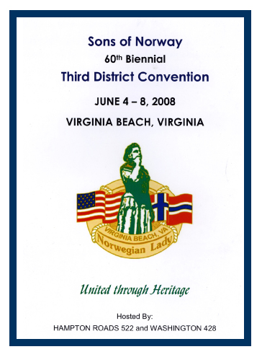
Did you miss the Hampton Roads Convention? Were you not able to go but wish you could? Thanks to June Cooper of Hampton Roads, there is a DVD of the Hampton Roads convention happenings! It's a 30 minute DVD-R program with highlights of the 2008 Convention; get an idea of what it is like to attend a Convention. It is available for $20; click on the Order form and show support for June’s efforts in putting this together for us. The order form is also available from the Forms & Downloads page of our 3D website.

Get more out of the Convention
Third District business is discussed at the convention. Read the Bylaws and follow the discussion on proposed amendments. The Bylaws are available on the Forms and Downloads page of the 3D website as well as the Convention page. If you want to propose an amendment, check out Article IX, you don’t have much time to submit an amendment!

Questions about the Convention?

Visit the 3D website and blog about it!!

Excerpt from a lodge newsletter
Taken from the January edition of The Strand, the newsletter of Southern Star, Dirk Hansen, editor

Of Valhalla, the Icelandic Snorri Sturluson gives us the most vivid detail in his Prose Edda. Valhalla, or "Hall of the Heroes", was the best-known hall in Asgard, which was another residency belonging to Odin, or Val-father ("Father of the Slain") as he was known in this hall. It was where the dead warriors, known as Einherjar (Einheriar), resided in a hall, and wait for the arrival of Ragnarök.

The Einherjar would fight alongside the Aesir at Ragnarok. When the bravest warriors were killed in battle or combat, they were brought to Valhalla by group of women warriors known as the Valkyries, which was translated as "Chooser of the Slain", and they were known as "Battle-maidens" and "Shield-maidens".

The Valkyries were sometimes were known as "Swan-Maidens", because their garments were made of swan feathers, which allowed them to fly. The Valkyries served Odin, by going through battlefield, choosing slain warriors who would be suited to fight in Ragnarök (Ragnarok) and therefore they have a place in Valhalla.

While the Valkyries are in Valhalla, they were known as Mead-Maidens, because they responsible for serving mead to Odin and the Einherjar along the long tables at Valhalla. The mead come from the goat Heidrun that feed from the foliage of branches of tree, called Lerad. Each day, the goat's udder would fill the vat with mead. Andhrimnir, the cook of Valhalla, prepared the meal for the Einherjar.

Andhrimnir cooked the wild boar, called Sæhrimnir, in a great cooking pot, Eldhrimnir. The meat of Sæhrimnir always rejuvenated the warriors at night. Each day Sæhrimnir was cooked before it was served, but by morning of the next day, the wild boar was whole, to be cooked again.

Odin usually dined with his warriors, but he never eats any meat placed before him. Odin would give his meat to the two wolves, Geri and Freki, that rest at his feet. Odin only drank wine with the dead warriors.

Snorri explained that while the Einherjar wait for Ragnarok, they fought each other in a sort of mock battle during the day, but at night they enjoy a great feast, before resting in their bed. In the morning, the Einherjar woke to the crowing of a cock called Salgofnir, which was perched on the rooftop of Valhalla.

Snorri wrote that Valhalla had overlapping shields for a roof, held up by the spear-shafts as rafters. There were 540 doors. And from each of the doors, eight hundred warriors could enter or leave the hall.

Instead of torch fires, the light in the great hall were lighted by the glowing blades of swords. Mail shirts were strewn on the benches. In front of the western doors, there hanged a wolf. Hovering above Valhalla was a single eagle. There was also a tree standing in front of the doors of Valhalla; the tree was called Glasir, because of the red-gold foliage.

Another hall that the fallen warriors resided in was called Vingolf, which means either "wine-hall" or "friend-hall", but this may be the hall for righteous men to live, and not just for the Einherjar. Another name for Vingolf is Gimle, and it was a Norse version of the Elysian Fields or the Blessed Isle. Snorri said Vingolf or Gimle was the fairest of place, located on the southernmost end of heaven. Snorri also mentioned other heavens. Also to the south, but above Vingolf was Andlang.

The third heaven, called Vidblain, was above the two previous heavens. Only half of the slain warriors (Einherjar) in battle were given to Odin. Freyja had the honour of receiving the other half, where the Einherjar resided with her in Folkvang ("Field of Folk"), her hall within her palace Fólkvangar (Folkvangar). The other hall she resided in was called Sessrumnir. The handmaiden named Fulla attended Freyja (most writers say that Fulla was Frigg's attendant).

Cultural Corner
Syttende Mai Parade in Brooklyn!! Mark your calendars – May 16, 2010
Let’s have a great turnout from Sons of Norway lodges. This year’s Grand Marshall is Boomer Esiason former NFL quarterback (Jets, Bengals, and Cardinals)
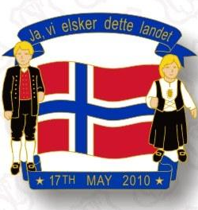

Click here for a letter with all the details!

Many of our lodges have on-going cultural programs!! If you are in the area, check them out:

Hartford Lodge –third Sunday of every month (except December, June, July & August) learn rosemaling, woodcarving and knitting!

Nor-bu – folk dancing on the second and fourth Monday of the month

SunViking –knitting on the third Friday of the month; rosemaling is available too!!

We can make this a regular feature; let us know your ongoing and upcoming cultural events; share your ideas and success stories, blog about it!

Geneaology
The following was excerpted from Asbjørn Lageraaen’s ( Henrik Ibsen President) February newsletter

“During the last few days, I have been trying hard to complete my family tree, but the further one goes the more there is to discover about the past family history and in my case Norwegian history. Some good examples are that during the 1850’s the Norwegian social services rounded up potential emigrant’s who did not have enough money to buy themselves a ticket to “Amerika”, hence they became ward of “Fattigkassa” “the Poor Man’s Support” at that time. Some of them were housed and others had to sleep in the streets. The government paid their fare to New York or Montreal in order to get rid of them. At the same time, there was mass immigration of merchants and traders from Germany, Switzerland, Sweden, Britain and Denmark to Norway. In my family’s case, my Great- Grandfather on my mother’s side came from Switzerland to teach Norwegians to build up the Dairy industry From him we have Jarlsberg cheese for which he received a Royal Silver Medal for contribution to the Norwegian Dairy industry. Then the Norwegians who were rounded up and sent to America traveled to Iowa and received 600 acres to cultivate.

All this you may obtain, when you start delving into the Norwegian Government’s archives to find your ancestors, not by intent, but accidentally, while searching for one’s ancestors. If any of you would like to get started, just see me and I will be happy to put you in the right direction. There are three Cultural Skill badges in Family tracking:
Level 1--Complete people 1-7 on a four generation ancestor chart, etc .
Level 2--Complete four more people on the ancestor, family group chart, and document
Level 3--Complete all information for 15 people on the charts--document and write an essay.”

Get started and blog about your experiences!!

Need to practice the Norwegian National Anthem? Click on the link!

What’s LOV got to do with us?

5th Annual Golf Tournament April 30 – May 2, 2010

The “L.O.V. Open” weekend is coming again to Land of the Vikings. Activities for non golfers as well! Don’t forget to add your Green fee of $65.00 in addition to your room reservation payment.
Payment must be received at Land of the Vikings by April 10th, arrangements can be made with the Golf Course. For Reservations Call Bev or Rick:-Phone: 570-461-3500E-mail- vikingland@tds.net It’s a Great Weekend!!! There will be a “Waiting List” for those that delay.

5th Annual Golf Tournament this year takes on very special meaning
From the LOV Golf Committee (Audun Gythfeldt, Ken Gundersen, Doris Beck)

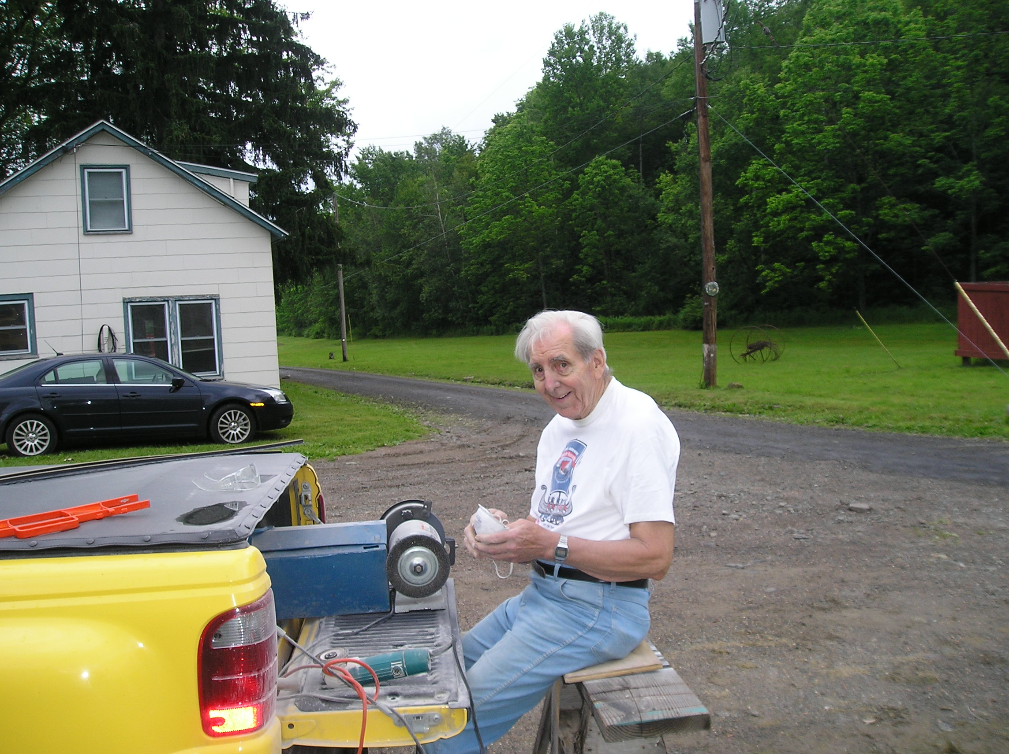
On October 19, 2009, we lost our fraternal brother, John Karlsen. He was a good friend to many and a big supporter of the Land of the Vikings annual golf tournament and attended many other activities there as well. He always had a smile on his face and had a warm welcome for everyone. He was always there to give a helping hand at the Oktoberfest and also contributed his skills on the work weekends. He was always taking pictures of the different events at LOV and contributing them to the albums of the History of Land of the Vikings that are on display at LOV.

John at the 2009 LOV work weekend

The LOV golf committee (Audun Gythfeldt, Ken Gundersen, Doris Beck) has decided to change the name of the annual golf tournament at Land of the Vikings to “The LOV John Karlsen annual memorial golf tournament”. His presence at these events will be sorely missed.
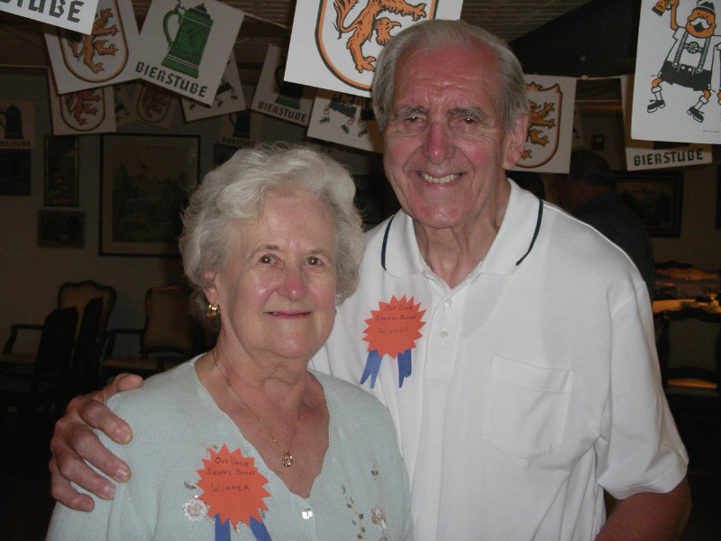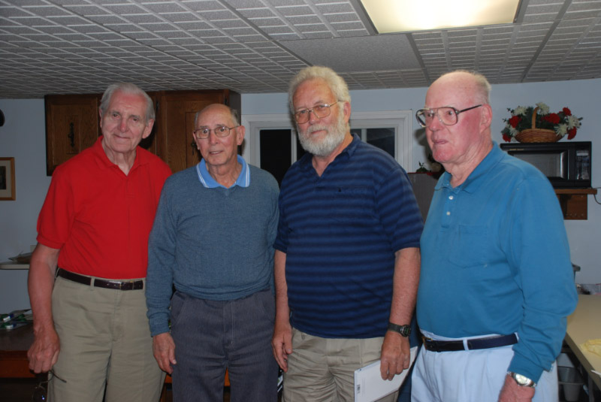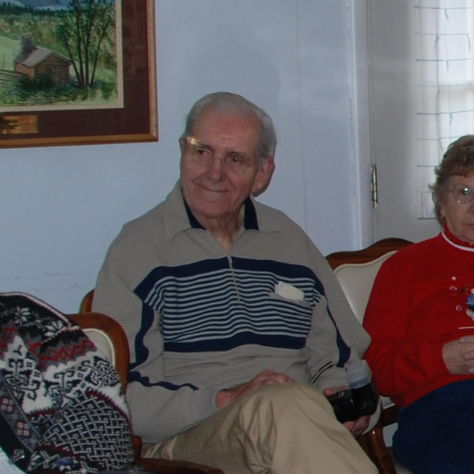
John and Betty at Oktoberfest John at the Golf Outing John at the LOV anniversary

“In the Zone”
Did you know you can find out what is going on in other lodges by clicking on About Us and then lodges on the 3D website? This will take you to the Sons of Norway page which contains all of our lodges. Lodge names highlighted in blue means they have their own website; check out what they are doing and if you are travelling in the area, drop in and say hello!!

Zone 1
Færder fun!

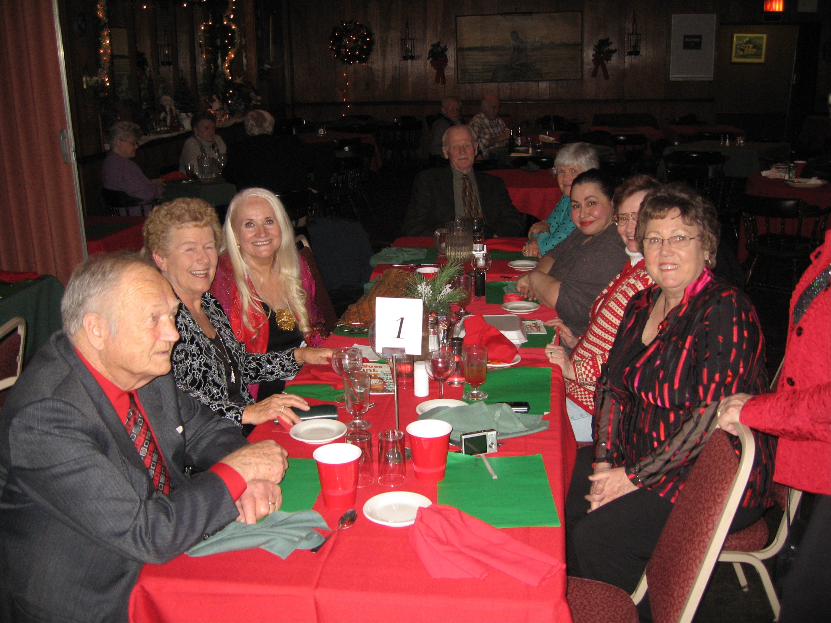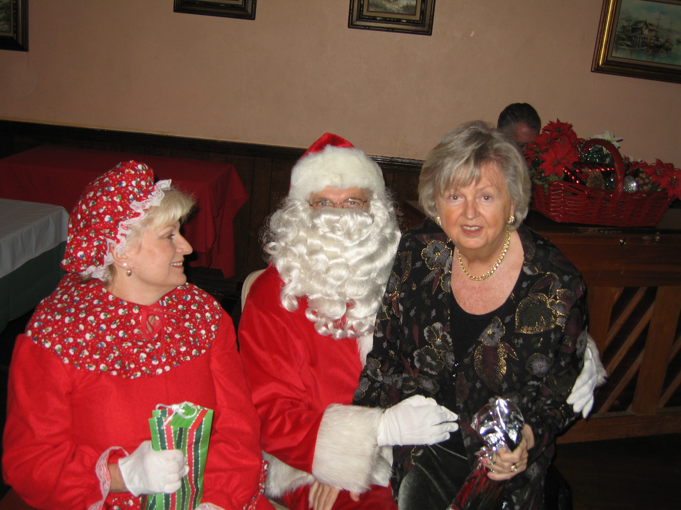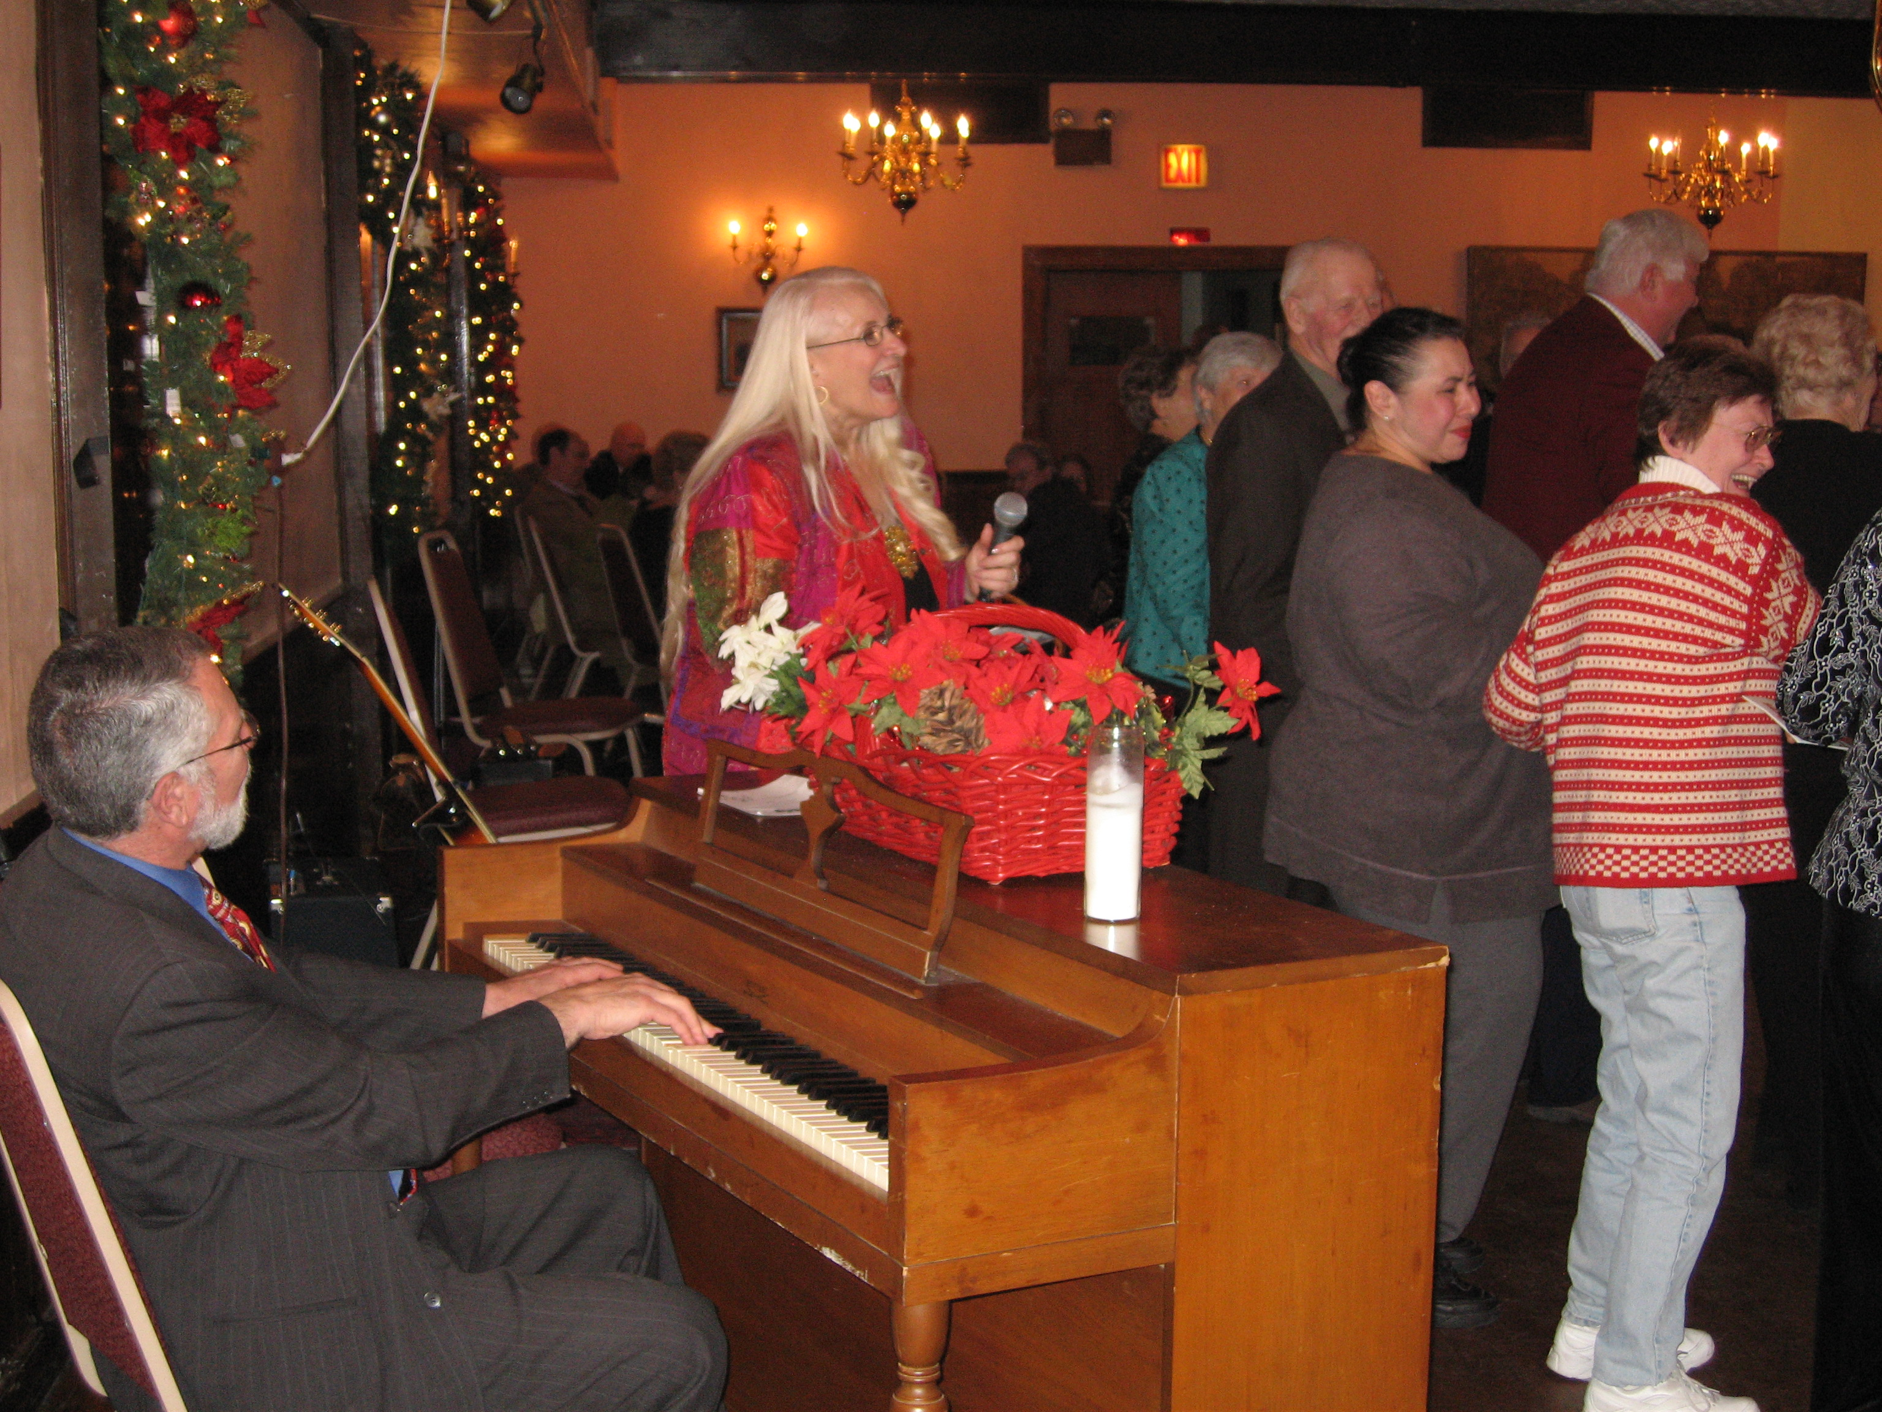

Zone 5

Lauderdale
This is the trophy Lodge won in the Coral Springs Parade. 12/16/09; 2nd year in a row! In the first photo are Jane, Jan, Michelle, and Erik. Congratulations!!!
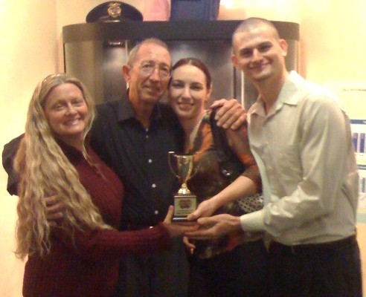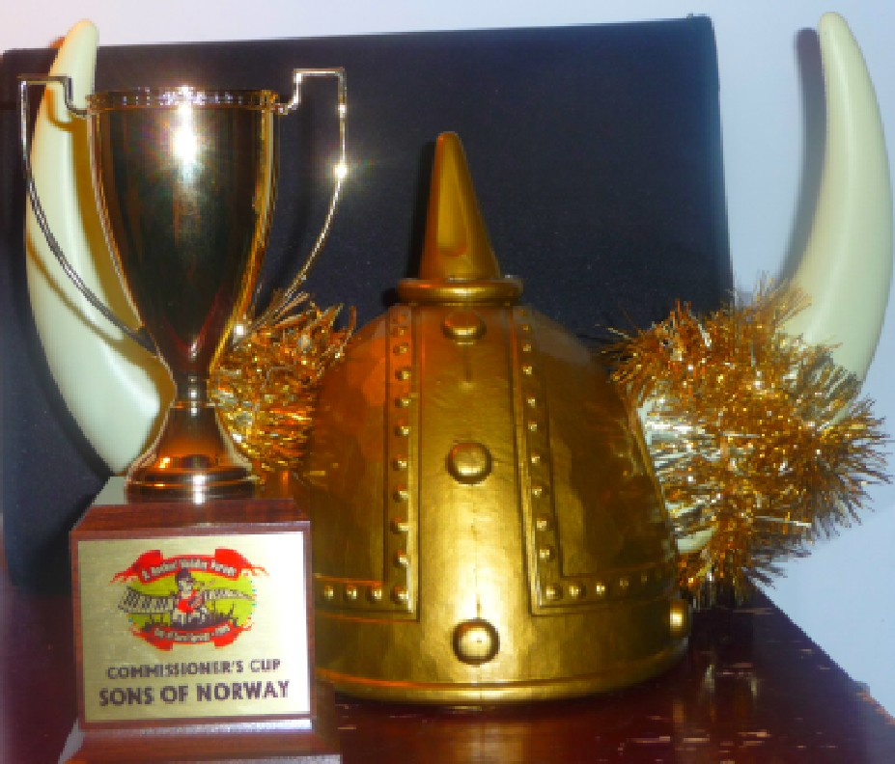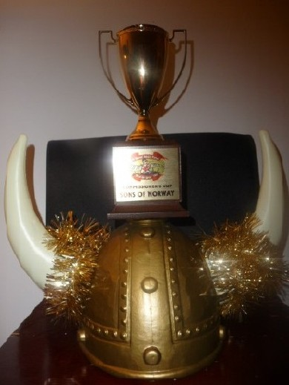

VikingWorld Orlando

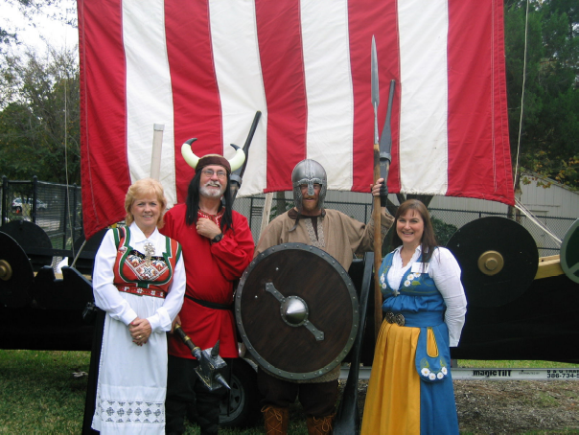
On Saturday, December 12, 2009, several VikingWorld Orlando lodge members attended the annual St. Lucia Festival held at the Museum of Seminole County History in Sanford Florida. They were invited to bring their Viking Ship “Valhalla” and to wear either the traditional Viking costume or more modern Scandinavian Bunads. The above picture shows, from left to right, Anne Smith (in her Norwegian Bunad), Dave Neston (in Viking battle dress), Keith Lavin (in a more authentic battle outfit with weapons), and last, the St. Lucia Host Coordinator, Teri Patterson (in her Swedish Bunad). Not pictured, but in attendance, were lodge members Harold and Judy Holter, Wilma Aubry, Louise DeWall, and Allan Strom. Many of the other St. Lucia attendees enjoyed the opportunity to take pictures of the Viking Ship with Viking Warriors! The VikingWorld Orlando Lodge has frequently participated in this annual St. Lucia Festival over the years and has always enjoyed the opportunity

Upcoming Events

February
5th, 6th, 7th Hartford – Vinterfest
6th Nansen – Mardi Gras Party
6th Nansen – Young Viking’s clothing drive
7th Nansen – Super Bowl Party
7th Southern Star – Super Bowl Party
7th Fram – Annual cod fish dinner
8th Nor-bu – folk dancing
12th Sun Viking – Viking weapons & armor
13th Hudson Valley - bowling
14th Færder – Valentine Party
19th Henrik Ibsen – Membership meeting
19th Noreg – Soup Tasting and Bingo Night
19th Nansen – Social meeting
19th Norrøna – jewelry sale fundraiser
21st Hartford – learn about Ski for Light
22nd Nor-bu – folk dancing
27th Lauderdale – Valentine’s Dinner

March
7th Henrik Ibsen- bowling
8th Nor-bu – folk dancing
12th Troll – Installation of Officers
12th Sun Viking – Vikings in Ireland
13th Southern Star – St. Patrick’s Day Parade
13th Hudson Valley – meeting at Maennerchor
19th-20th Gateway to Florida - Viking Boat Regatta
19th Henrik Ibsen – Brothers night
19th Norrøna – St. Patrick’s Day
20th Nor-bu –St. Patrick’s Day Dinner
21st – Færder – Bowling followed by lapskaus dinner
21st Hartford – author David Faxon discusses his book re the murder of two Norwegian immigrants
22nd Nor-bu – folk dancing
27th Nansen – Viking Auction
27th Lauderdale – St. Patty’s Day Social

April

9th Sun Viking – Easter Bonnet Parade
10th Sun Viking – Picnic at Crews Lake Park
10th Hudson Valley – Yutes night at Maennerchor
11th Færder – Sisters Night
16th Norrøna –Argentine Tango dancers
17th Nor-bu – Brother’s Night
18th Zone 1 (Brooklyn) Memorial Service
18th Hartford – Ham Dinner
24th Zone 4 Scholarship Dinner at LOV

25th Lauderdale – Spring Picnic
30th-May2nd LOV Golf Outing

May
30th-May2nd LOV Golf Outing
2nd Færder – Kentucky Derby Dinner
2nd Zone 1 (Long Island) Memorial Service
14th Nansen – Syttende Mai dinner dance
14th Sun Viking – Syttende Mai celebration
15th Nansen – Syttende Mai picnic
15th Nor-bu – Syttende Mai dinner
16th Syttende Mai parade in Brooklyn
16th Lauderdale – Social in Miami

June
9th-13th Third District Convention
11th Sun Viking – mid-summer festival
13th Færder – business and bingo
18th Henrik Ibsen – Strawberry Festival
19th Henrik Ibsen – yard sale
20th Hartford – Ice cream social
23rd Nor-bu – St. Hans Bonfire
26th Nansen – St. Hans Bonfire
26th Norrøna –St. Hans Dag picnic

Remember to post your events to the Events Calendar on our 3d website http://www.3dsofn.org/eventscalendar/
Get the word out and remember one of Vice President’s “A’s” - ADVERTISE

SONS of NORWAY
61st Third District Convention
Harrisburg, Pennsylvania
June 9 -13, 2010

Explore Your Heritage
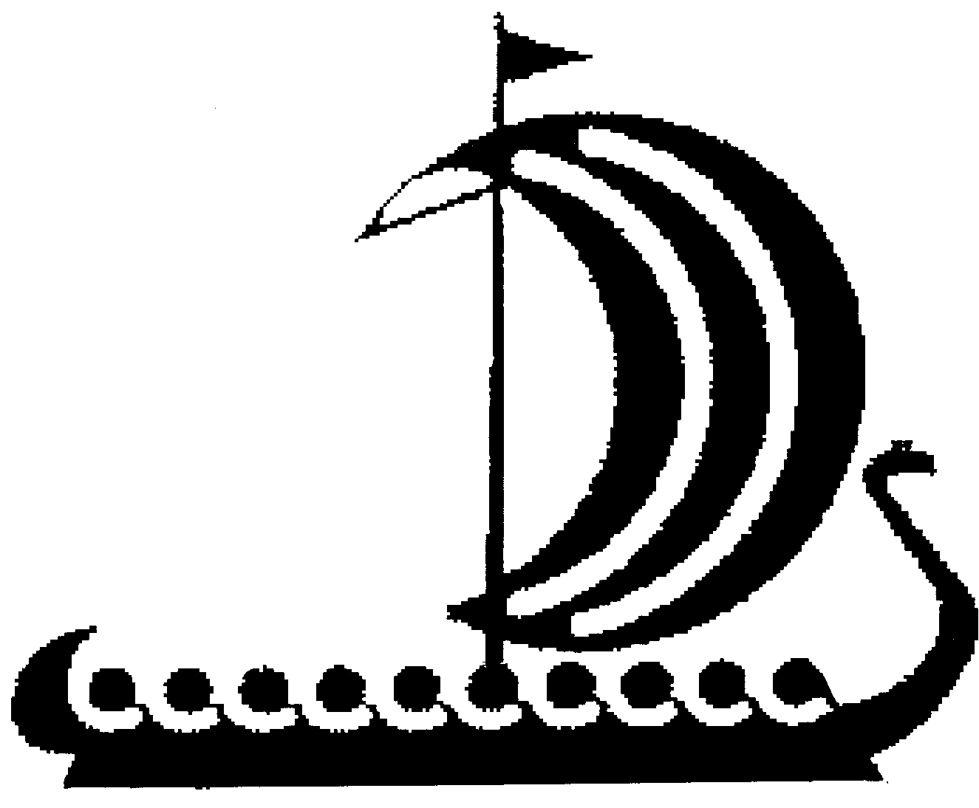

WHEN: June 9-13 2010

WHERE: Harrisburg Holiday Inn Hotel & Conference Center
148 Sheraton Drive,
New Cumberland, Pa 17070
1-717-774-2721 (use group code SON )

COST: Rooms: $101.00 (+ taxes) standard room
(Hotel will honor rate 3 days pre / post)

PACKAGES: $285.00 Delegates / $200.00 Non-delegates

Packages include at this time:
Registration Fee, Wednesday President’s Reception, Thursday luncheon, Friday luncheon, Saturday Banquet and Dancing, Meet and Great with Dignitaries, Live Musical Entertainment, Cultural Displays, Viking Presentation, five (5) coffee breaks, including 25 tickets for the Viking Auction. Transportation from airport, bus or train station or parking for your auto.

WEBSITE: http://www.holidayinn.com/hotels/us/en/mdtcc/hoteldetail#Hotel-Information

Parting Shot

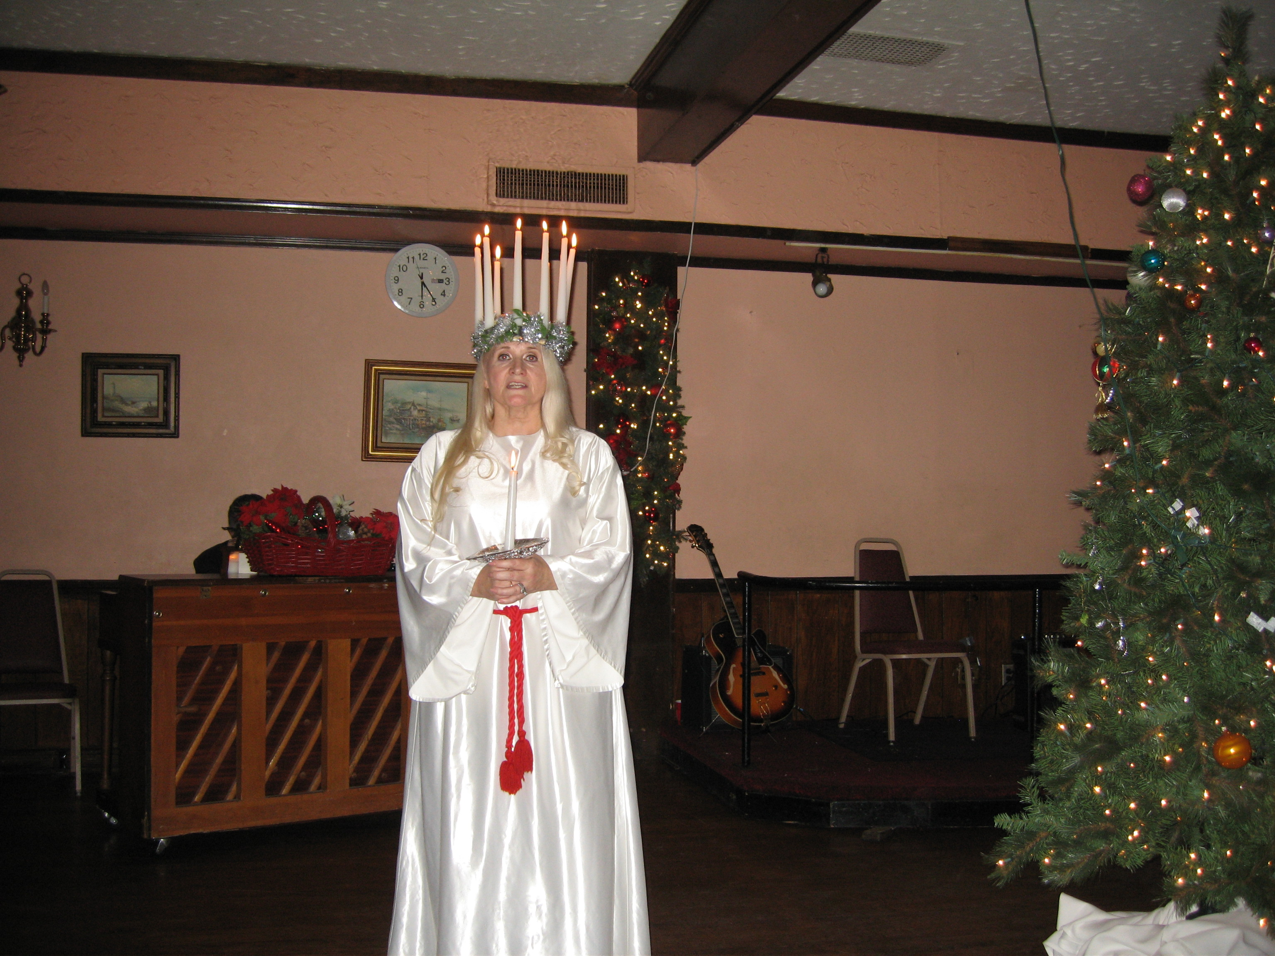

Lucia is performed by Ingrid Feingold, accompanied by her husband Dick at Færder’s (2009) Christmas Party. This has become an annual tradition at Faerder lodge’s adult Christmas Party. Ingrid is very well known amongst the Scandinavians in the NYC metropolitan area and she has recorded several CDs. Dick at one time lead the Faerder Singers, a male chorus started in 1975 that was active for about 10 years.

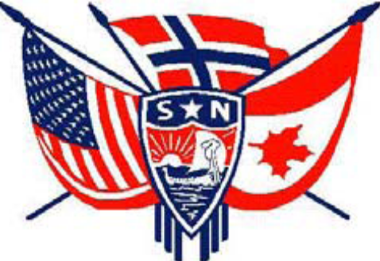

3D Officers

President, Ralph Peterson President@sofn3d.org
Vice President, Gail Ekloff VicePresident@sofn3d.org
Secretary, Marci Larson Secretary@sofn3d.org
Treasurer, John Gregg Treasurer@sofn3d.org
Counselor, Louis Olsen Counselor@sofn3d.org
Youth Director, Evelyn Karpack Youth@sofn3d.org
Sports/Recreation Director – Phil Nelsen Sports@sofn3d.org
Publicity Director, Mary Andersen Publicity@sofn3d.org
Cultural Director, Karen Doty Cultural@sofn3d.org
Adopt A School Coordinators, The Olson’s adoptaschool@d3sofn.org

Zone 1 Director, Kris Rasmussen Zone1@sofn3d.org
Zone 2 Director, Judith Mack Zone2@sofn3d.org
Zone 3 Director, Joan McKillop Zone3@sofn3d.org
Zone 4 Director, Arnold Johnsen Zone4@sofn3d.org
Zone 5 Director, Carol Anderson Zone5@sofn3d.org
Zone 6 Director, Kathy Dollymore Zone6@sofn3d.org

PRIVACY NOTICE: This information is for official Sons of Norway business use only. Use of this information for solicitation or commercial purposes is a violation of the Sons of Norway privacy policy and is strictly prohibited.

